**Understanding Life Stages**

**RO25**

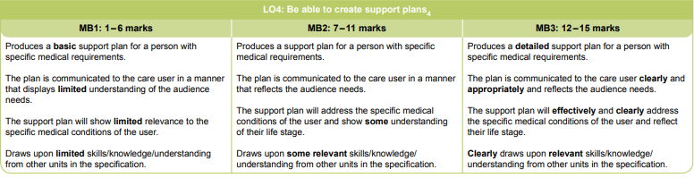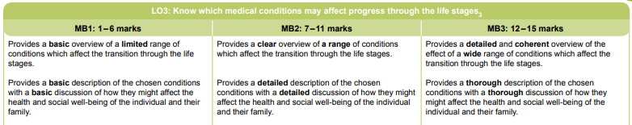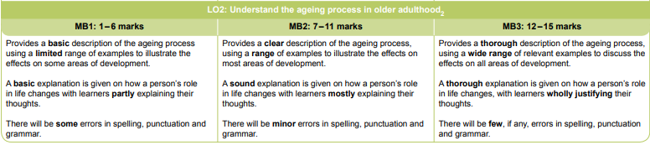A screenshot of a cell phone

Description generated with very high confidence