

Additional Assessment Materials

Pearson Edexcel GCE in A level Business

9BS0

Resource Set 6

3.6 Managing change

3.6.1 Causes and effects of change

3.6.3 Scenario planning

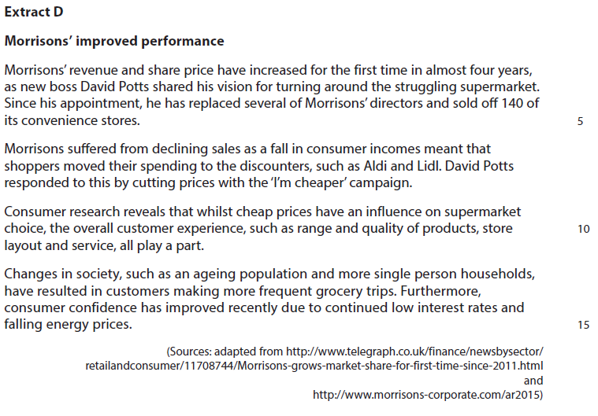**3.6.1 Causes and effects of change**

1 Assess whether the transformational leadership shown by David Potts is the main cause of Morrisons’ improved performance.

(12)

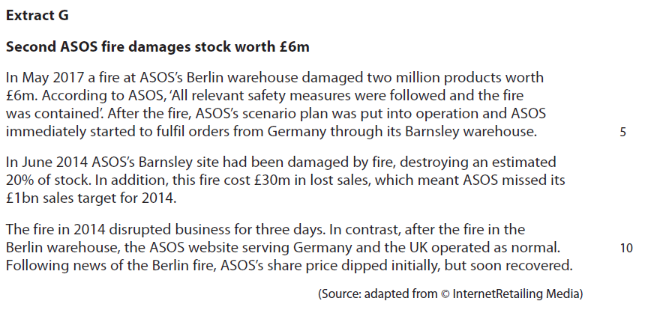**3.6.3 Scenario planning**

2 Assess the usefulness of scenario planning to a business, such as ASOS.

(12)

|  |  |  |
| --- | --- | --- |
| Question Number | Indicative content | Mark |
| **1** | **Knowledge 2, Application 2, Analysis 4, Evaluation 4**  **Indicative content**   * Transformational leadership is the ability to implement a vision through radical policies and strategies to bring about a positive change * **Reasons why:** * He has replaced several directors. This may have resulted in the introduction of new ideas, such as the ‘I’m cheaper’ campaign * The previous directors may have been resistant to his ideas and consequently made the implementation of his strategy to achieve his vision more difficult * He has sold off 140 convenience stores in order to focus on improving the performance of its supermarkets, which could have been met with resistance from employees and customers   *Possible counterbalance*   * Improved performance could be due to the recent rise in consumer confidence which meant that they had increased their spending at Morrisons which led to 0.6% increase in revenue * Consumers could have greater disposable incomes because of continued low interest rates / lower energy costs leading to increased spending on groceries which has little to do with transformational leadership   *Potential judgement*   * David Potts’ transformational leadership has been responsible for the improved performance as he has recruited new directors who shared his vision which then brought about positive change to Morrisons * David Potts is a newly appointed leader, therefore it is too soon to make an effective judgement whether he has been transformational in the change process. The improvement to Morrisons’ performance could be due to external factors such as greater disposable incomes. | **(12)** |

|  |  |  |
| --- | --- | --- |
| Level | Mark | Descriptor |
|  | 0 | A completely inaccurate response. |
| Level 1 | 1–2 | Isolated elements of knowledge and understanding – recall based.  Weak or no relevant application to business examples.  Generic assertions may be presented. |
| Level 2 | 3–4 | Elements of knowledge and understanding, which are applied to the business example.  Chains of reasoning are presented, but may be assertions or incomplete.  A generic or superficial assessment is presented. |
| Level 3 | 5–8 | Accurate and thorough knowledge and understanding, supported throughout by relevant and effective use of the business behaviour/context.  Analytical perspectives are presented, with developed chains of reasoning, showing cause(s) and/or effect(s).  An attempt at an assessment is presented, using quantitative and/or qualitative information,though unlikely to show the significance of competing arguments. |
| Level 4 | 9–12 | Accurate and thorough knowledge and understanding, supported throughout by relevant and effective use of the business behaviour/context.  A coherent and logical chain of reasoning, showing cause(s) and/or effect(s).  Assessment is balanced, wide ranging and well contextualised, using quantitative and/or qualitative information, and shows an awareness of competing arguments/factors leading to a supported judgement |

|  |  |  |
| --- | --- | --- |
| Question Number | Indicative content | Mark |
| **2** | **Knowledge 2, Application 2, Analysis 4, Evaluation 4**  **Indicative content**   * Scenario planning is the process of anticipating possible changes in a business’s situation and devising ways of dealing with them   **Potential usefulness of scenario planning:**   * The Barnsley fire enabled ASOS to identify key risks and therefore ASOS was able to quickly respond to the Berlin fire and limit potential damage to their business * ASOS only suffered short term disruption after the Berlin fire and were able to fulfil orders from its Barnsley warehouse so sales did not suffer * The ASOS website in Germany and the UK were able to continue to operate normally so online orders were still fulfilled as normal   **Potential limitations:**   * ASOS still lost stock worth £6m as a result of the fire in Berlin therefore scenario planning cannot totally eliminate damage to the business * The opportunity cost/trade offs in terms of time and money spent on identifying and mitigating potential risks e.g. less money available to spend on website development/TV advertising * ASOS would have faced an increase in costs for the business by having to fulfil European orders through the Barnsley warehouse   *Potential judgement*   * ASOS’s scenario plan was useful because it was put into operation after the Berlin fire, resulting in its share price recovering quickly which may have reassured investors * ASOS cannot plan for all potential disasters, such as flood damage to stock or its website being hacked. Therefore scenario planning is more useful if ASOS can identify the risk and implement effective plans to limit the damage to the business | **(12)** |

|  |  |  |
| --- | --- | --- |
| Level | Mark | Descriptor |
|  | 0 | A completely inaccurate response. |
| Level 1 | 1–2 | Isolated elements of knowledge and understanding – recall based.  Weak or no relevant application to business examples.  Generic assertions may be presented. |
| Level 2 | 3–4 | Elements of knowledge and understanding, which are applied to the business example.  Chains of reasoning are presented, but may be assertions or incomplete.  A generic or superficial assessment is presented. |
| Level 3 | 5–8 | Accurate and thorough knowledge and understanding, supported by relevant and effective use of the business behaviour/context.  Analytical perspectives are presented, with developed chains of reasoning, showing cause(s) and/or effect(s).  An attempt at an assessment is presented, using quantitative and/or qualitative information, though unlikely to show the significance of competing arguments. |
| Level 4 | 9–12 | Accurate and thorough knowledge and understanding, supported throughout by relevant and effective use of the business behaviour/context.  A coherent and logical chain of reasoning, showing cause(s) and/or effect(s).  Assessment is balanced, wide ranging and well contextualised, using quantitative and/or qualitative information, and shows an awareness of competing arguments/factors leading to a supported judgement. |