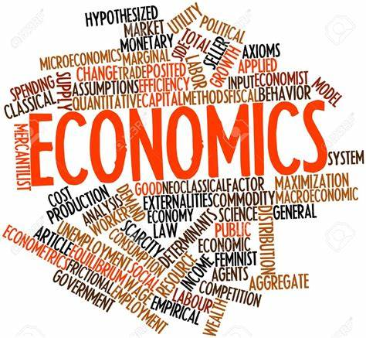

A level Economics
Student Handbook

Course name: Economics B
Exam board: Edexcel

Email: sraza01@beckfoot.org

Table of contents

- Qualification at a glance
- Assessment objectives
- Tips for success
- 5 hours in Economics
- Homework
- Quantitative skills
- Accountancy ratios
- Equipment
- Textbooks & reading
- Useful websites
- Grade boundaries
- Curriculum map
- Them 1 – 4 outline
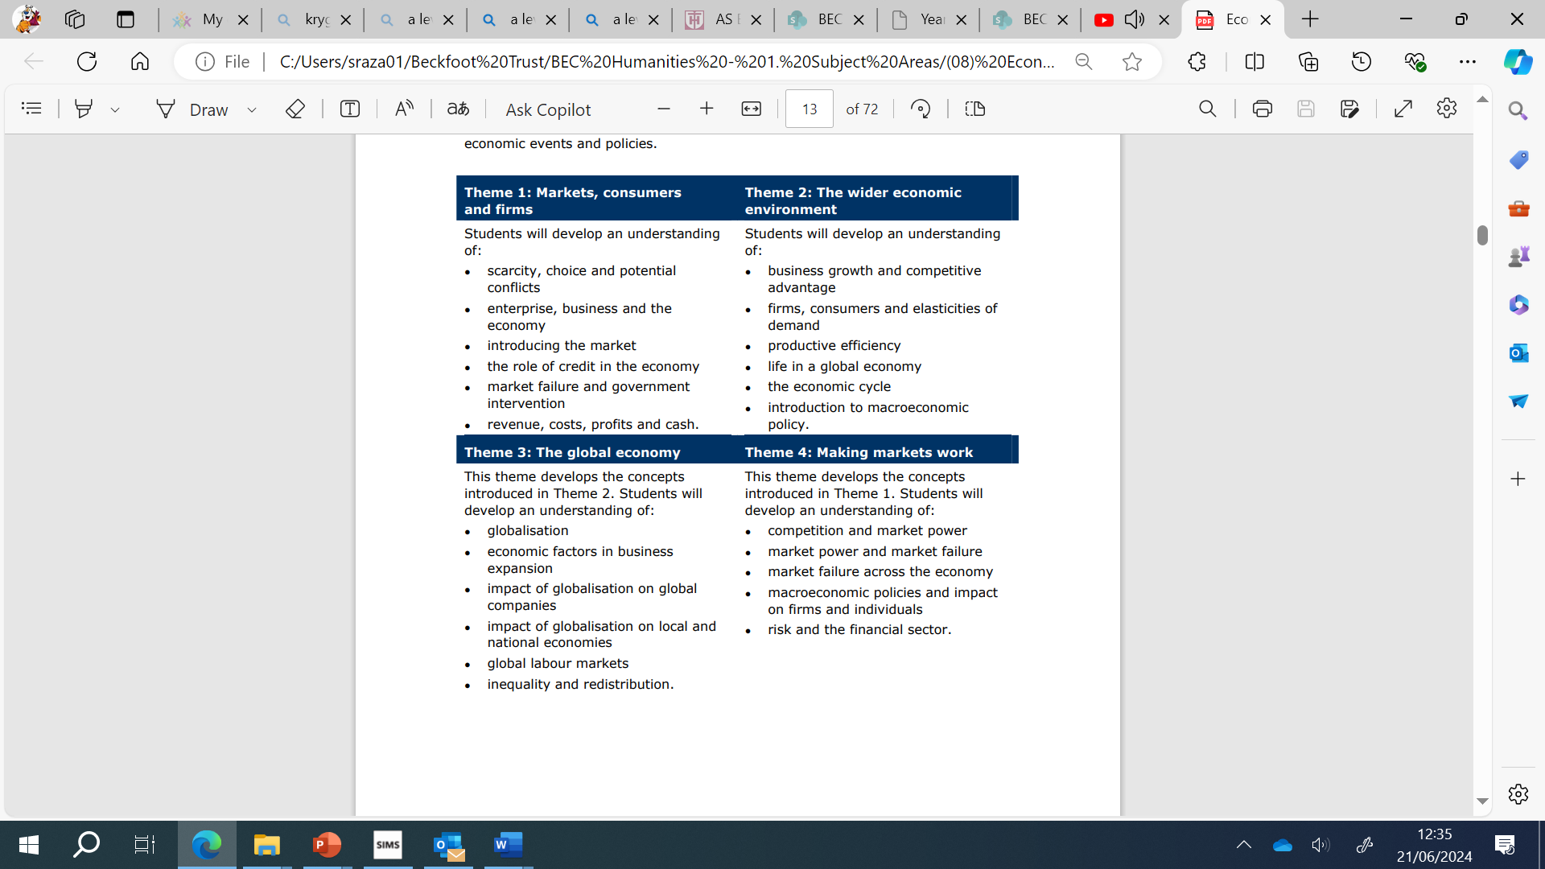
- Qualification at a glance
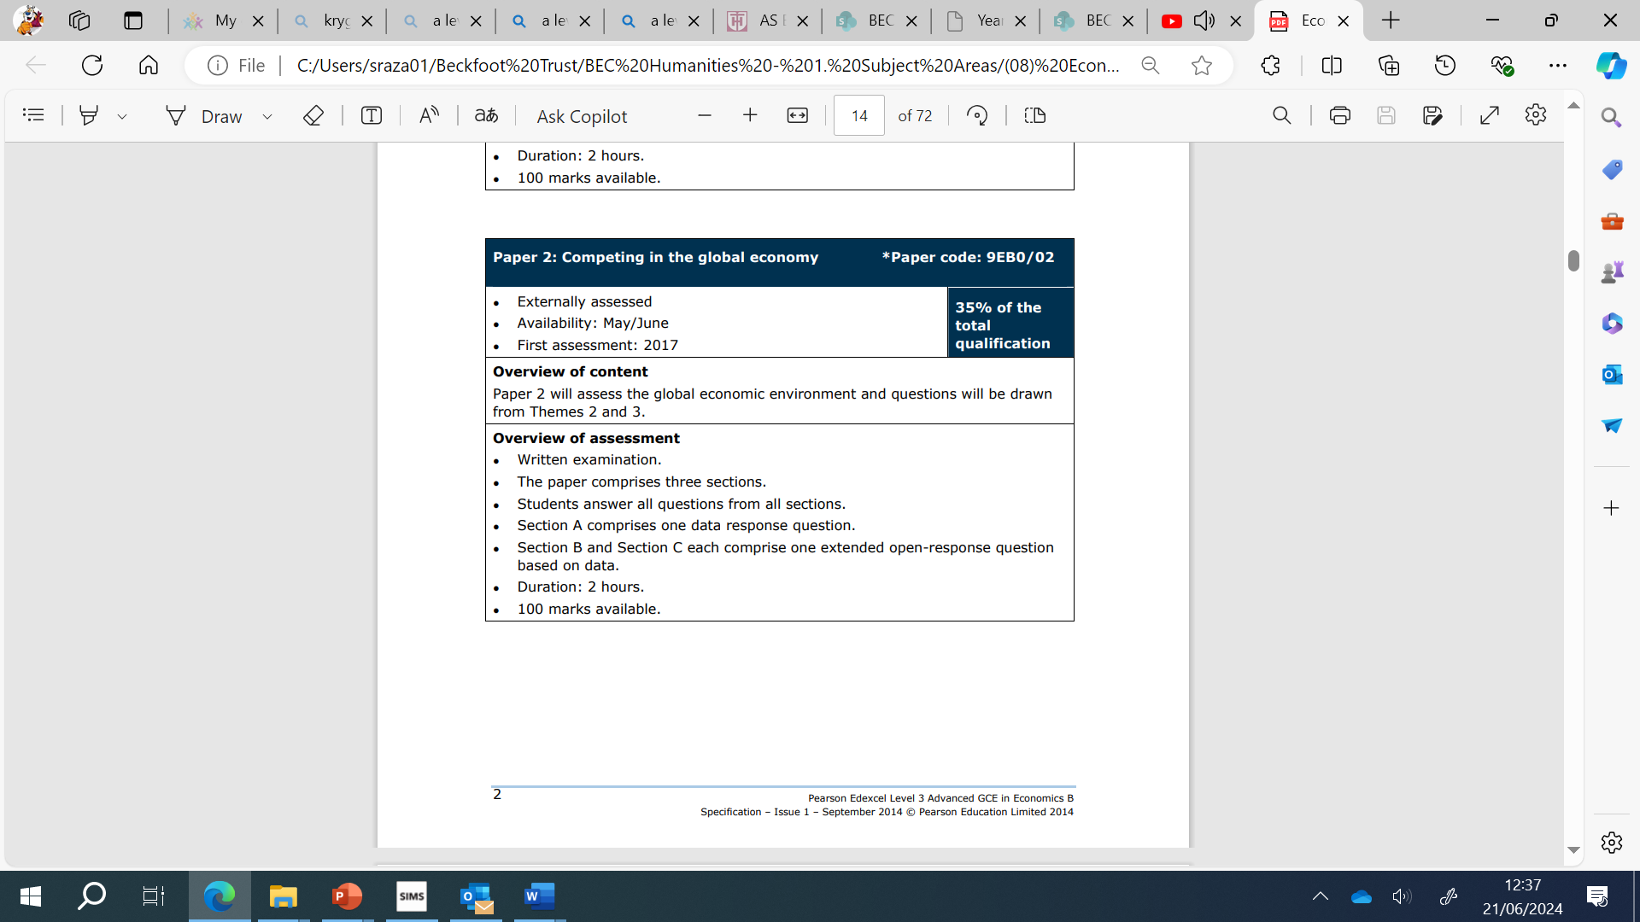
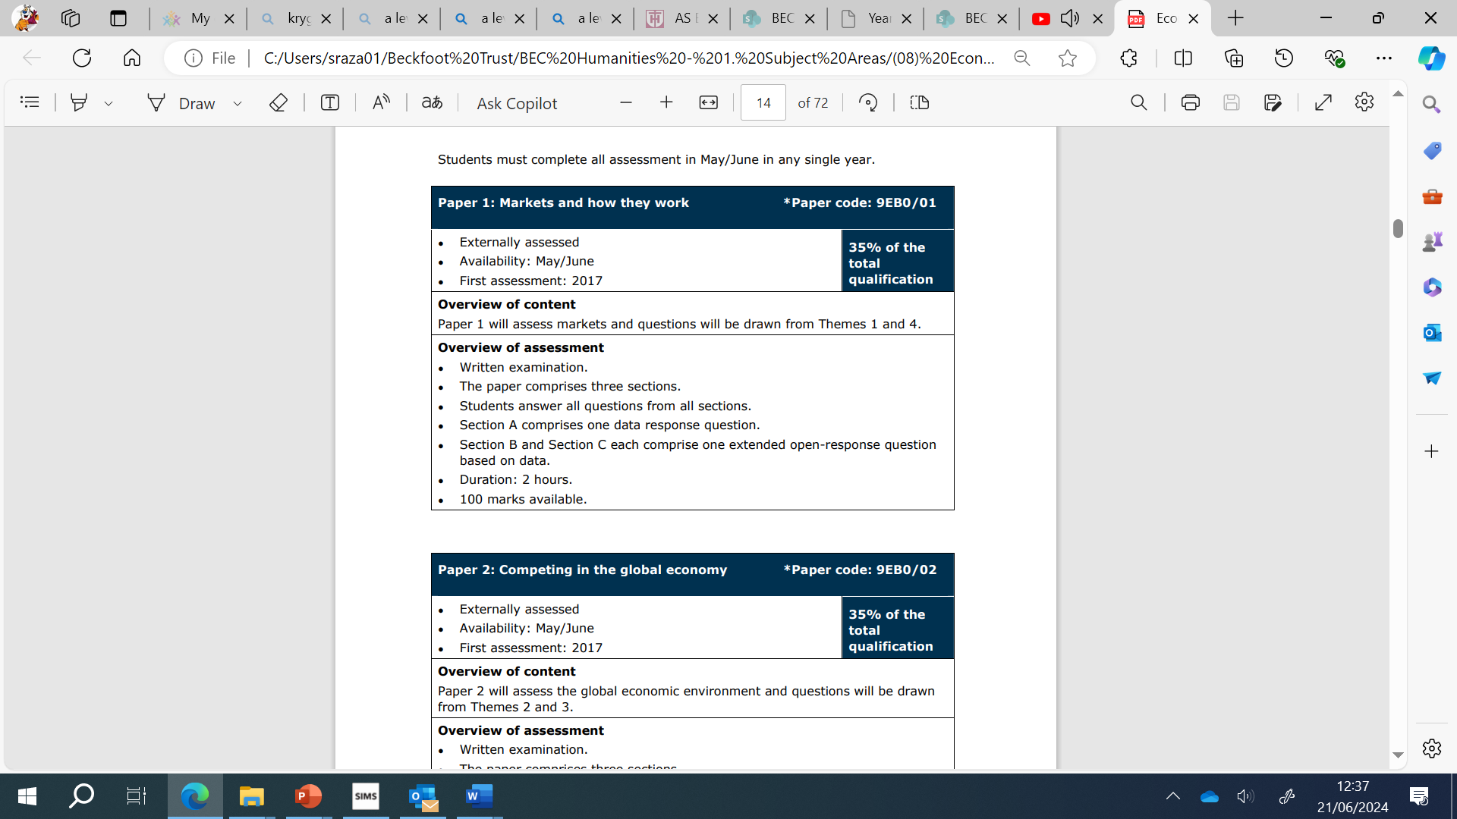

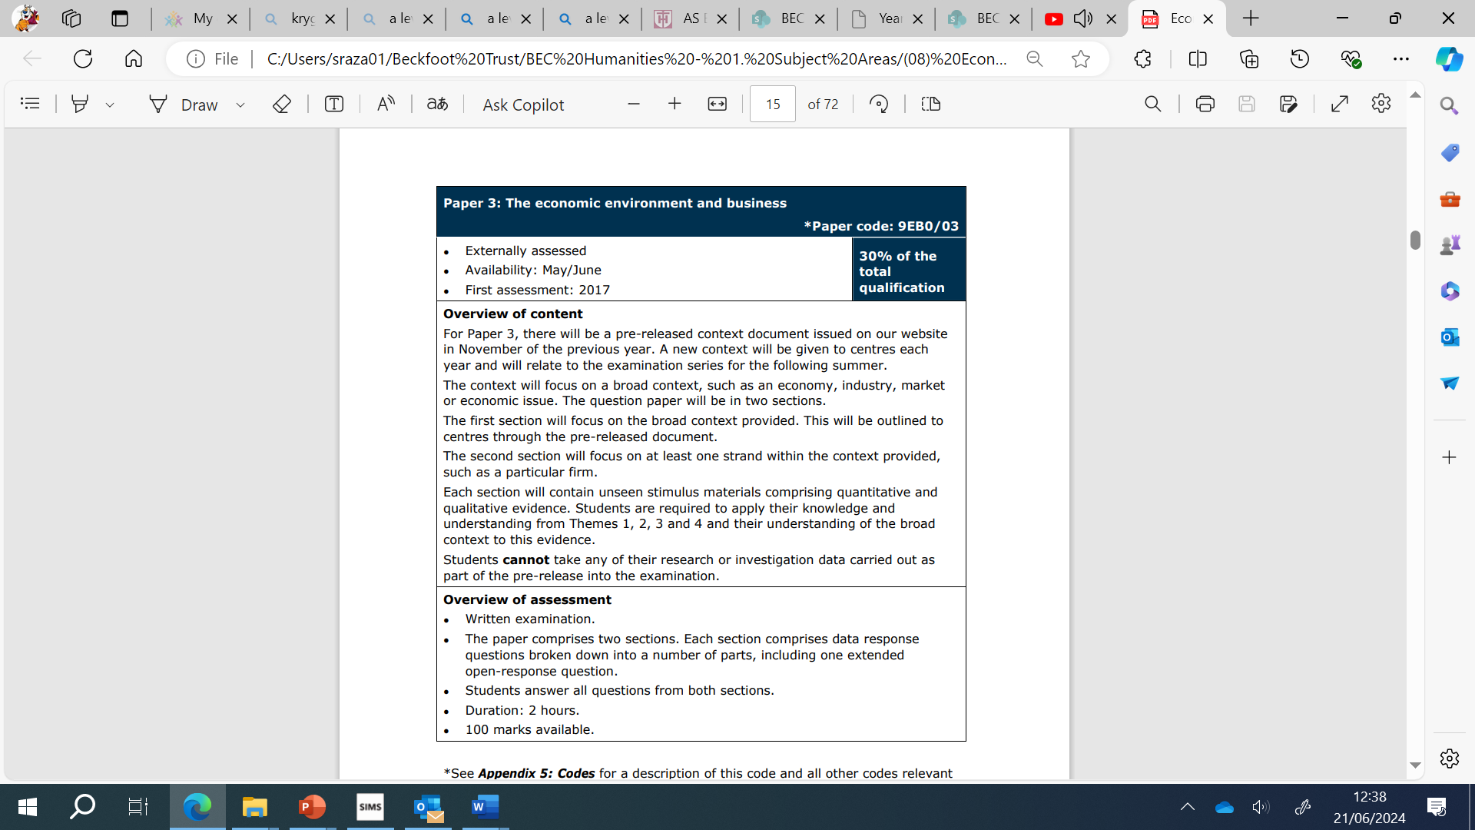

- Assessment Objectives

AO1 – Knowledge: this means you have to show that you:
- Recognise and understand business terms and concepts and theories
- Understand how individuals and organisations are affected by respond to economic issues

All questions will test knowledge to some extent. A minority of questions will test knowledge alone. These can be recognised by the mark allocation, they tend to carry just 4 marks.

AO2 – Application: this means that you have to apply knowledge and understanding to various contexts to show how individuals and organisations are affected by respond to issues. This might involve:
- Using a s formula in appropriate circumstances, for example, calculating the price elasticity of demand for a product
- Using a theory to show why a business has chosen a particular course of action
- Using a theory to show the impact on a the economy of choosing a particular course of action

AO3 - Analysis: this means you have to show that you can break down information and understand the implications of the information presented in the question. You will need to show an understanding of the impact on individuals and organisations of external and internal influences. This might involve:
- Explaining causes and effects and interrelationships, for example by recognising from a graph that sales are falling and could be the result of new competition in the market
- Breaking down information to identify specific causes or problems, for example by realising that a business is suffering from inefficiency because staff motivation has fallen as a result of a pay cut.
- Using appropriate techniques to analyse data, for example using the net profit ratio to assess the performance of a business

You will often be required to construct an argument. For example by explaining the possible reasons for events or discussing the advantages or disadvantages of particular course of action.

AO4 – Evaluation: evaluation involves making a judgement.
You will need to evaluate both qualitative and quantitative evidence to make informed judgements and propose evidence-based solutions to economic issues. This might involve
- Showing judgement when weighing up the relative importance of different points o sides of an argument in order to reach a conclusion.
- Drawing conclusion from the evidence that you present.
- Assessing the relative importance of particular issues to individuals, businesses or the economy.
- Suggesting a course of action for a business, supported by plausible motives or evidence.

When evaluating, it is often possible to draw a number of different conclusions. Very often in economics there is no “right” answer, so examiners are likely to be more interested in whether your judgement in support of that judgement. Questions that carry eight markers or more are likely to test evaluation.

3. Tips for success in economics
1. Active Learning
Studying Economics requires an active, not passive, approach. Try to read through the chapters within a day or two of your class. With the teacher's examples still fresh in your mind, it will be easier to understand the textbook or any supporting materials. The goal here is comprehension, not memorization. Even if you have other commitments, try to do this at least weekly. And remember, textbooks are there for a reason, they help you to understand the scope of your syllabus at the level you're in. Videos and other resources can supplement your learning, but don't neglect the basic reading.

2. Highlight Keywords
As you read, have a pencil handy to highlight keywords. These keywords are like the secret language of Economics. These are important. If I use the terms, ‘motion’ or ‘acceleration’, you will immediately realize that I am talking about Physics. Similarly, Economics has it’s own language. By identifying and understanding them, you'll grasp the core ideas much more easily. The best way to approach this is to:
- List the steps in each logical argument
- Retrace the cause-and-effect steps in each model
- Draw the graphs that represent the model
- Think about the basic principles of economics and how they relate to what you are learning
Doing this even once a week will help you understand the subject at a deeper level and will make your studies more enjoyable.

3. Break It Down
Divide and conquer - break the lesson into manageable parts, and tackle each one separately. Start with the first part, revise it the next day, then move onto the next. This method reinforces your understanding and makes studying less overwhelming. This approach helps you to build connections and comparisons between concepts, and helps you to analyze and understand graphs. Graphs should not be memorized. Instead, develop a basic understanding of the concept, and you'll be able to derive your own.

4. Practice
Practice makes perfect! Completing exercises and past question papers will consolidate your knowledge and sharpen your exam skills. It's the best way to ensure you're really grasping the content. This process will enable you to gain mastery over the chapters, and by the time of final examinations, you may not need to go through each topic again because you've already internalized most of the material.

5. Consistency is Key
Maintaining a regular study and review schedule is crucial in Economics. Stick to your plan, and your efforts will pay off. Consistency helps you to understand economics because many topics are linked with each other.

- Ensure you have 100% commitment to the course – if you do not you will struggle next year
– Ensure you have excellent attendance and punctuality. If you are going to miss a lesson then let your teacher know in advance and copy up all the work that you miss
– Get yourself organized right from the start. You will need to have a folder for each theme. Make sure all the materials I give you get put into the folders in the correct order
– Ensure you complete, at the very minimum, 5 hours of private study/homework in Economics each week. This includes homework that your teacher sets you, additional notes to extend understanding, organizing folders, reading over class work, preparing revision notes and flash cards as the unit progresses. It is important to realise that you will have considerably more work to do than Y11. Not all work is set by your teacher. You must take responsibility for your own learning. You will need to do a lot of note taking and background reading in order to prepare yourself for the longer written answers testing analysis and evaluation.
– Make sure you use all the resources that are available to you including the course text book, online resources and your teachers!


4. 5 hours in… Economics

Research shows that the most successful students (i.e. those that make the most progress and get the highest grades) are doing between 20 and 25 hours of independent study per week by the end of Year 13. That may seem a lot, but it’s something that you would build up to over the course of your A-Levels. In Year 12, we’re talking something more like 15 hours per week. This equates to roughly 5 hours of independent study per A-Level per subject.
Remember that your independent study is divided into three types – Consolidation, Reactive and Proactive.
Consolidation
The evening following an Economics lesson, you should spend 12-15 minutes (24-30 minutes for a double) rereading your notes, writing the summary section at the bottom of your Cornell notes and making relevant flashcards e.g. for formulas, definitions, advantages/disadvantages etc.
Reactive
This is your ’homework’. Usually this will be making notes for the next lesson, completing a knowledge-based task or completing an essay/essay plan. If you find you finish your reactive work quickly, spend more time on your proactive work.
Proactive
This is the section that will broaden and deepen your overall understanding of the subject you are studying. It will not necessarily involve work that has been set by your teacher, but instead it is about you doing the extra practice questions, reading articles, watching videos, etc which may contain some of the following:
- Use websites (e.g. tutor2u, economics help, maths & physics tutor) to complete and add to class notes (30 minutes)
- Use the specification checklist in your course booklets to evaluate your understanding (10 mins)
- Answer questions in your zig zag booklet and check answers that are in the back (30 mins)
- Practice exam questions from the past papers available on the S: drive (30 mins)
- Read the latest economics and business news story of the day (15 mins)
- Watch EconplusDal YouTube videos to get another insight into the topic
- Make topic fact sheets, flashcards, key terms tables, advantages and disadvantages of a particular topic laid out in table form (20-40 mins)
- Practice writing timed essays (30 minutes)
Useful links
- https://www.tutor2u.net/
- https://www.economicshelp.org/
- https://youtu.be/NEcfy0HpewQ EconplusDal YouTube videos

5. Homework

- Homework will be set weekly and communicated through class charts. Follow the instructions on class charts and submit home in a timely manner. Failure to do so will result in supervision and/or informing parents.

- Independent notes – these will be completed each week after you have covered the topic to help consolidate your learning. Use the resource in this handbook to help guide you with what you should be including for each topic. Lesson PPTs, textbooks, other business books or information on the recommended websites can be used.

- Exam questions – these will be completed to the best of your ability and you may be asked to re-draft them if necessary.

- Activities – general activities to build on the lessons.

6. Quantitative skills
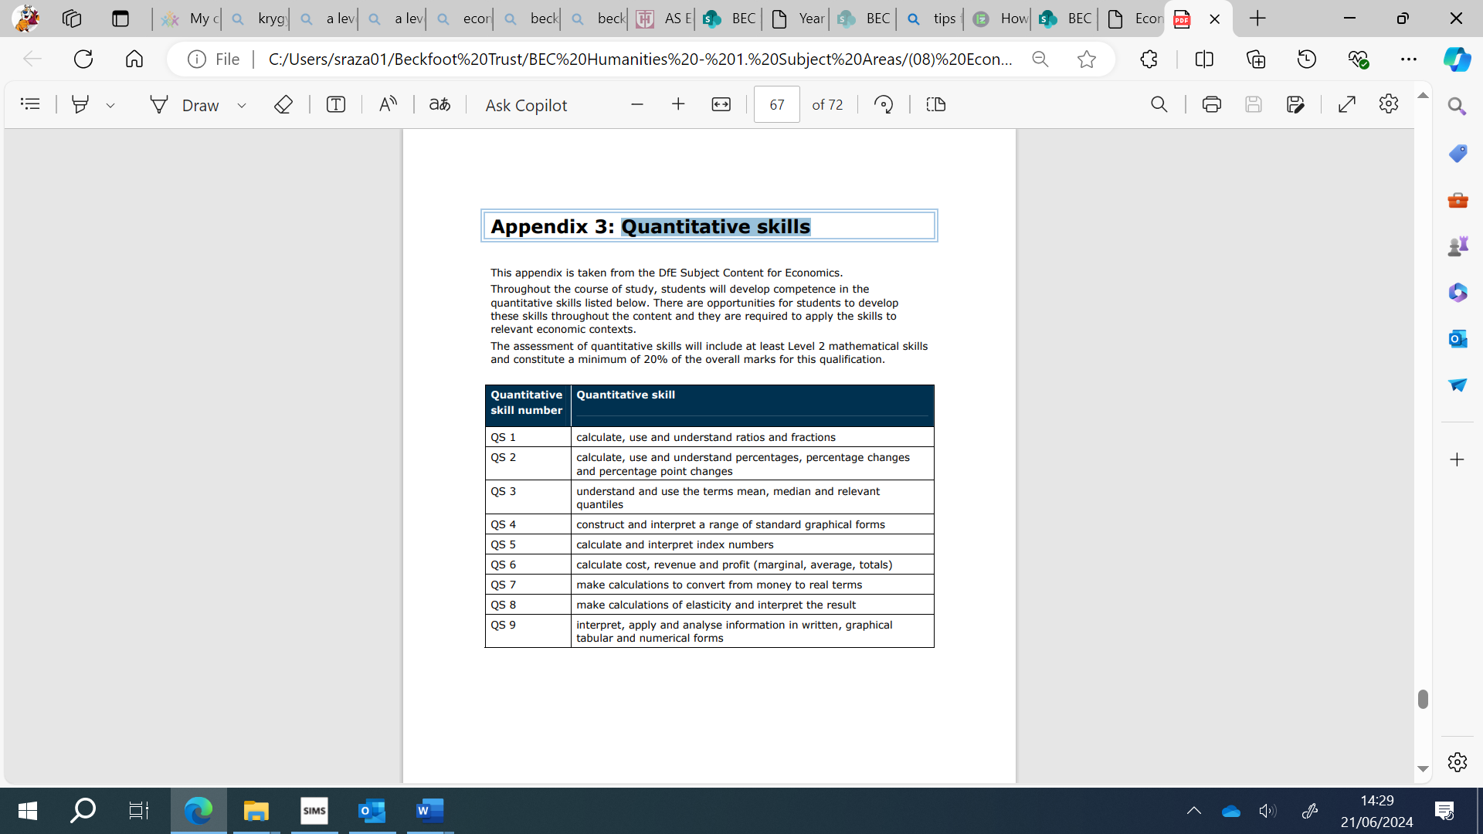
7. Accounting ratios
Students will need to learn the following accounting ratios for this qualification.
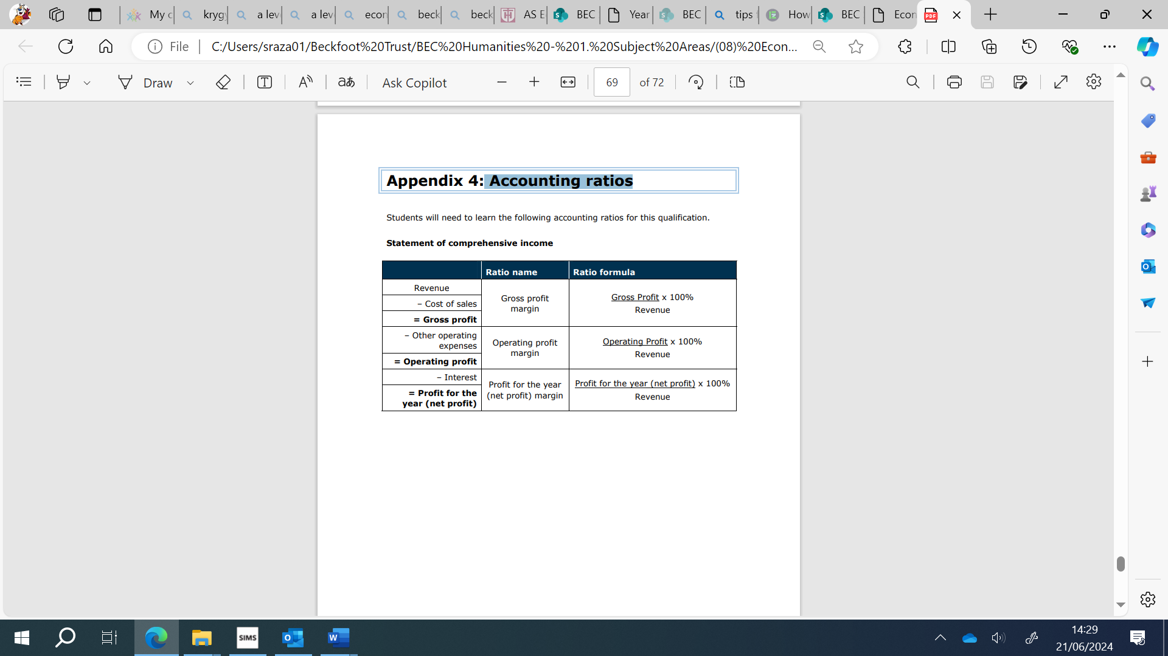

8. Equipment
You must bring the following to all lessons:
- Black pens, green pen, mini-whiteboard pen, pencil.
- Scientific calculator
- Folder (this must be upto date at all times)
- Zigzag booklet (in the folder)

9. Textbooks and reading

- Edexcel AS/A level Economics By Alain Anderton et al
- Edexcel AS/A level Business by Dave Hall et al
(both above books are the recommended textbooks for the course)
- The undercover economist by Tim Harford
- The Armchair Economist: Economics and Everyday Life, Steven E. Landsburg
- Naked Economics: Undressing the Dismal Science, Charles Wheelan
- Freakonomics, Steven D. Levitt and Stephen J. Dubner

10. Useful websites:
www.Tutor2u.net
www.economicsonline.co.uk
www.economicshelp.org

11. Economics B grade boundaries June 2023
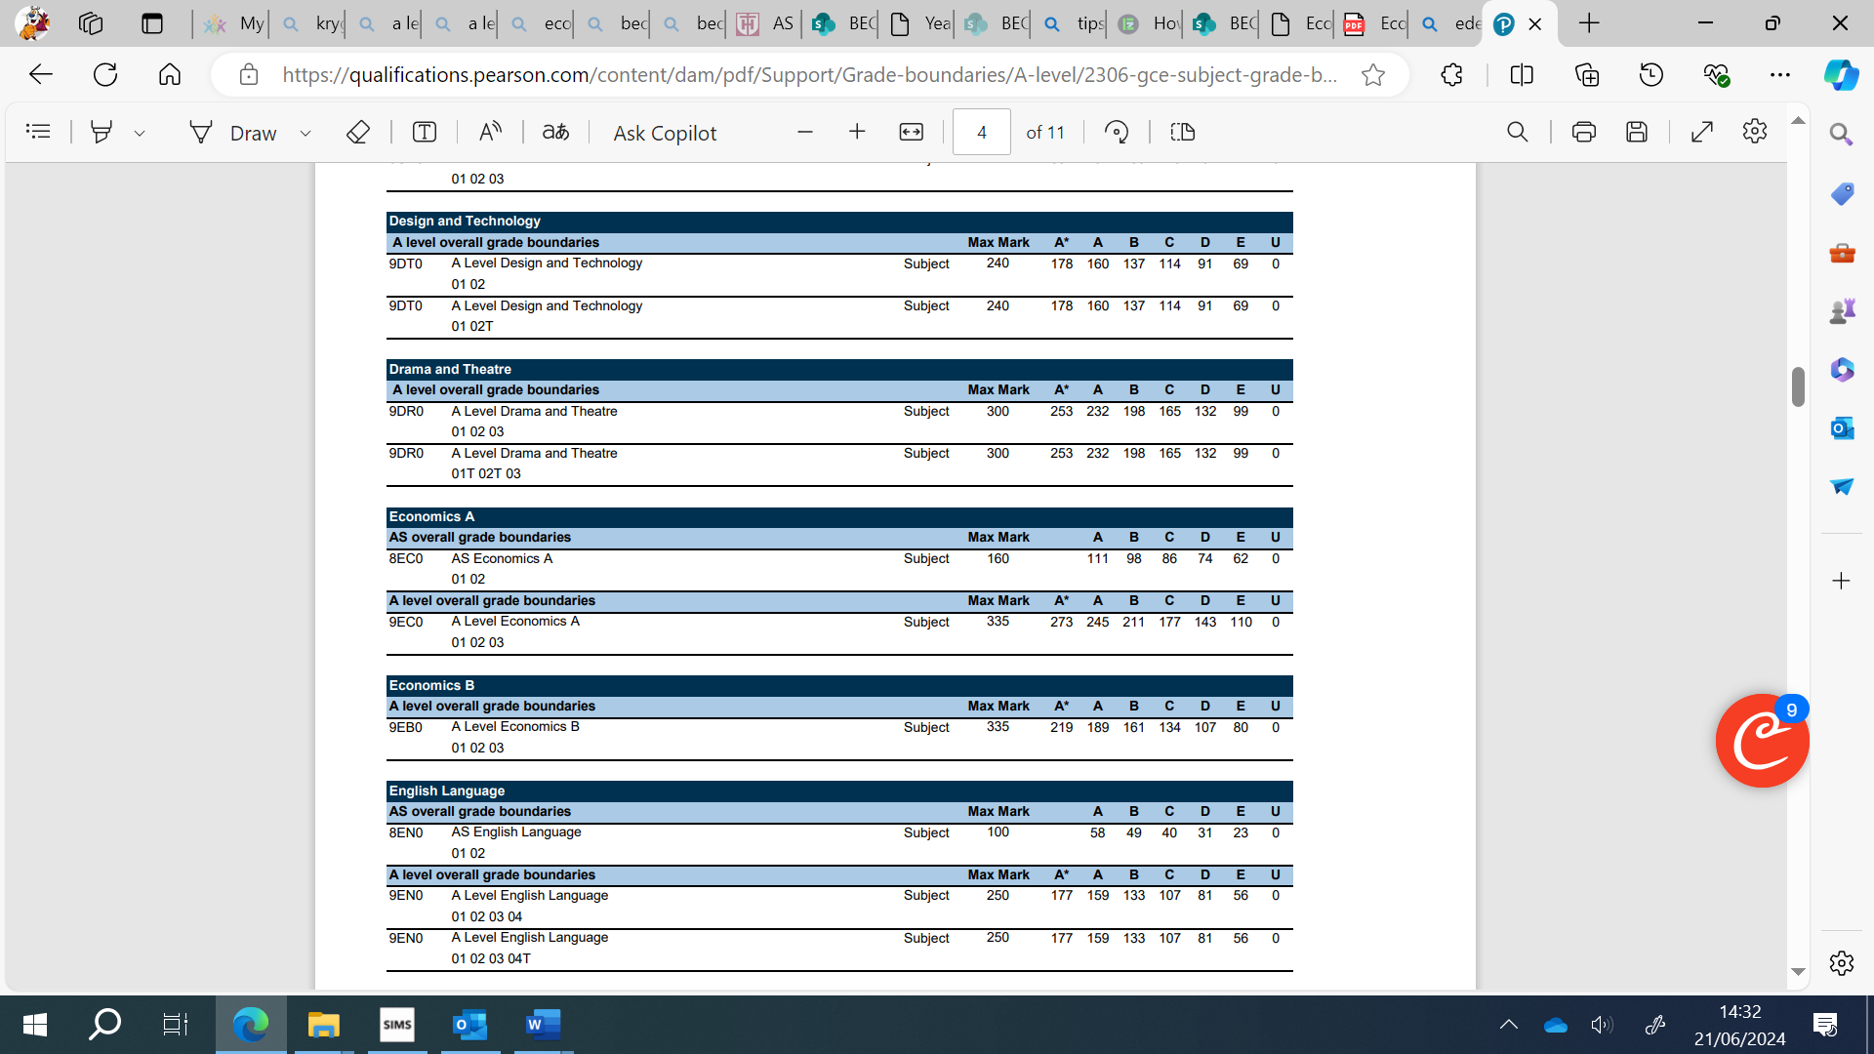

12. Curriculum Map: Economics
 | Half Term 1  J-J | Half Term 2  Sep - Oct | Half Term 3  Oct - Dec | Half Term 4  Jan - Feb | Half Term 5  Feb- Apr | Half Term 6  Apr - Jun
Year 12 |  | 1.1 Scarcity, Choice & Potential conflicts  1.3 Introducing the market | 1.2 Enterprise, Business & the economy  1.4 The role of credit in the economy  1.5 Market failure and government intervention | 1.6 Revenues, costs, profits and cash  AS Paper 1 mock/80  2.1 Business growth and competitive advantage | 2.2 Firms, consumers and elasticities of demand  2.3 Productive efficiency  2.4 Life in a global economy | 2.5 The economic cycle  2.6 Introduction to macroeconomic policy  AS Paper 2 mock/80
Shadow Curriculum | n/a | 1.1 & 1.3 | 1.1 & 1.3, and 1.2 after teaching | 1.4 & 1.5 | 1.6 & 2.1 | 2.2 & 2.3
Year 13 | 3.1  Globalisation | 3.2 Economic factors in business expansion  3.3 Impact of globalisation on global companies | 3.4 Impact of globalisation on local and national economies  3.5 Global labour markets  3.6 Inequalities and redistribution  Paper 2 mock | 4.1 Competition and market power  4.2 Market power and market failure  4.3 Market failure across the economy | 4.4 Macroeconomic policies and impact on firms and individuals  4.5 Risk and the financial sector  Paper 1 mock | Exams
Shadow curriculum | 2.4 & 2.5 | 3.1 | 3.2 & 3.3 | 3.4 – 3.6 | 4.1 – 4.3 | 4.4 & 4.5

- Theme 1-4 outline

Theme 1: Markets, consumers and firms
In this theme, students explore the way in which consumers make choices and entrepreneurs create desirable products. Students will need to build upon the knowledge, skills and understanding developed in Theme 1 in Theme 4, making connections across these two themes in Paper 1, and across Themes 1, 2, 3 and 4 in Paper 3. Teaching approaches to content must reflect this. Students will need to apply their knowledge and understanding of both familiar and unfamiliar contexts in the assessments, and demonstrate an awareness of current economic events and policies. Students should have knowledge of the UK economy in the last 10 years.

1.1 Scarcity, choice and potential conflicts

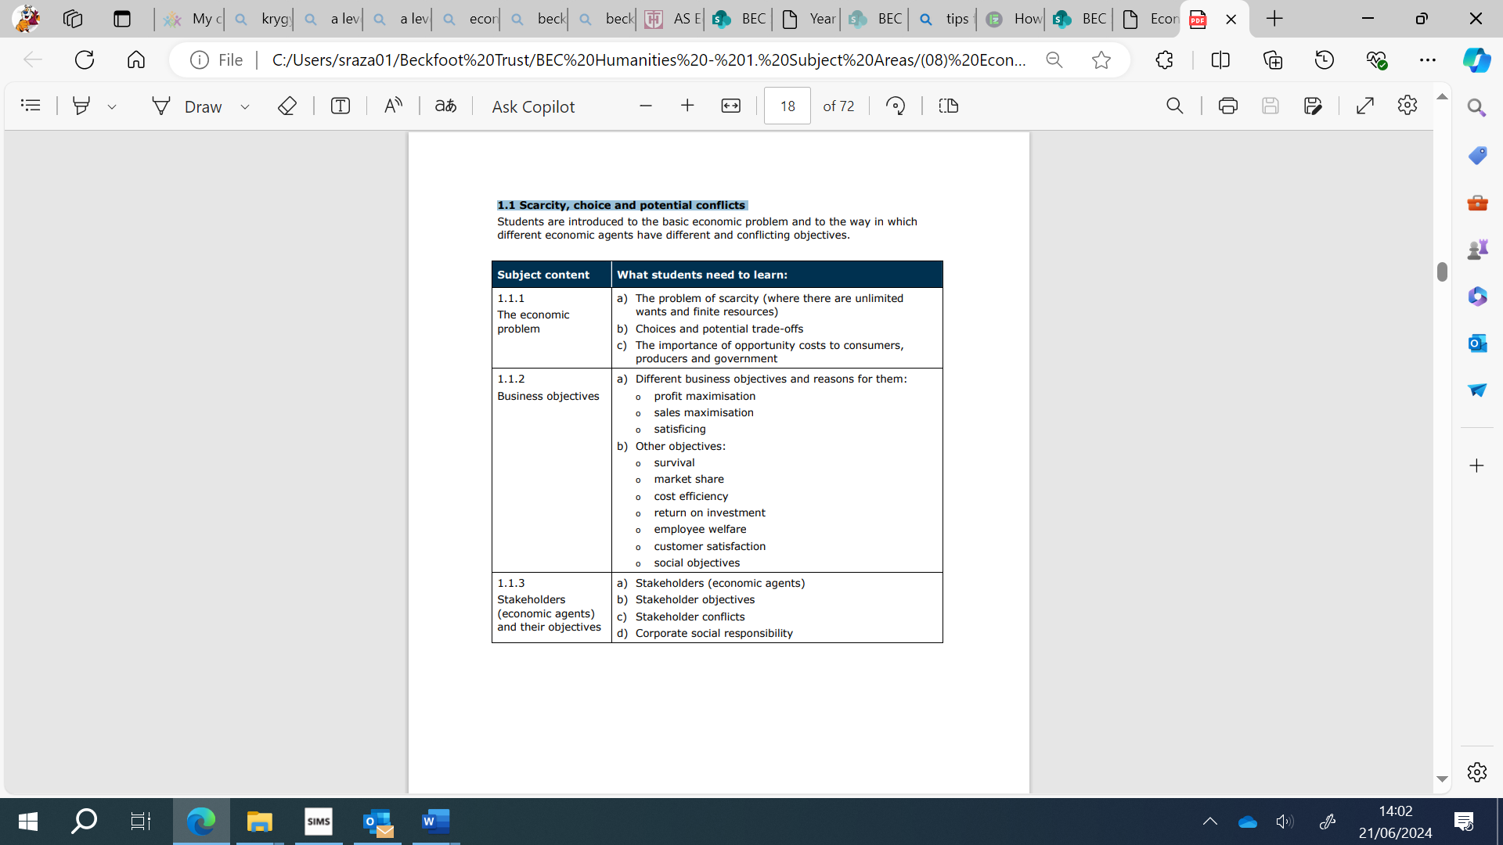
1.2 Enterprise, business and the economy
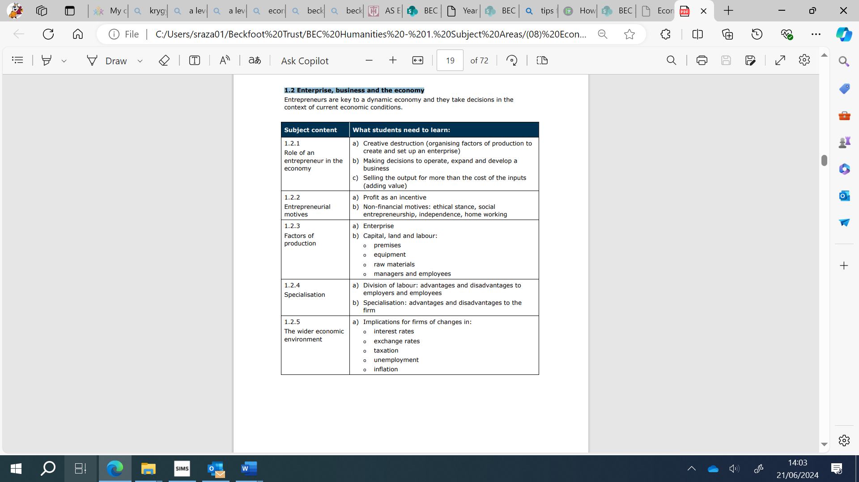

1.3 Introducing the market
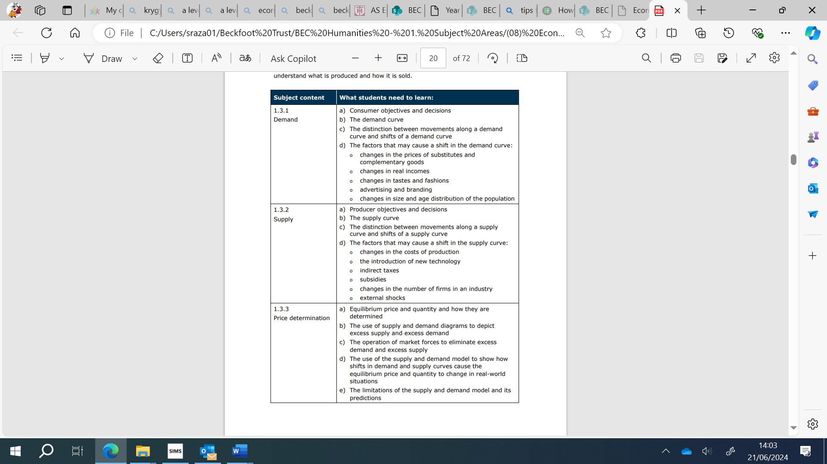

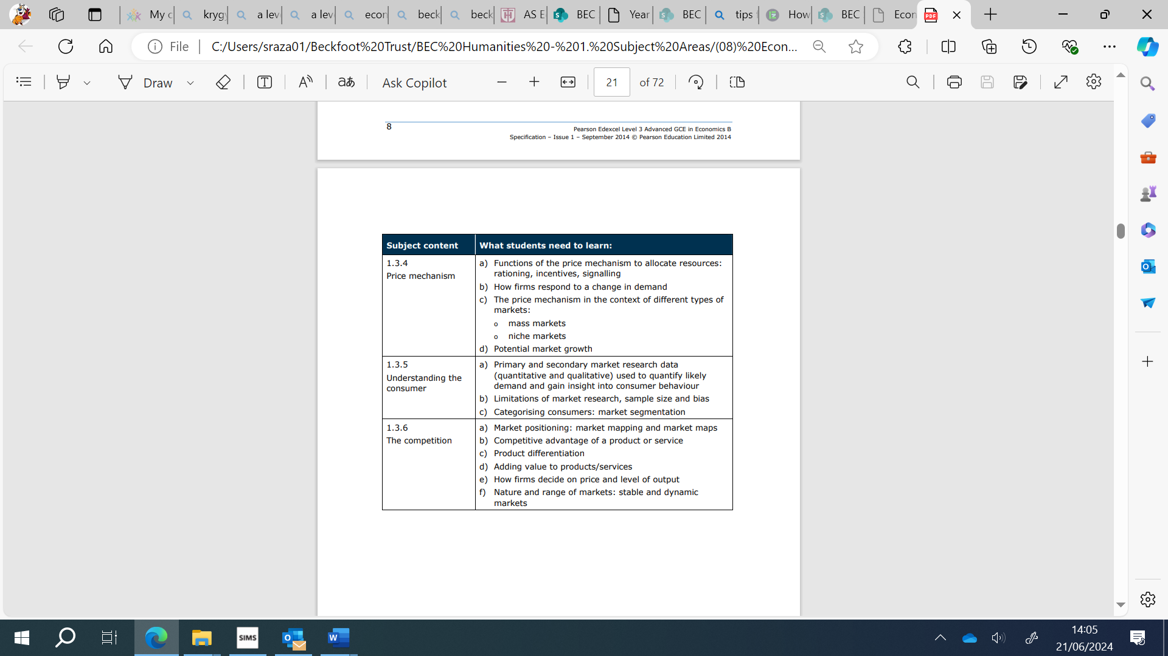

1.4 The role of credit in the economy
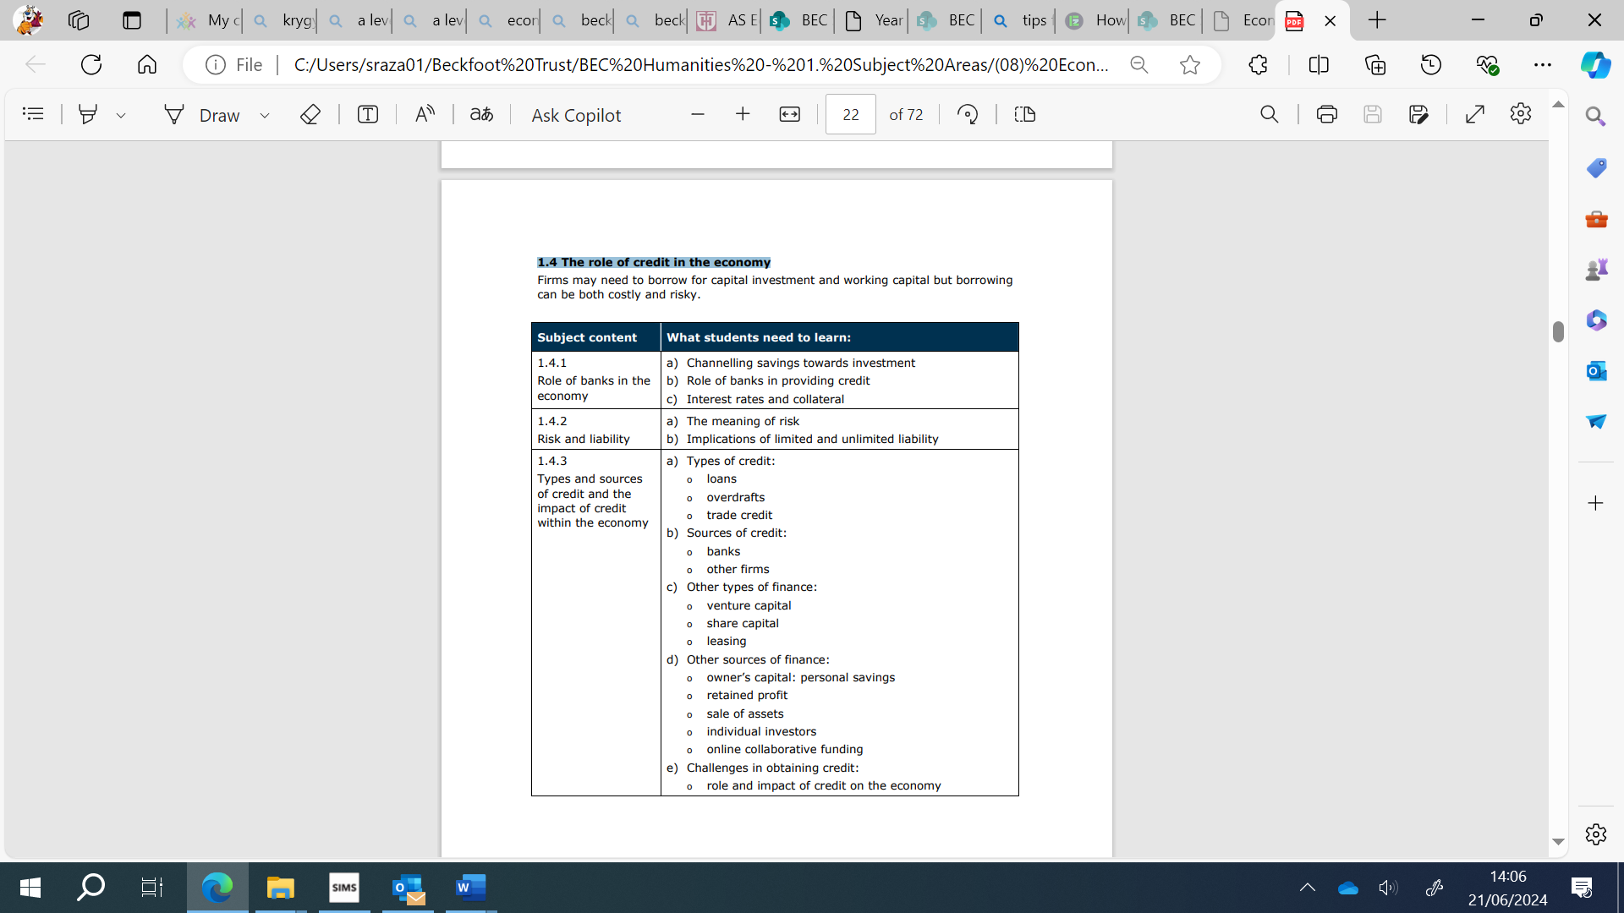

1.5 Market failure and government intervention
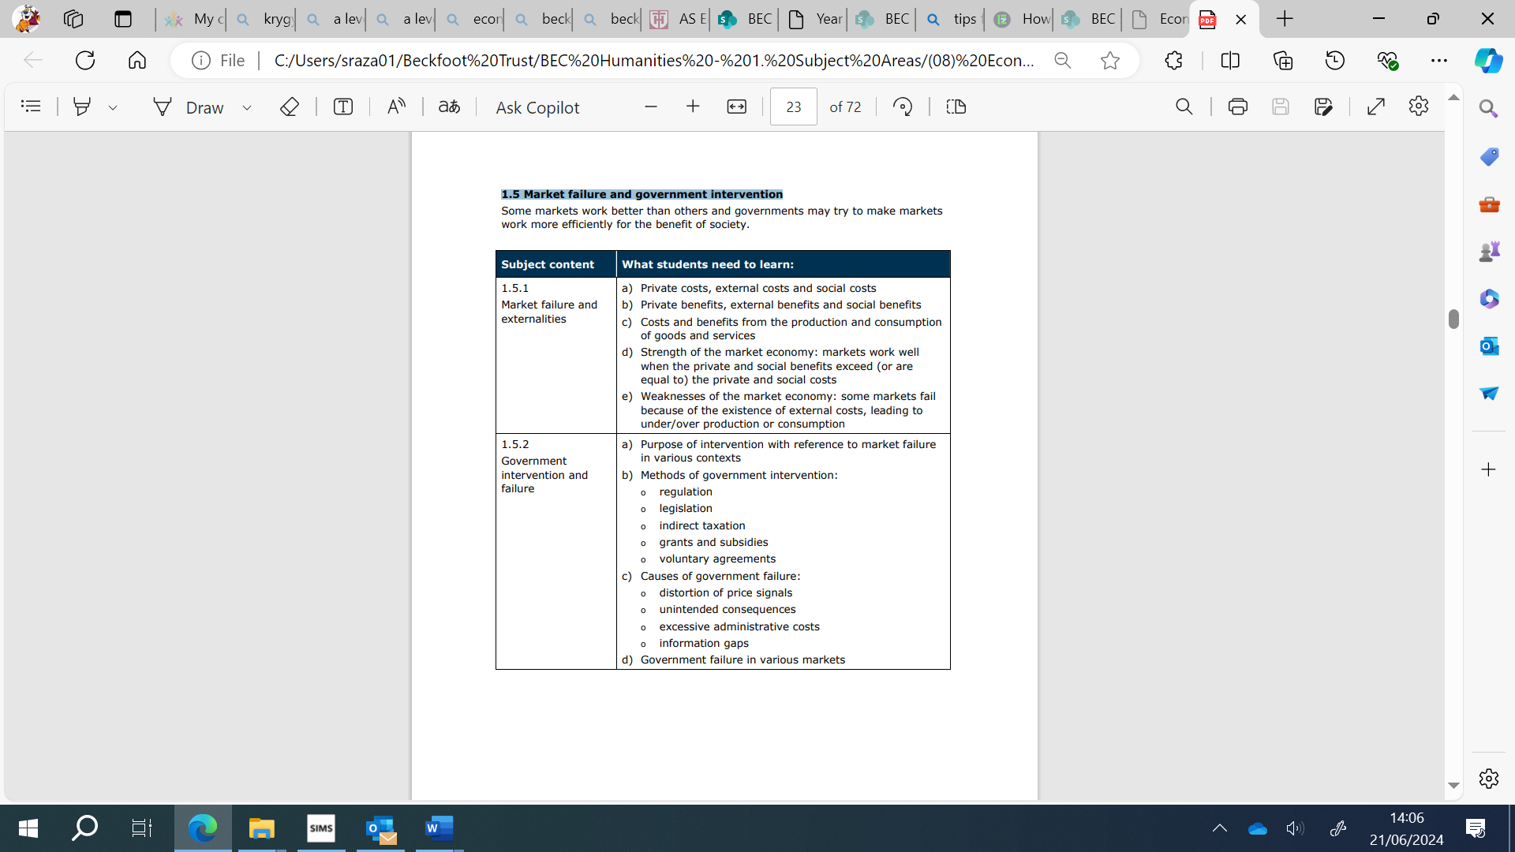

1.6 Revenue, costs, profits and cash

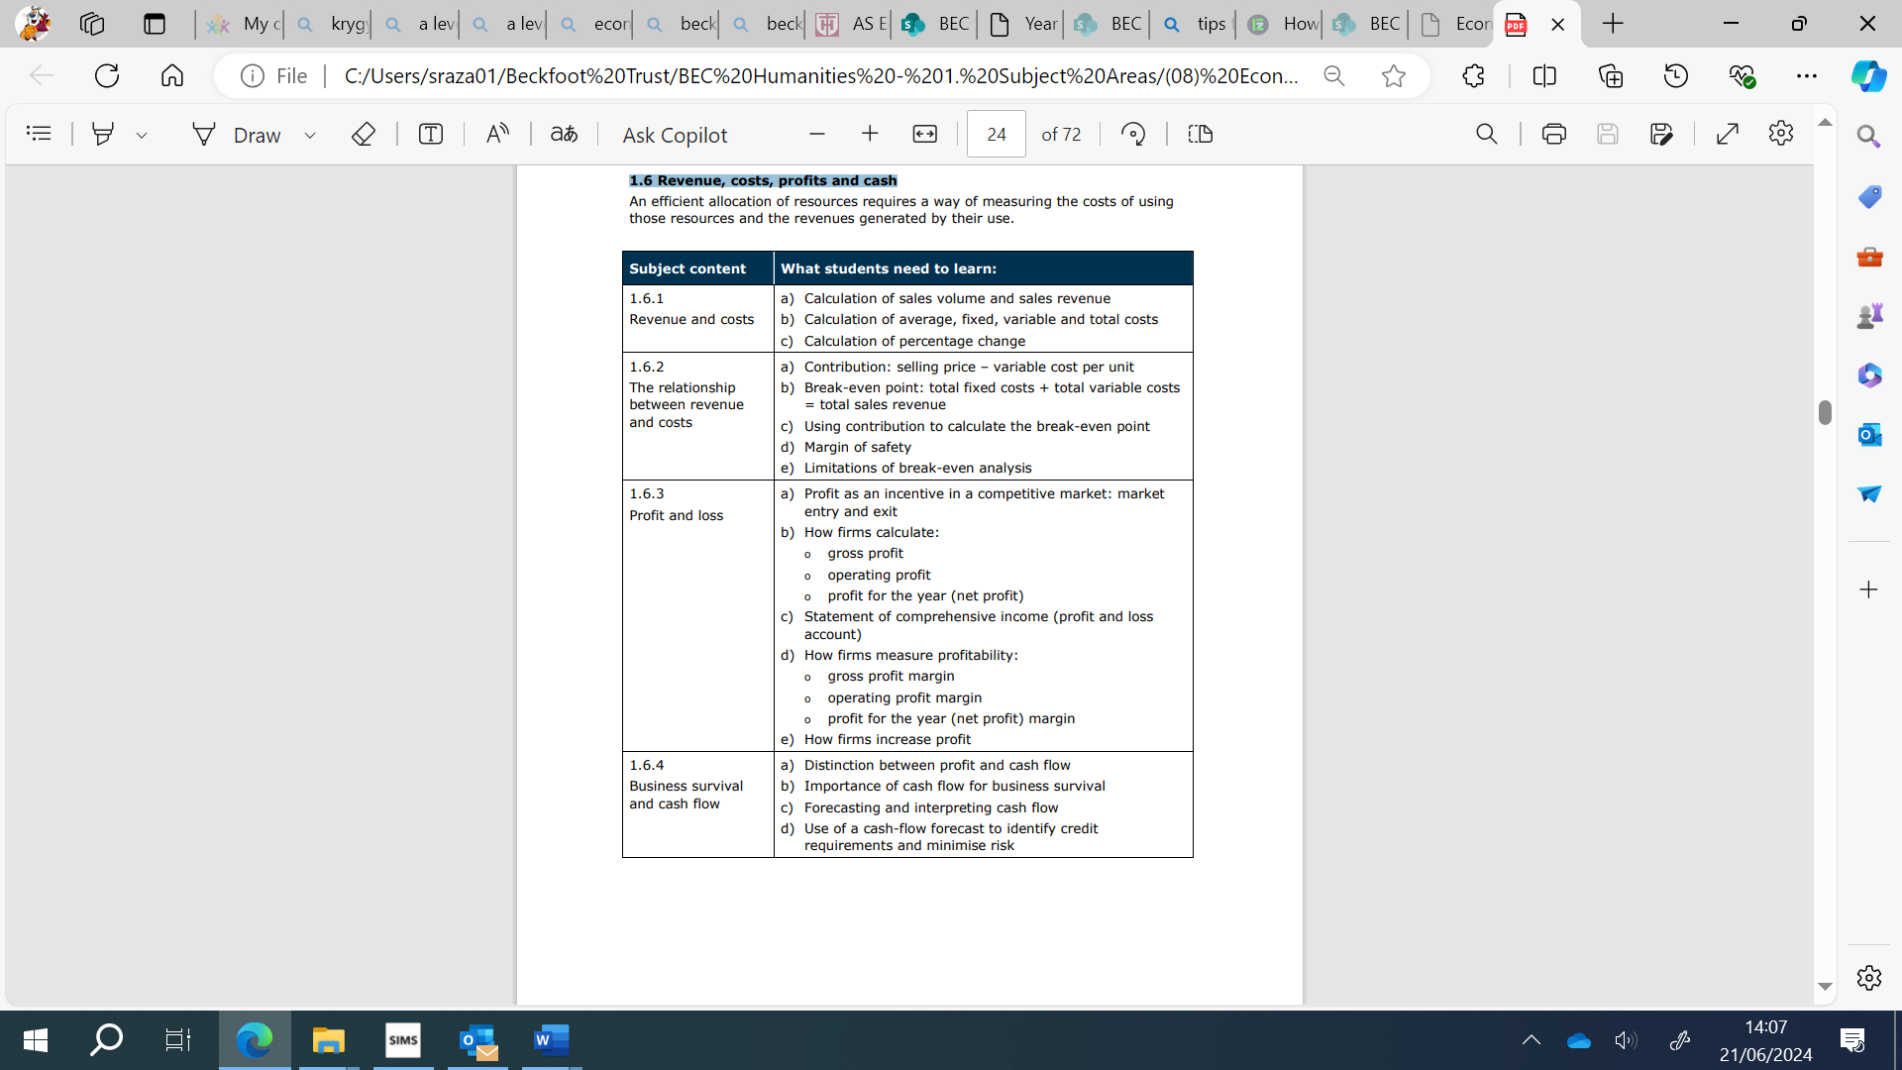
Theme 2: The wider economic environment

This theme helps students to explore how firms can become more competitive. It introduces them to the wider international and economic environment in which firms operate. Students will need to build upon the knowledge, skills and understanding developed in Theme 2 in Theme 3, making connections across these two themes in Paper 2, and across Themes 1, 2, 3 and 4 in Paper 3. Teaching approaches to content must reflect this. Students will need to apply their knowledge and understanding of both familiar and unfamiliar contexts in the assessments, and demonstrate an awareness of current economic events and policies. Students should have knowledge of the UK economy in the last 10 years.

2.1 Business growth and competitive advantage
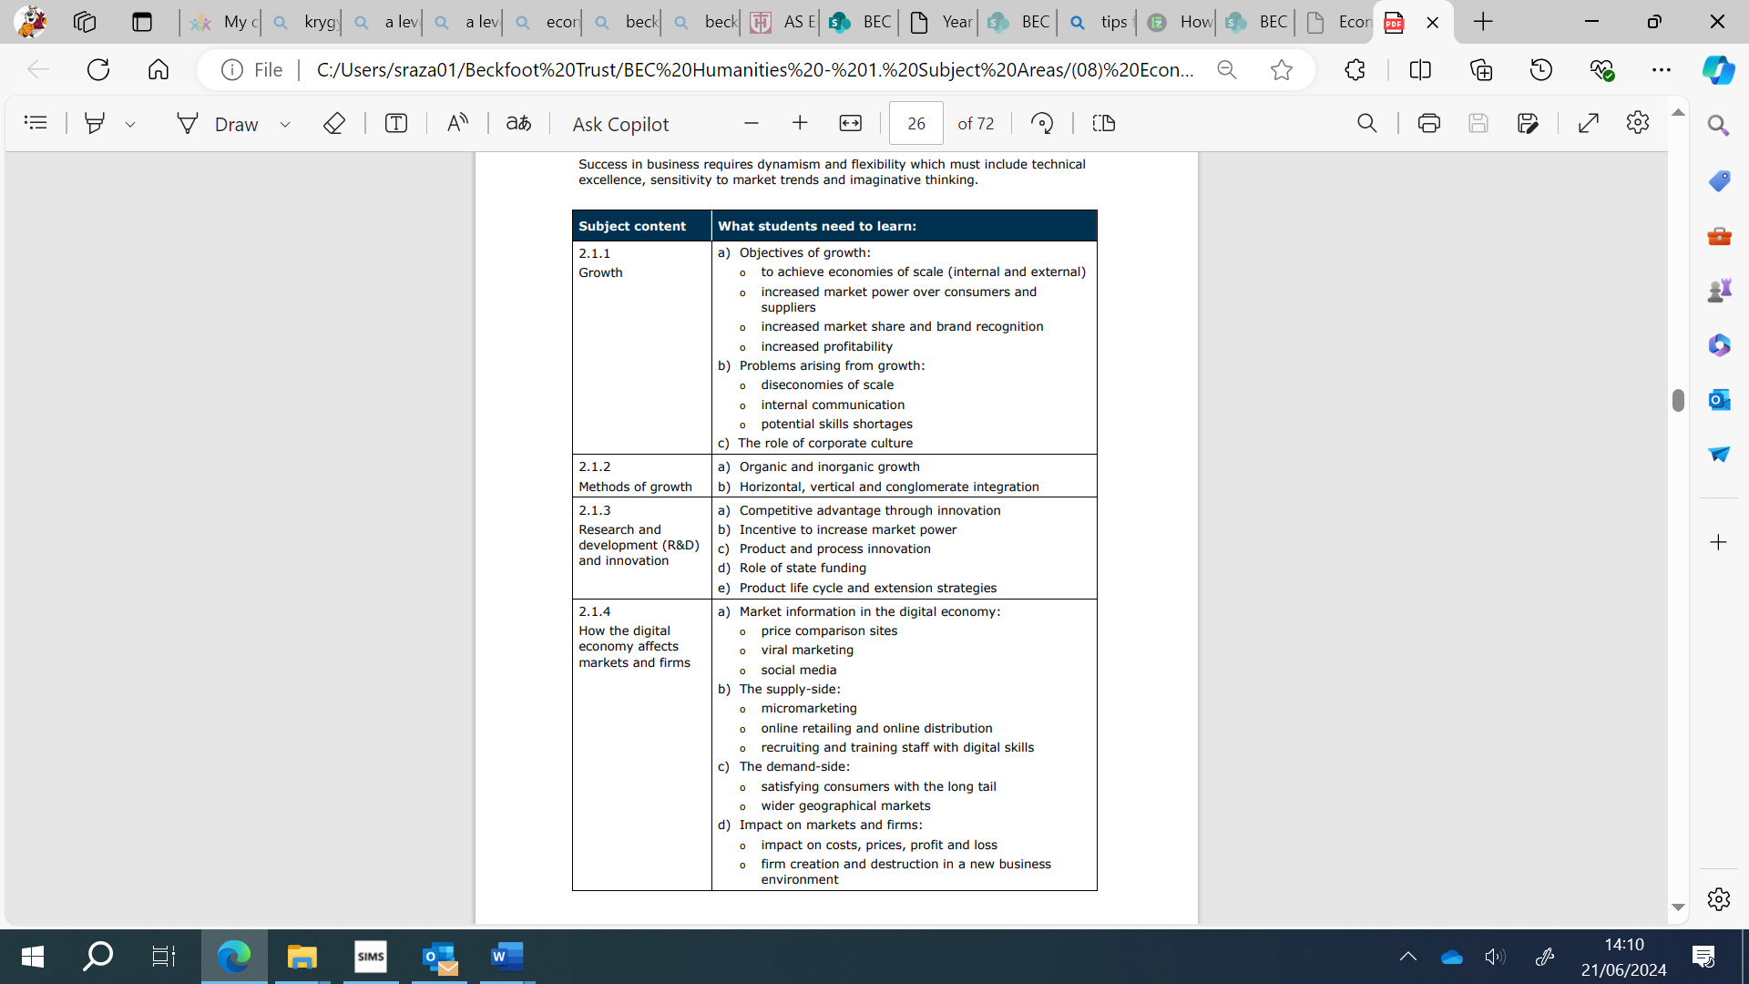
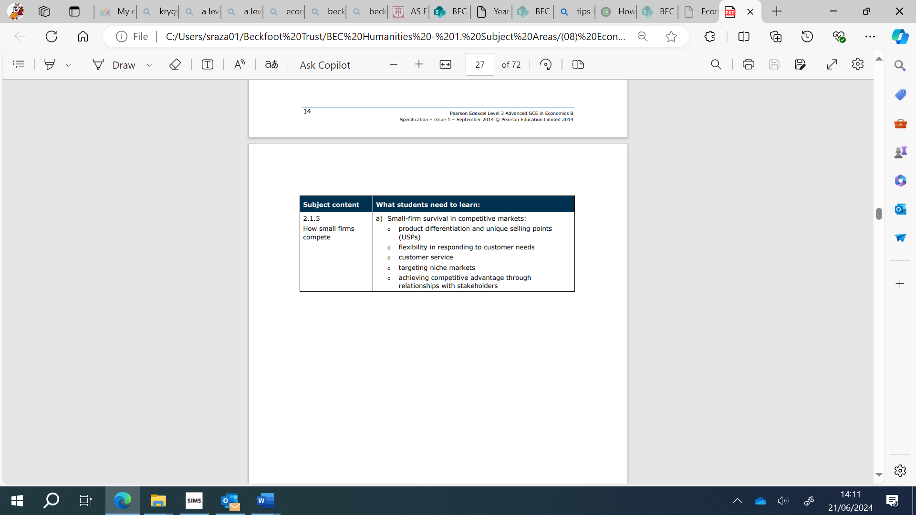

2.2 Firms, consumers and elasticities of demand

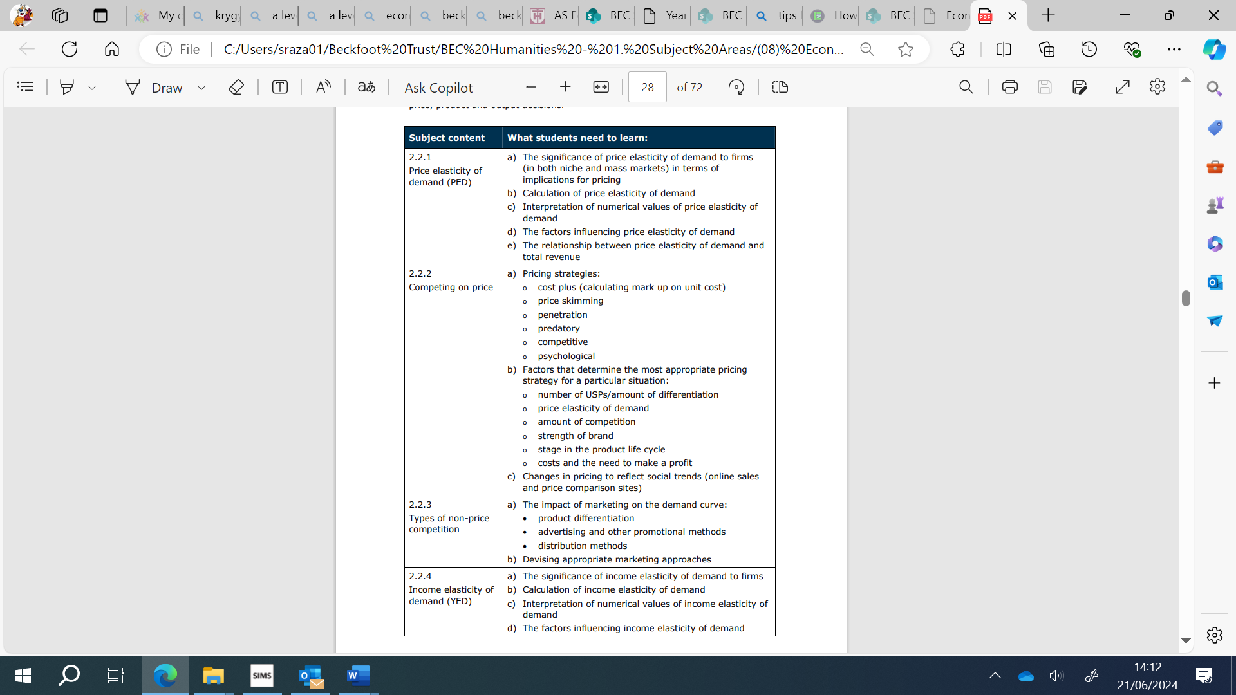

2.3 Productive efficiency
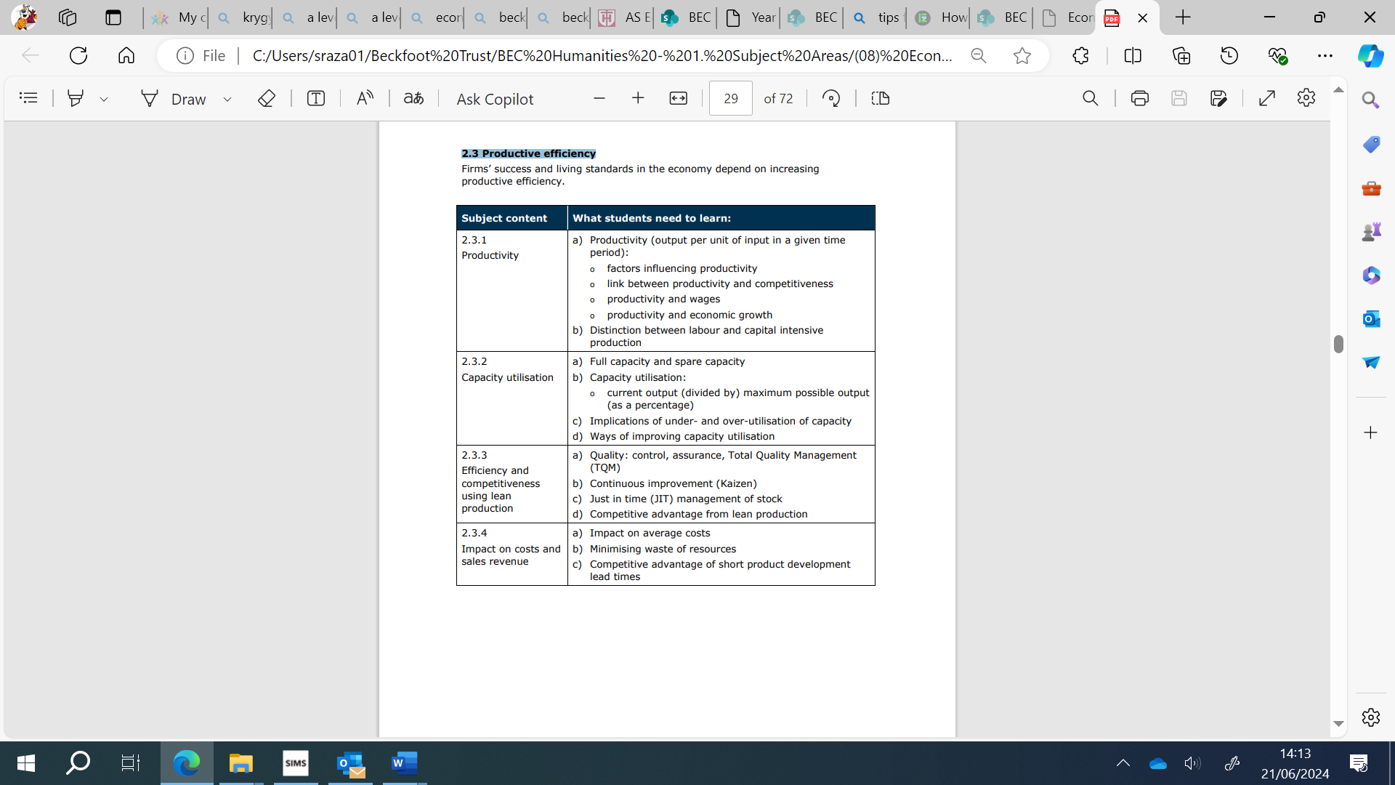
2.4 Life in a global economy
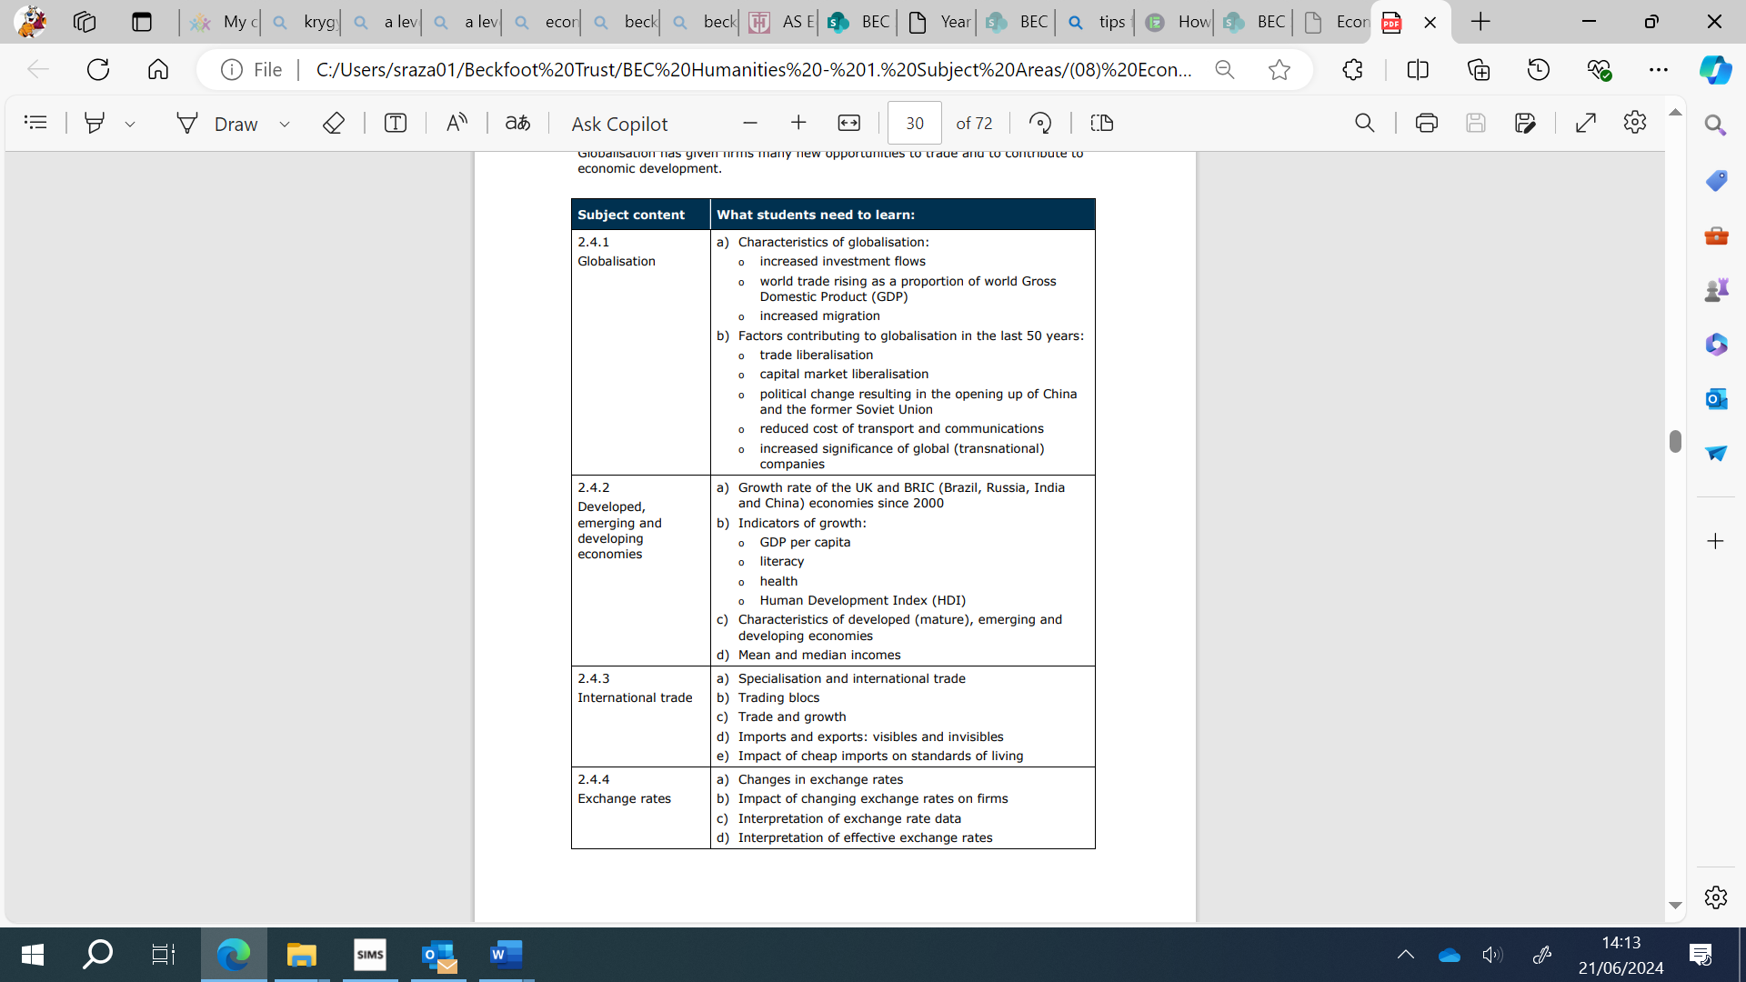
2.5 The economic cycle
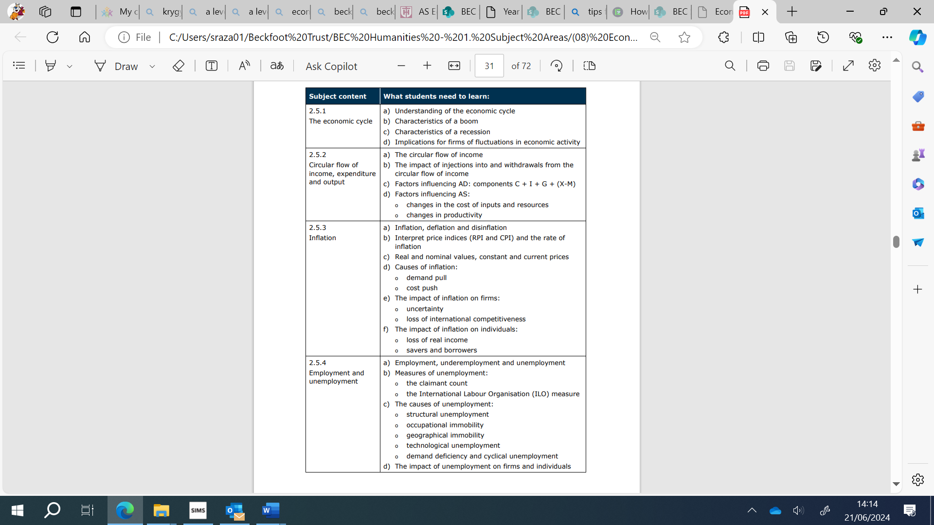
2.6 Introduction to macroeconomic policy
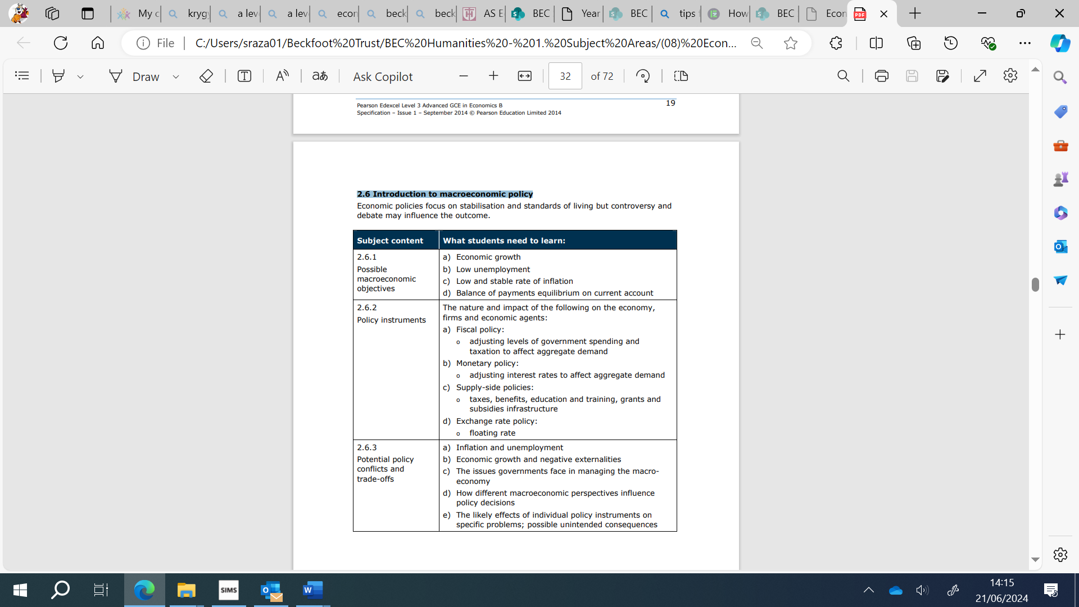

Theme 3: The Global Economy

This theme builds on the content of Theme 2: The wider economic environment and continues its focus on the international economic environment. Students will need to build upon the knowledge, skills and understanding developed in Theme 2 in Theme 3, making connections across these two themes in Paper 2, and across Themes 1, 2, 3 and 4 in Paper 3. Teaching approaches to content must reflect this. Students will need to apply their knowledge and understanding of both familiar and unfamiliar contexts in the assessments, and demonstrate an awareness of current economic events and policies. Students should have knowledge of the UK economy in the last 10 years.

3.1 - Globalisation
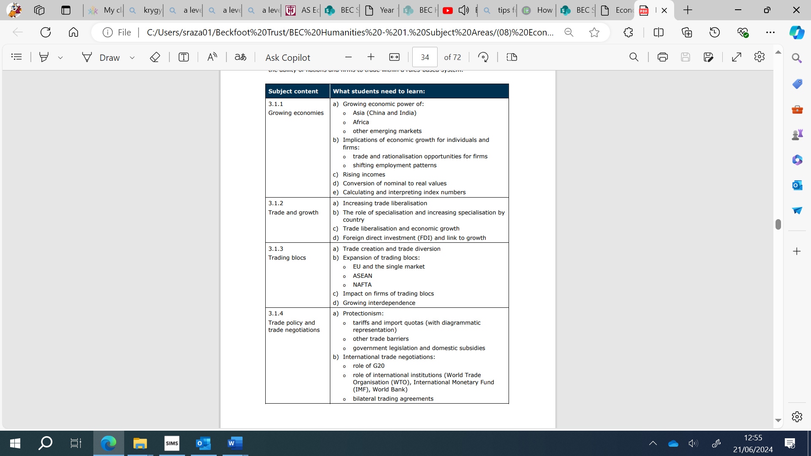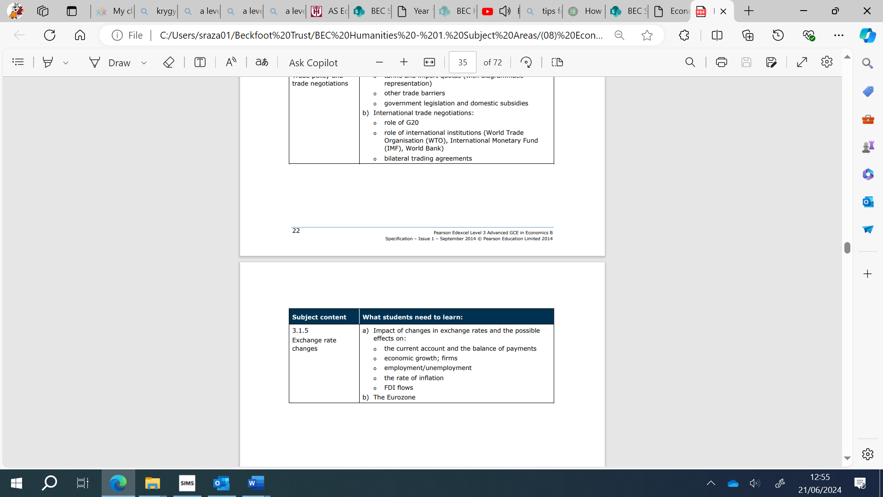

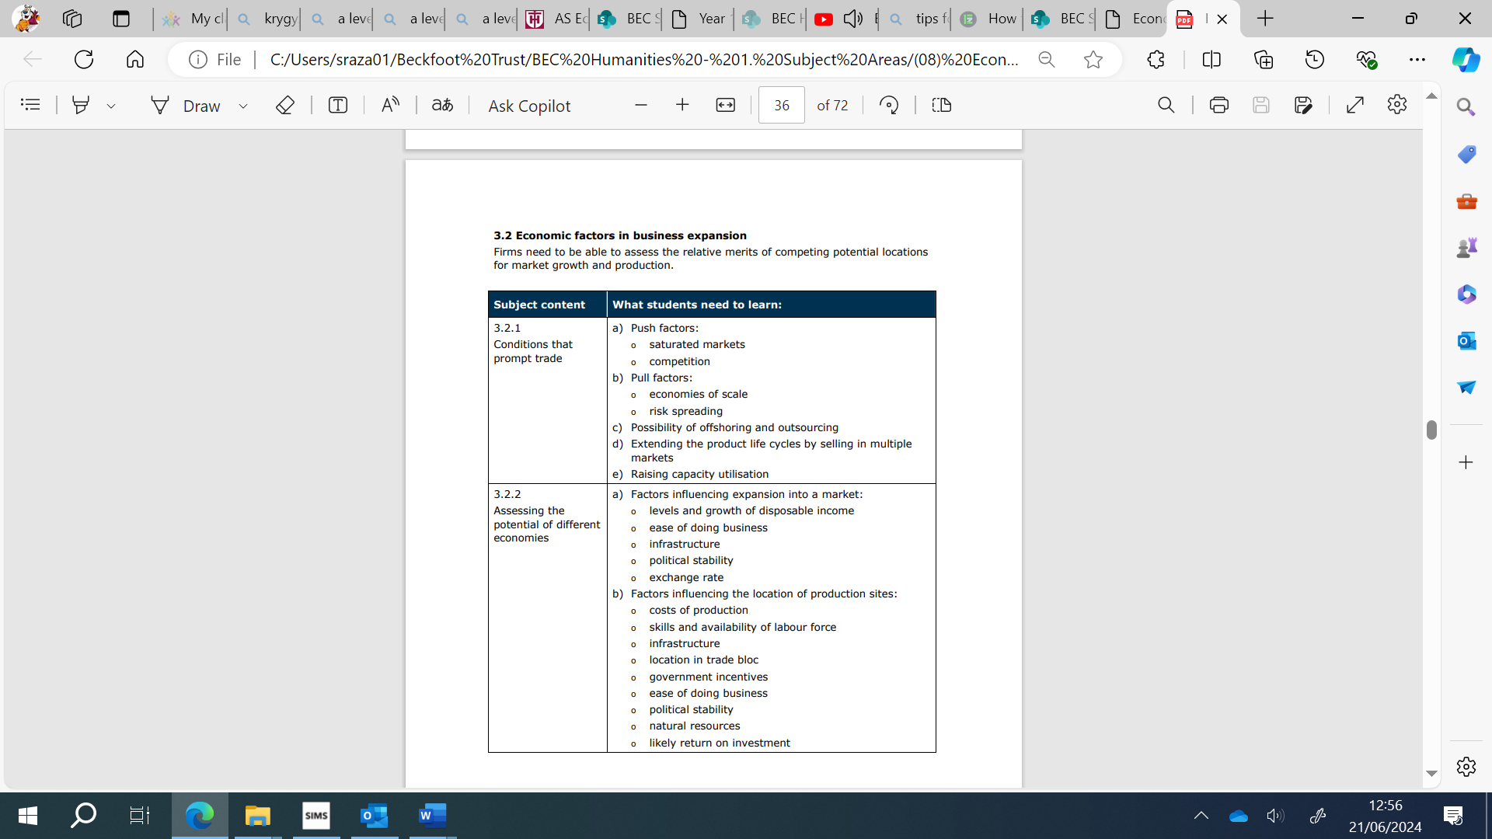
3.2 Economic factors in business expansion

3.3 Impact of globalisation on global companies

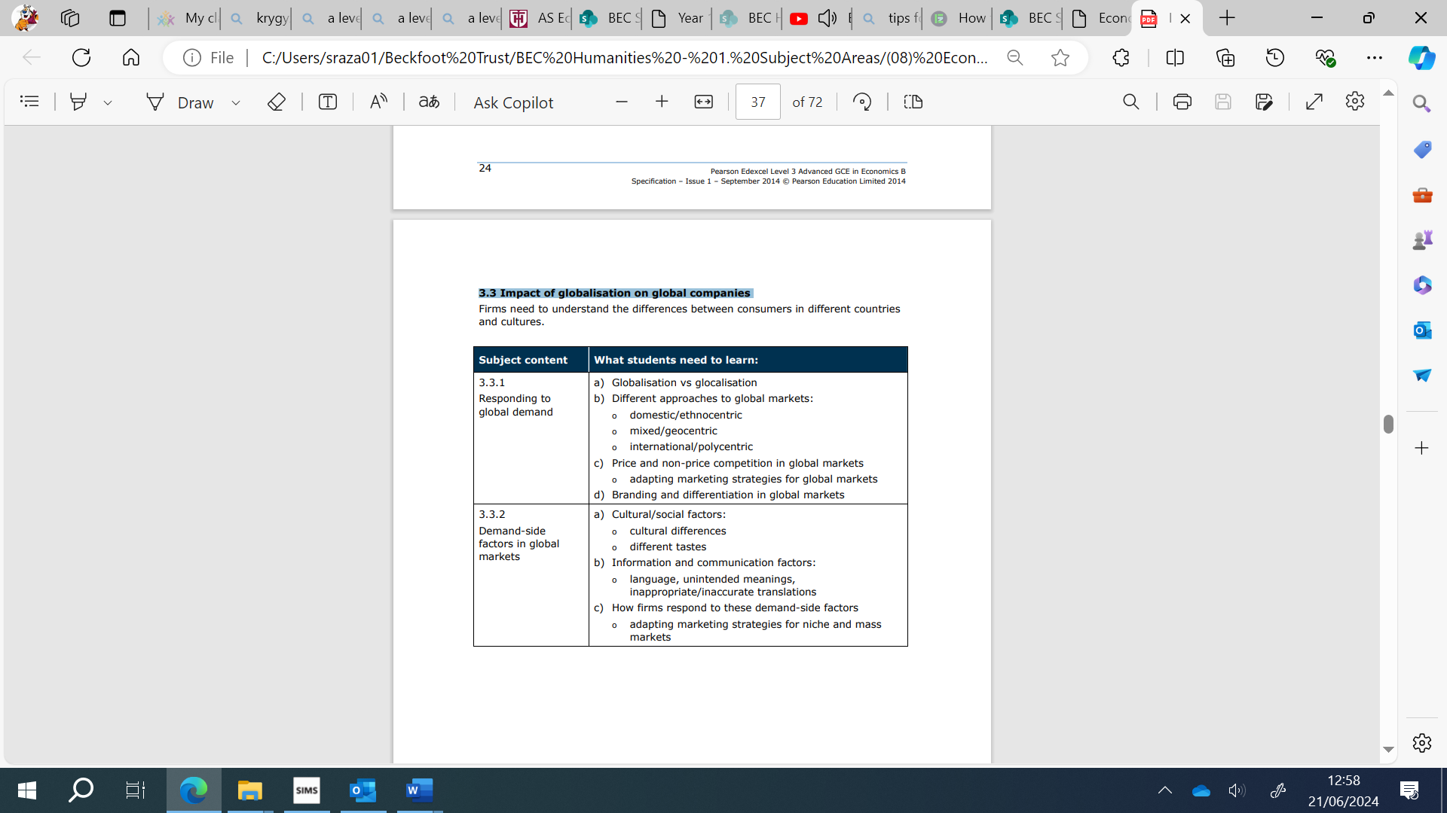

3.4 Impact of globalisation on local and national economies
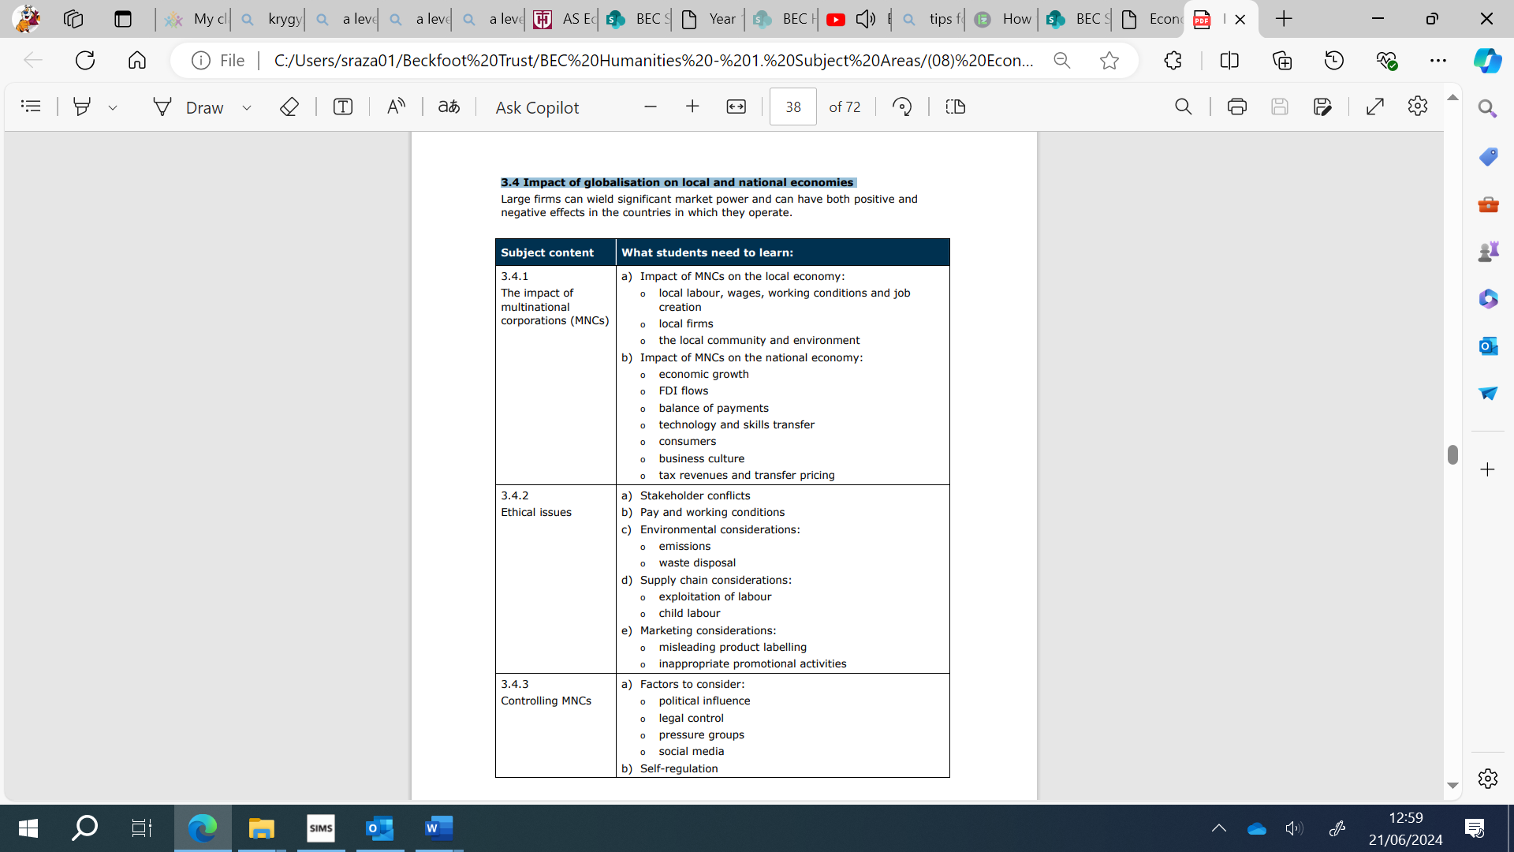

3.5 Global labour markets
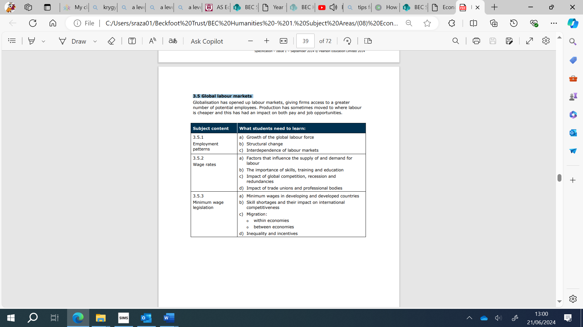

3.6 Inequality and re-distribution
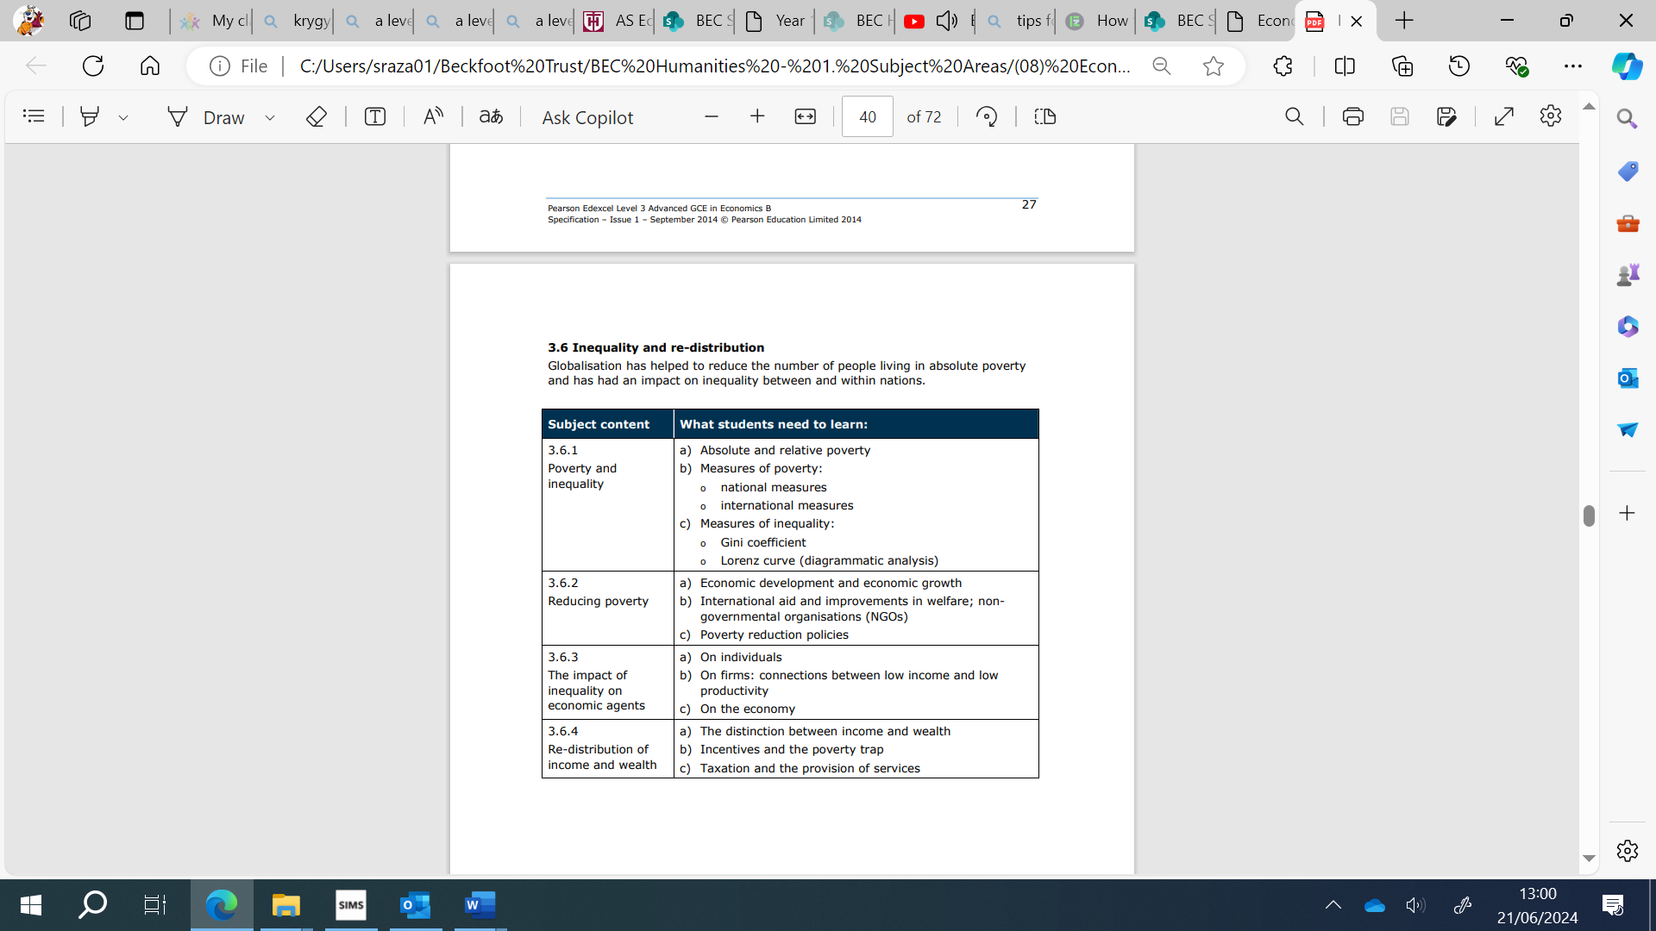

Theme 4: Making markets work

This theme starts by considering degrees of competition within markets and then encourages students to apply their understanding to how governments may improve the functioning of markets and the economy. Students will need to build upon the knowledge, skills and understanding developed in Theme 1 in Theme 4, making connections across these two themes in Paper 1, and across Themes 1, 2, 3 and 4 in Paper 3. Teaching approaches to content must reflect this. Students will need to apply their knowledge and understanding of both familiar and unfamiliar contexts in the assessments, and demonstrate an awareness of current economic events and policies. Students should have knowledge of the UK economy in the last 10 years.

4.1 Competition and market power
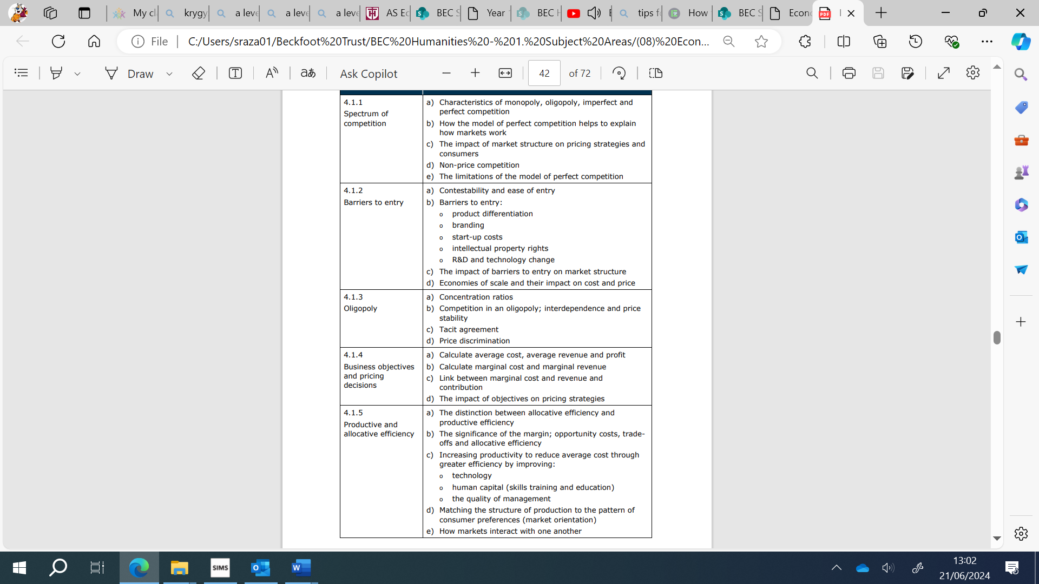

4.2 Market power and market failure

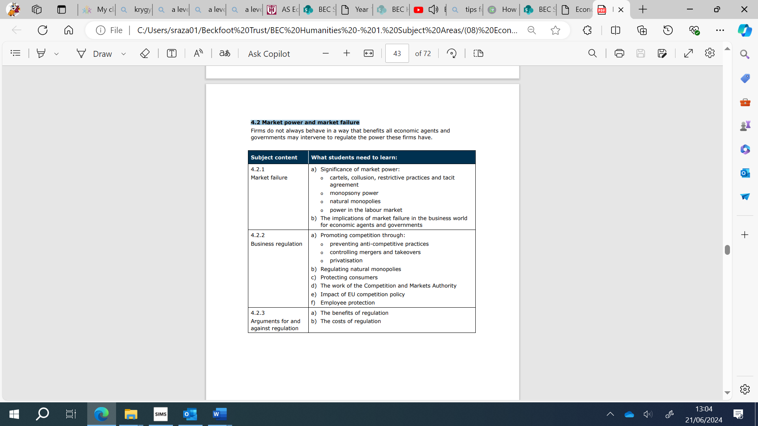

4.3 Market failure across the economy
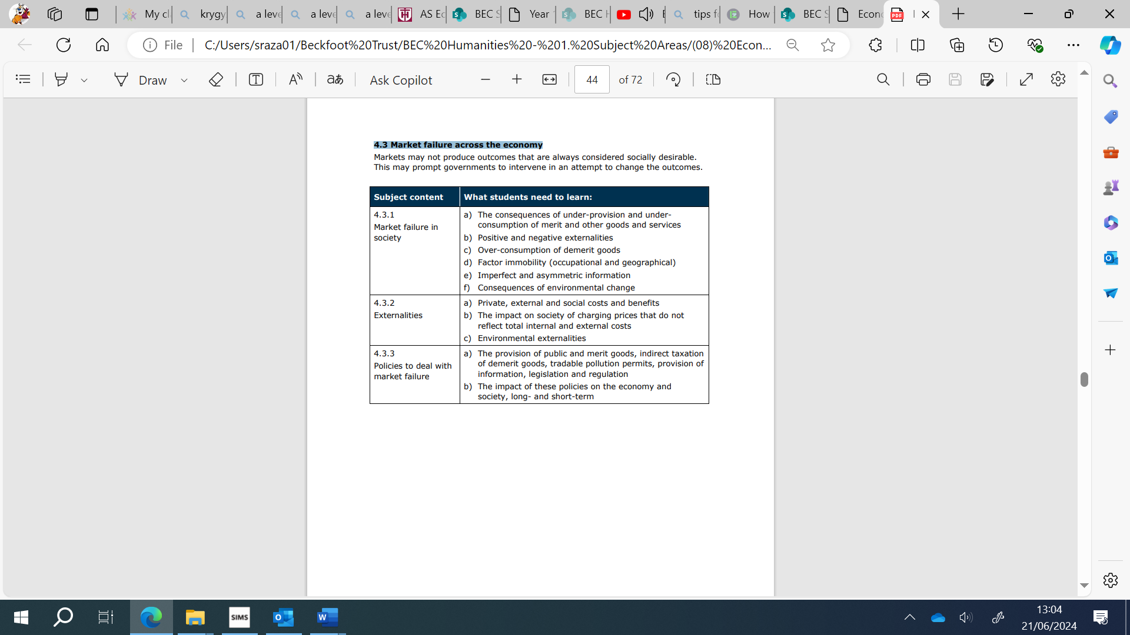

4.4 Macroeconomic policies and impact on firms and individuals

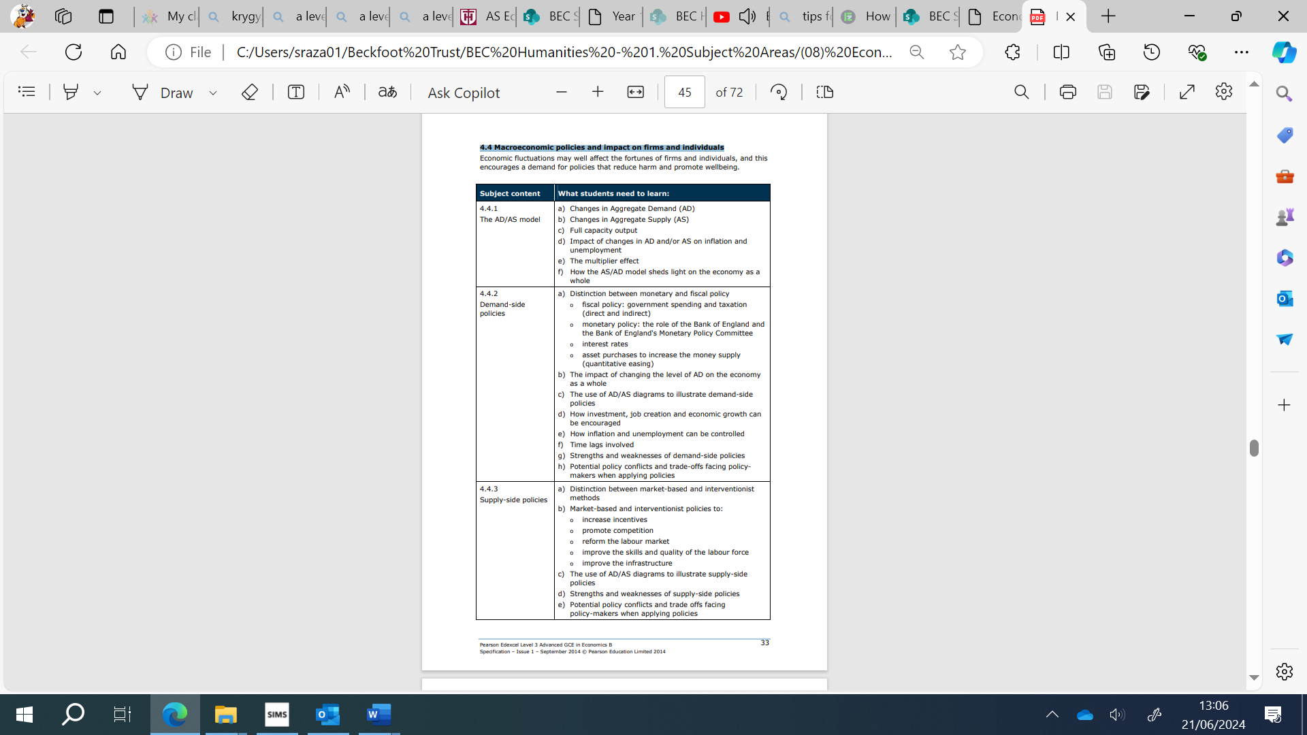

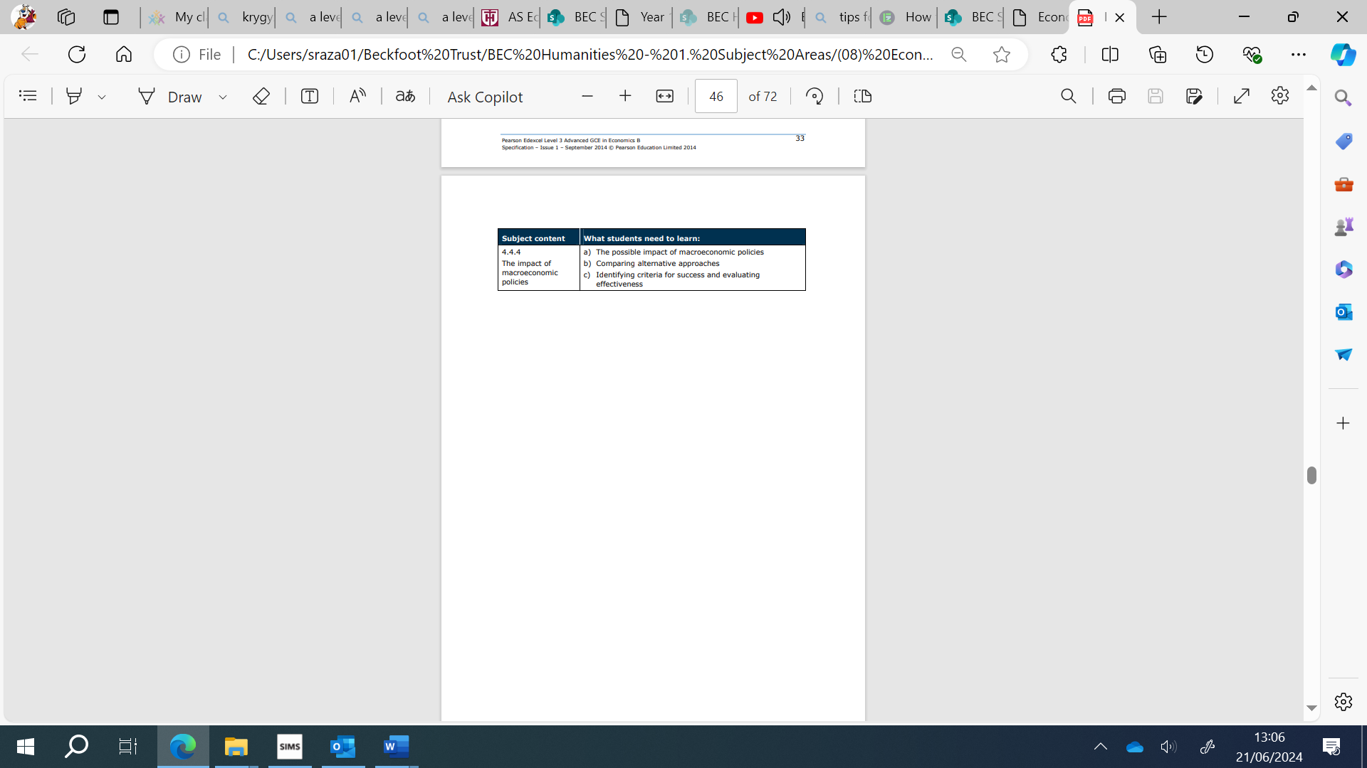

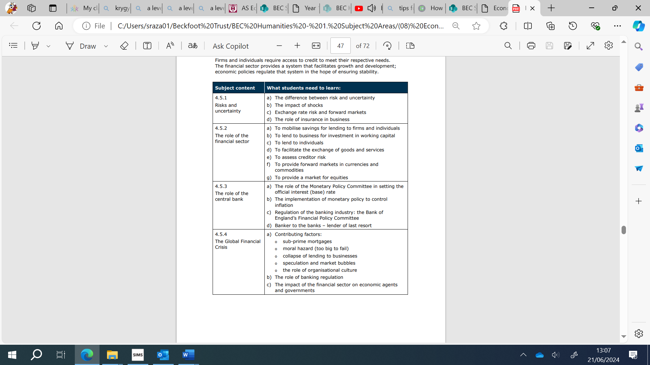
4.5 Risk and the financial sector

