

Additional Assessment Materials

Pearson Edexcel AS Level in Business (8BS0)

Resource Set 1.2: The market

The Office for National Statistics stated that incomes fell by 2.2% in 2014.

1. (a) Using the data in Extract B, calculate the income elasticity of demand for Approved Food, following an increase in weekly orders to 3,500 in 2014. You are advised to show your working.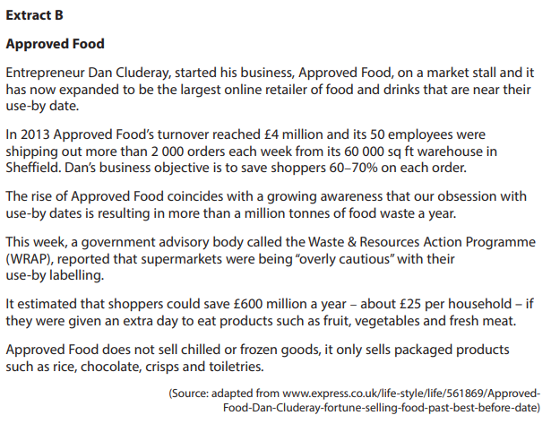 (4)

________________________________________________________________________________________________________________________________________________________________________________________________________________________________________________________________________________________________________________________________________________

________________________________________________________________________________________________________________________________________________________________________________________________________________________________________________________________________________________________________________________________________________

(b) Explain how a business, such as Approved Food, might use income elasticity of demand data. (4)

________________________________________________________________________________________________________________________________________________________________________________________________________________________________________________________________________________________________________________________________________________

________________________________________________________________________________________________________________________________________________________________________________________________________________________________________________________________________________________________________________________________________________

1. Construct a supply and demand diagram to illustrate the likely impact of changing consumer tastes on Burger King.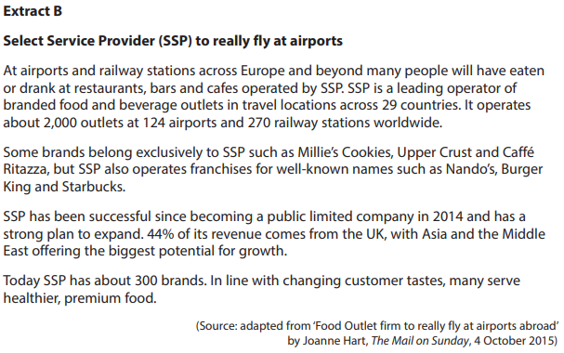 (4)

________________________________________________________________________________________________________________________________________________________________________________________________________________________________________________________________________________________________________________________________________________

________________________________________________________________________________________________________________________________________________________________________________________________________________________________________________________________________________________________________________________________________________

At the start of 2016, Beaverbrooks sold 600 Omega Seamaster watches. By 2017 this had increased to 690. Beaverbrooks calculated that the PED for this product was -0.8.

1. (a) Calculate, to 2 decimal places, the percentage fall in the price of an Omega Seamaster watch.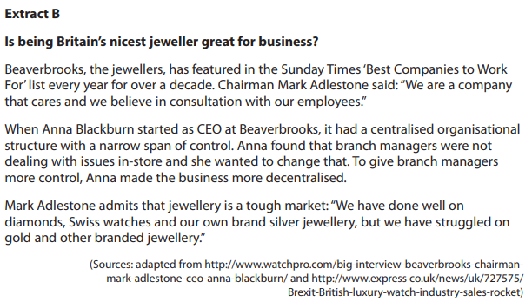 (4)

________________________________________________________________________________________________________________________________________________________________________________________________________________________________________________________________________________________________________________________________________________

________________________________________________________________________________________________________________________________________________________________________________________________________________________________________________________________________________________________________________________________________________

(b) Assess **two** factors that could affect the supply of Beaverbrooks’ silver jewellery. (8)

________________________________________________________________________________________________________________________________________________________________________________________________________________________________________________________________________________________________________________________________________________

________________________________________________________________________________________________________________________________________________________________________________________________________________________________________________________________________________________________________________________________________________

________________________________________________________________________________________________________________________________________________________________________________________________________________________________________________________________________________________________________________________________________________

________________________________________________________________________________________________________________________________________________________________________________________________________________________________________________________________________________________________________________________________________________

1. (a) Using the data from Extract B, construct a supply and demand diagram to illustrate the impact of ageing coconut trees on the existing coconut market.

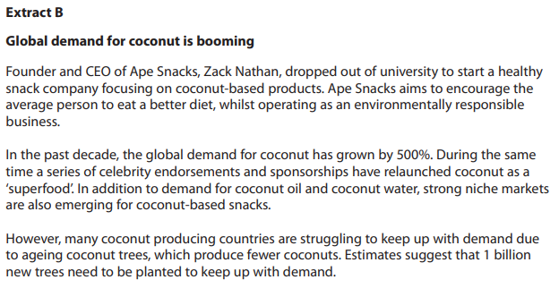 (4)

________________________________________________________________________________________________________________________________________________________________________________________________________________________________________________________________________________________________________________________________________________

________________________________________________________________________________________________________________________________________________________________________________________________________________________________________________________________________________________________________________________________________________

(b) Assess **two** factors that could cause a change in demand for Ape Snacks.

(8)

________________________________________________________________________________________________________________________________________________________________________________________________________________________________________________________________________________________________________________________________________________

________________________________________________________________________________________________________________________________________________________________________________________________________________________________________________________________________________________________________________________________________________

________________________________________________________________________________________________________________________________________________________________________________________________________________________________________________________________________________________________________________________________________________

________________________________________________________________________________________________________________________________________________________________________________________________________________________________________________________________________________________________________________________________________________

________________________________________________________________________________________________________________________________________________________________________________________________________________________________________________________________________________________________________________________________________________

________________________________________________________________________________________________________________________________________________________________________________________________________________________________________________________________________________________________________________________________________________

________________________________________________________________________________________________________________________________________________________________________________________________________________________________________________________________________________________________________________________________________________

________________________________________________________________________________________________________________________________________________________________________________________________________________________________________________________________________________________________________________________________________________

________________________________________________________________________________________________________________________________________________________________________________________________________________________________________________________________________________________________________________________________________________

________________________________________________________________________________________________________________________________________________________________________________________________________________________________________________________________________________________________________________________________________________

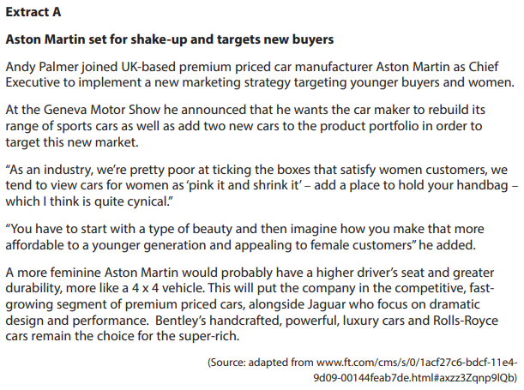

1. Assess **two** non-price factors that might affect the demand for premium priced cars in the UK. (8)

________________________________________________________________________________________________________________________________________________________________________________________________________________________________________________________________________________________________________________________________________________

________________________________________________________________________________________________________________________________________________________________________________________________________________________________________________________________________________________________________________________________________________

________________________________________________________________________________________________________________________________________________________________________________________________________________________________________________________________________________________________________________________________________________

________________________________________________________________________________________________________________________________________________________________________________________________________________________________________________________________________________________________________________________________________________

________________________________________________________________________________________________________________________________________________________________________________________________________________________________________________________________________________________________________________________________________________

________________________________________________________________________________________________________________________________________________________________________________________________________________________________________________________________________________________________________________________________________________

________________________________________________________________________________________________________________________________________________________________________________________________________________________________________________________________________________________________________________________________________________

________________________________________________________________________________________________________________________________________________________________________________________________________________________________________________________________________________________________________________________________________________

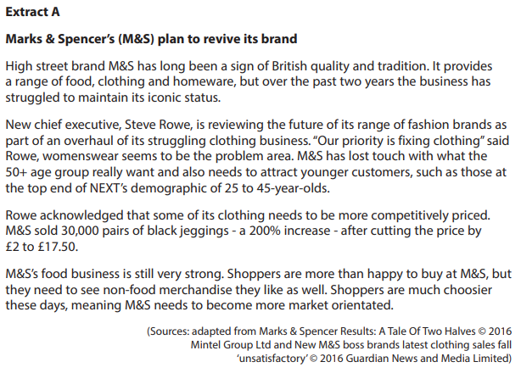

1. Assess **two** factors that could influence the price elasticity of demand for M&S’s clothing range. (8)

________________________________________________________________________________________________________________________________________________________________________________________________________________________________________________________________________________________________________________________________________________

________________________________________________________________________________________________________________________________________________________________________________________________________________________________________________________________________________________________________________________________________________

________________________________________________________________________________________________________________________________________________________________________________________________________________________________________________________________________________________________________________________________________________

________________________________________________________________________________________________________________________________________________________________________________________________________________________________________________________________________________________________________________________________________________

________________________________________________________________________________________________________________________________________________________________________________________________________________________________________________________________________________________________________________________________________________

________________________________________________________________________________________________________________________________________________________________________________________________________________________________________________________________________________________________________________________________________________

________________________________________________________________________________________________________________________________________________________________________________________________________________________________________________________________________________________________________________________________________________

________________________________________________________________________________________________________________________________________________________________________________________________________________________________________________________________________________________________________________________________________________

**1(a)**

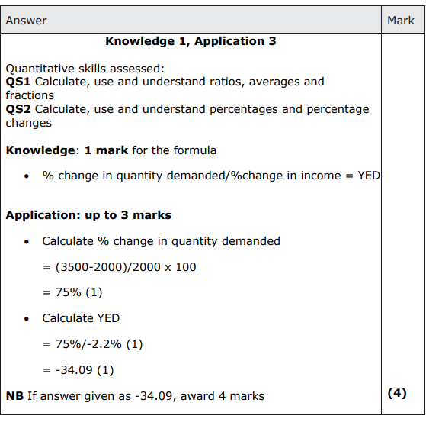

**1(b)**

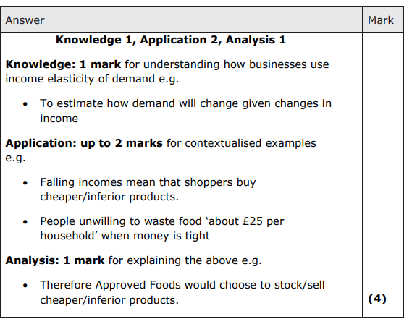

**2**

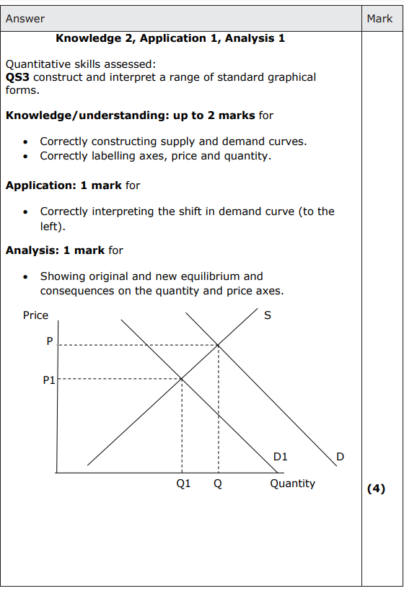

**3(a)**

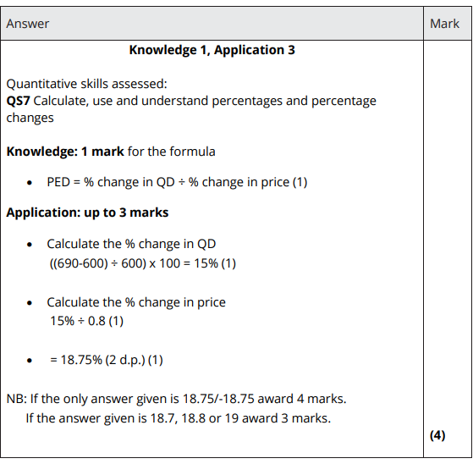

**3(b)**

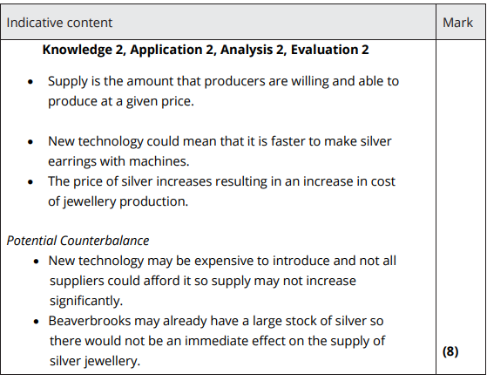

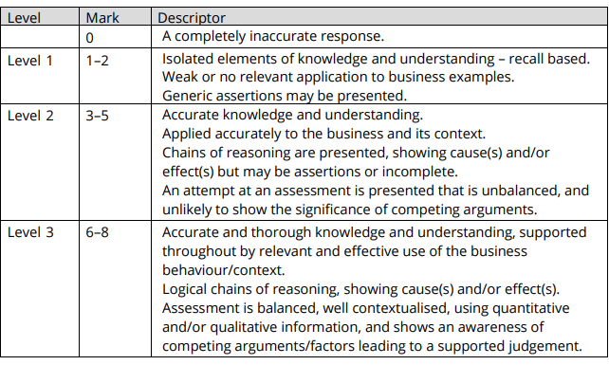

**4(a)**

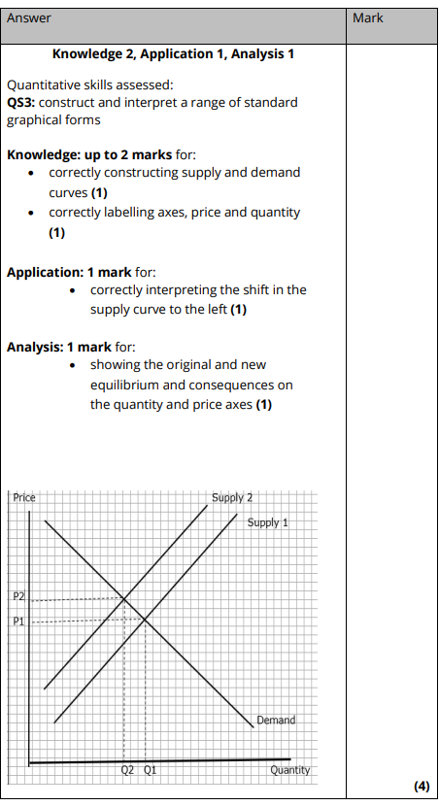

**4(b)**

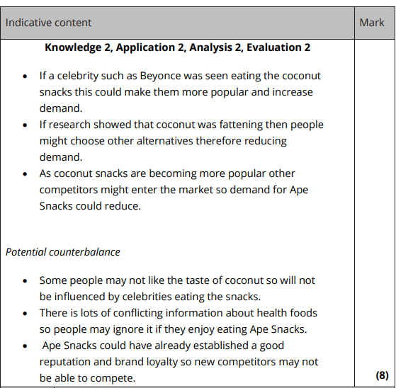

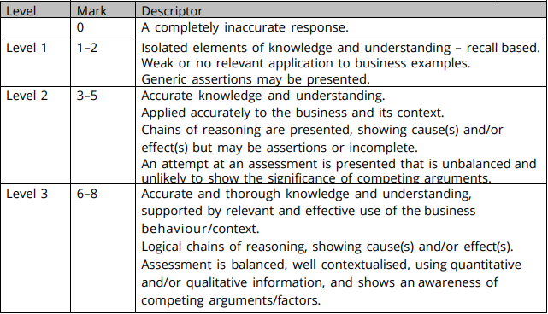

**5**

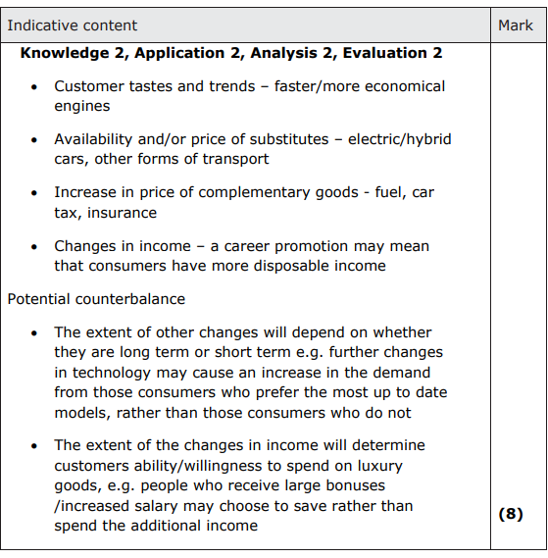

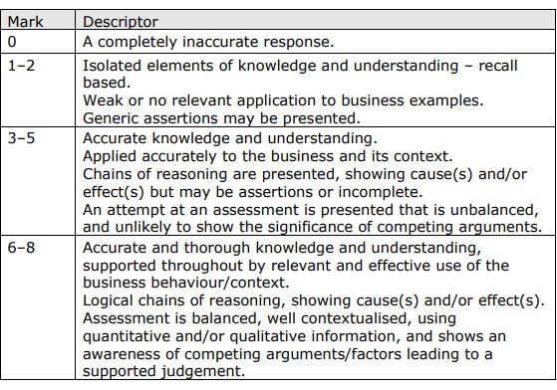

**6**

