

A-Level Further Maths Handbook

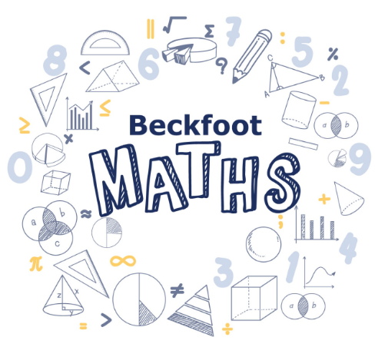

Contents

Contents

Contents 2
Course details 3
Qualification 3
Specification 3
AQA | AS and A-level | Further Mathematics | Specification at a glance 3
Entry Requirements 3
Contact details 4
Further Maths Specifics 4
Internal assessments 4
Grade boundaries 5

Course details

Qualification
AQA A-Level Further Maths

Specification

AQA | AS and A-level | Further Mathematics | Specification at a glance
We follow the Mechanics and Decision model (MD)

Entry Requirements
- Grade 8 in GCSE Mathematics
Calendar
Year 12 maths is taught up until December. Followed by the following content split between Miss McLean and Mr Kendall.

 | Maths | Further Maths
Pure | Algebra  Quadratics and Cubics  Inequalities and Simultaneous equations  Co-ordinate geometry, Graphs and Circles  Trigonometry  Exponentials and Logarithms  Vectors  The Binomial Expansion  Differentiation  Integration | Complex Numbers 1  Curve Sketching 1  Matrices 1  Vectors 1  Algebra and Series  Integration 1
Mechanics | Kinematics  Forces and Newton’s Law | Forces and Energy  Momentum  Circular Motion
Applied | Sampling, Data Presentation and Interpretation  Probability  Statistical Distributions  Statistical Hypothesis Testing | Graphs and Networks 1  Critical Path Analysis 1  Linear Programming and Game Theory  Abstract Algebra

Year 13 maths is taught up until December. Followed by the following content split between Miss McLean and Mr Kendall.
 | Maths | Further Maths
Pure | Algebra and Functions  Sequences and Series  Parametric Equations  Differentiation 2  Integration  The Binomial Expansion 2  Trigonometry 2  Vectors  Numerical Methods | Series  Complex Numbers 2  Curve Sketching 2  Differential Equations  Integration 2  Partial fractions  Numerical Methods  Matrices 2  Vectors 2
Mechanics | Kinematics 2  Dynamics  Moments | Circular Motion 2  Centres of Mass and Stability
Applied | Correlation and Regression  Probability 2  The Normal Distribution | Graphs and Networks 2  Critical Path Analysis 2  Linear Programming and Game Theory 2  Group Theory

Contact details
Miss McLean hmclean01@beckfoot.org
Mr Kendall nkendall01@beckfoot.org

Further Maths Specifics
Further Maths is taught alongside maths. This handbook is to supplement the maths handbook which also applies to you. Please look carefully at the super-curricular information. We will supplement this with offers from the AMSP (Advanced Maths Support Programme) throughout the year.
Maths content is typically taught between September and December. Further Maths content is then typically taught between January and June. Remember, you are taking two full A Levels in the same time other students are taught one so expect a fast lesson pace.
Independent work and consolidation is the key to success in Further Maths. We very much need you to be proactive and seek help from us when you are unsure.
We will issue you with 5 hours in booklets plus the QR code booklet linking to independent working each half term. Please refer to the 5 hours in page in the maths handbook.

Internal assessments
Due to the speed at which further maths is taught, all assessments will match the external exams. For example, on finishing the pure content in year 12, you will sit a pure AS paper. On finishing the mechanics content in year 13 further maths, you will sit a mechanics further maths paper etc..

External Assessments
A-Level Further Maths is a linear course, and you will sit all external exams at the end of Year 13. These take the form of three papers, as shown below:
What's assessed
Paper 1 and Paper 2
May assess content from the following sections:
A: Proof
B: Complex numbers
C: Matrices
D: Further Algebra and Functions
E: Further Calculus
F: Further Vectors
G: Polar coordinates
H: Hyperbolic functions
I: Differential equations
J: Trigonometry
K: Numerical Methods

Paper 3
One question paper answer booklet on Mechanics and one question paper answer booklet
on Discrete.
How it's assessed
Written exam: 2 hours
100 marks
33⅓ % of A-level
Questions
A mix of question styles, from short, single-mark questions to multi-step problems.

Grade boundaries
Below is an indication of the highest grade boundaries that have been used in AS and A-Level Chemistry exams, up to 2023. These are indicative only – actual grade boundaries used for in-class assessments may vary.
Grade | AS Further Maths (Year 12) | A-Level Further Maths (Year 13)
A* |  | 71%
A | 73% | 59%
B | 65% | 48%
C | 57% | 38%
D | 49% | 28%
E | 42% | 17%

