

Additional Assessment Materials

Pearson Edexcel GCE in A level Business

9BS0

Resource Set 5

3.5 Assessing competitiveness

3.5.3 Human resources

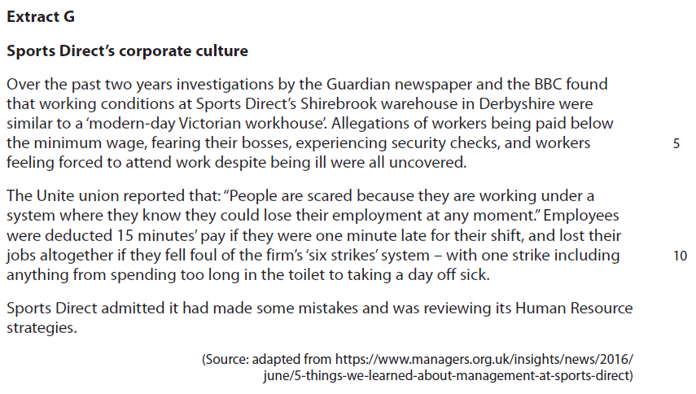**3.5.3 Human resources**

Sports Direct aims to reduce the labour turnover of its workforce. To achieve this, it could introduce an employee share ownership scheme or implement an empowerment strategy.

1 Evaluate these two options and recommend which **one** is most suitable for Sports Direct to achieve its aim of reducing labour turnover.

(20)

|  |  |  |
| --- | --- | --- |
| Question Number | Indicative content | Mark |
| **1** | **Knowledge 4, Application 4, Analysis 6, Evaluation 6**  **Indicative content**   * Labour turnover measures the percentage of employees leaving a business over a period of time.   **Arguments for an employee share ownership scheme:**   * Employee share ownership is a financial incentive whereby companies give shares to their employees or sell them at rates below the market price. * Sports Direct is changing its Human Resource strategies; employee share ownership may be one way to improve motivation because employees will now have a direct interest in the success of the business. * Sports Direct is profitable - in 2018 it generated an operating profit of £179 million. Consequently, its employees would benefit from a share ownership scheme. * Employees could have a direct interest in the financial performance of the business and consequently may be less likely to leave and more likely to accept current working practices. * Sports Direct has ambitious expansion plans. It aims to be the ‘Selfridges of Sport’. An employee share ownership scheme may encourage its workers to remain with the business, because they could directly benefit from its growth through increased dividend payments and a rising share price. * However, the value of employee ownership may depend upon the number of shares each employee owns and the amount of dividends received.   **Arguments for empowerment:**   * Empowerment is a non-financial method of motivation in which employees are given more control over their day to day work. * Empowerment indicates that managers are now becoming less autocratic and consequently workers may feel more appreciated. This may improve morale, particularly at the Shirebrook warehouse, where workers are reported to fear their bosses. * It could be argued that many of the jobs at Sports Direct either in the stores or the warehouse are boring and repetitive. Empowerment may enable the employees to gain more authority and be more interested in their work, resulting in lower labour turnover. * Empowerment may be preferred by the management rather than employee share ownership to achieve the aim of reducing labour turnover, because the owners of Sports Direct would not have to share the company’s profits with its employees. * However, some employees may not want the increased responsibility of empowerment as they may prefer to be told to what to do by their supervisors.   *Potential recommendation*   * Sports Direct should choose employee share ownership because it may lead to improved employee commitment and loyalty, as workers now have a direct financial interest in the success of the business. * Sports Direct should choose empowerment because it   needs to improve its damaged reputation amongst its workers resulting from its current Human Resource strategies.  Examples of possible ‘MOPS’ responses  **Market –** Sports Direct is in the retail market. This market is experiencing rapid structural change. Improving labour turnover is important because it may enable Sports Direct to provide better customer service, which could provide a competitive advantage.  **Objectives –** Sports Direct aims to be the ‘Selfridges of Sport’. Its acquisition of House of Fraser indicates that it is now targeting customers who visit department stores, who may have higher expectations of customer service.  A more stable workforce with good product knowledge could develop good relations with customers and improve customer service.  **Product –** Sports Direct currently sells sportswear at competitive prices. It favours a ‘cost leadership’ strategy according to Porter’s Strategic Matrix. Improving labour turnover could reduce recruitment and selection costs resulting in greater efficiency.  **Situation –** Sports Direct is successful and has ambitious expansion plans. However, it is currently suffering from bad publicity. Better treatment of its employees may lead to an improved reputation and help to reduce labour turnover in the future. | **(20)** |