

Additional Assessment Materials

Summer 2021

Pearson Edexcel GCE in A level Business

9BS0

Resource Set 1

4.1 Globalisation

4.1.1 Growing economies

4.1.2 International trade and business growth

4.1.4 Protectionism

4.1.5 Trading blocs

**Pearson: helping people progress, everywhere**

Pearson aspires to be the world’s leading learning company. Our aim is to help everyone progress in their lives through education. We believe in every kind of learning, for all kinds of people, wherever they are in the world. We’ve been involved in education for over 150 years, and by working across 70 countries, in 100 languages, we have built an international reputation for our commitment to high standards and raising achievement through innovation in education. Find out more about how we can help you and your students at: [www.pearson.com/uk](http://www.pearson.com/uk)

Additional Assessment Materials, Summer 2021

All the material in this publication is copyright

© Pearson Education Ltd 2021

**General guidance to Additional Assessment Materials for use in 2021**

**Context**

* Additional Assessment Materials are being produced for GCSE, AS and A levels (with the exception of Art and Design).
* The Additional Assessment materials presented in this booklet are an **optional** part of the range of evidence you may use when deciding on a candidate’s grade.
* 2021 Additional Assessment Materials have been drawn from previous examination materials, namely past papers.
* Additional Assessment Materials have come from past papers both published (those materials available publicly) and unpublished (those currently under padlock to our centres) presented in a different format to allow you to adapt them to use with your candidates.

**Purpose**

* The purpose of this resource to provide qualification-specific sets/groups of questions covering the knowledge, skills and understanding relevant to this Pearson qualification.
* This document should be used in conjunction with the mapping guidance which will map content and/or skills covered within each set of questions. The mapping guidance will also highlight where the question originally came from to allow you to access further support materials (mark schemes, examiner reports).
* Use of these assessment materials will assist you in assessing candidates’ current performance in areas not assessed elsewhere. Their use will also provide an extra opportunity for candidates to demonstrate their performance at the end of their course of study.
* These materials are only intended to support the summer 2021 series.

**4.1.1 Growing economies**

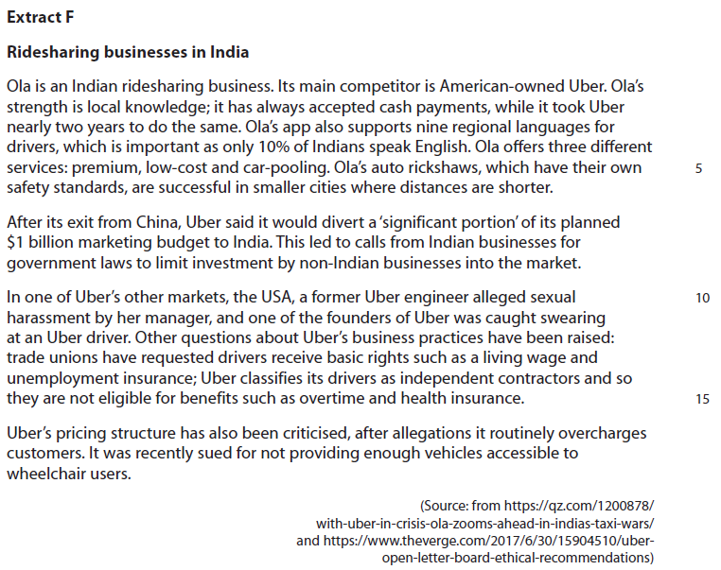

1 Assess the likely future growth of ridesharing businesses in an emerging economy, such as India.

(10)

**4.1.2 International trade and business growth**

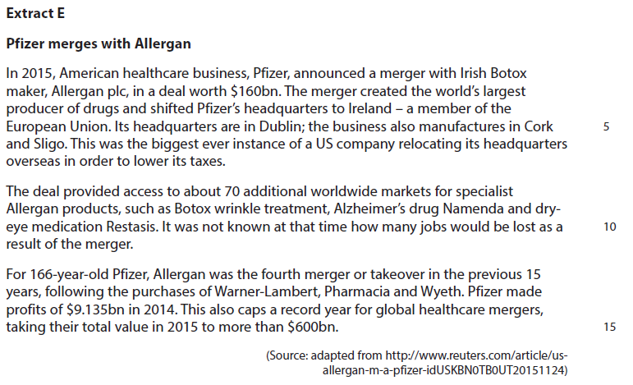

2 Assess the ways in which specialisation might give a business, such as Pfizer, a competitive advantage when trading internationally.

(10)

**4.1.4 Protectionism**

3 Explain **one** way the Indian government might use legislation to protect the Indian ridesharing market from non-Indian businesses.

(4)

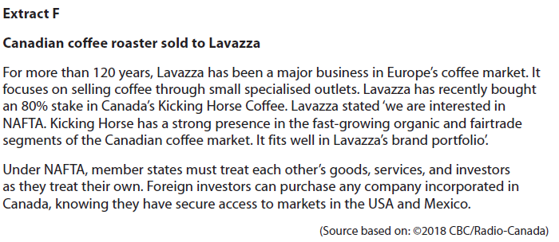**4.1.5 Trading blocs**

4 Assess the likely benefits to Lavazza of operating in the NAFTA trading bloc.

(10)

|  |  |  |  |  |
| --- | --- | --- | --- | --- |
| Question Number | | Indicative content | | Mark |
| **1** | | **Knowledge 2, Application 2, Analysis 2, Evaluation 3**  **Marks for application and analysis include up to two marks for quantitative skills**  **QS9:** interpret, apply and analyse information in written, graphical and numerical forms   * GDP per capita in India is growing quickly and therefore consumers may have increased disposable income to spend on ridesharing. * Literacy rates are rising, so customers can use the ridesharing apps on their phones easily to connect to these services. * Ridesharing markets in developed economies may be saturated, so emerging economies such as India provide businesses like Ola and Uber with an opportunity to grow quickly. * The number of customers is forecast to be 539.49m in 2021, so much of this growth is likely to be in emerging markets such as India.   *Potential counterbalance*   * Large parts of India, especially rural areas still have high levels of poverty, this can limit the growth of businesses such as ridesharing. * Although literacy rates are growing, there is still a huge range of languages in India, which can provide barriers to communication in service business such as ridesharing. * Infrastructure, such as the road network and mobile communication/mobile internet, may not be reliable enough to support the growth of ridesharing.   *Potential judgement*   * Ridesharing is likely to continue to grow in a market such as India because it provides a cheap alternative to car ownership for consumers who might have limited disposable income. * Further growth in India depends on incomes and demand for travel in urban areas to continue to grow. If substitute means of transport such as car ownership or public transport grow, then ridesharing may be limited in growth. | | **(10)** |
| Level | Mark | Descriptor | |
|  | 0 | A completely inaccurate response. | |
| Level 1 | 1–2 | Isolated elements of knowledge and understanding – recall based.  Weak or no relevant application to business examples.  Generic assertions may be presented. | |
| Level 2 | 3–4 | Elements of knowledge and understanding, which are applied to the business example.  Chains of reasoning are presented, but may be assertions or incomplete.  A generic or superficial assessment is presented. | |
| Level 3 | 5–6 | Accurate knowledge and understanding, supported by relevant and effective use of the business behaviour/context.  Analytical perspectives are presented, with developed chains of reasoning, showing cause(s) and/or effect(s). An attempt at an assessment is presented, using quantitative and/or qualitative information though unlikely to show the significance of competing arguments. | |
| Level 4 | 7–10 | Accurate and thorough knowledge and understanding, supported throughout by relevant and effective use of the business behaviour/context.  A coherent and logical chain of reasoning, showing cause(s) and/or effect(s).  Assessment is balanced, wide ranging and well contextualised, using quantitative and/or qualitative information, and shows an awareness of competing arguments/factors leading to a supported judgement. | |

|  |  |  |
| --- | --- | --- |
| Question Number | Indicative content | Mark |
| **2** | **Knowledge 2, Application 2, Analysis 3, Evaluation 3**   * Specialisation means a business concentrates on a specific range of products or services. * The healthcare/pharmaceutical market is dominated by a few multinationals, as implied by the record year in 2015 for global healthcare mergers * The healthcare product market is extremely specialised in terms of specific medicines and treatments, which require a large quantity of research and development and specialist skills from employees. Healthcare companies may need to sell internationally in order to make sufficient revenue to recover the high R&D and labour costs * Specialisation means that Pfizer does not compete directly with the same product with other businesses (such as Astrazeneca) in the same national market and they are therefore able to charge a premium price in that country for their products, gaining a competitive advantage through differentiation.   *Potential Counterbalance*   * Specialisation can make a business, such as Pfizer, vulnerable to changes in market demand. For example, there may be sudden growth in an aspect of health products in which they are not involved, which means it misses out on potential sales. * Research and development in pharmaceuticals is necessary in a dynamic market, but extremely expensive. If this is linked to an area of unsuccessful specialisation, can impact negatively on profit as development costs are not recovered * International competitive advantage can be gained through being the lowest cost producer in a global market charging lower prices. This could mean that Pfizer might focus more on mass market products such as painkillers, rather than specialist areas of healthcare, in order to benefit from lower average costs   *Potential Judgement*   * Specialisation based on intense and expensive research and development is more likely to lead to Pfizer gaining a competitive advantage internationally based on differentiation given the nature of products / dynamic market. | **(10)** |

|  |  |  |
| --- | --- | --- |
| Level | Mark | Descriptor |
|  | 0 | A completely inaccurate response. |
| Level 1 | 1–2 | Isolated elements of knowledge and understanding – recall based.  Weak or no relevant application to business examples. Generic assertions may be presented. |
| Level 2 | 3–4 | Elements of knowledge and understanding, which are applied to the business example.  Chains of reasoning are presented, but may be assertions or incomplete.  A generic or superficial assessment is presented. |
| Level 3 | 5–6 | Accurate and thorough knowledge and understanding, supported throughout by relevant and effective use of the business behavior/context.  Analytical perspectives are presented, with developed chains of reasoning, showing cause(s) and/or effect(s). An attempt at an assessment is presented, using quantitative and/or qualitative information though unlikely to show the significance of competing arguments. |
| Level 4 | 7–10 | Accurate and thorough knowledge and understanding, supported throughout by relevant and effective use of the business behavior/context.  A coherent and logical chain of reasoning, showing cause(s)  and/or effect(s).  Assessment is balanced, wide ranging and well contextualised, using quantitative and/or qualitative information and shows an awareness of competing arguments/factors leading to a supported judgement. |

|  |  |  |
| --- | --- | --- |
| Question  Number | Answer | Mark |
| **3** | **Knowledge 1, Application 2, Analysis 1**  **Knowledge: 1 mark** for understanding, e.g.:   * Protectionism mean policies used by a government to protect domestic businesses by making foreign owned products less attractive * Legislation is a collective name for laws and regulations used by governments to restrict certain activities * government legislation as a protectionist measure is when it is framed in such a way that can give an advantage to a domestic business.   **Application: up to 2 marks** for contextualised examples, e.g.:   * there were calls to limit the level of foreign investment by foreign multinationals into Indian markets. * safety rules specific to the Indian market e.g. those governing auto rickshaws.   **Analysis: 1 mark** is available for, e.g.:   * ridesharing cannot be protected by tariffs or quotas as it is not a traded product, so legislation is a potential option if the Indian government wanted to protect Ola and similar businesses. | **(4)** |

|  |  |  |
| --- | --- | --- |
| Question Number | Indicative content | Mark |
| **4** | **Knowledge 2, Application 2, Analysis 3, Evaluation 3**   * A trading bloc is a group of countries that trade freely with reduced or no tariffs and quotas on trade between businesses in these countries   Benefits to Lavazza   * Lavazza has purchased Kicking Horse and therefore has a business based in Canada. This will allow Lavazza to access the market in USA and Mexico freely as well. * There is no common tariff structure in NAFTA; each member state has its own policies and imports from economies outside NAFTA. This means that supplies of coffee beans may be imported more freely than if there was a common external tariff.   *Potential counterbalance*   * Free trade as part of NAFTA means that US businesses such as Starbucks provide competition to Lavazza in the Canadian market and may limit competition through aggressive pricing and promotion * NAFTA membership may not be a large advantage to Lavazza because it is a business supplying mainly to specialist outlets, rather than importing or exporting manufactured goods. The cost advantages may therefore be smaller.   *Potential judgement*   * NAFTA gives Lavazza a range of opportunities to expand from Canada into the US and Mexico, but it seems to be more focused on the more niche organic/fair-trade segment in Canada in the short-term, and may therefore be less concerned with the access to other markets NAFTA offers. | **(10)** |

|  |  |  |
| --- | --- | --- |
| Level | Mark | Descriptor |
|  | 0 | A completely inaccurate response. |
| Level 1 | 1–2 | Isolated elements of knowledge and understanding – recall based.  Weak or no relevant application to business examples.  Generic assertions may be presented. |
| Level 2 | 3–4 | Elements of knowledge and understanding, which are applied to the business example.  Chains of reasoning are presented, but may be assertions or incomplete.  A generic or superficial assessment is presented. |
| Level 3 | 5–6 | Accurate and thorough knowledge and understanding, supported by relevant and effective use of the business behaviour/context.  Analytical perspectives are presented, with chains of reasoning, showing cause(s) and/or effect(s).  An attempt at an assessment is presented, using quantitative and qualitative information, though unlikely to show the significance of competing arguments. |
| Level 4 | 7–10 | Accurate and thorough knowledge and understanding, supported by relevant and effective use of the business behaviour/context.  A coherent and logical chain of reasoning, showing cause(s) and/or effect(s).  Assessment is balanced and well contextualised, using quantitative and qualitative information, and shows an awareness of competing arguments/factors leading to a supported judgement. |