

Additional Assessment Materials

Pearson Edexcel AS Level in Business (8BS0)

Resource Set 1.3: Marketing mix and strategy



1. (a) What is meant by a marketing strategy? (2)

________________________________________________________________________________________________________________________________________________________________________________________________________________________________________________________________________________________________________________________________________________

(b) What is meant by product portfolio? (2)

________________________________________________________________________________________________________________________________________________________________________________________________________________________________________________________________________________________________________________________________________________

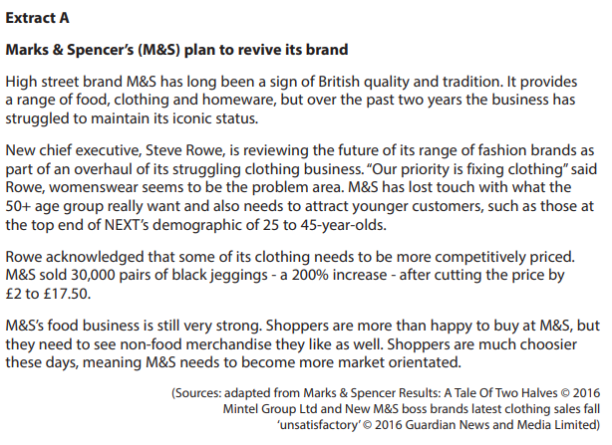

1. (a) What is meant by competitive pricing? (2)

________________________________________________________________________________________________________________________________________________________________________________________________________________________________________________________________________________________________________________________________________________

(b) Explain how M&S could build its clothing brand. (4)

________________________________________________________________________________________________________________________________________________________________________________________________________________________________________________________________________________________________________________________________________________

________________________________________________________________________________________________________________________________________________________________________________________________________________________________________________________________________________________________________________________________________________



1. (a) What is meant by business to business (B2B) marketing? (2)

________________________________________________________________________________________________________________________________________________________________________________________________________________________________________________________________________________________________________________________________________________

(b) Explain **one** reason why Hydra Creative might use an extension strategy.

(4)

________________________________________________________________________________________________________________________________________________________________________________________________________________________________________________________________________________________________________________________________________________

________________________________________________________________________________________________________________________________________________________________________________________________________________________________________________________________________________________________________________________________________________

1. (a) What is meant by brand? (2)

________________________________________________________________________________________________________________________________________________________________________________________________________________________________________________________________________________________________________________________________________________

(b) Assess **two** methods Mars could use to promote its new protein bars.

(8)

________________________________________________________________________________________________________________________________________________________________________________________________________________________________________________________________________________________________________________________________________________

________________________________________________________________________________________________________________________________________________________________________________________________________________________________________________________________________________________________________________________________________________

________________________________________________________________________________________________________________________________________________________________________________________________________________________________________________________________________________________________________________________________________________

________________________________________________________________________________________________________________________________________________________________________________________________________________________________________________________________________________________________________________________________________________

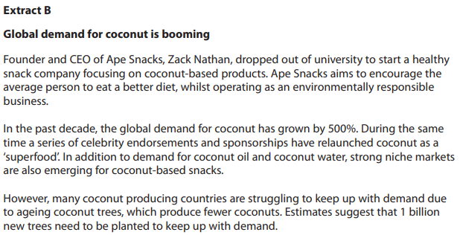

1. (a) What is meant by sponsorship? (2)

________________________________________________________________________________________________________________________________________________________________________________________________________________________________________________________________________________________________________________________________________________

(b) Assess whether social trends might affect the design mix for Ape Snacks’ coconut snacks. (10)

________________________________________________________________________________________________________________________________________________________________________________________________________________________________________________________________________________________________________________________________________________

________________________________________________________________________________________________________________________________________________________________________________________________________________________________________________________________________________________________________________________________________________

________________________________________________________________________________________________________________________________________________________________________________________________________________________________________________________________________________________________________________________________________________

________________________________________________________________________________________________________________________________________________________________________________________________________________________________________________________________________________________________________________________________________________

________________________________________________________________________________________________________________________________________________________________________________________________________________________________________________________________________________________________________________________________________________

________________________________________________________________________________________________________________________________________________________________________________________________________________________________________________________________________________________________________________________________________________

________________________________________________________________________________________________________________________________________________________________________________________________________________________________________________________________________________________________________________________________________________

________________________________________________________________________________________________________________________________________________________________________________________________________________________________________________________________________________________________________________________________________________

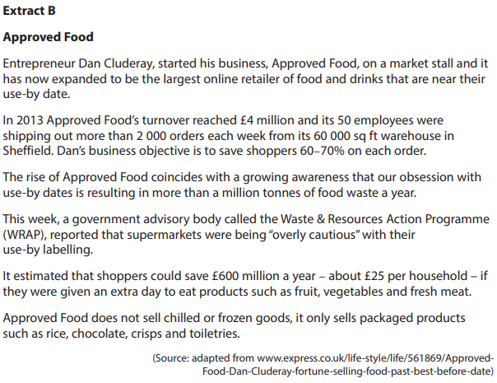

1. (a) Explain how a business, such as Approved Food, might use income elasticity of demand data. (4)

________________________________________________________________________________________________________________________________________________________________________________________________________________________________________________________________________________________________________________________________________________

________________________________________________________________________________________________________________________________________________________________________________________________________________________________________________________________________________________________________________________________________________

(b) Assess **two** ways social trends might affect the channels of distribution for a business such as Approved Food. (8)

________________________________________________________________________________________________________________________________________________________________________________________________________________________________________________________________________________________________________________________________________________

________________________________________________________________________________________________________________________________________________________________________________________________________________________________________________________________________________________________________________________________________________

________________________________________________________________________________________________________________________________________________________________________________________________________________________________________________________________________________________________________________________________________________

________________________________________________________________________________________________________________________________________________________________________________________________________________________________________________________________________________________________________________________________________________

________________________________________________________________________________________________________________________________________________________________________________________________________________________________________________________________________________________________________________________________________________

________________________________________________________________________________________________________________________________________________________________________________________________________________________________________________________________________________________________________________________________________________

________________________________________________________________________________________________________________________________________________________________________________________________________________________________________________________________________________________________________________________________________________

________________________________________________________________________________________________________________________________________________________________________________________________________________________________________________________________________________________________________________________________________________

1. Explain how Beaverbrooks could use the Boston matrix. (4)

________________________________________________________________________________________________________________________________________________________________________________________________________________________________________________________________________________________________________________________________________________

________________________________________________________________________________________________________________________________________________________________________________________________________________________________________________________________________________________________________________________________________________

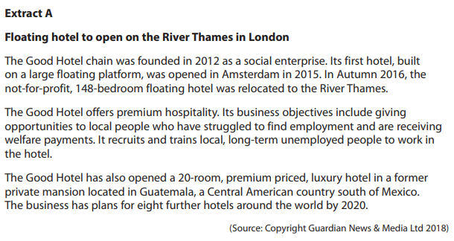

1. (a) Assess **two** methods The Good Hotel could use to develop customer loyalty.

(8)

________________________________________________________________________________________________________________________________________________________________________________________________________________________________________________________________________________________________________________________________________________

________________________________________________________________________________________________________________________________________________________________________________________________________________________________________________________________________________________________________________________________________________

________________________________________________________________________________________________________________________________________________________________________________________________________________________________________________________________________________________________________________________________________________

________________________________________________________________________________________________________________________________________________________________________________________________________________________________________________________________________________________________________________________________________________

________________________________________________________________________________________________________________________________________________________________________________________________________________________________________________________________________________________________________________________________________________

________________________________________________________________________________________________________________________________________________________________________________________________________________________________________________________________________________________________________________________________________________

(b) Assess whether a unique selling point (USP) is the most important factor in determining a pricing strategy for a premium priced hotel, such as The Good Hotel. (10)

________________________________________________________________________________________________________________________________________________________________________________________________________________________________________________________________________________________________________________________________________________

________________________________________________________________________________________________________________________________________________________________________________________________________________________________________________________________________________________________________________________________________________

________________________________________________________________________________________________________________________________________________________________________________________________________________________________________________________________________________________________________________________________________________

________________________________________________________________________________________________________________________________________________________________________________________________________________________________________________________________________________________________________________________________________________

________________________________________________________________________________________________________________________________________________________________________________________________________________________________________________________________________________________________________________________________________________

________________________________________________________________________________________________________________________________________________________________________________________________________________________________________________________________________________________________________________________________________________

________________________________________________________________________________________________________________________________________________________________________________________________________________________________________________________________________________________________________________________________________________

________________________________________________________________________________________________________________________________________________________________________________________________________________________________________________________________________________________________________________________________________________

________________________________________________________________________________________________________________________________________________________________________________________________________________________________________________________________________________________________________________________________________________

________________________________________________________________________________________________________________________________________________________________________________________________________________________________________________________________________________________________________________________________________________

**1(a)**

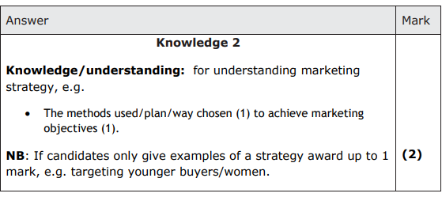

**1(b)**

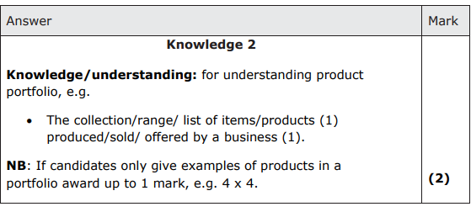

**2(a)**

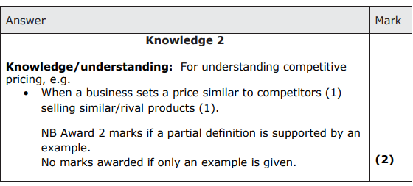

**2(b)**

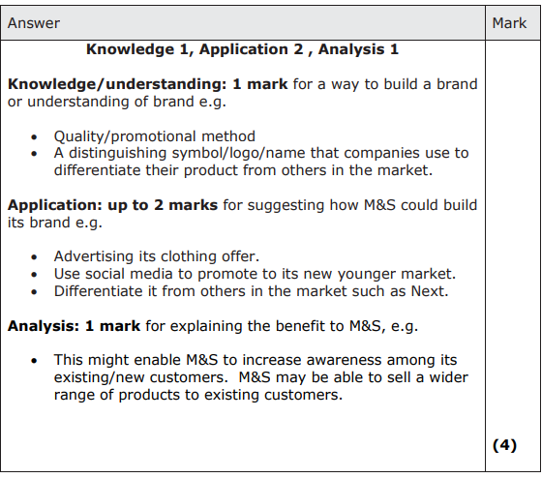

**3(a)**

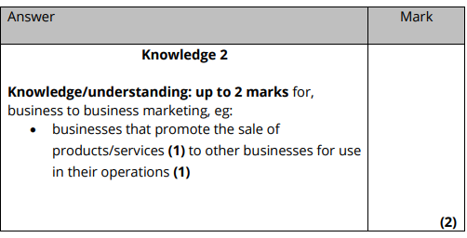

**3(b)**

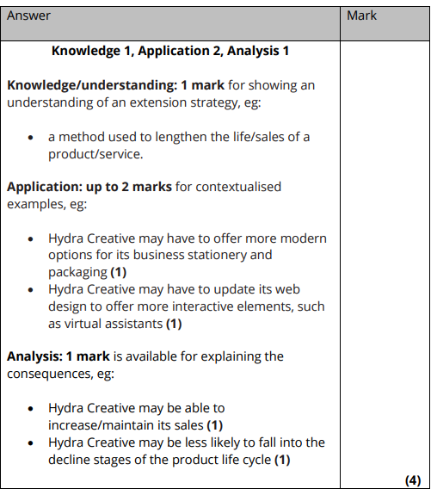

**4(a)**

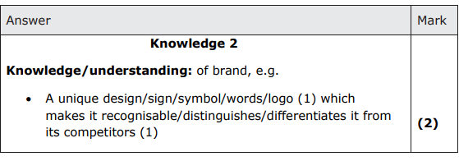

**4(b)**

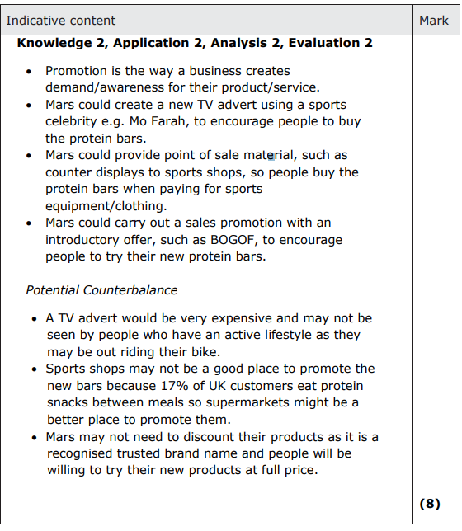

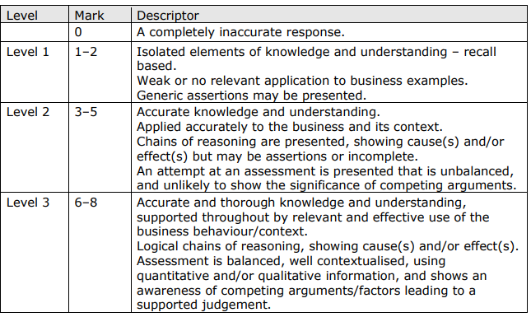

**5(a)**

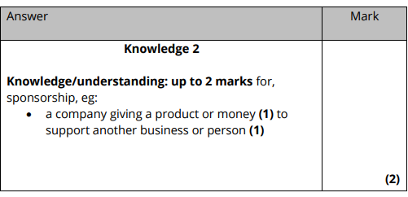

**5(b)**

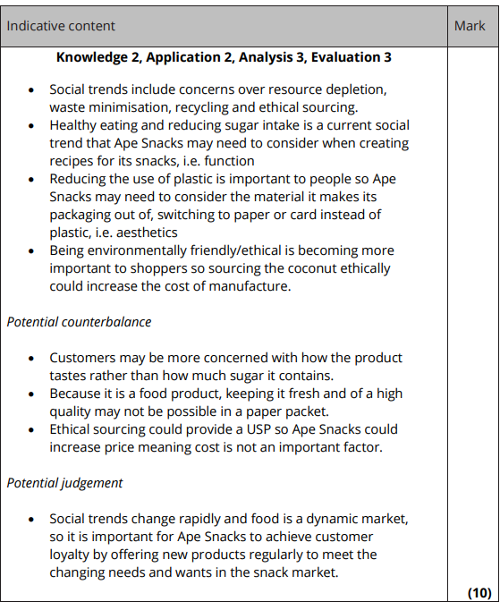

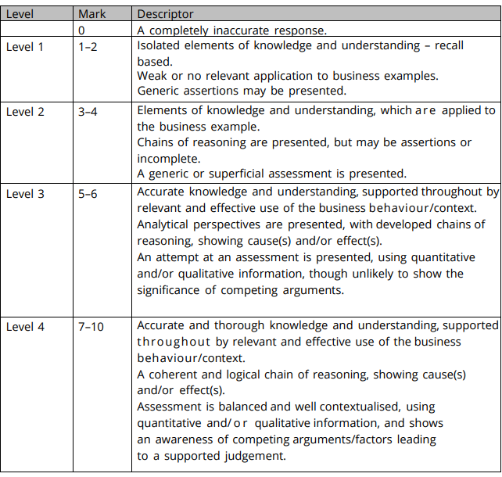

**6(a)**

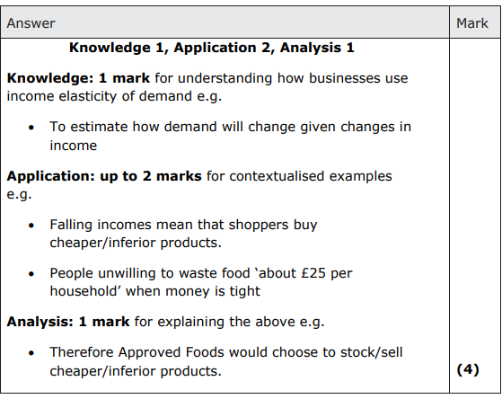

**6(b)**

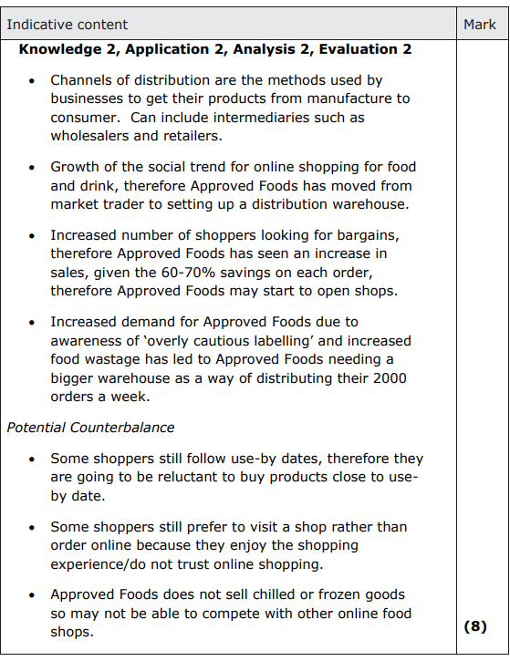

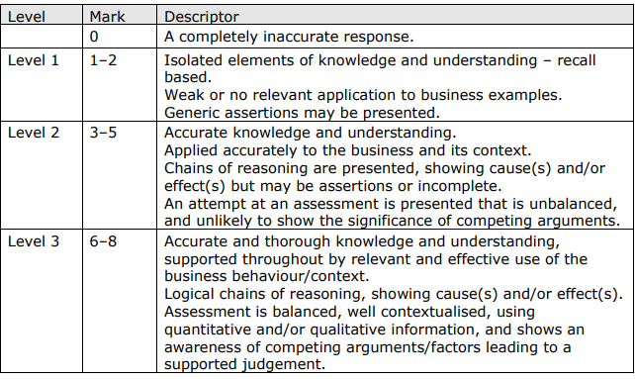

**7**

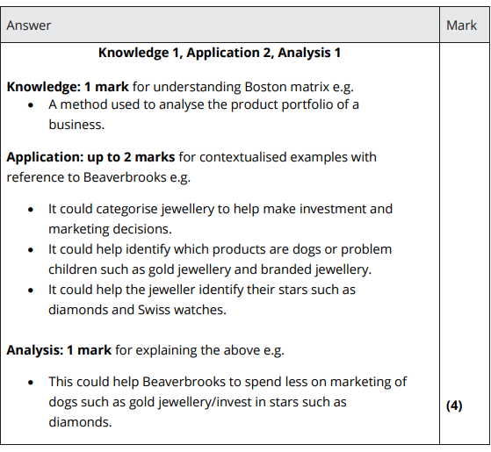

**8(a)**

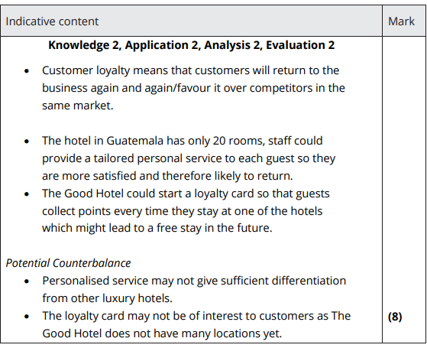

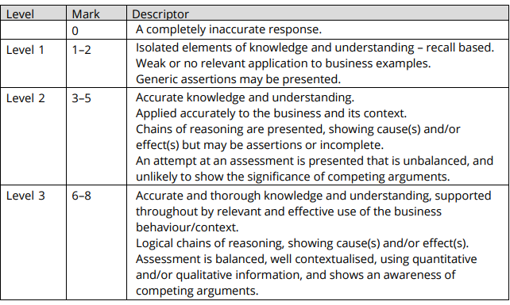

**8(b)**

