

A-Level German Handbook



Contents
Contents 2
Course details 3
Qualification 3
Specification 3
Entry Requirements 3
Calendar 3
Contact details 3
Organisation 4
Equipment 4
Assessment 5
Grade boundaries 5
Internal assessments 6
Year 12/13 7
5 hours in… German 8
Supercurricular 9
Read 9
Compete 9
Watch 9
Speak 9
Listen……………………………………………………………………………………………………………………………………………9
Visit………………………………………………………………………………………………………………………………………………9
Online 9
Write like a linguist……………………………………………………………………………………………………………………….10-11
How to write your component 3 essay 12-13
How your IRP is assessed component 1………………………………………………………………………………………… 14-15
Numeracy……………………………………………………………………………………………………………………………………… 16
Specification………………………………………………………………………………………………………………………………17-29

Course details

Qualification
Eduqas A-Level German

Specification:
A level specification template (eduqas.co.uk)

Entry Requirements
- Grade 4 in GCSE English Language or GCSE English Literature, 5 in GCSE Maths
- Grade 6 in GCSE German

Calendar
Year 12 Year 13
Half-term | Teacher 1 | Teacher 2 | Teacher 1 | Teacher 2
1 | Grammar | Family and relationships | Book: der Vorleser | Modern Germany post 1989 continued  IRP
2 | Grammar and Education/employment | Film: Goodbye Lenin | Diversity and difference | Changing German society after reunification.
3 | Festivals and Traditions | Cultural Trends: music, cinema and TV | Marginalisation and integration | Revision of year 12 topics
4 | Image and fashion/ health | Digital society | Exam preparation  Translation & Essays | Exam preparation  Speaking and R+L
5 | Historical background of book | Cultural Trends: museums and art | Exam preparation  Translation & Essays | Exam preparation  Speaking and R+L
6 | Book: der Vorleser | Modern Germany after 1989  IRP

Contact details
Head of German: Sarah Lee slee01@beckfoot.org
A-Level German teacher: Dr Dye ldye01@beckfoot.org

Organisation
You are expected to maintain a well-organised folder, which will be checked by a teacher once per half-term. You must use file dividers, and should contain the following sections:
- Course documents
  - Specification
  - Teaching plan?
- Independent learning
  - 5 hours in… guidance and templates
  - German Vocabulary booklet
  - Homework
  - Independent learning
- Topic notes
  - Component 1 - Speaking
  - Component 2 – Reading/Listening/Translation
  - Component 3 – Essay – film/novel
Notes from each lesson should have a title and date, and placed into your files so that you have a useful set of notes from which you can revise.

Equipment
You must bring the following to all lessons:
- Black pens, green pen, mini-whiteboard pen, pencil, ruler.
- Highlighters

Assessment

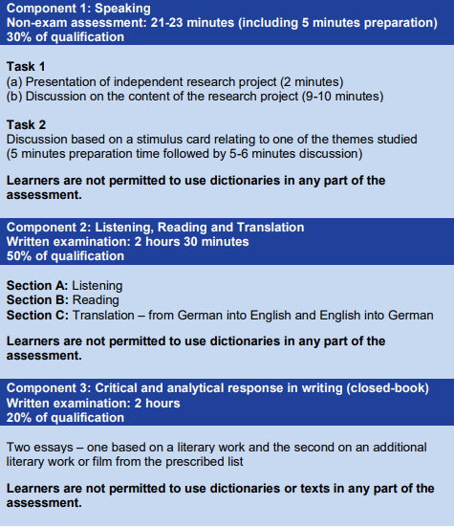

Grade boundaries
Below is an indication of the highest grade boundaries that have been used in A-Level German exams, up to 2023. These are indicative only – actual grade boundaries used for in-class assessments may vary.
Grade | A-Level German(Year 13)
A* | 90 %
A | 80 %
B | 69 %
C | 58 %
D | 47 %
E | 37 %

Internal assessments
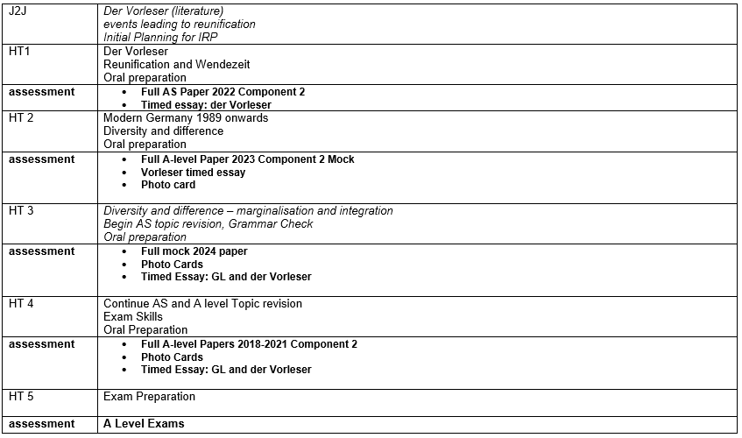
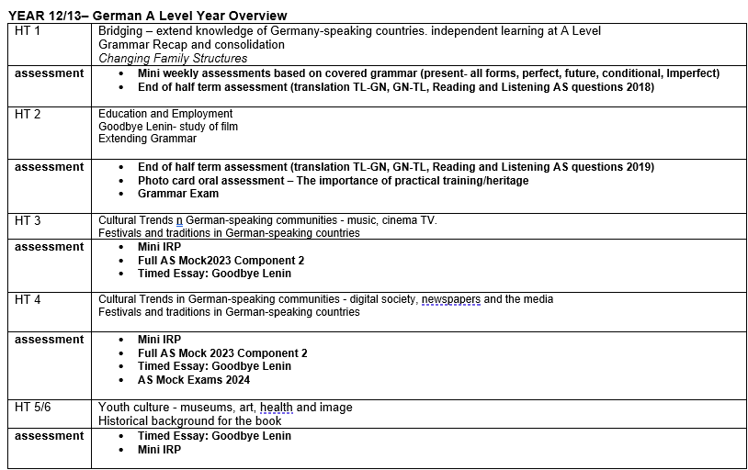.

Year 12:
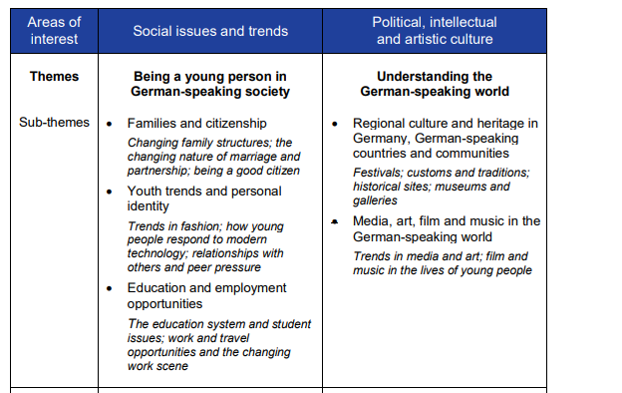
Film studied: Goodbye Lenin

Year 13
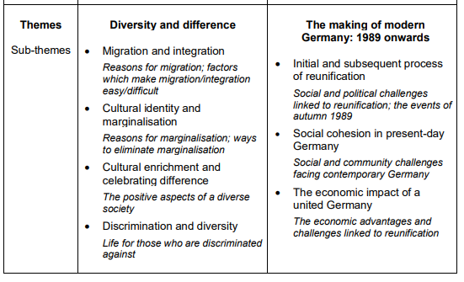

Book studied: Der Vorleser Bernhard Schlink

5 hours in… German

Research shows that the most successful students (i.e. those that make the most progress and get the highest grades) are doing between 20 and 25 hours of independent study per week by the end of Year 13. That may seem a lot, but it’s something that you would build up to over the course of your A-Levels. In Year 12, we’re talking something more like 15 hours per week. This equates to roughly 5 hours of independent study per A-Level per subject.
Remember that your independent study is divided into three types – Consolidation, Reactive and Proactive.
Consolidation
The evening following a German lesson, you should spend 12-15 minutes (24-30 minutes for a double) rereading your notes, checking grammar points and ensuring vocabulary and facts have been absorbed. You can do this by making flashcards, going on Quizlet or by filling in knowledge organisers.
Reactive
This is your ’homework’. Each of your German teachers should give you at least 1 hour’s worth of homework each week. If they don’t – ask them for some! If you find this takes more than 1 hour, that’s fine, you can take this from the proactive phase (not from the consolidation phase though). Equally, if you find you finish your reactive work quickly, spend more time on your proactive work.
Proactive
This is the section that will broaden and deepen your overall understanding of the subject you are studying. It will not necessarily involve work that has been set by your teacher, but instead it is about you doing the extra practice questions, reading articles, watching videos. In German, this might contain some of the following:
- Complete Eduqas exam style questions (link below)– (1 hr)
- Use websites to complete and add to class notes…find facts liked to the topics and continue to develop your vocabulary (30 minutes)
- Use the specification and evaluate whether you are confident with topics covered (10 mins)
- Make notes on tenses – add additional grammar points to your grammar revision booklet (30 mins)
- Work through the listening and reading revision booklet (30 mins)
- Test yourself on vocabulary in the Eduqas vocabulary booklet (30 mins)
- Work through the translation booklet (30 minutes)
- Learn essay phrases (20 mins)
- Watch Goodbye Lenin scene by scene and make notes relating to key themes (20 mins)
- Re-read chapter notes on der Vorleser (30 mins)
- Plan essays for the film/book using PEEL sheet (1-2hrs)
- Research the education system in Germany and society in Germany post 1989 (20 mins)
- Learn facts linked to topics so that you can use them in your speaking exam (30 mins)
- Complete past papers

Useful links
- www.languagesonline.org – Grammar
- www.quizlet.com - Vocabulary
- tagesschau.de - die erste Adresse für Nachrichten und Information | tagesschau.de- News and current affairs videos

- AS and A Level German | Eduqas- Eduqas resources linked to all themes and exam style question

Supercurricular

Read (Ask Mrs Lee and Dr Dye if you would like copies)
- Andorra – Max Frisch (1961)
- Tschick – Wolfgand Herrndorf (2010)
- Homofaber – Max Frisch (1957)
- Sag Alex er soll nicht auf mich warten – Irene Diwiak (2023)
- Beyond the Wall – Katja Hoyer (2023)

Watch
- Das Leben der Anderen – Florien Henckel
- Die Welle – Denis Gansel
- Der Baader Meinhof Komplex – Bernd Eichinger
- Dark – Netflix series ( rated 15 for dark content)
- Kleo – Netflix series about a German spy
- Lola rennt – Tom Tykwer
- Der Untergang - Oliver Hirschbiegel

Listen
- Vorleser- Bing Videos
- Interview with Bernhard Schlink: Bernhard Schlink, Schriftsteller und Jurist: "Der Vorleser" - Eins zu Eins. Der Talk | BR Podcast
- Die Mauer: Mauer Macht Mensch · Podcast-Tipp: Die Mauerstadt · Podcast in der ARD Audiothek
- German radio: Radio online hören => Deutschland.FM

Compete
- Stephen Spender Poetry Competition – May 2023 (Y12/13)
- Lancaster Essay Writing Competition – February each year (Y12/13)
- Anthea Bell Translation Competition April each year (Y12/13)
- Oxford Classics Literature Essay - June each year (Y12/13)

Online
- www.languagesonline.org
- www.tagesschau.de
- Goethe-Institut | Sprache. Kultur. Deutschland.

Write like a Linguist
It is important that you can explain yourself clearly in your written work. Writing like a Linguist will ensure you are able to get your points across in an accurate and sophisticated manner.

A linguist always
- Writes an essay plan
- Uses complex grammatical structures and tenses accurately
- Applies a range of sophisticated phrases
- Accurately uses idiomatic phrases
- Supports arguments with specific reference to the text
- Analyses rather than describes
- References social and historical contexts

Use the following language in essays :
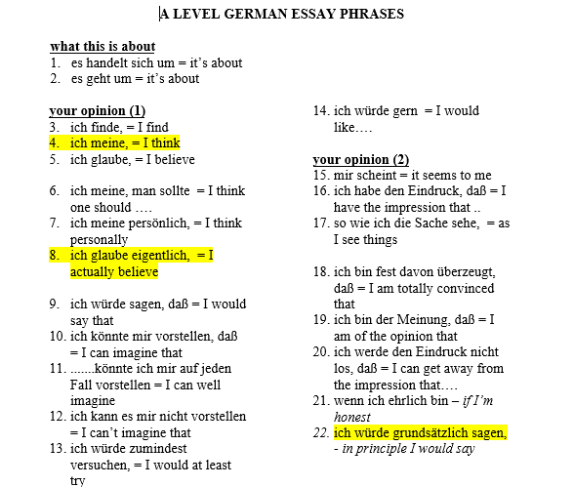

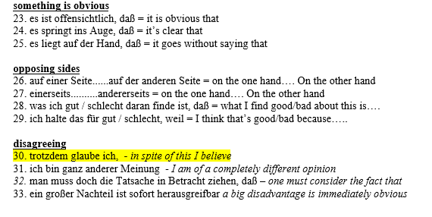
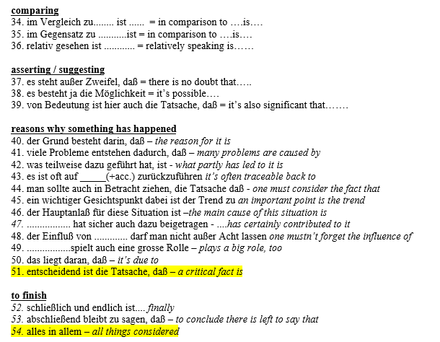

Component 3

As a rough guide you should spend about 10 minutes planning your essay, 50 minutes writing it and 5 minutes checking it.

Planning your essay:
It is important to plan your essay well. Make points clearly and logically so that the examiner can follow your argument. Take time to devise a plan before you start writing. This avoids rambling account and allow a structure which is easy to follow. You might find that the following points help you to plan your essay well:
- Read the question carefully. Make sure you have understood what you are being asked to do and stick to the question.

- It is sensible to plan your essay in French. This will prevent you writing ideas you are not able to express in the target language.

- Focus on the key words. For example, you may be asked to analyse, evaluate, explore or explain.

- Select the main point you want to make in your essay and then break this down into 3 or 4 sub-sections. They will become your paragraphs. Think about how you can link your arguments to themes and society at the time.

- Choose relevant information only!

- Decide on the order of your paragraphs. It might be a good idea to keep your strongest idea for your last paragraph. Note down linking words or phrases you can use between paragraphs to make your essay flow as a coherent and logical argument.

- Select one or two relevant and concise quotations which you can use to illustrate some of the points you make.

- Think about the suggested word count for the essay. It should always be possible to write a meaningful essay within the allocated number of words.

- Think about how to introduce and conclude your essay, ensuring that you have answered the question set. Keep these short and to the point.

You might find the following template helpful to plan your essay ensuring you make a point, provide evidence, evaluate and analyse and link to society.

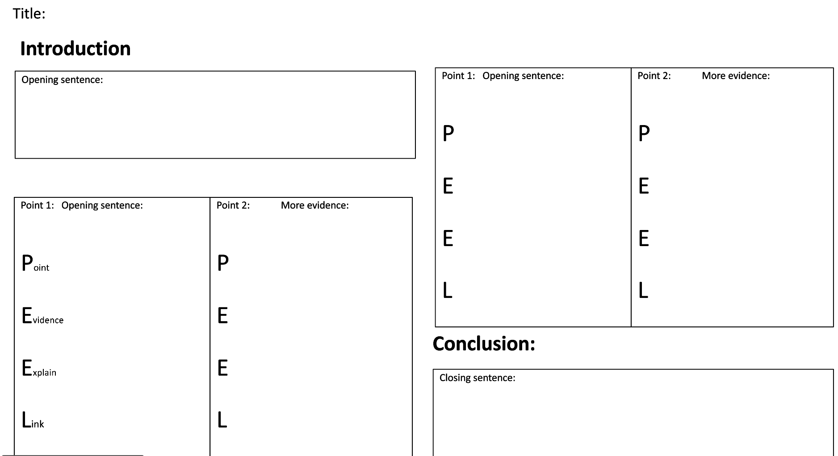

Structure:
Introduction:

- You can use a short sentence to introduce the film or the text you have studied.

- Show your understanding of the question: you should explain to your reader what you understand the question to mean, identify the issue it raises and how you are going to tackle them.
Development :
- This part will be divided into a number of interconnected paragraphs, each of which will pick up and develop the points raised in your introduction.

- Each paragraph should be introduced with a sentence stating what the paragraph is about.

- Make sure you are following a clear pathway through your paragraphs leading to your conclusion.

- Each paragraph must have an internal logic whereby you examine a separate point, making your argument, supporting it with evidence and possibly quotations and drawing conclusions. Ensure you link points/arguments to themes/society at the time.

- Try to have balanced paragraphs (with about the same amount of content).

Conclusion :
- Read through what you have written again and THEN write your conclusion.

- It should summarise your arguments succinctly

Component 1
What is the IRP?
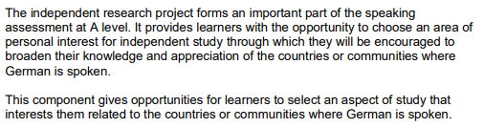

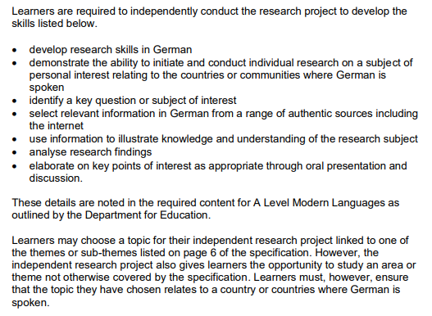

Assessment criteria for the IRP:
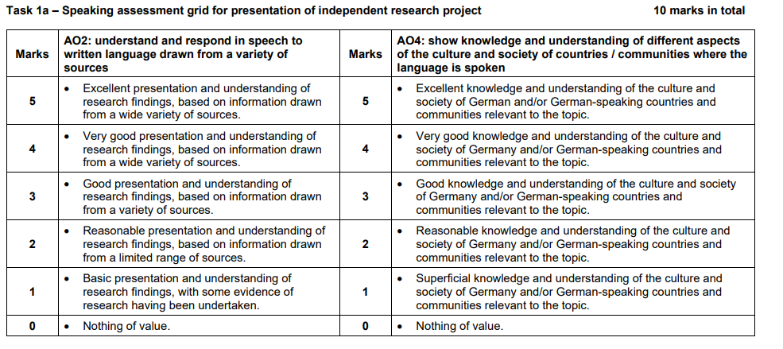

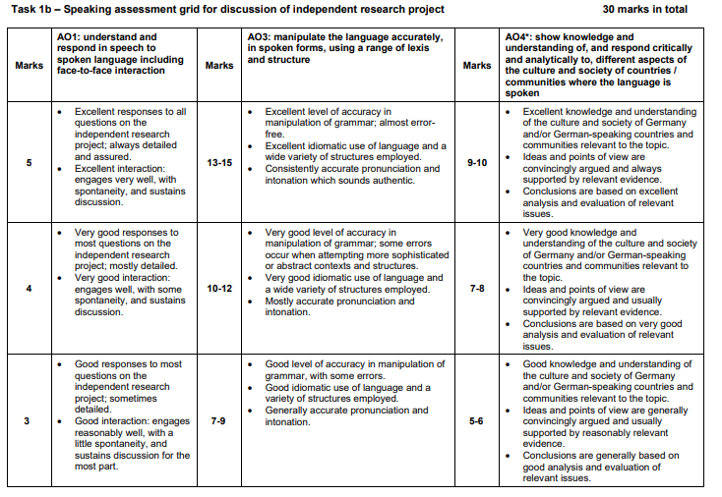
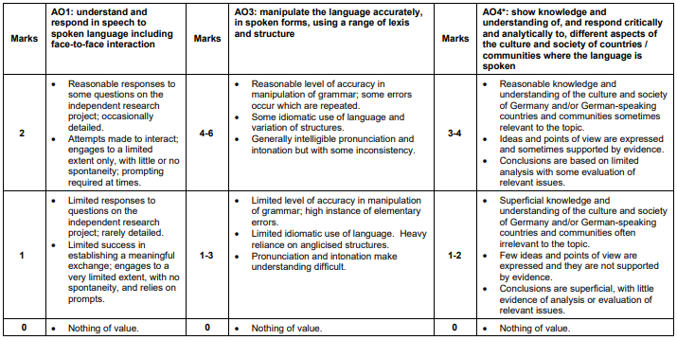

Numeracy
Marks across your exam papers will at time require numeracy skills:
- Cardinal numbers
- Complex numbers
- Ordinal numbers
- Quantities
- Use of ratios, fractions and percentages
- Dates/years
- Time

Specification

