

Additional Assessment Materials

Pearson Edexcel GCE in A level Business

9BS0

Resource Set 1

3.1 Business objectives and strategy

3.1.1 Corporate objectives

3.1.2 Theories of corporate strategy

3.1.3 SWOT Analysis

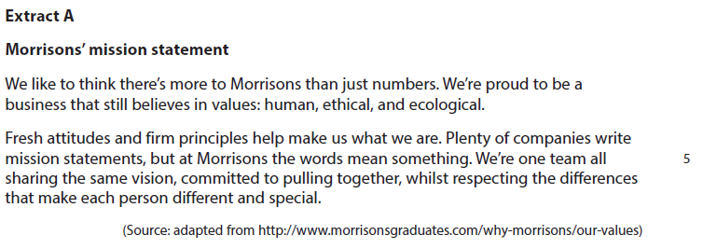**3.1.1 Corporate objectives**

1 Explain how Morrisons may benefit from having a mission statement.

(4)

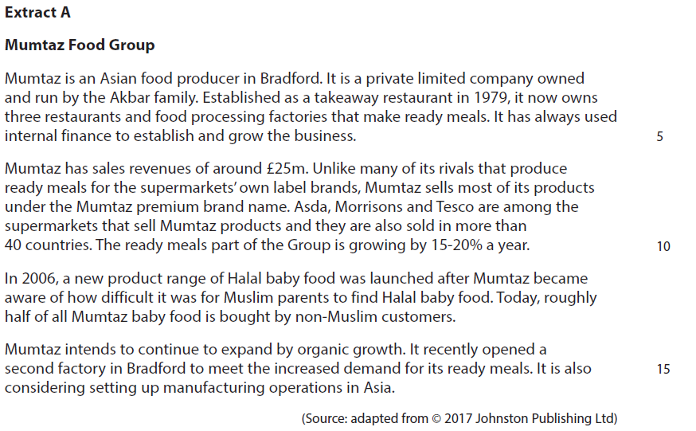**3.1.2 Theories of corporate strategy**

Mumtaz’s aim is to become the UK’s market leader in Asian ready meals.

To achieve this, it could produce own label ready meals for supermarkets or focus on

selling more Mumtaz premium brand name products.

2 Evaluate these **two** options and recommend which is most suitable for Mumtaz to achieve its aim.

(20)

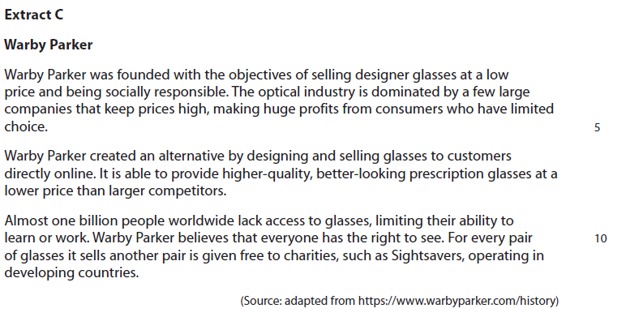

Warby Parker’s main corporate objective is to grow the business. The management is

considering two options, either to develop a new range of contact lenses for the high

income market, or to start selling glasses in the low income market.

3 Evaluate these two options and recommend which **one** is most likely to achieve Warby Parker’s main corporate objective.

(20)

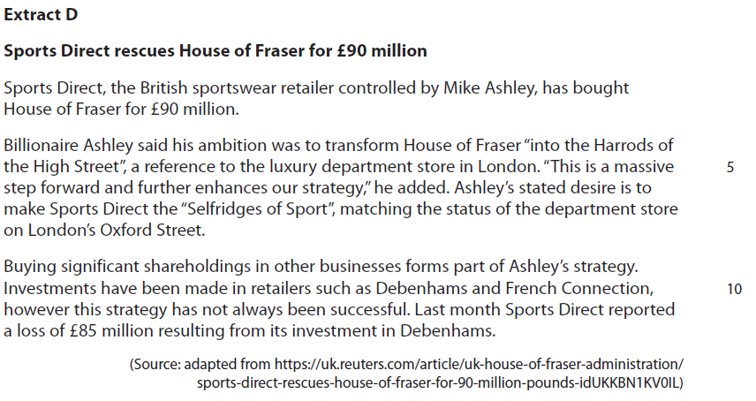**3.1.3 SWOT Analysis**

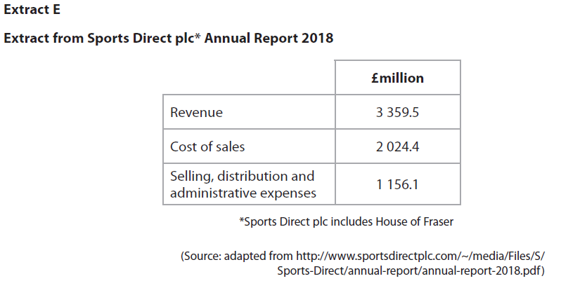

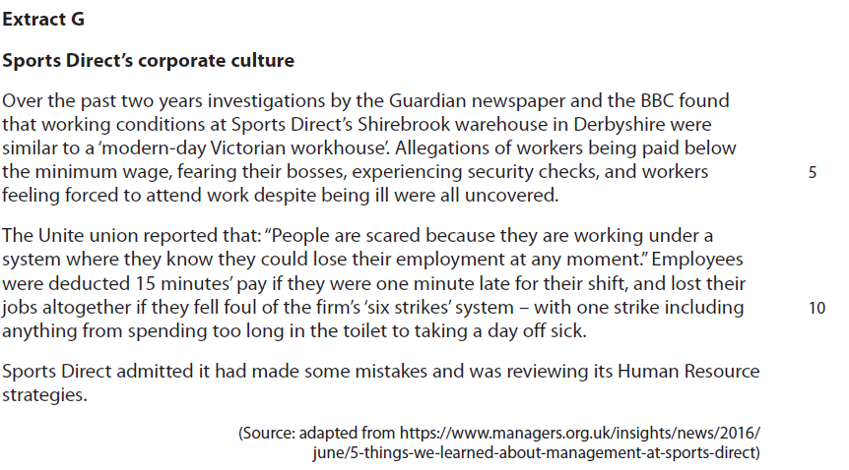

4 Explain **one** benefit Sports Direct could gain from conducting a SWOT analysis.

(4)

|  |  |  |
| --- | --- | --- |
| Question Number | Answer | Mark |
| **1** | **Knowledge 1, Application 2, Analysis 1**  **Knowledge: 1 mark for** understanding of mission statements e.g. a qualitative statement of an organisation’s aims.  **Application: up to 2 marks for** answers in the context of Morrisons, e.g. refers to   * Human, ethical and ecological values * We are one team * Not just focused on numbers * Competitors such as Lidl or Aldi   **Analysis: 1 mark for** answers that explain the benefit of a mission statement to Morrisons e.g.   * Customers may agree with its values and consequently prefer to shop there rather than at competitors * Motivational and sense of direction for employees. | **(4)** |

|  |  |  |
| --- | --- | --- |
| Question Number | Indicative content | Mark |
| **2** | **Knowledge 4, Application 4, Analysis 6, Evaluation 6**  **Arguments for producing own label ready meals for supermarkets**   * The ready meals market grew by 2% in volume and value in 2016 * Supermarket ‘own label’ ready meals have a combined market share of 68%, with Tesco owning 18% * Mumtaz already supplies Tesco, Asda and Morrisons * ‘own label’ ready meals can be used by supermarkets to meet a wide range of customer needs and specific tastes * Mumtaz has increased its production capacity enabling it to meet the potential increased demand from supermarkets * Increased demand may enable the business to benefit from economies of scale and higher levels of capacity utilisation, resulting in lower unit costs * Higher sales and lower unit costs may result in greater profitability and further expansion for Mumtaz Foods   **Arguments for selling more Mumtaz premium brand name products**   * There is a trend amongst consumers to prefer premium ready meals * It is predicted that future success may be for innovative new products – Mumtaz’s successful Halal baby food range proves that it is capable of developing successful new products * Ansoff would classify this strategy as market penetration, which carries the least risk * Porter would classify this strategy as ‘differentiation’ enabling Mumtaz to gain a competitive advantage through a USP of quality and authenticity * ‘Own label’ relies heavily on price discounts and promotional offers – focusing on selling Mumtaz products would avoid this and enable the business to charge higher prices   *Possible recommendations*   * Mumtaz should choose the option of supermarket ‘own label’ ready meals because supermarkets own 68% of the market. Supermarkets have a greater distribution |  |

|  |  |  |
| --- | --- | --- |
|  | which might therefore enable Mumtaz to sell more of their products and enable them to achieve the aim of becoming the UK’s market leader in Asian ready meals   * Mumtaz should choose to sell more Mumtaz premium brand name products because it is an established brand that is already growing rapidly in UK supermarkets and abroad. This strategy is less risky as it is not dependent on a few supermarkets and enables the business to maintain competitive advantage through differentiation   Example of possible ‘MOPS’ recommendations  **Market** – the market is the ready meals market. It is a growing market which is dominated by supermarket own brands.  Consequently, in order to achieve the aim of market leader, focusing on producing ‘own label’ ready meals would appear to be the best option.  **Objectives** – Mumtaz aims to be the market leader in Asian ready meals. It already has an established reputation for premium products and supplies the big supermarkets (e.g. Tesco 18%) with its own products. Consequently, selling more Mumtaz premium brand products would be the best option.  **Product** – Mumtaz is innovative e.g. the new Halal baby food range. The introduction of new product ranges is an important factor in driving sales. Retailers offer different recipes which enable them to meet a wide range of consumer tastes.  Consequently, the supermarket ‘own label’ option should be chosen because it offers Mumtaz more opportunities to sell a wider range of products enabling it to achieve its aim of becoming market leader.  **Situation** – Mumtaz is an expanding business with the ready meals part of the Group growing by 15-20% a year. It is also exporting to over 40 countries and planning to manufacture ready meals in Asia. Consequently, the best option would be to focus on premium brand products so they could establish Mumtaz as a global brand and achieve its aim of becoming market leader. | **(20)** |

|  |  |  |
| --- | --- | --- |
| Level | Mark | Descriptor |
|  | 0 | A completely inaccurate response. |
| Level 1 | 1–4 | Isolated elements of knowledge and understanding. Weak or no relevant application of business examples. An argument may be attempted, but will be generic and fail to connect cause(s) and/or consequence(s)/effect(s). |
| Level 2 | 5–8 | Elements of knowledge and understanding, which are applied to the business example.  Arguments and chains of reasoning are presented, but connections between cause(s) and/or consequence(s)/ effect(s) are incomplete. Attempts to address the question. A comparison or judgement may be attempted, but it will not successfully show an awareness of the key features of  business behaviour or business situation. |
| Level 3 | 9–14 | Accurate and thorough knowledge and understanding, supported throughout by relevant and effective use of the business behaviour/context.  Uses developed chains of reasoning, so that cause(s) and/or consequence(s)/effect(s) are complete, showing an understanding of the question. Arguments are well developed.  Quantitative or qualitative information is introduced in an attempt to support judgements, a partial awareness of the validity and/or significance of competing arguments and  may lead to a conclusion. |
| Level 4 | 15–20 | Accurate and thorough knowledge and understanding, supported throughout by use of relevant and effective use of the business behaviour/context.  Uses well-developed and logical, coherent chains of reasoning, showing a range of cause(s) and/or effect(s). Arguments are fully developed.  Quantitative and/or qualitative information is/are used well to support judgements. A full awareness of the validity and significance of competing arguments/factors, leading to balanced comparisons, judgements and an effective conclusion that proposes a solution and/or recommendation(s). |

|  |  |  |
| --- | --- | --- |
| Question Number | Indicative content | Mark |
| **3** | **Knowledge 4, Application 4, Analysis 6, Evaluation 6**  **Indicative content**   * Corporate objective is a goal that a business strives to achieve in order to meet its long term aim.   **New range of contact lenses – arguments for:**   * Warby Parker already have a good reputation for selling glasses at low prices – this may enable them to persuade customers to also buy contact lenses * Ansoff would classify this option as product development – it may enable Warby Parker to target new customers * Innovation in a new optical product, such as contact lenses, may be a source of distinctive capability and as a result may enhance its appeal/reputation amongst high income customers   **Sell glasses in the low income market – arguments for:**   * Warby Parker already has a distinctive capability as a result of its association with Sightsavers plus the fact that it designs its own glasses * The low income market has a size by volume of 4 billion people which therefore means more volume of sales potential. Ansoff would classify this option as market development * Warby Parker’s approach could be very suitable for the low income market because of its low prices and online availability   *Possible recommendations*   * The contact lens option could lead to a higher growth rate because Warby Parker has a trusted reputation for selling high quality products at a low price online, which it could apply to existing as well as new customers in the high income market * The low income market could lead to a higher growth rate because it enables Warby Parker to target a market of 4 billion people that is currently not served by other large optical businesses. Selling online may be more accessible to customers in this market However VisionSpring are already well established in this market | **(20)** |

**Market** – the market for glasses is divided into high income (high profit margin, low volume) and low income (low profit margin, high volume)

**Objectives –** Warby Parker’s main objective is to grow the business

**Product –** Warby Parker has a USP of offering low priced designer glasses that can be ordered online as well as promoting itself as an ethical business

**Situation –** Warby Parker has spotted and exploited successfully a niche in the market. It has developed a good reputation in the high income market

|  |  |  |
| --- | --- | --- |
| Question Number | Answer | Mark |
| **4** | **Knowledge 1, Application 2, Analysis 1**  **Knowledge/understanding: 1 mark** for a knowledge of SWOT, e.g. strengths/internal weaknesses/external opportunities/external threats  OR a benefit, e.g. enables the business to gain a better understanding of its internal strengths/internal weaknesses/external opportunities/external threats.  **Application: up to 2 marks** for:   * internal strength - Sports Direct generated sales revenue of £3.359.5 million in 2018. * internal weakness - Sports Direct lost £85 million as a result of its investment in Debenhams. * external opportunity - Buying House of Fraser provides an opportunity to transform it into ‘the Harrods of the High Street’. * external threat – Growth in online sales (growing at 10x the rate of physical store sales).   **Analysis: 1 mark** for:   * SWOT analysis is key to planning Sports Direct’s strategy for achieving its aim to be the ‘Selfridges of Sport’, because it can use its strengths to exploit opportunities. | **(4)** |