

Additional Assessment Materials

Pearson Edexcel GCE in A level Business

9BS0

Resource Set 3

3.3 Decision-making techniques

3.3.2 Investment appraisals

3.3.3 Decision trees

3.3.4 Critical path analysis

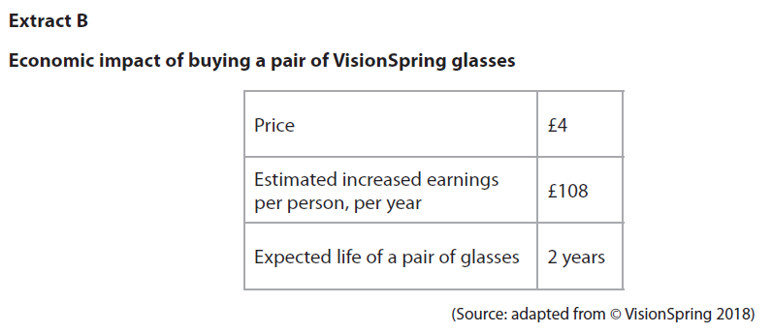**3.3.2 Investment appraisals**

For people in developing countries, purchasing a pair of VisionSpring glasses may be

considered as an investment.

1 Using the data in Extract B, calculate the average rate of return from purchasing a pair of glasses. You are advised to show your working.

(4)

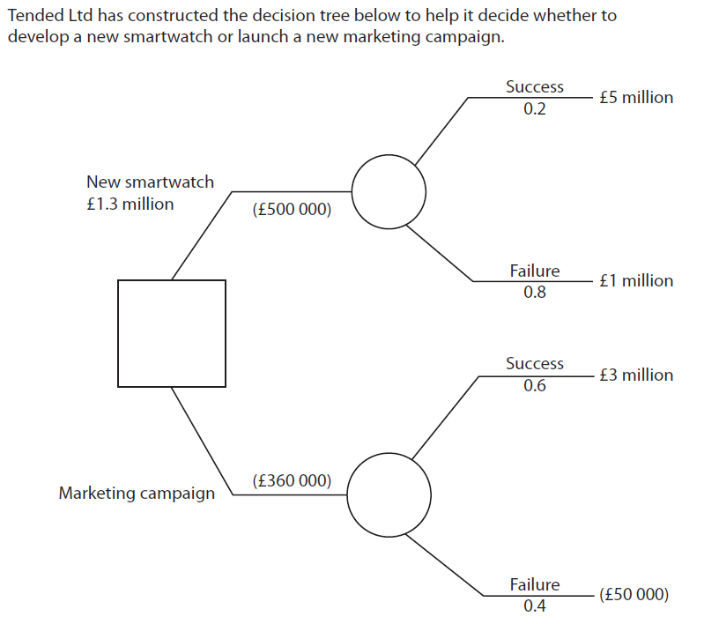**3.3.3 Decision trees**

The net gain for the new smartwatch is £1.3 million.

2 Using the data in the decision tree, calculate the net gain for the marketing campaign.

State your answer to two decimal places. You are advised to show your working.

(4)

**3.3.4 Critical path analysis**

Innocent Drinks has constructed the network diagram below to plan the launch of

a new line of smoothies. Each number represents how many days each activity is

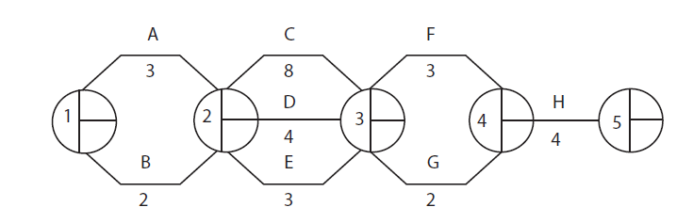estimated to take.

3 Using the data in the network diagram above, calculate the Earliest Start Times (EST) and Latest Finishing Times (LFT) for each activity and identify the critical path.

(4)

|  |  |  |
| --- | --- | --- |
| Question Number | Answer | Mark |
| **1** | **Knowledge 1, Application 3**  Quantitative skills assessed:  **QS1:** calculate, use and understand ratios, averages and fractions  **QS2:** calculate, use and understand percentages and percentage changes  **QS6:** calculate investment appraisal outcomes and interpret results  **Knowledge: 1 mark for** identifying the formula for calculating Average Rate of Return:  average annual return/initial cost x 100 (can be implied)  **Application: up to 3 marks for**   * Total return **=** 216 – 4 = 212 * Average annual return = 212/2 = 106 * ARR = 106/4 X 100 = 2650%   NB: if the only answer given is 2650% award 4 marks | **(4)** |

|  |  |  |
| --- | --- | --- |
| Question Number | Answer | Mark |
| **2** | **Knowledge 1, Application 3**  Quantitative skills assessed:  **QS3:** construct and interpret a range of standard graphical forms  **QS8:** use and interpret quantitative and non-quantitative information in order to make decisions  **Knowledge: 1 mark for** an understanding of net gain expected value – initial cost (this can be implied)  **Application: up to 3 marks for:**   * Marketing campaign: (0.6 x £3 million) = £1.8 million (0.4 x -£50,000) = - £20,000 * Expected value: £1.8 million - £20,000 = £1.78 million * Net gain: £1.78 million - £360,000 = £1.42 million   **NB:** Award 4 marks if candidate only states £1.42 m/1.42 million  Award only 3 marks if candidate only states £1.4 m/1.4 million | **(4)** |

|  |  |  |
| --- | --- | --- |
| Question Number | Answer | Mark |
| **3** | **Knowledge 1, Application 3**  Quantitative skills assessed:  **QS 3:** construct and interpret a range of standard graphical forms  **QS 8:** use and interpret quantitative and non quantitative information in order to make decisions  **Knowledge: 1 mark for** implicit understanding of network diagrams  E.g. at least 1 correct calculation of either EST or LFT  **Application: 3 marks for:**    Circle 1: top 0, bottom 0  Circle 2: top 3, bottom 3  Circle 3: top 11, bottom 11  Circle 4: top 14, bottom 14  Circle 5: top 18, bottom 18  (to be entered on a diagram)  **1 mark** for correct calculation of all ESTs for each node  **1 mark** for correct calculation of all LFTs for each node  **1 mark** for identification of critical path A, C, F and H | **(4)** |