

Additional Assessment Materials

Pearson Edexcel AS Level in Business (8BS0)

Resource Set 1.1: Meeting customer needs

(a) What is meant by market orientation?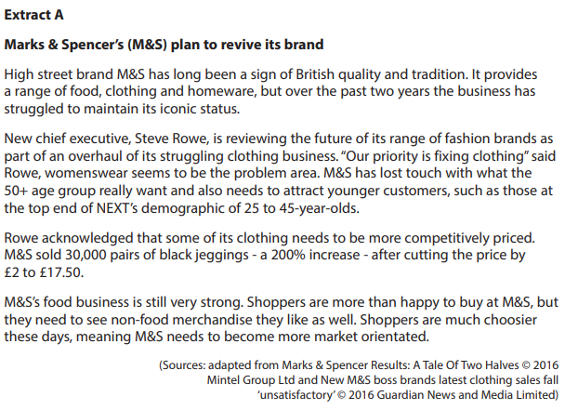 (2)

________________________________________________________________________________________________________________________________________________________________________________________________________________________________________________________________________________________________________________________________________________

(b) Construct a market map to illustrate the impact of M&S’s decision to aim its clothing range at a younger target market. (4)

________________________________________________________________________________________________________________________________________________________________________________________________________________________________________________________________________________________________________________________________________________

________________________________________________________________________________________________________________________________________________________________________________________________________________________________________________________________________________________________________________________________________________

1. (a) Explain how The Good Hotel’s social objectives could lead to an increase in added value.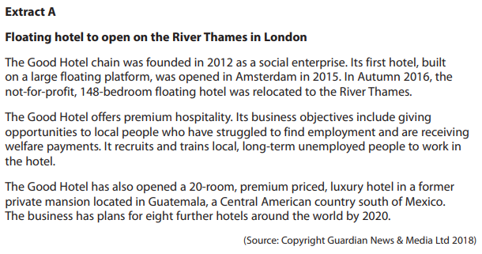 (4)

________________________________________________________________________________________________________________________________________________________________________________________________________________________________________________________________________________________________________________________________________________

________________________________________________________________________________________________________________________________________________________________________________________________________________________________________________________________________________________________________________________________________________

(b) Explain how The Good Hotel in Guatemala could benefit from operating in a niche market. (4)

________________________________________________________________________________________________________________________________________________________________________________________________________________________________________________________________________________________________________________________________________________

________________________________________________________________________________________________________________________________________________________________________________________________________________________________________________________________________________________________________________________________________________

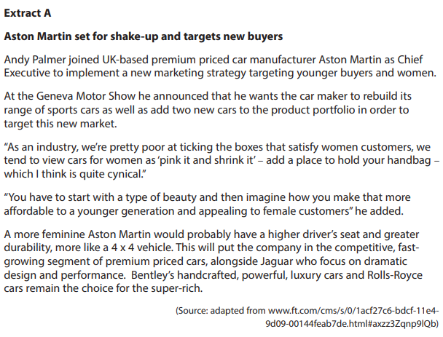

1. Explain how Aston Martin uses differentiation in the premium car market.

(4)

________________________________________________________________________________________________________________________________________________________________________________________________________________________________________________________________________________________________________________________________________________

________________________________________________________________________________________________________________________________________________________________________________________________________________________________________________________________________________________________________________________________________________

1. 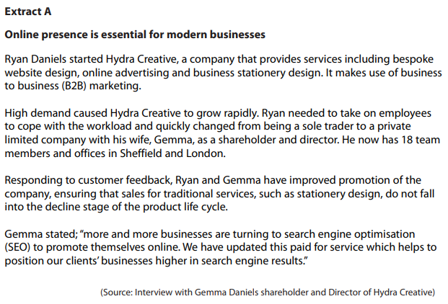Explain how market orientation could benefit Hydra Creative. (4)

________________________________________________________________________________________________________________________________________________________________________________________________________________________________________________________________________________________________________________________________________________

________________________________________________________________________________________________________________________________________________________________________________________________________________________________________________________________________________________________________________________________________________

1. 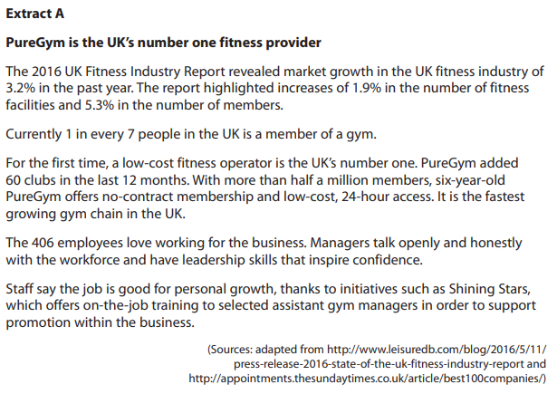(a) What is meant by market growth? (2)

________________________________________________________________________________________________________________________________________________________________________________________________________________________________________________________________________________________________________________________________________________

(b) Explain how PureGym has gained a competitive advantage in the fitness market. (4)

________________________________________________________________________________________________________________________________________________________________________________________________________________________________________________________________________________________________________________________________________________

________________________________________________________________________________________________________________________________________________________________________________________________________________________________________________________________________________________________________________________________________________

(c) Explain how the growth of the fitness market from 2015 to 2016 could have affected PureGym. (4)

________________________________________________________________________________________________________________________________________________________________________________________________________________________________________________________________________________________________________________________________________________

________________________________________________________________________________________________________________________________________________________________________________________________________________________________________________________________________________________________________________________________________________

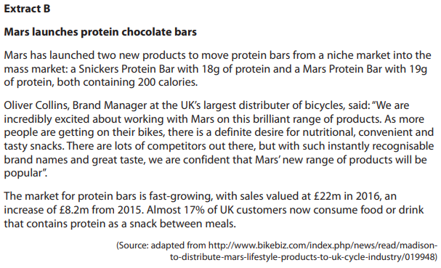

1. (a) What is meant by niche market? (2)

________________________________________________________________________________________________________________________________________________________________________________________________________________________________________________________________________________________________________________________________________________

In 2015 the protein food and drink market was worth £310m.

(b) Using the data in Extract B, calculate, to 2 decimal places, the market share of protein bars in the protein food and drink market for 2015. You are advised to show your workings. (4)

________________________________________________________________________________________________________________________________________________________________________________________________________________________________________________________________________________________________________________________________________________

________________________________________________________________________________________________________________________________________________________________________________________________________________________________________________________________________________________________________________________________________________

(c) Explain how Mars could research the protein bar market. (4)

________________________________________________________________________________________________________________________________________________________________________________________________________________________________________________________________________________________________________________________________________________

________________________________________________________________________________________________________________________________________________________________________________________________________________________________________________________________________________________________________________________________________________

(d) Assess the importance of adapting to market change for a business such as Mars. (10)

………………………………………………………………………………………………………………………………………………………………………………………………………………………………………………………………………………………………………………………………………………………………………………………………………………………………………………………………………………………………………………………………………………………………………………………………………………………………………………………………………………………………………………………………………………………………………………………………………………………………………………………………………………………………………………………………………………………………………………………………………………………………………………………………………………………………………………………………………………………………………………………………………………………………………………………………………………………………………………………………………………………………………………………………………………………………………………………………………………………………………………………………………………………………………………………………………………………………………………………………………………………………………………………………

……………………………………………………………………………………………………………………………………………………………………………………………………………………………………………………………………………………………………………………………………………………………………………………………………………………………………………………………………………………………………………………………………………………………………………………………………………………………………………………………………………………………………………………………………………………………………………………………………………………………………………………………………………………………………………………………………………………………………………………………………………………………………………………………………………………………………………………………………………………………………………………………………………………………………………………………………………………………………………………………………………………………………………………………………………………………………………………………………………………………………………………………………………………………………………………………………………………………………………………………………………………………………………………………..……………………………………………………………………………………………………………………………………………………………………………………………………………………………………………………………………………………………………………………………………………………………………………………………………………………………………………………………………………………………………………………………………………………………………………………………………………………………………………………………………………………………………………………………………………………………………………………………………………………………………………………………………………………………………………………………………………………………………………………………………………………………………………………………………………………………………………………………………………………………………………………………………………………………………………………………………………………………………………………………………………………………………………………………………………………………………………………………………………………………………………………………………………………………………………………………………………………………………………………………………………………………………………………………..……………………………………………………………………………………………………………………………………………………………………………………………………………………………………………………………………………………………………………………………………………………………………………………………………………………………………………………………………………………………………………………………………………………………………………………………………………………………………………………………………………………………………………………………………………………………………………………………………………………………………………………………………………………………………………………………………………………………………………………………………………………………………………………………………………………………………………………………………………………………………………………………………………………………………………………………………………………………………………………………………………………………………………………………………………………………………………………………………………………………………………………………………………………………………………………………………………………………………………………………………………………………………………………………..

**1(a)**

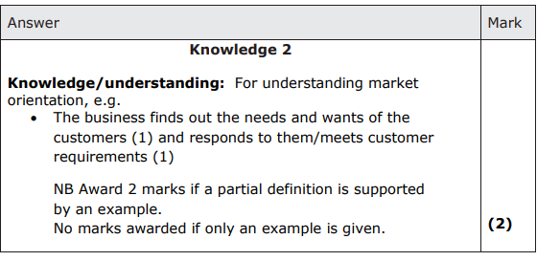

**1(b)**

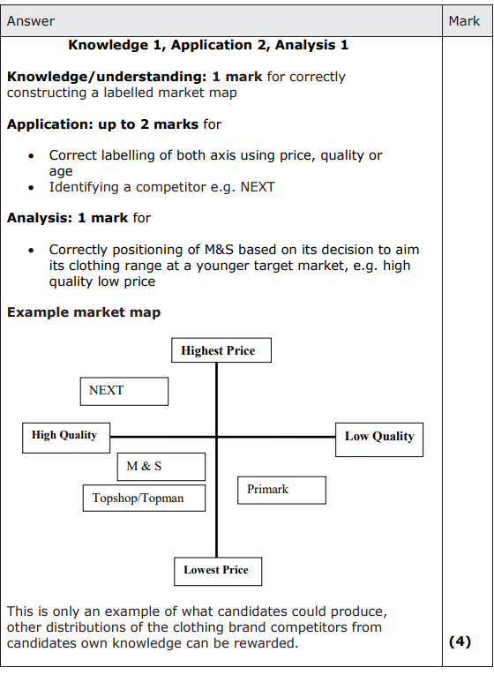

**2(a)**

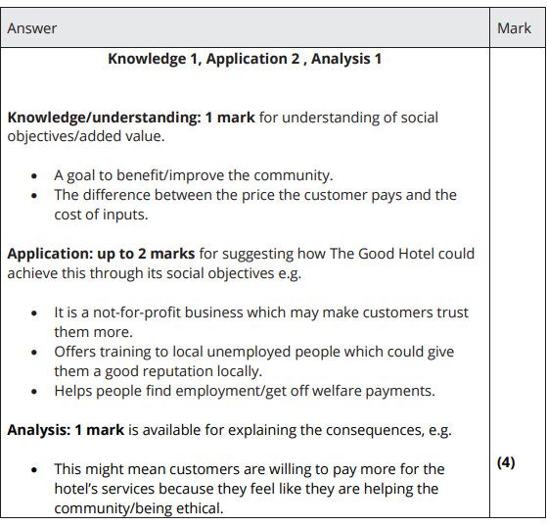

**2(b)**

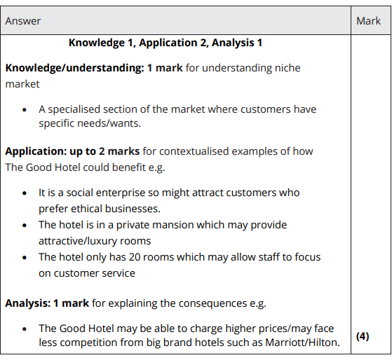

**3**

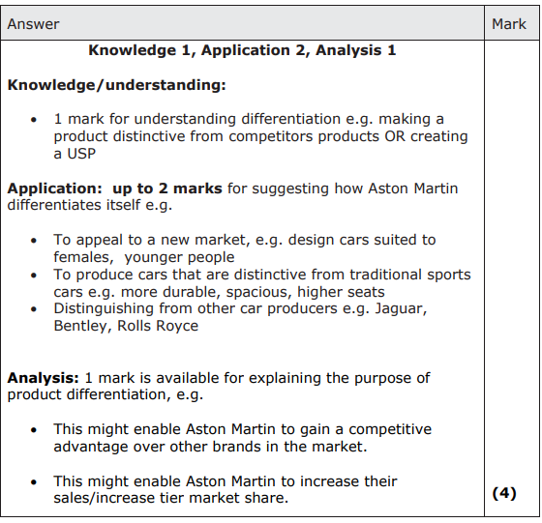

**4**

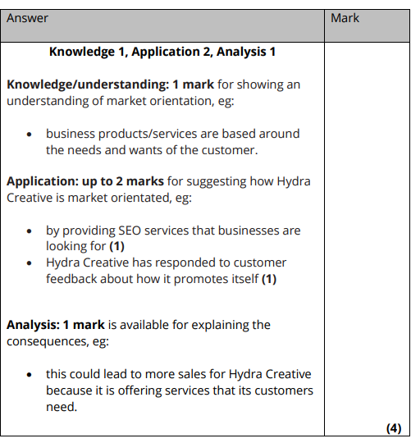

**5(a)**

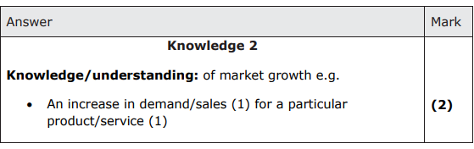

**5(b)**

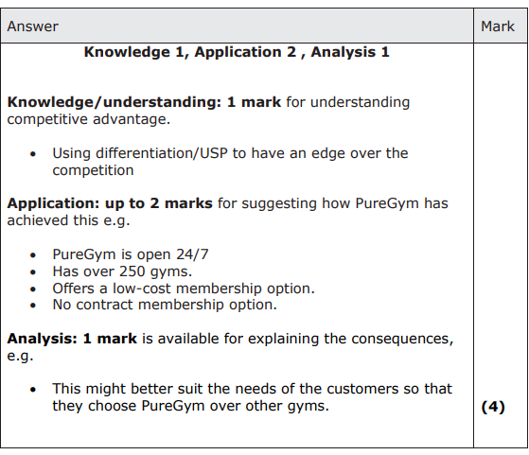

**5(c)**

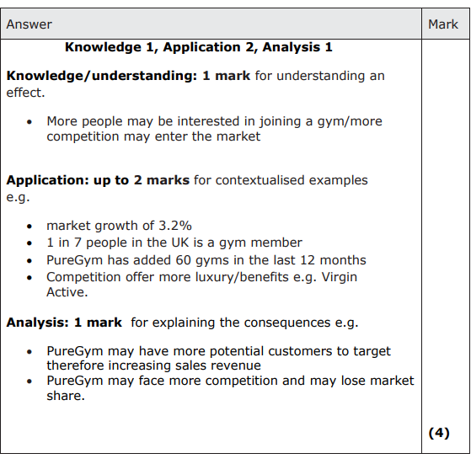

**6(a)**

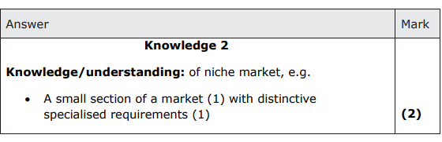

**6(b)**

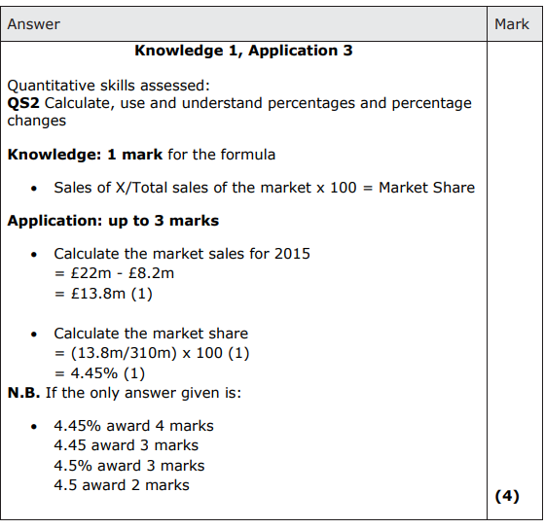

**6(c)**

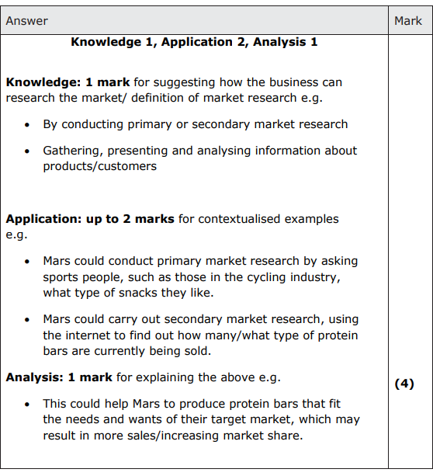

**6(d)**

