A-Level Graphic Communication Handbook

# Contents

Contents 2

Course details 3

Qualification 3

Specification 3

Entry Requirements 3

Calendar 3

Contact details 3

Organisation 4

Equipment 4

Assessment 5

External assessments 5

Grade boundaries 5

Internal assessments 6

Year 12 6

Year 13 6

5 hours in… Graphics 7

Supercurricular 8

Read 8

Watch 8

Listen 8

Compete 8

Online 8

Write like a Artist 9

Command words 9

Component 1- Portfolio 10

How to write your related study 10

Required Practical Activities 12

Component 2 – Externally Set Task 12

Specification 13

# Course details

## Qualification

OCR A-Level Graphic Communication

## Specification

## <https://www.ocr.org.uk/qualifications/as-and-a-level/art-and-design-h200-h600-from-2015/specification-at-a-glance/>

## Entry Requirements

* Grade 4 in GCSE English Language or GCSE English Literature, 5 in GCSE Maths
* Grade 4 in Art and Design, Graphics or Textiles at GCSE

## Calendar

|  |  |  |  |  |  |
| --- | --- | --- | --- | --- | --- |
| Half Term | Description of activity | AO1 | AO2 | AO3 | AO4 |
| Half Term 2  Sept – Oct | **Artist Research Sheets**  Risa Rodil, Zeka design, Mathew Reinheart, Duncan Birmingham  **Mind map** on ‘Pop-up Books’ with secondary images.  **Double Research Sheet** Chosen Theme/pop up/cards  **Double research Sheet** Traditional and Modern pop up books  **Triple research sheet on book formats:** Accordion Books, Carousel Books and Tunnel Books (with a theme)  **Artist Study 1 Risa Rodil** – Poster featuring lettering and 5-10 illustrations inspired by a quote linked to chosen theme. Lettering must be bespoke, and illustrations must include detail, tonal modelling, and depth. Composition must be sophisticated and complex. (Pen Tool, Layer Styles, Drawing Tablet)  **Review of Risa Rodil artist study** using 30 screenshots |  |  |  |  |
| Half term 3  Nov – Dec | **X3 Sculptural (abstract) pop-ups: Duncan Birmingham - Building Technique 5**  (Counter-Folds)  (arch and shapes)  (7 Bending Planes)  35 Photographs of each pop-up using backdrop and lighting (total 105) with brief annotations  **Artist Study 2 Zeka Design** – Poster. Digital composition with secondary images, typography, abstract shapes, patterns, layering, strokes, blend options, scanned transfer techniques and surface texture backgrounds. Composition must reflect the preferred popup format.  **Review of Zeka Design** (digital) artist study using screenshots and photographs of transfers & textures.  **ZEKA Design 90-degrees pop-up** – Print and present as a complex 90 degrees pop-up with engineering elements inspired by ‘Pocket Fairy Tales’ books. Photograph the making process (minimum 30 photos) and a further 35 of the completed pop-up. Present photographs. |  |  |  |  |
| Half term 4  Jan – March | **Pop up Book x 6 pages**  Research sheet on suitable fonts (linked to your theme)  Refine research on suitable fonts by exploring layer styles (linked to your theme)  **Triple research Sheet** At least three additional artists chosen for techniques/approaches (playing to strengths) or because their ideas are linked to your chosen theme. (Techniques must reflect a potential Grade B-A* at A-level and be transferable to upcoming design work) |  |  |  |  |
| Half term 5  Mar – April | **Business branding**  **3 x Artist studies** (imitation or pastiche)developing different techniques & approaches and using a range of appropriate media.  Present each study as a double page spread along with supporting research which includes: A stylistic title, concise bio, contextual analysis and images of the artist’s work.  X6 Mind-maps one for each double page (with secondary images) for Final Pop-up Book. You must make references to imagery and symbolism, typography, composition (shape/layout), aesthetics, target audience, colour, mediums, artists and influences.  • Choose an appropriate book format for your pop-up. In most instances this will be an accordion style. However, you can discuss an alternative format with your teacher.  • Use ‘secondary imagery’ or ‘quality sketching’ to produce 1 draft plan (dummy) of a POPUP BOOK with a front/back cover and 3-6 double spreads linked to your theme with either a 180/90 degrees pop-up or pull-tab/pivot mechanism on every page. Consider the theme, explore a range of materials, techniques and approaches, typography and digital designs. Make links to additional artists as required. Remember this will be a pop-up book with sculptural qualities. It may therefore be viewed as one long strip and/or may be double-sided.  • Write a critical reflection for your draft to clarify your intentions. |  |  |  |  |
| Half term 6  May - June | **Business Branding logos**  Development of ideas for logo – Name generation, shortlisting, questionnaire.  Further development of ideas and designing logos. Supported with logo research, detailed analysis.  Introduction to sketching logo concepts and refining/presenting logo variants.  Students will develop 3-6 logos using techniques and approaches identified from research/studies. |  |  |  |  |
| Half Term 1-2  July - Oct | **Business branding logos**  **Related Studies** |  |  |  |  |
| Half term 3  Nov - Dec | **Final outcomes and Presentation**  Development of final outcomes.  Refinement through drafting/reviewing.  Presentation of final outcomes in physical form (where applicable) and presentation boards showing creative journey in relation to research, development and outcome. |  |  |  |  |
| Half Term 4  Jan - Feb | **Externally Set Task**  Introduction to Externally Set Task. Students choose from 2-3 shortlisted themes from the paper and gather artist research and research related to theme. Statement of intent to clarify intentions.  Development of good approaches to recording primary photography linked to the theme.  Presenting primary photographs or collection of documents, objects etc.  Development of techniques and approaches through 2-3 composition studies/imitations/pastiches of 3 chosen artists using a range of mediums.  Artist study review sheets using 30 screenshots.  Primary photographs from relevant visits/trips to generate further research. |  |  |  |  |
| Half term 5  March - April | **Externally Set task**  Introduction to Externally Set Task. Students choose from 2-3 shortlisted themes from the paper and gather artist research and research related to theme. Statement of intent to clarify intentions.  Development of good approaches to recording primary photography linked to the theme.  Presenting primary photographs or collection of documents, objects etc.  Development of techniques and approaches through 2-3 composition studies/imitations/pastiches of 3 chosen artists using a range of mediums.  Artist study review sheets using 30 screenshots.  Primary photographs from relevant visits/trips to generate further research. |  |  |  |  |

## Contact details

Head of Art: Talib Hussain Thussain01@beckfoot.org

A-Level Fine Art teacher: Sarah Davis Sdavis01@beckfoot.org

A-Level Graphics teacher: Lisa Clayton Lclayton01@becfoot.org

A-Level Graphics and Fine Art teacher: Rob Sandercock Rsandercock01@beckfoot.org

# Organisation

You are expected to maintain a well-organised folder, which will be checked by a teacher once per half-term. You must use file dividers, and should contain the following sections:

1. Course documents
   1. Specification (need to know)
   2. Teaching plan
   3. Learning outcome checklist
2. Independent learning
   1. 5 hours in… guidance and templates
   2. Independent learning
3. Transition work

# Overview

• Learners should be able to explore, research and acquire techniques and develop their skills, knowledge and understanding in a range of media specific to Graphic Communication.

• Learners should explore relevant images, text, design and resources relating to Graphic Communication. Learners may use traditional methods such as drawing, printing and/or digital techniques to produce graphic images.

• Learners in Graphic Communication are expected to demonstrate specialisations in particular materials, media or processes to allow for an appropriate depth of study. This can be achieved by working toward the extension and development of particular themes, ideas or issues.

• Drawing skills should be understood and developed as appropriate to the ways of recording and communicating intentions, ideas and emotions in the context of Graphic Communication.

# Areas Of Study

# Learners are required to work in one or more area(s) of Graphic Communication, such as those listed below. Combinations of these areas are also possible:

# • image and typography

# • illustration

# • advertising

# • layout design

# • packaging

# • editorial design

# • experimental imagery

# • signage

# • abstract approaches.

# Techniques The following are some of the techniques available to learners in Graphic Communication: image editing, digital manipulation, layout, presentational and editorial techniques, printing, mark making, collage and construction.

# Skills

# Learners will be expected to demonstrate skills as defined in the Art and Design Core Content section of this specification, in the context of their chosen area(s) of Graphic Communications. In addition, learners will be required to demonstrate skills in all of following:

# • applying and using composition in Graphic Communication

# • understanding and application of scale appropriate to the chosen work and direction relevant to learners’ intentions

# • understanding and applying formal elements such as colour, tone, texture, shape and form in relation to Graphic Communication

# • selecting, editing, and highlighting Graphic Communications imagery and text

# • using appropriate visual language and terminology within Graphic Communication

• manipulating imagery • understanding and using relevant conventions and genres in Graphic Communication.

# Knowledge And Understanding

Learners must use an appropriate range of processes and techniques using traditional and/or digital media, appropriate to the chosen subject area, enabling research, exploration and the creation of the final outcome(s). Learners will build and evidence an understanding of:

• relevant technologies, materials, processes and resources

• continuity and change in different genres, styles and traditions relevant to Graphic Communication and the chosen areas of study within this specialism

• how ideas, feelings and meanings can be conveyed and interpreted in images and artefacts

• how images and artefacts relate to the time and place in which they were made and to their social and cultural context

• a working vocabulary and specialist terminology which are relevant to their chosen area(s) of study.

# Assessment

A-Level Fine Art is a linear course, and you will sit an external exam at the end of Year 13. This will take the form of a 15-hour practical exam.

**Component 01: Personal investigation**

Learners must produce two elements in response to a centre- or learner-set starting point, brief, scenario or stimulus: a portfolio of practical work and a related study. This component is a non exam assessment. It is internally marked and externally moderated using the marking criteria in. This component is marked out of 120 marks and contributes 60% to the overall weighting of OCR’s Art and Design A Level.

**Element 2: Related study**

Learners are required to establish through this written and, where appropriate, illustrated component, the

related context in which their chosen practical portfolio exists.

This may be established by exploring the genre, subject matter, movement or historical framework of the

overarching starting point, course of study or theme selected.

The aim of the related study is to enable learners to develop their ability to communicate their knowledge

and understanding of art historical movements, genres, practitioners and artworks, considering the way that

these change and evolve within chronological and other frameworks. It also builds their understanding

of the relationship between society and art: art historical terms, concepts and issues; methods of

researching, investigating and analysing; and how works are interpreted and evaluated.

The related study should be separate and clearly identifiable from the contextual research embedded

in the development of the practical portfolio. Learners should also highlight their own work and clearly

distinguish it from collected or transposed material. Learners may produce the related study in an

appropriate form of which the following are some examples: an illustrated essay, digital presentation/

blog, illustrated study sheets or written report. It is a requirement of the related study that all source

material and research are listed and acknowledged in a bibliography and should be clearly identifiable in the

work presented for assessment.

**Component 02: Externally set task**

For this component, an early release paper will be despatched to centres based on estimated entries

made and will also be available on the OCR website from 1 February.

This paper can be given to learners at the discretion of centres any time on or after 1 February in the

year of certification. Centres may determine the amount of time for preparatory study prior to learners

undertaking their 15-hour supervised period. The paper will give learners a choice of seven themes,

each with a choice of written and/or visual starting points, briefs or stimuli. From this paper, learners

are expected to choose one option for which they will generate an appropriate personal response for

assessment.

**Planning and preparation**

The amount of time given to learners for the preparation period should be determined by centres.

Learners must be given a preparatory period during which they will research, plan and develop ideas for

their own response to the option they have chosen. During this preparatory period teachers may give

limited guidance. Guidance should be given to learners about availability and choice of materials, health and

safety, avoidance of plagiarism and completion of work in accordance with specification requirements and

procedures. However, it should be remembered that learners are required to reach their own judgements

and conclusions and must work independently to produce their own personal response.

All work must be completed by the designated finishing time set by the centre. Dates and deadlines

for preparatory work and the 15-hour supervised time must be set by centres to facilitate the

completion of marking and internal standardisation by the OCR-set deadline.

Learners can continue to work on their preparatory work until the first period of supervised time

commences. Learners must refer to their preparatory work during the supervised 15-hour period.

Preparatory work should not be amended or developed further during or after the timetable 15

hours supervised time. No additional work should be brought into the supervised sessions. Preparatory

work and outcome(s) should be kept under secure conditions at all times when not in use and once the

supervised period is completed.

**Realising intentions**

Learners will have up to fifteen hours in which to independently realise their response(s). The 15-hour

supervised time can be divided into several sessions and timetabled to suit the centre. At least

one session should be at least 2–3 hours in duration.

**Examinations**

Learners are required to provide evidence of all assessment objectives in response to their chosen

starting point, brief or stimulus, within the 15-hour supervised period. It is expected that during

the supervised period, learners will realise their intentions to an outcome(s).

All selected work produced for the component, including the research, planning and development

work produced in the preparatory period, must be submitted for assessment

**Assessment objectives (AO)**

There are four assessment objectives in OCR’s A Level in Art and Design.

These are detailed in the table below.

Learners are expected to demonstrate their ability to:

**AO1 Develop** ideas through sustained and focused investigations informed by contextual and other

sources, demonstrating analytical and critical understanding.

**AO2 Explore** and select appropriate resources, media, materials, techniques and processes,

reviewing and refining ideas as work develops.

**AO3 Record** ideas, observations and insights relevant to intentions, reflecting critically on work and

progress.

**AO4 Present** a personal and meaningful response that realises intentions and, where appropriate,

makes connections between visual and other elements.

## Grade boundaries

|  |  |  |
| --- | --- | --- |
| **A-level OCR Grade Boundaries 2023 Component 1** | | |
| **Grade** | **Overall mark out of 120 (Min)** | **Per Assessment Objective out of 24 (Min)** |
| **A\*** | **114**/120 | **23**/24 |
| **A** | **107**/120 | **22**/24 |
| **B** | **92**/120 | **19**/24 |
| **C** | **77**/120 | **16**/24 |
| **D** | **62**/120 | **13**/24 |
| **E** | **47**/120 | **10**/24 |
| **U** | **0**/120 | **0**/24 |

|  |  |  |
| --- | --- | --- |
| **A-level OCR Grade Boundaries 2023**  **Component 2** | | |
| **Grade** | **Overall mark out of 80 (Min)** | **Per Assessment Objective out of 20 (Min)** |
| **A\*** | **76**/80 | **19**/20 |
| **A** | **72**/80 | **18**/20 |
| **B** | **62**/80 | **16**/20 |
| **C** | **52**/80 | **13**/20 |
| **D** | **43**/80 | **11**/20 |
| **E** | **34**/80 | **9**/20 |
| **U** | **0**/80 | **0**/20 |

## Internal assessments

You will have weekly deadlines set by your Art teachers who will record expectations on your weekly review document.

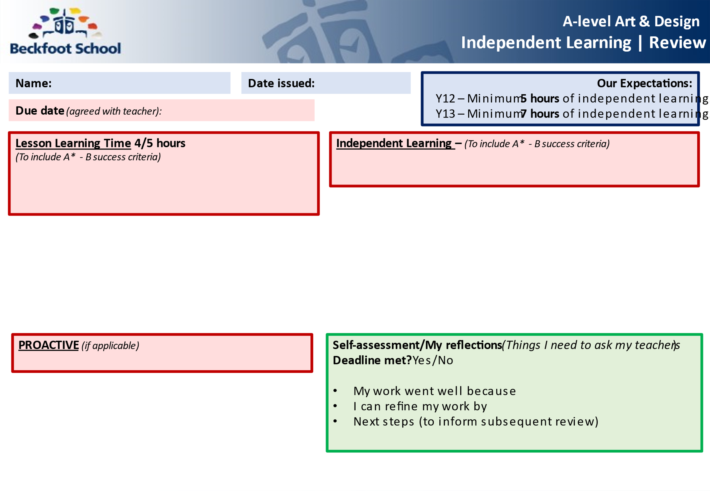

**5/7 hours in…Graphic Communication**

Research shows that the most successful students (i.e. those that make the most progress and get the highest grades) are doing between 20 and 25 hours of independent study per week by the end of Year 13. That may seem a lot, but it’s something that you would build up to over the course of your A-Levels. In Year 12, we’re talking something more like 15 hours per week. This equates to roughly 5 hours of independent study per A-Level per subject.

Independent study can be divided into three types – Consolidation, Reactive and Proactive.

**Consolidation**

The evening following an Graphics lesson, you should spend 12-15 minutes (24-30 minutes for a double) rereading your weekly review.

**Reactive**

This is your ’homework’. Each of your Graphics teachers should give you at least 2 hours’ worth of homework each week. If they don’t – ask them for some! If you find this takes more than 2 hours, that’s fine, you can take this from the proactive phase (not from the consolidation phase though). Equally, if you find you finish your reactive work quickly, spend more time on your proactive work.

**Proactive**

This is the section that will broaden and deepen your overall understanding of the subject you are studying. It will not necessarily involve work that has been set by your teacher, but instead it is about you doing the extra practice of techniques and skills, reading articles, watching videos, visiting exhibitions etc. This might contain some of the following:

* The shock of the New
* The 20th century Art book
* [Gardner's Art Through the Ages](https://mymodernmet.com/best-art-history-books/#Gardners_Art_Through_the_Ages)
* [The Art Book](https://mymodernmet.com/best-art-history-books/#The_Art_Book)
* [The Collins Big Book of Art: From Cave Art to Pop Art](https://mymodernmet.com/best-art-history-books/#The_Collins_Big_Book_of_Art_From_Cave_Art_to_Pop_Art)
* [50 Artists You Should Know](https://mymodernmet.com/best-art-history-books/#50_Artists_You_Should_Know)
* [The Story of Art](https://mymodernmet.com/best-art-history-books/#The_Story_of_Art)
* [Ways of Seeing](https://mymodernmet.com/best-art-history-books/#Ways_of_Seeing)
* [The Lives of the Artists](https://mymodernmet.com/best-art-history-books/#The_Lives_of_the_Artists)
* [Styles, Schools and Movements: The Essential Encyclopaedic Guide to Modern Art](https://mymodernmet.com/best-art-history-books/#Styles_Schools_and_Movements_The_Essential_Encyclopaedic_Guide_to_Modern_Art)
* [The Duchamp Dictionary](https://mymodernmet.com/best-art-history-books/#The_Duchamp_Dictionary)
* [Show Time: The 50 Most Influential Exhibitions of Contemporary Art](https://mymodernmet.com/best-art-history-books/#Show_Time_The_50_Most_Influential_Exhibitions_of_Contemporary_Art)
* Designing Brand Identity by Alina Wheeler
* Type: A Visual History of Typefaces and Graphic Styles by Cees W De Jong
* Stationary Design Now! By Julius Wiedemann

# Super curricular

## Read

See above

## Watch

* <https://www.youtube.com/watch?v=OXc-VZ4Vwbo>
* https://www.youtube.com/watch?v=C_RzDqgGcao
* <https://www.youtube.com/watch?v=VlUikQ7OvgM&list=PLllFqBuTM0WKIzw-SArdjwLAdTsR9YIIX>
* <https://www.youtube.com/watch?v=6lHB8Cesj0k&list=PLllFqBuTM0WKIzw-SArdjwLAdTsR9YIIX&index=2>
* <https://www.youtube.com/watch?v=Relm8ykxoME&list=PLllFqBuTM0WKIzw-SArdjwLAdTsR9YIIX&index=4>
* <https://www.youtube.com/watch?v=Y6dWEiFrfow&list=PLllFqBuTM0WKIzw-SArdjwLAdTsR9YIIX&index=13>
* <https://www.youtube.com/watch?v=LTPEu1N_JT8&list=PLllFqBuTM0WKIzw-SArdjwLAdTsR9YIIX&index=27>
* <https://www.youtube.com/watch?v=-19z_ldzPes>
* <https://www.youtube.com/watch?v=DPSs1IxiDsM&list=PL9pkETrdJ0rb-BsDHwE0gmsj0duEXqbQ3>

## Visit

* Leeds city Art gallery
* Yorkshire sculpture park
* Bradford Industrial Museum
* Cartwright Hall Art Gallery
* Henry Moore Institute
* The Hepworth Museum

# Write like an Artist

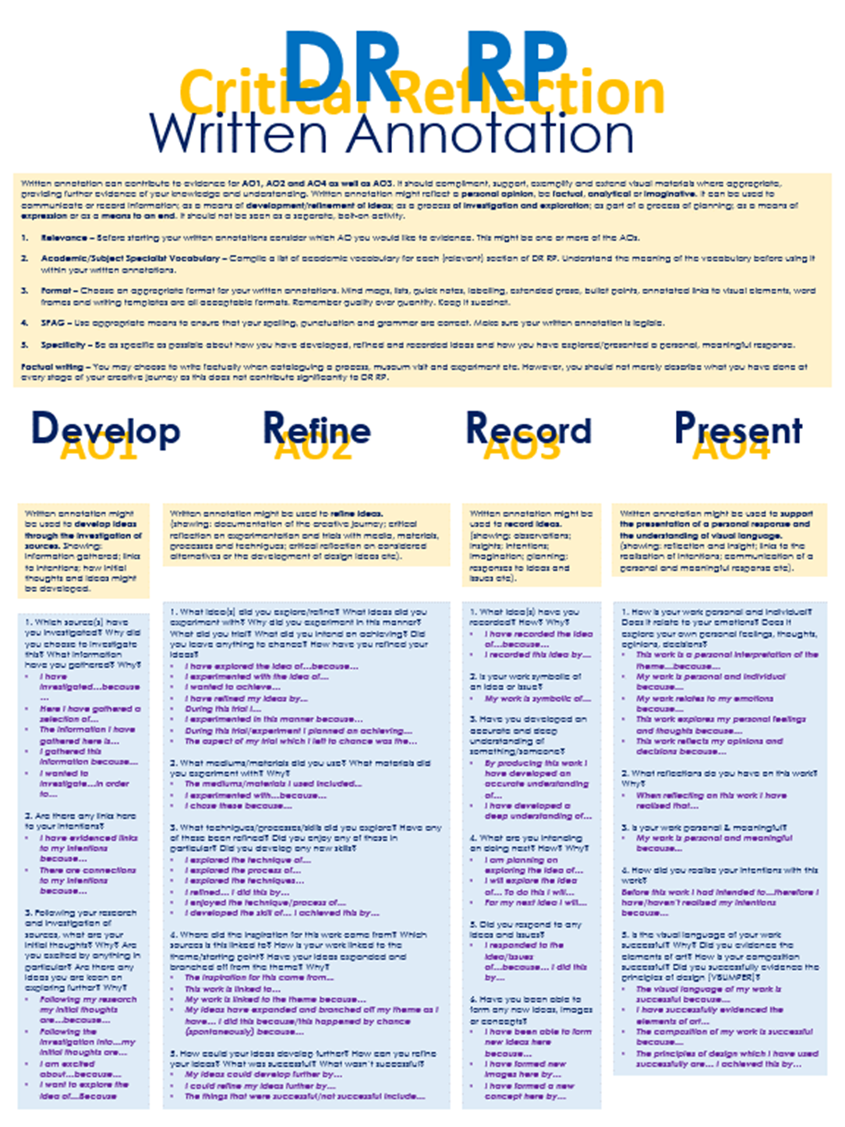

## Command words

Analyse Interpret data to arrive at a conclusion.

Annotate to add notes or remarks to text or an image.

Comment Present an informed opinion.

Compare Identify similarities and/or differences.

Complete Finish a task by adding to given information.

Define Specify meaning.

Describe Set out characteristics/qualities.

Design Set out how something will be done.

Draw Produce an observational drawing.

Evaluate Judge from available evidence or against success criteria.

Explain Set out purposes or reasons.

Identify Name or otherwise characterise.

Justify Support a case with evidence.

Outline Set out main characteristics.

Reflect Critically reflect on progress and success.

Show Provide structured evidence to reach a conclusion.

Sketch Draw approximately.

Gradient  Two or more hues flowing into one another, creating a gradual blend of colour.

# Related Study

# How to write your related study

* **Topic/Title/Question/Quote – *Formulated by your teacher and agreed with you. Will be linked to your coursework.***​
* **Context (1000-2000 words approx.)**​
* **Contextual analysis (200 words approx.)**​
* **Conclusion (200 words approx.)** ​
* **Intention/introduction (200 words approx.)**​
* **Bibliography - This includes all source material used.** ​

t