

Additional Assessment Materials

Summer 2021

Pearson Edexcel AS Level in Business (8BS0)

Resource Set 2.3: Managing finance

# **Pearson: helping people progress, everywhere**

Pearson aspires to be the world’s leading learning company. Our aim is to help everyone progress in their lives through education. We believe in every kind of learning, for all kinds of people, wherever they are in the world. We’ve been involved in education for over 150 years, and by working across 70 countries, in 100 languages, we have built an international reputation for our commitment to high standards and raising achievement through innovation in education. Find out more about how we can help you and your students at: [www.pearson.com/uk](http://www.pearson.com/uk)

Additional Assessment Materials, Summer 2021

All the material in this publication is copyright

© Pearson Education Ltd 2021

**General guidance to Additional Assessment Materials for use in 2021**

**Context**

* Additional Assessment Materials are being produced for GCSE, AS and A levels (with the exception of Art and Design).
* The Additional Assessment materials presented in this booklet are an **optional** part of the range of evidence you may use when deciding on a candidate’s grade.
* 2021 Additional Assessment Materials have been drawn from previous examination materials, namely past papers.
* Additional Assessment Materials have come from past papers both published (those materials available publicly) and unpublished (those currently under padlock to our centres) presented in a different format to allow you to adapt them to use with your candidates.

**Purpose**

* The purpose of this resource to provide qualification-specific sets/groups of questions covering the knowledge, skills and understanding relevant to this Pearson qualification.
* This document should be used in conjunction with the mapping guidance which will map content and/or skills covered within each set of questions. The mapping guidance will also highlight where the question originally came from to allow you to access further support materials (mark schemes, examiner reports).
* Use of these assessment materials will assist you in assessing candidates’ current performance in areas not assessed elsewhere. Their use will also provide an extra opportunity for candidates to demonstrate their performance at the end of their course of study.
* Specific guidance relating to this selection of material for this subject is detailed below.
* These materials are only intended to support the summer 2021 series.

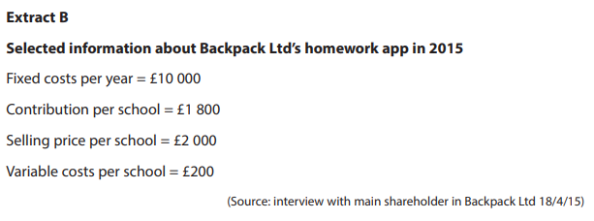

1. Using the data in Extract B, and assuming a sales volume of 20 schools in 2015, calculate Backpack Ltd’s likely profit. You are advised to show your working.

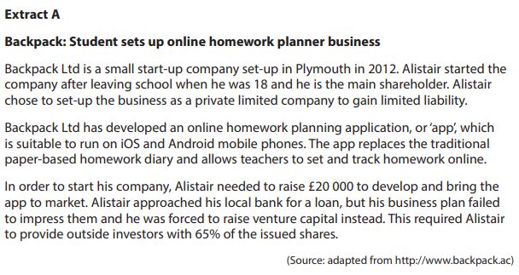 (4)

________________________________________________________________________________________________________________________________________________________________________________________________________________________________________________________________________________________________________________________________________________

________________________________________________________________________________________________________________________________________________________________________________________________________________________________________________________________________________________________________________________________________________

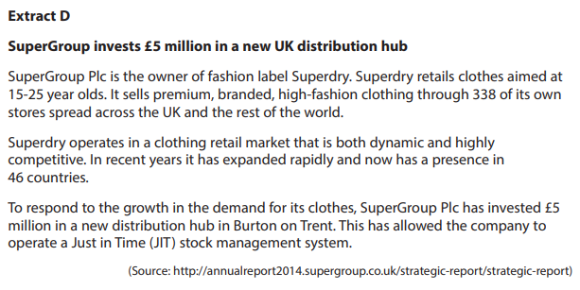

1. (a) What is meant by current liabilities?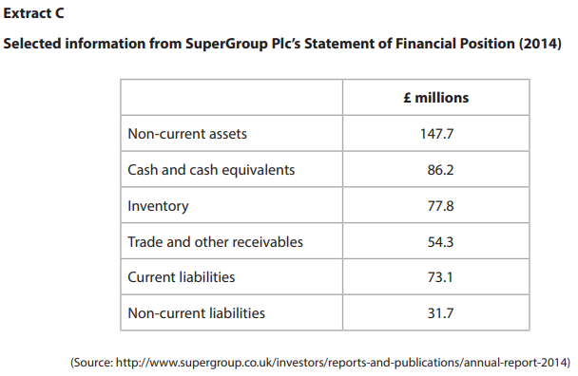 (2)

________________________________________________________________________________________________________________________________________________________________________________________________________________________________________________________________________________________________________________________________________________

(b) Give **two** examples of non-current assets that a business may have on its Statement of Financial Position. (2)

________________________________________________________________________________________________________________________________________________________________________________________________________________________________________________________________________________________________________________________________________________

(c) Using the data in Extract C, calculate the current ratio for SuperGroup Plc in 2014. You are advised to show your working. (2)

________________________________________________________________________________________________________________________________________________________________________________________________________________________________________________________________________________________________________________________________________________

(d) Explain how poor management of its working capital might affect SuperGroup Plc. (4)

________________________________________________________________________________________________________________________________________________________________________________________________________________________________________________________________________________________________________________________________________________

________________________________________________________________________________________________________________________________________________________________________________________________________________________________________________________________________________________________________________________________________________

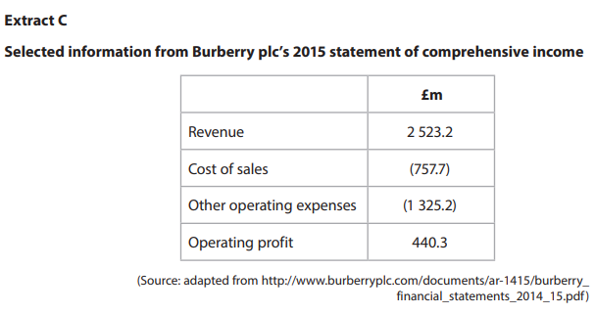

1. Using the data in Extract C, calculate Burberry plc’s gross profit margin to 2 decimal places (2 d.p). You are advised to show your working. (4)

________________________________________________________________________________________________________________________________________________________________________________________________________________________________________________________________________________________________________________________________________________

________________________________________________________________________________________________________________________________________________________________________________________________________________________________________________________________________________________________________________________________________________

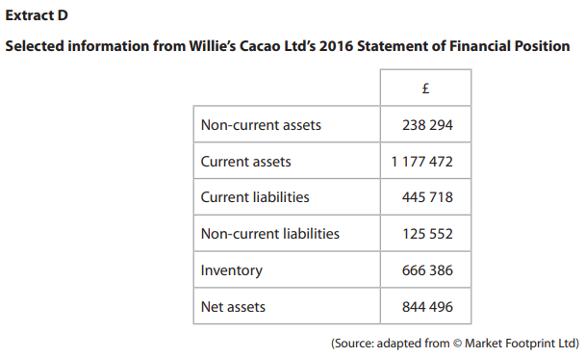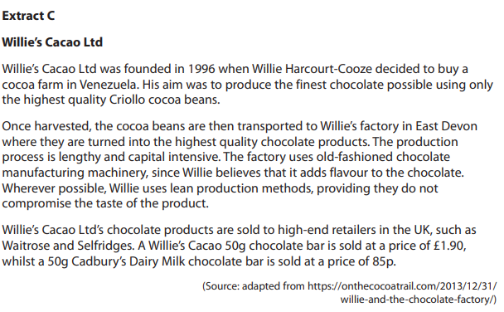

1. (a) Give **two** examples of current assets. (2)

________________________________________________________________________________________________________________________________________________________________________________________________________________________________________________________________________________________________________________________________________________

(b) Using the data in Extract D, calculate, to 2 decimal places, the acid test ratio for Willie’s Cacao Ltd in 2016. You are advised to show your working.

(4)

________________________________________________________________________________________________________________________________________________________________________________________________________________________________________________________________________________________________________________________________________________

________________________________________________________________________________________________________________________________________________________________________________________________________________________________________________________________________________________________________________________________________________

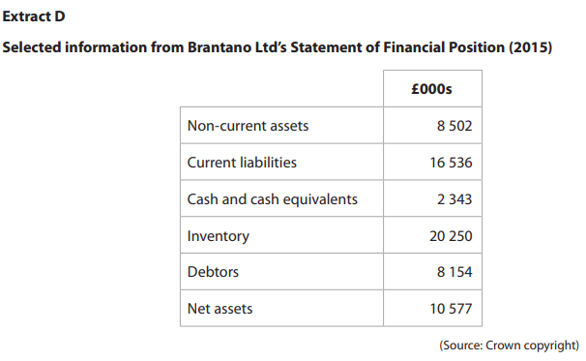

1. 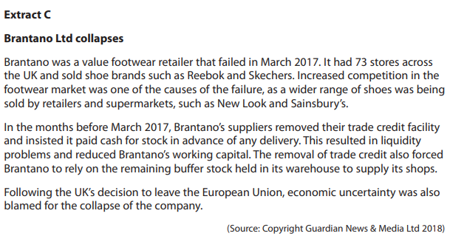(a) What is meant by working capital? (2)

________________________________________________________________________________________________________________________________________________________________________________________________________________________________________________________________________________________________________________________________________________

(b) Explain the distinction between Brantano Ltd’s cash and its profit. (4)

________________________________________________________________________________________________________________________________________________________________________________________________________________________________________________________________________________________________________________________________________________

________________________________________________________________________________________________________________________________________________________________________________________________________________________________________________________________________________________________________________________________________________

(c) Using the data in Extract D, calculate, to 2 decimal places, the current ratio for Brantano Ltd. You are advised to show your working. (4)

________________________________________________________________________________________________________________________________________________________________________________________________________________________________________________________________________________________________________________________________________________

________________________________________________________________________________________________________________________________________________________________________________________________________________________________________________________________________________________________________________________________________________

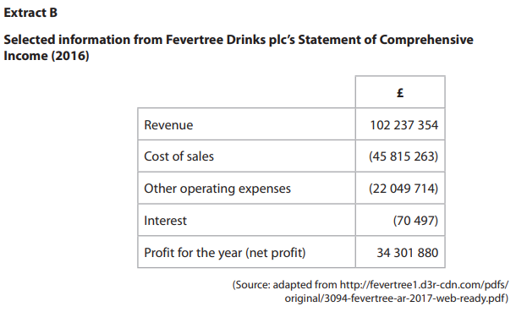

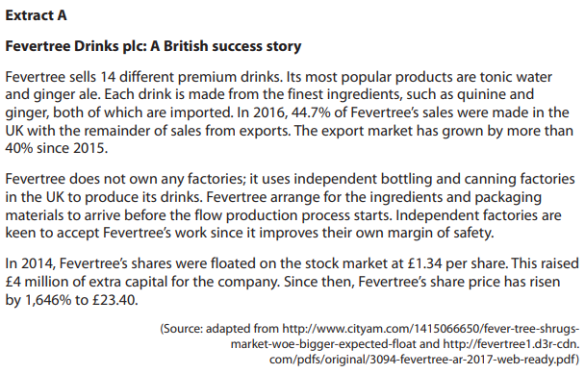

1. (a) Using the information in Extract B, calculate the operating profit for Fevertree Drinks plc in 2016. You are advised to show your working. (4)

________________________________________________________________________________________________________________________________________________________________________________________________________________________________________________________________________________________________________________________________________________

________________________________________________________________________________________________________________________________________________________________________________________________________________________________________________________________________________________________________________________________________________

(b) Using the information in Extract B, calculate, to 2 decimal places, the profit for the year (net profit) margin for Fevertree Drinks plc in 2016. You are advised to show your working. (4)

________________________________________________________________________________________________________________________________________________________________________________________________________________________________________________________________________________________________________________________________________________

________________________________________________________________________________________________________________________________________________________________________________________________________________________________________________________________________________________________________________________________________________

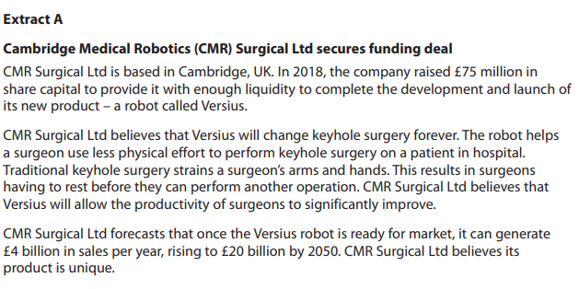

1. 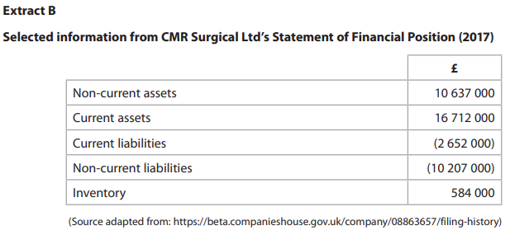(a) Using the information in Extract B, calculate the net assets of CMR Surgical Ltd in 2017. You are advised to show your working. (4)

________________________________________________________________________________________________________________________________________________________________________________________________________________________________________________________________________________________________________________________________________________

________________________________________________________________________________________________________________________________________________________________________________________________________________________________________________________________________________________________________________________________________________

(b) Using the information in Extract B, calculate the acid test ratio, to 2 decimal places, for CMR Surgical Ltd in 2017. You are advised to show your working.

(4)

________________________________________________________________________________________________________________________________________________________________________________________________________________________________________________________________________________________________________________________________________________

________________________________________________________________________________________________________________________________________________________________________________________________________________________________________________________________________________________________________________________________________________

(c) Assess how important CMR Surgical Ltd’s liquidity is to the successful development of its new product. (10)

1. Assess the extent to which rising costs of raw materials may have led to the failure of JE Wilson & Sons Ltd. 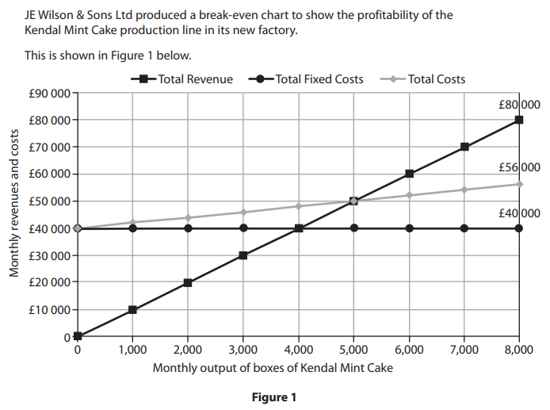 (10)

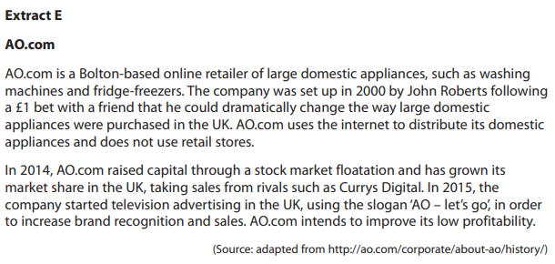

In order to increase its profits, AO.com could either sell a wider range of products through the internet or improve its branding.

1. Evaluate these **two** options and recommend which option AO.com should use to increase its profits. (20)
2. To increase its profits, Tesco could use competitive pricing or increase the amount of innovation within its stores.

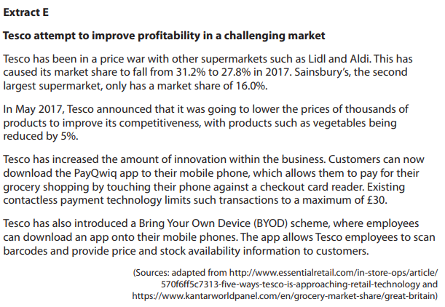Evaluate these **two** options and recommend which option Tesco should use to improve its profits. (20)

**1**

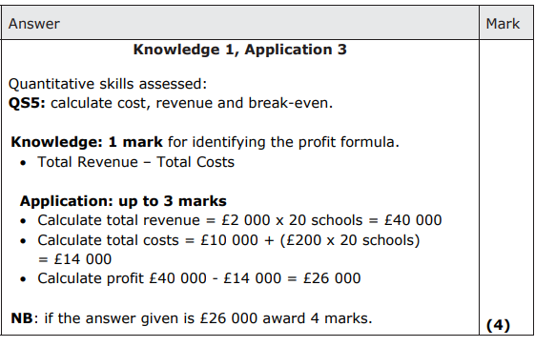

**2(a)**

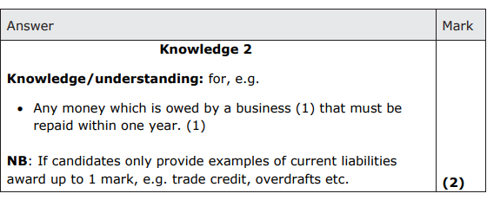

**2(b)**

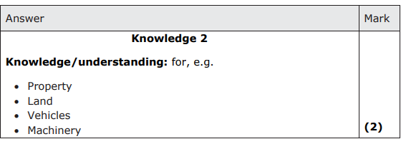

**2(c)**

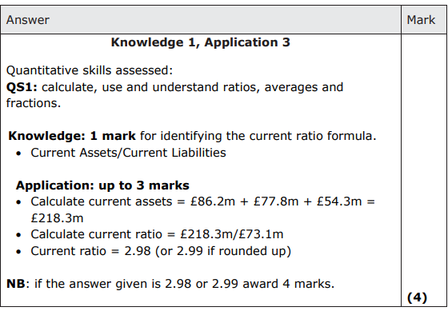

**2(d)**

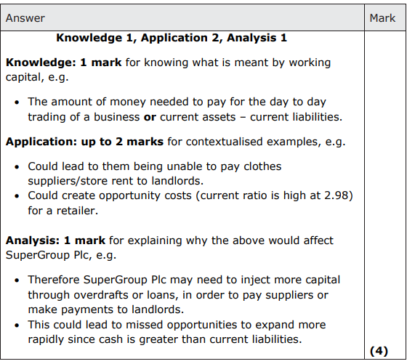

**3**

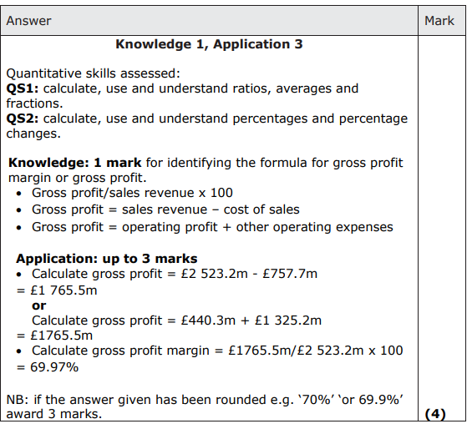

**4(a)**

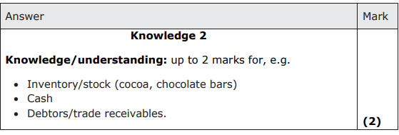

**4(b)**

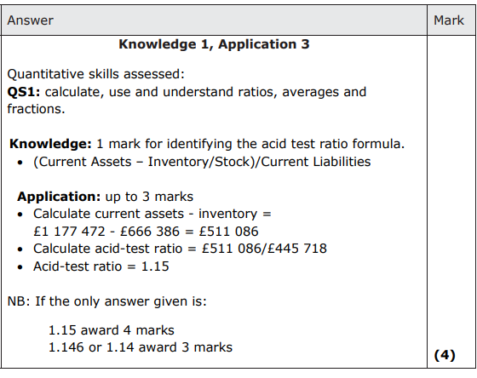

**5(a)**

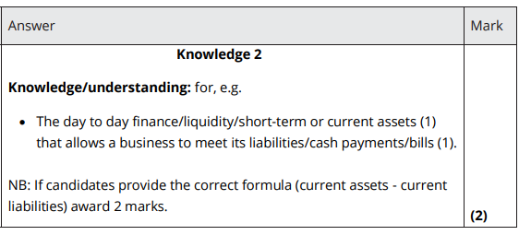

**5(b)**

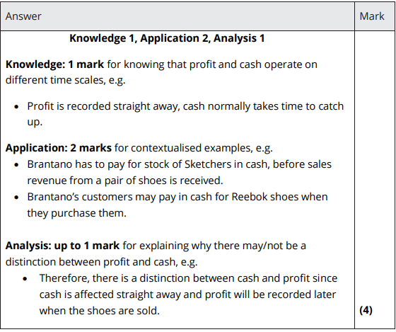

**5(c)**

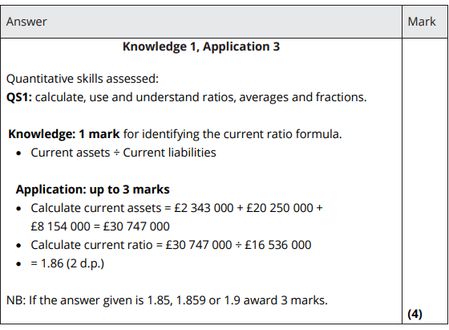

**6(a)**

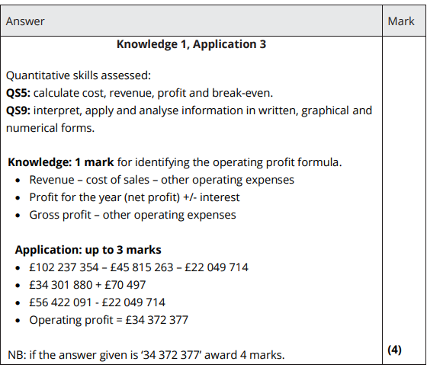

**6(b)**

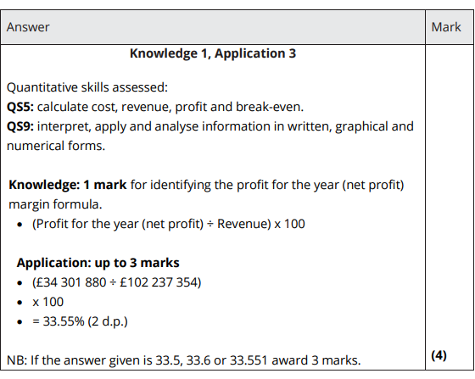

**7(a)**

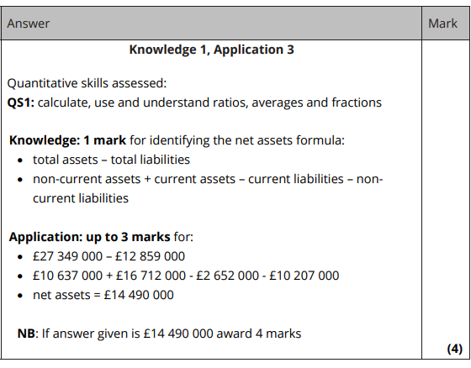

**7(b)**

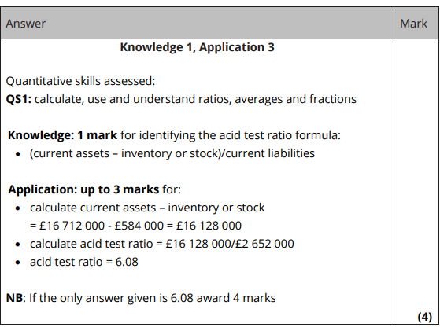

**7(c)**

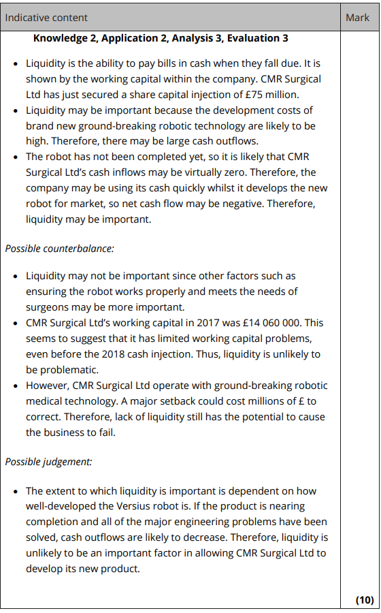

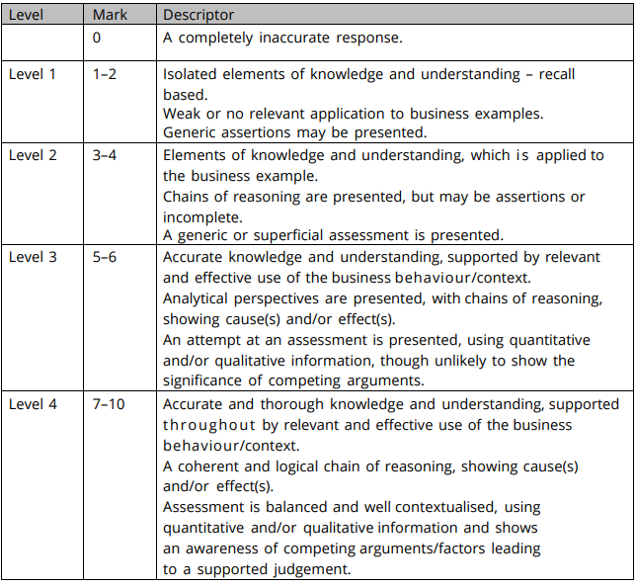

**8**

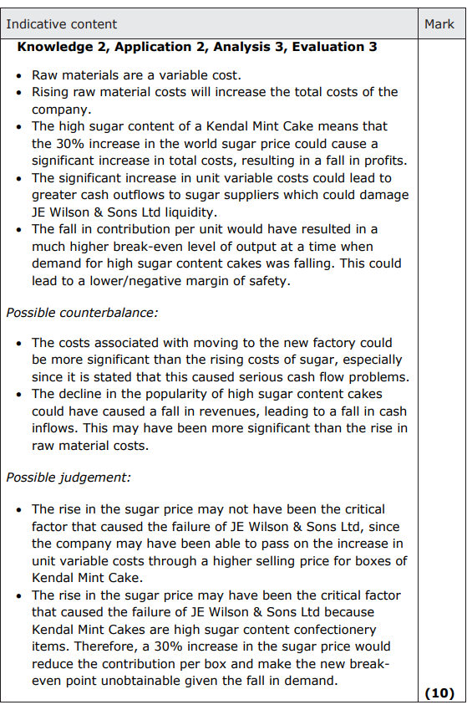

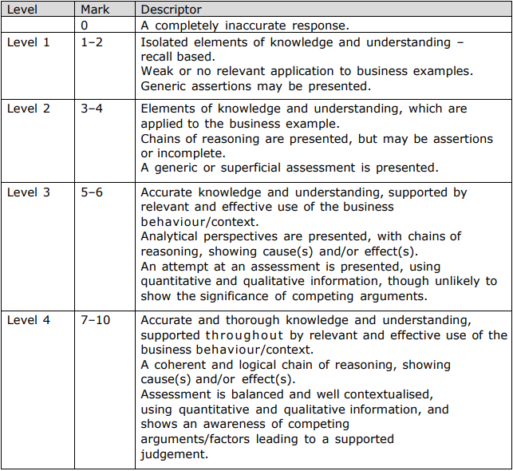

**9**

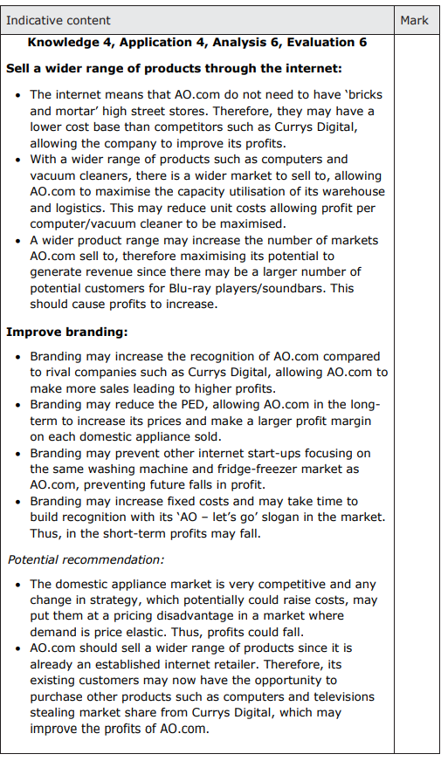

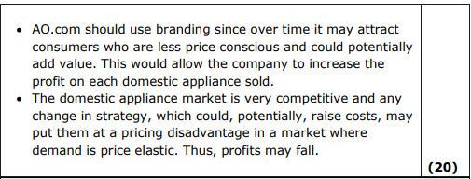

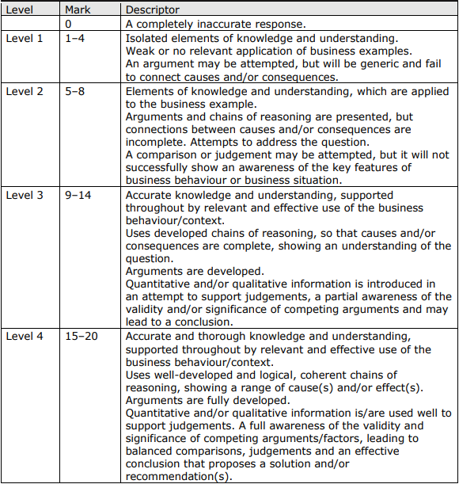

**10**

