A-Level Fine Art Handbook

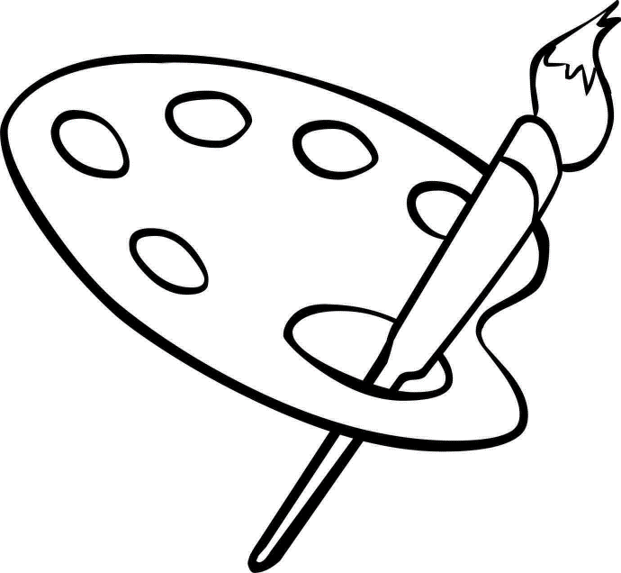

# Contents

Contents 2

Course details 3

Qualification 3

Specification 3

Entry Requirements 3

Calendar 3

Contact details 4

Organisation 5

Equipment 5

Assessment 6

Grade boundaries 11

Internal assessments 12

5/7 hours in… Fine Art 12

Supercurricular 13

Read 13

Watch 13

Write like a Artist 14

Command words 14

How to write your related study 18

# Course details

## Qualification

OCR A-Level Fine Art

## Specification

## <https://www.ocr.org.uk/qualifications/as-and-a-level/art-and-design-h200-h600-from-2015/specification-at-a-glance/>

## Entry Requirements

* Grade 4 in GCSE English Language or GCSE English Literature, 5 in GCSE Maths
* Grade 4 in Art and Design, Graphics or Textiles at GCSE

## Calendar for Year 12/13 (term1)

|  |  |  |  |  |  |
| --- | --- | --- | --- | --- | --- |
| Half Term | Description of activity | AO1 | AO2 | AO3 | AO4 |
| Sept – Oct | **Observations**  Title Page for Human Form project using a reference image and a medium(s) of choice.  Observational drawings of mannequins x4 on mixed media background exploring composition, proportion and tonal modelling. (Pencil, biro, pen & wash and chalk pastel)  **Hand – Oil painting on canvas**  35+ primary photographs of hands. Digital edits adjusting brightness, contrast, vibrancy and saturation.  Research on **Wanjin Gim & Lucien Freud**. Include: Stylistic title, concise bio, contextual analysis and images.  Painting of hand using oil paints. Record photos evidencing development. |  |  |  |  |
| Nov – Dec | **Foreshortened Limb(s) – Acrylic on acetate**  Collage on foreshortening recording examples of historic and contemporary works *e.g. Lamentation of Christ (Mantegna), Duarte Vitoria, Cristina Troufa etc.*  35+ primary photographs of the human form evidencing foreshortening.  Research sheet and study on **Duarte Vitoria or Cristina Troufa**. Include: Stylistic title, concise bio, contextual analysis and images. Produce an A4/A3 study of limbs on acetate using acrylic paint. Record photos evidencing development.  **Portrait – Charcoal and acrylic glaze on gesso paper**  35+ primary photographs of a portrait evidencing high contrast.  Research sheet and study on Anthony Barrow. Include: Stylistic title, concise bio, contextual analysis and images. Produce a large-scale charcoal and acrylic glaze portrait on gesso paper in the style of **Anthony Barrow**. Record photos evidencing development. |  |  |  |  |
| Jan – Feb | **Extended Project**  **Mind map** which includes: A good composition, stylistic title, drawings/paintings of relevant imagery, skilful application of the formal elements and annotations mind mapping the theme.  **Visual collage** using secondary images representing the theme.  **Statement of intent** referring to each of the assessment objectives.  **Primary photographs** (140+) of human form linked to theme. Experimenting with props, viewpoints, lighting, composition, projection etc.  3-5 **observational drawings** relating to chosen topic using different media and on different surfaces. E.g. surface textures, chalk pastel, ink wash, pyrography etc. |  |  |  |  |
| Mar – April | 3 **Artist studies** (imitation or pastiche)developing different techniques & approaches and using a range of appropriate media.  Present each study as a double page spread along with supporting research which includes: A stylistic title, concise bio, contextual analysis and images of the artist’s work. |  |  |  |  |
| May – Oct | **Venn diagram** exploring connections between your chosen artists in terms of aesthetics, meaning and context. Explore formal, technical and content connections between your chosen artists within overlapping areas. Consider what characterises each artist’s work and what the areas of commonality and difference are.  **Experimentation/Exploration & Refinement.** Complete 15-20 drawings, paintings or sculptures that show a smooth transition from your original observational studies to images that are influenced by chosen artists. You must develop your ideas with each piece as you go along.  The purpose of this exercise is to learn particular techniques or compositional strategies – not to copy your artists work in its entirety. The result should be a series of paintings, drawings, sculptures, maquettes which show gradual changes and exploration. The intention is that by the time you get to your final piece, your work is a combination of your **own ideas** and the influence of several artists. Your work should look original – a mixture gained from a multitude of sources. |  |  |  |  |
| Nov - Dec | **Final Piece(s)** – Plan (annotated sketches) and make a personal resolved piece as a conclusion to your journey, showing a link to your chosen artist/designer. |  |  |  |  |

## Contact details

Head of Art: Talib Hussain Thussain01@beckfoot.org

A-Level Fine Art teacher: Sarah Davis Sdavis01@beckfoot.org

A-Level Graphics teacher: Lisa Clayton Lclayton01@becfoot.org

A-Level Graphics and Fine Art teacher: Rob Sandercock Rsandercock01@beckfoot.org

# 

# Organisation

You are expected to maintain a well-organised assessment folder, which will be checked by a teacher once per half-term. You must use file dividers, and should contain the following sections:

1. Course documents
   1. Specification (need to know)
   2. Teaching plan
   3. Learning outcome checklist
2. Independent learning
   1. 5 hours in… guidance and templates
   2. Independent learning
3. Transition work

# Equipment

You must bring the following to all lessons:

* A3 pink pig sketch book
* Assessment folder
* Any resources that you are using above and beyond the equipment and materials provided by your class room teachers.

# Assessment

A-Level Fine Art is a linear course, and you will sit an external exam at the end of Year 13. This will take the form of a 15-hour practical exam.

**Component 01: Personal investigation**

This component comprises two discrete but linked elements.

**Element 1: Practical portfolio**

This is a practical portfolio with supporting contextual research in which learners are expected to develop a

personal response based on the centre-set or learners set theme leading to a finished realisation(s) or outcome(s).

This portfolio will consist of a sustained project, theme or course of study. It may be presented in appropriate formats for the specialism and area of study chosen using, for example, sketchbooks, mounted sheets,

maquettes, prototypes, digital presentations, animation, scale models or illustrated written work.

There is no restriction on the scale of work produced or the timeframe for undertaking the work but learners

should carefully select, organise and present work to ensure that they provide evidence of meeting all four

assessment objectives.

Learners must show they have:

• independently developed ideas through sustained and focused investigations in response to a given starting point

• produced material informed by contextual and other sources that informs the development of

their practical work

• explored ideas, techniques or processes appropriate to their chosen specialism(s)

• recorded observations from sources relevant to intentions

• critically reviewed and refined their work as it progresses

• used their planning and preparation to produce coherent realisation(s)/outcome(s).

For the purposes of assessment, learners will provide evidence of all the assessment objectives through the

careful selection and presentation of their work. The practical portfolio should be viewed as a whole and

judgements regarding the extent to which all the assessment objectives have been met should be made

across the submission.

**Element 2: Related study**

Learners are required to establish through this written and, where appropriate, illustrated component, the

related context in which their chosen practical portfolio exists.

This may be established by exploring the genre, subject matter, movement or historical framework of the

overarching starting point, course of study or theme selected.

The aim of the related study is to enable learners to develop their ability to communicate their knowledge

and understanding of art historical movements, genres, practitioners and artworks, considering the way that

these change and evolve within chronological and other frameworks. It also builds their understanding

of the relationship between society and art: art historical terms, concepts and issues; methods of

researching, investigating and analysing; and how works are interpreted and evaluated.

The related study should be separate and clearly identifiable from the contextual research embedded

in the development of the practical portfolio. Learners should also highlight their own work and clearly

distinguish it from collected or transposed material. Learners may produce the related study in an

appropriate form of which the following are some examples: an illustrated essay, digital presentation/

blog, illustrated study sheets or written report. It is a requirement of the related study that all source

material and research are listed and acknowledged in a bibliography and should be clearly identifiable in the

work presented for assessment.

**Component 02: Externally set task**

**Example of a checklist for externally set task. Year 13 (Terms 2&3).**

For this component, an early release paper will be despatched to centres based on estimated entries

made and will also be available on the OCR website from 1 February.

This paper can be given to learners at the discretion of centres any time on or after 1 February in the

year of certification. Centres may determine the amount of time for preparatory study prior to learners

undertaking their 15-hour supervised period. The paper will give learners a choice of seven themes,

each with a choice of written and/or visual starting points, briefs or stimuli. From this paper, learners

are expected to choose one option for which they will generate an appropriate personal response for

assessment.

**Planning and preparation**

The amount of time given to learners for the preparation period should be determined by centres.

Learners must be given a preparatory period during which they will research, plan and develop ideas for

their own response to the option they have chosen. During this preparatory period teachers may give

limited guidance. Guidance should be given to learners about availability and choice of materials, health and

safety, avoidance of plagiarism and completion of work in accordance with specification requirements and

procedures. However, it should be remembered that learners are required to reach their own judgements

and conclusions and must work independently to produce their own personal response.

All work must be completed by the designated finishing time set by the centre. Dates and deadlines

for preparatory work and the 15-hour supervised time must be set by centres to facilitate the

completion of marking and internal standardisation by the OCR-set deadline.

Learners can continue to work on their preparatory work until the first period of supervised time

commences. Learners must refer to their preparatory work during the supervised 15-hour period.

Preparatory work should not be amended or developed further during or after the timetable 15

hours supervised time. No additional work should be brought into the supervised sessions. Preparatory

work and outcome(s) should be kept under secure conditions at all times when not in use and once the

supervised period is completed.

**Realising intentions**

Learners will have up to fifteen hours in which to independently realise their response(s). The 15-hour

supervised time can be divided into several sessions and timetabled to suit the centre. At least

one session should be at least 2–3 hours in duration.

**Examinations**

Learners are required to provide evidence of all assessment objectives in response to their chosen

starting point, brief or stimulus, within the 15-hour supervised period. It is expected that during

the supervised period, learners will realise their intentions to an outcome(s).

All selected work produced for the component, including the research, planning and development

work produced in the preparatory period, must be submitted for assessment

**Assessment objectives (AO)**

There are four assessment objectives in OCR’s A Level in Art and Design.

These are detailed in the table below.

Learners are expected to demonstrate their ability to:

**AO1 Develop** ideas through sustained and focused investigations informed by contextual and other

sources, demonstrating analytical and critical understanding.

**AO2 Explore** and select appropriate resources, media, materials, techniques and processes,

reviewing and refining ideas as work develops.

**AO3 Record** ideas, observations and insights relevant to intentions, reflecting critically on work and

progress.

**AO4 Present** a personal and meaningful response that realises intentions and, where appropriate,

makes connections between visual and other elements.

## Grade boundaries

|  |  |  |
| --- | --- | --- |
| **A-level OCR Grade Boundaries 2023 Component 1** | | |
| **Grade** | **Overall mark out of 120 (Min)** | **Per Assessment Objective out of 24 (Min)** |
| **A\*** | **114**/120 | **23**/24 |
| **A** | **107**/120 | **22**/24 |
| **B** | **92**/120 | **19**/24 |
| **C** | **77**/120 | **16**/24 |
| **D** | **62**/120 | **13**/24 |
| **E** | **47**/120 | **10**/24 |
| **U** | **0**/120 | **0**/24 |

|  |  |  |
| --- | --- | --- |
| **A-level OCR Grade Boundaries 2023**  **Component 2** | | |
| **Grade** | **Overall mark out of 80 (Min)** | **Per Assessment Objective out of 20 (Min)** |
| **A\*** | **76**/80 | **19**/20 |
| **A** | **72**/80 | **18**/20 |
| **B** | **62**/80 | **16**/20 |
| **C** | **52**/80 | **13**/20 |
| **D** | **43**/80 | **11**/20 |
| **E** | **34**/80 | **9**/20 |
| **U** | **0**/80 | **0**/20 |

## Internal assessments

You will have weekly deadlines set by your Art teachers who will record expectations on your weekly review document.

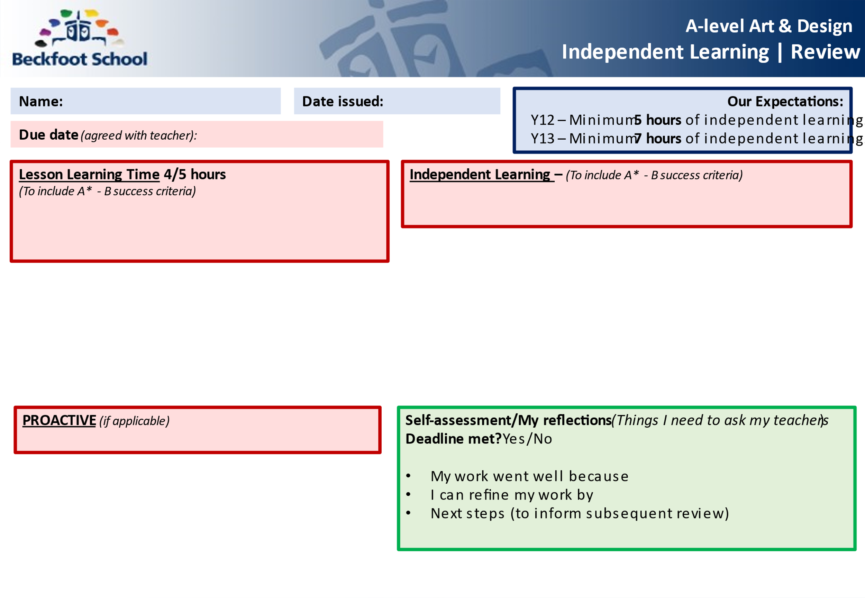

**5/7 hours in…Fine Art**

Research shows that the most successful students (i.e. those that make the most progress and get the highest grades) are doing between 20 and 25 hours of independent study per week by the end of Year 13. That may seem a lot, but it’s something that you would build up to over the course of your A-Levels. In Year 12, we’re talking something more like 15 hours per week. This equates to roughly 5 hours of independent study per A-Level per subject.

Independent study can be divided into three types – Consolidation, Reactive and Proactive.

**Consolidation**

The evening following an Art lesson, you should spend 12-15 minutes (24-30 minutes for a double) rereading your weekly review.

**Reactive**

This is your ’homework’. Each of your Art teachers should give you at least 2 hours’ worth of homework each week. If they don’t – ask them for some! If you find this takes more than 2 hours, that’s fine, you can take this from the proactive phase (not from the consolidation phase though). Equally, if you find you finish your reactive work quickly, spend more time on your proactive work.

**Proactive**

This is the section that will broaden and deepen your overall understanding of the subject you are studying. It will not necessarily involve work that has been set by your teacher, but instead it is about you doing the extra practice of techniques and skills, reading articles, watching videos, visiting exhibitions etc. This might contain some of the following:

* The shock of the New
* The 20th century Art book
* [Gardner's Art Through the Ages](https://mymodernmet.com/best-art-history-books/#Gardners_Art_Through_the_Ages)
* [The Art Book](https://mymodernmet.com/best-art-history-books/#The_Art_Book)
* [The Collins Big Book of Art: From Cave Art to Pop Art](https://mymodernmet.com/best-art-history-books/#The_Collins_Big_Book_of_Art_From_Cave_Art_to_Pop_Art)
* [50 Artists You Should Know](https://mymodernmet.com/best-art-history-books/#50_Artists_You_Should_Know)
* [The Story of Art](https://mymodernmet.com/best-art-history-books/#The_Story_of_Art)
* [Ways of Seeing](https://mymodernmet.com/best-art-history-books/#Ways_of_Seeing)
* [The Lives of the Artists](https://mymodernmet.com/best-art-history-books/#The_Lives_of_the_Artists)
* [Styles, Schools and Movements: The Essential Encyclopaedic Guide to Modern Art](https://mymodernmet.com/best-art-history-books/#Styles_Schools_and_Movements_The_Essential_Encyclopaedic_Guide_to_Modern_Art)
* [The Duchamp Dictionary](https://mymodernmet.com/best-art-history-books/#The_Duchamp_Dictionary)
* [Show Time: The 50 Most Influential Exhibitions of Contemporary Art](https://mymodernmet.com/best-art-history-books/#Show_Time_The_50_Most_Influential_Exhibitions_of_Contemporary_Art)

# 

# Super curricular

## Read

See above

## Watch

* Loving Vincent. Year: 2017. Length: 95 minutes.
* Lust for Life. Year: 1956. Length: 122 minutes.
* Woman in Gold. Year: 2015. Length: 109 minutes.
* Frida. Year: 2002. Length: 123 minutes.

## Visit

* Leeds city Art gallery
* Yorkshire sculpture park
* Bradford Industrial Museum
* Cartwright Hall Art Gallery
* Henry Moore Institute
* The Hepworth Museum

# Write like an Artist

## Command words

Analyse Interpret data to arrive at a conclusion.

Annotate to add notes or remarks to text or an image.

Comment Present an informed opinion.

Compare Identify similarities and/or differences.

Complete Finish a task by adding to given information.

Define Specify meaning.

Describe Set out characteristics/qualities.

Design Set out how something will be done.

Draw Produce an observational drawing.

Evaluate Judge from available evidence or against success criteria.

Explain Set out purposes or reasons.

Identify Name or otherwise characterise.

Justify Support a case with evidence.

Outline Set out main characteristics.

Reflect Critically reflect on progress and success.

Show Provide structured evidence to reach a conclusion.

Sketch Draw approximately.

Hatching Parallel lines are used to create shading or texture.

Cross hatching Where lines are placed at an angle to one another to create form.

Gradient  Two or more hues flowing into one another, creating a gradual blend of colour.

# Related Study

# How to write your related study

* **Topic/Title/Question/Quote – *Formulated by your teacher and agreed with you. Will be linked to your coursework.***​
* **Context (1000-2000 words approx.)**​
* **Contextual analysis (200 words approx.)**​
* **Conclusion (200 words approx.)** ​
* **Intention/introduction (200 words approx.)**​
* **Bibliography - This includes all source material used.** ​

