

Additional Assessment Materials

Pearson Edexcel GCE in A level Business

9BS0

Resource Set 2

3.2 Business growth

3.2.1 Growth

3.2.2 Mergers and takeovers

3.2.3 Organic growth

3.2.4 Reasons for staying small

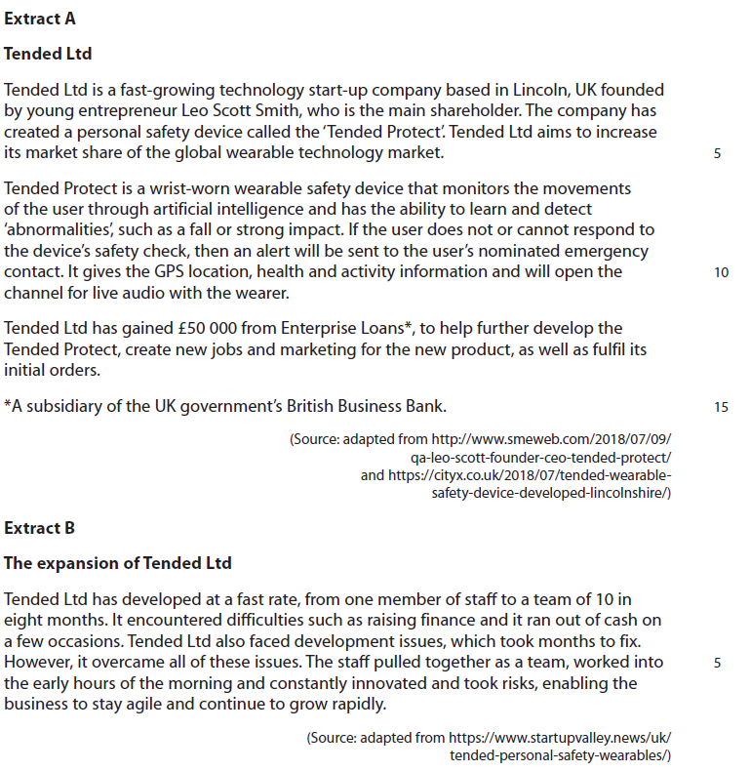**3.2.1 Growth**

1 Assess the extent to which the problems of rapid growth may have been managed by Tended Ltd.

(12)

**3.2.2 Mergers and takeovers**

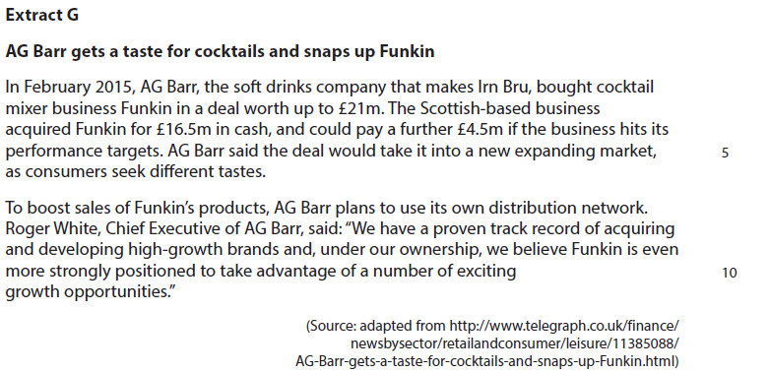

2 Assess the likely effects for AG Barr of taking over Funkin, the cocktail mixer

business.

(12)

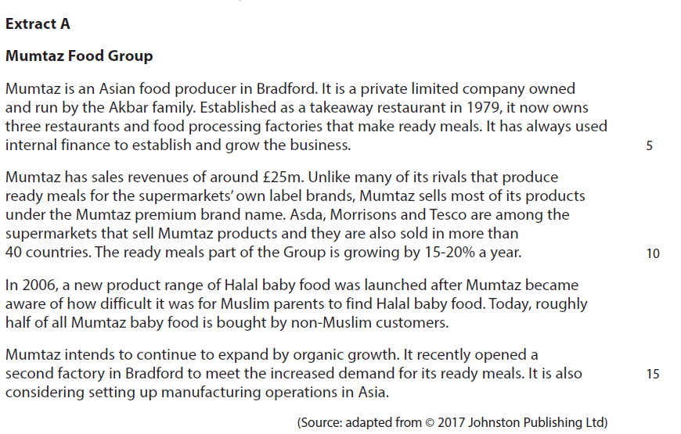**3.2.3 Organic growth**

3 Assess whether expanding by organic growth was the right decision for Mumtaz.

(10)

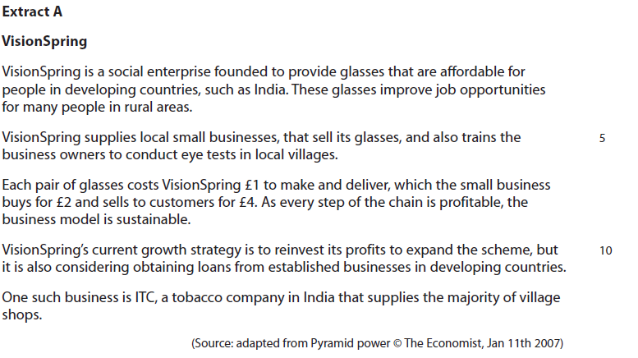**3.2.4 Reasons for staying small**

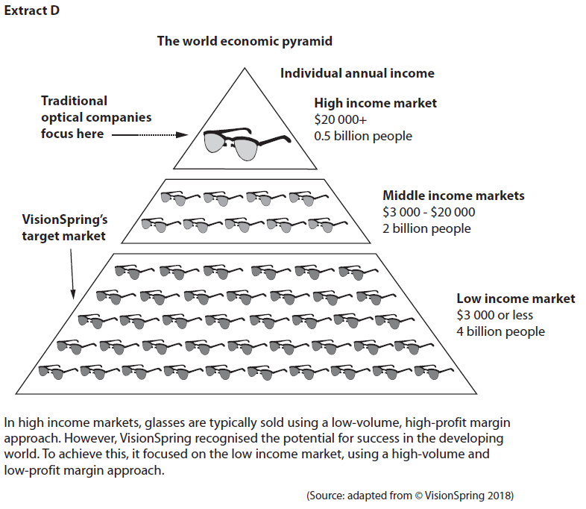

4 Explain **one** reason why businesses that sell VisionSpring’s glasses may prefer to stay small.

(4)

|  |  |  |
| --- | --- | --- |
| Question Number | Indicative content | Mark |
| **1** | **Knowledge 2, Application 2, Analysis 4, Evaluation 4**  **Indicative content**   * Knowledge of problems of rapid growth such as diseconomies of scale, communication and overtrading.   **Ways in which the problems have been managed:**   * Good leadership may have enabled Tended Ltd to overcome communication difficulties e.g. employees have pulled together as a team. * Overtrading difficulties were eased by obtaining additional finance – Tended Ltd was loaned £50,000 from Enterprise Loans. * Development issues, such as creating new products e.g. new smartwatch were addressed through securing the additional necessary funding from Enterprise Loans.   *Possible counterbalance*   * In the short-term communication and co-ordination may have still been a problem as a result of the rapid expansion of the workforce from a team of one to 10 employees in eight months. * Despite obtaining additional finance, Tended Ltd may have struggled with overtrading – the business had difficulties raising finance and still faced cash flow issues on a few occasions. * Longer term development issues may not be managed – these may include finding bigger premises and obtaining more suppliers for new products such as smartwatches.   *Potential judgement*   * Tended Ltd has survived and overcome the problems of rapid growth, because it is still constantly innovating and staying agile through careful planning and effective management of the increased workload. * Tended Ltd may not overcome all the problems of rapid growth. This is because Leo Scott Smith is young and may lack experience to solve problems such as effectively managing a bigger workforce. | **(12)** |

|  |  |  |
| --- | --- | --- |
| Level | Mark | Descriptor |
|  | 0 | A completely inaccurate response. |
| Level 1 | 1–2 | Isolated elements of knowledge and understanding – recall based.  Weak or no relevant application to business examples.  Generic assertions may be presented. |
| Level 2 | 3–4 | Elements of knowledge and understanding, which are applied to the business example.  Chains of reasoning are presented, but may be assertions or incomplete.  A generic or superficial assessment is presented. |
| Level 3 | 5–8 | Accurate knowledge and understanding, supported by relevant and effective use of the business behaviour/context.  Analytical perspectives are presented, with developed chains of reasoning, showing cause(s) and/or effect(s). An attempt at an assessment is presented, using quantitative and/or qualitative information though unlikely to show the significance of competing arguments. |
| Level 4 | 9–12 | Accurate and thorough knowledge and understanding, supported throughout by relevant and effective use of the business behaviour/context.  A coherent and logical chain of reasoning, showing cause(s) and/or effect(s).  Assessment is balanced, wide ranging and well contextualised, using quantitative and/or qualitative information and shows an awareness of competing arguments/factors leading to a supported judgement. |

|  |  |  |
| --- | --- | --- |
| Question Number | Indicative content | Mark |
| **2** | **Knowledge 2, Application 2, Analysis 4, Evaluation 4**  **Indicative content**  A takeover is where one business buys a majority shareholding in another business and obtains full management control  **Potential financial risks:**   * Initial cost of £16.5m which could rise to £21m. This is a significant amount which could be lost if the takeover is not successful * Opportunity cost – could the £21m be better spent on developing new soft drinks or increased marketing? * Lack of expertise – this is a new market for AG Barr and carries greater risk and uncertainty, which could negatively affect profitability   **Potential financial rewards:**   * Diversification into new markets. AG Barr would no longer be reliant on the soft drinks market for its sales revenue and profits * Entering a new market. The cocktail mixer market is growing and AG Barr can sell its products to another market segment, providing the opportunity for increased sales and profits * Potential economies of scale. AG Barr can use its existing distribution network and production facilities. This could lead to reduced unit costs   *Potential judgement*   * The financial rewards could be greater as the takeover provides the opportunity for AG Barr to diversify into a growing market * The financial risks could be greater as AG Barr is entering a new market and due to their lack of expertise, could potentially fail with the loss of at least £21m | **(12)** |

|  |  |  |
| --- | --- | --- |
| Question Number | Indicative content | Mark |
| **3** | **Knowledge 2, Application 2, Analysis 3, Evaluation 3**  **Indicative content**   * Organic growth occurs when a business expands internally and does not involve another business taking over or merging with it   **Reasons for organic growth:**   * Mumtaz Foods retains control especially as it is a family owned business * It maintains its existing management/structure/culture * It enables the business to plan for and control growth   e.g. the decision to enter the ready meals and halal baby food market plus to open its own restaurants and factories  *Possible counterbalance:*   * Organic growth is slower e.g. Mumtaz Foods has existed since 1979 and has only gradually grown to its current size * Organic growth is limited, for example the business has only expanded in the Asian food market * Limited finance available to fund organic growth e.g. Mumtaz has only used internal finance   *Potential judgement*   * Organic growth is the right decision because it enables the business to maintain control, which is especially important because Mumtaz is a long established business that has always been owned by the Akbar family * Organic growth is not the right decision because the business may have been slower than its competitors to grasp the opportunities offered by the growing ready meals market | **(10)** |

|  |  |  |
| --- | --- | --- |
| Level | Mark | Descriptor |
|  | 0 | A completely inaccurate response. |
| Level 1 | 1–2 | Isolated elements of knowledge and understanding – recall based.  Weak or no relevant application to business examples.  Generic assertions may be presented. |
| Level 2 | 3–4 | Elements of knowledge and understanding, which are applied to the business example.  Chains of reasoning are presented, but may be assertions or incomplete.  A generic or superficial assessment is presented. |
| Level 3 | 5–8 | Accurate and thorough knowledge and understanding, supported throughout by relevant and effective use of the business behaviour/context.  Analytical perspectives are presented, with developed chains of reasoning, showing cause(s) and/or effect(s).  An attempt at an assessment is presented, using quantitative and/or qualitative information,though unlikely to show the significance of competing arguments. |
| Level 4 | 9–12 | Accurate and thorough knowledge and understanding, supported throughout by relevant and effective use of the business behaviour/context.  A coherent and logical chain of reasoning, showing cause(s) and/or effect(s).  Assessment is balanced, wide ranging and well contextualised, using quantitative and/or qualitative information, and shows an awareness of competing arguments/factors leading to a supported judgement |

|  |  |  |
| --- | --- | --- |
| Question Number | Answer | Mark |
| **4** | **Knowledge 1, Application 2, Analysis 1**  **Knowledge: 1 mark for** one reason why businesses that sell VisionSpring glasses may prefer to stay small:   * Flexibility in responding to customer needs * Reduced risk of business failure   **Application: up to 2 marks for two uses of context e.g**   * Shops selling glasses are located in rural areas * Small business owners visit villages to conduct eye tests.   **Analysis: 1 mark for**   * Local businesses may have greater knowledge of their customers’ needs. * Therefore the small business owners can respond quickly to their customer needs by supplying glasses immediately if needed. | **(4)** |