

Additional Assessment Materials

Summer 2021

Pearson Edexcel GCE in A level Business

9BS0

Resource Set 3

4.3 Global marketing

4.3.1 Marketing

4.3.2 Niche markets

4.3.3 Cultural/social factors

**Pearson: helping people progress, everywhere**

Pearson aspires to be the world’s leading learning company. Our aim is to help everyone progress in their lives through education. We believe in every kind of learning, for all kinds of people, wherever they are in the world. We’ve been involved in education for over 150 years, and by working across 70 countries, in 100 languages, we have built an international reputation for our commitment to high standards and raising achievement through innovation in education. Find out more about how we can help you and your students at: [www.pearson.com/uk](http://www.pearson.com/uk)

Additional Assessment Materials, Summer 2021

All the material in this publication is copyright

© Pearson Education Ltd 2021

**General guidance to Additional Assessment Materials for use in 2021**

**Context**

* Additional Assessment Materials are being produced for GCSE, AS and A levels (with the exception of Art and Design).
* The Additional Assessment materials presented in this booklet are an **optional** part of the range of evidence you may use when deciding on a candidate’s grade.
* 2021 Additional Assessment Materials have been drawn from previous examination materials, namely past papers.
* Additional Assessment Materials have come from past papers both published (those materials available publicly) and unpublished (those currently under padlock to our centres) presented in a different format to allow you to adapt them to use with your candidates.

**Purpose**

* The purpose of this resource to provide qualification-specific sets/groups of questions covering the knowledge, skills and understanding relevant to this Pearson qualification.
* This document should be used in conjunction with the mapping guidance which will map content and/or skills covered within each set of questions. The mapping guidance will also highlight where the question originally came from to allow you to access further support materials (mark schemes, examiner reports).
* Use of these assessment materials will assist you in assessing candidates’ current performance in areas not assessed elsewhere. Their use will also provide an extra opportunity for candidates to demonstrate their performance at the end of their course of study.
* These materials are only intended to support the summer 2021 series.

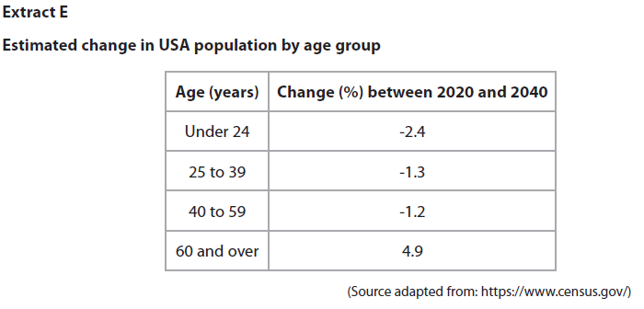**4.3.1 Marketing**

Consumers aged 40–59 years old are the largest age group in the USA coffee market.

1 Using the data in Extract E, draw a demand and supply diagram to show the likely effects of the estimated change in population for the 40–59 age group on the USA coffee market.

(4)

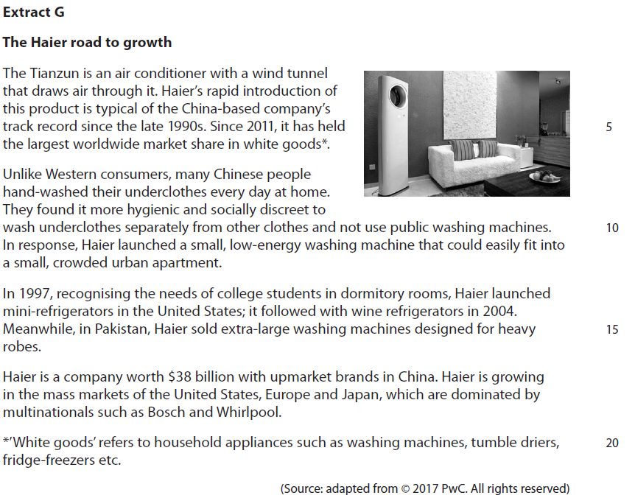**4.3.2 Niche markets**

Haier is aiming to continue its global expansion in the white goods market. It could do this by focusing on either global niche markets or global mass markets for white goods.

2 Evaluate these **two** options and recommend which approach is most suitable

for Haier.

(20)

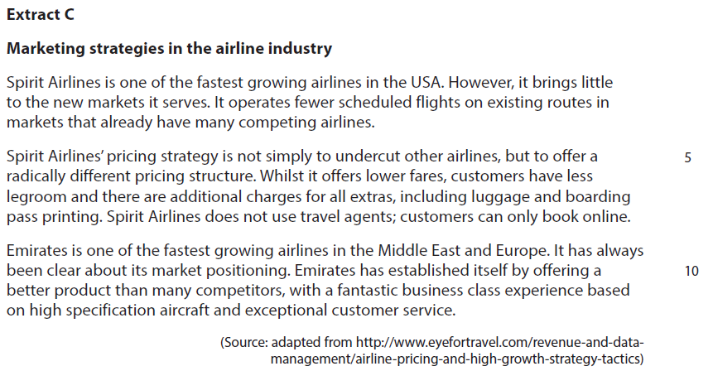**4.3.3 Cultural/social factors**

3 Assess the consequences to a business, such as Spirit Airlines, of only selling its tickets online.

(10)

|  |  |  |
| --- | --- | --- |
| Question Number | Answer | Mark |
| **1** | **Knowledge 2, Application 1, Analysis 1**  **QS3:** construct and interpret a range of standard graphical forms  **Knowledge/understanding:**  **1 mark** for correctly constructing supply and demand curves  **1 mark** for correctly labelling axes, price and quantity  **Application: 1 mark** for   * Correctly interpreting the shift in demand curve to the left   **Analysis: 1 mark** for drawing the original and new equilibrium on the quantity and price axes  Image result for decrease in demand | **(4)** |

|  |  |  |
| --- | --- | --- |
| Question  Number | Indicative content | Mark |
| **2** | **Knowledge 4, Application 4, Analysis 6, Evaluation 6**  **Decision for focussing on global niche markets**   * A global niche market is a specialist segment of a global market for a good or service. The marketing mix is adjusted in order to meet this local need – in Haier’s case this is through design of the product. * Haier have a history of successfully selling to global niches, such as small, low energy washing machines for the Chinese markets, and this focus has provided the foundation for their global growth into other white good markets such as mini- refrigerators * Haier’s focus on customer service and market research allows them to identify further global niches, such as over-sized washing machines for the Pakistani market. * Focussing on global market niches is likely to lead to higher profit margins per sale for Haier as customers are more willing to pay a higher price in order to satisfy their particular needs * Focussing on global niches provides Haier with a clear point of differentiation from competitors such as Bosch and Whirlpool – this could lead to improved brand reputation and boost future sales for new products such as the Tianzun air-conditioning unit   **Decision for focussing on global mass markets**   * The global mass market for white goods is much larger than global niches and as such provides an increased chance of sales. This might be particularly the case as markets such as India expand and customers have the income and desire to purchase domestic appliances. * Global niches are more limited in their potential sales and, although the margin per sale is likely to be higher, the possible sales volume overall is likely to be lower, limiting Haier’s profitability in the long-term * Selling to global niches demands good understanding of local specialist needs – this may require detailed market research and an understanding of specific values and local needs, adding to costs and potentially reducing the higher margins of a niche market. * As a China-based business, Haier can exploit a production cost advantage over European or American based brands such as   Whirlpool and Bosch. This should make mass market supply |  |

|  |  |  |
| --- | --- | --- |
|  | at competitive prices possible for Haier.  *Potential judgement:*   * Global market niches help a business such as Haier establish itself globally, without directly competing with existing multinationals such as Bosch and Whirpool which have loyal customers and established brands. However, global market niches, by their very nature are limited in size and in the long- term may not provide the opportunities for growth that Haier is looking for. * The Tianzun air-conditioner proves that global market niches may continue to evolve in the white goods market and as technological advances continue, satisfying these needs through product innovation could still be as financially rewarding in the future, as it has been in Haier’s recent past. * Overall the judgement depends on the strength and adaptability of the Haier brand. If it can adapt this successful niche brand to the highly competitive mass market and capitalise on low costs in China, this may be the way forward. However, if customers see Haier as a successful niche supplier only, expanding into the mass market may prove unsuccessful as customers no longer buy niche products and do not trust the Haier brand in the competitive global market for white goods.   Example of possible ‘MOPS’ recommendations  **Market** - Global niche markets typically have loyal consumers and established brands so this might support market penetration.  However, global niche markets are limited in their size so in the longer term may not provide the opportunities for significant growth.  **Objectives** - Global expansion implies growth in sales and revenue to provide profits for investment. Mass markets given more income streams  **Product** - As technologies advance in the white goods market, it may be that a global niche market is the most appropriate way given that research and development costs may otherwise not be recouped from mass market sales so quickly (e.g. Tiazun air conditioner)  **Situation** - Haier could adapt the niche brand to the highly competitive mass market and capitalise on low costs in China, assuming customers do not see Haier as a successful niche supplier  only. | **(20)** |

|  |  |  |
| --- | --- | --- |
| Level | Mark | Descriptor |
|  | 0 | A completely inaccurate response. |
| Level 1 | 1–4 | Isolated elements of knowledge and understanding. Weak or no relevant application of business examples. An argument may be attempted, but will be generic and fail to connect cause(s) and/or consequence(s)/effect(s). |
| Level 2 | 5–8 | Elements of knowledge and understanding, which are applied to the business example.  Arguments and chains of reasoning are presented, but connections between cause(s) and/or consequence(s)/ effect(s) are incomplete. Attempts to address the question. A comparison or judgement may be attempted, but it will  not successfully show an awareness of the key features of business behaviour or business situation. |
| Level 3 | 9–14 | Accurate and thorough knowledge and understanding, supported throughout by relevant and effective use of the business behaviour/context.  Uses developed chains of reasoning, so that cause(s) and/or consequence(s)/effect(s) are complete, showing an understanding of the question. Arguments are well developed.  Quantitative or qualitative information is introduced in an attempt to support judgements, a partial awareness of the validity and/or significance of competing arguments and  may lead to a conclusion. |
| Level 4 | 15–20 | Accurate and thorough knowledge and understanding, supported throughout by use of relevant and effective use of the business behaviour/context.  Uses well-developed and logical, coherent chains of reasoning, showing a range of cause(s) and/or effect(s). Arguments are fully developed.  Quantitative and/or qualitative information is/are used well to support judgements. A full awareness of the validity and significance of competing arguments/factors, leading to balanced comparisons, judgements and an effective conclusion that proposes a solution and/or recommendation(s). |

|  |  |  |
| --- | --- | --- |
| Question Number | Indicative content | Mark |
| **3** | **Knowledge 2, Application 2, Analysis 3, Evaluation 3**   * Selling online means that tickets are purchased electronically via a website or application * Selling online means that the costs of distributing airline tickets to customers are reduced to virtually zero * This reduces Spirit’s costs of operation and allows them either to reduce fares charged to customers for airline tickets, or increase their profit margins if ticket prices remain the same * It is quicker and easier for Spirit customers to book online as they can do this from home at any time of the day/night which might increase its sales volume * Customers may be attracted because they are able to track price changes for tickets to achieve the best price which might increase Spirit’s sales volume * As Spirit’s customers and potential customers are less likely to expect the additional customer service that might be expected by using ticket agents or selling airline tickets via call centres, operating costs should be lower.   *Potential counterbalance*   * Customers do not gain the customer service that a ticket agent can offer, such as explaining additional costs in the ticket price, which may reduce sales * Spirit needs to have effective back-office support to ensure that their online booking service is reliable and secure for passengers – there is no alternative method of purchase. If it does not then sales will not be possible * Not all potential customers are able, or are comfortable with, using the internet to pay for airline tickets and might feel happier dealing with an agent. This could lead to reduced sales from this market segment.   *Potential judgement*   * Low-cost airlines such as Spirit rely on reducing their operating costs to a minimum so that savings can be passed on to the customer in lower fares. Online ticket sales is one of the simplest and most reliable ways of doing this and most customers, when booking tickets for these airlines, would expect to use this method * Faceless online booking systems that can add additional charges, such as for luggage or insurance, can be part of the reasons low-cost airlines, such as Spirit, gain poor reputations for customer service. This may limit potential customer numbers and market growth for a business, such as Spirit. | **(10)** |

|  |  |  |
| --- | --- | --- |
| Level | Mark | Descriptor |
|  | 0 | A completely inaccurate response. |
| Level 1 | 1–2 | Isolated elements of knowledge and understanding – recall based.  Weak or no relevant application to business examples. Generic assertions may be presented. |
| Level 2 | 3–4 | Elements of knowledge and understanding, which are applied to the business example.  Chains of reasoning are presented, but may be assertions or incomplete.  A generic or superficial assessment is presented. |
| Level 3 | 5–6 | Accurate and thorough knowledge and understanding, supported throughout by relevant and effective use of the business behavior/context.  Analytical perspectives are presented, with developed chains of reasoning, showing cause(s) and/or effect(s). An attempt at an assessment is presented, using quantitative and/or qualitative information though unlikely to show the significance of competing arguments. |
| Level 4 | 7–10 | Accurate and thorough knowledge and understanding, supported throughout by relevant and effective use of the business behavior/context.  A coherent and logical chain of reasoning, showing cause(s)  and/or effect(s).  Assessment is balanced, wide ranging and well contextualised, using quantitative and/or qualitative information and shows an awareness of competing arguments/factors leading to a supported judgement. |