

Additional Assessment Materials

Pearson Edexcel GCE in A level Business

9BS0

Resource Set 4

3.4 Influences on business decisions

3.4.1 Corporate influences

3.4.2 Corporate culture

3.4.3 Shareholders versus stakeholders

3.4.4 Business ethics

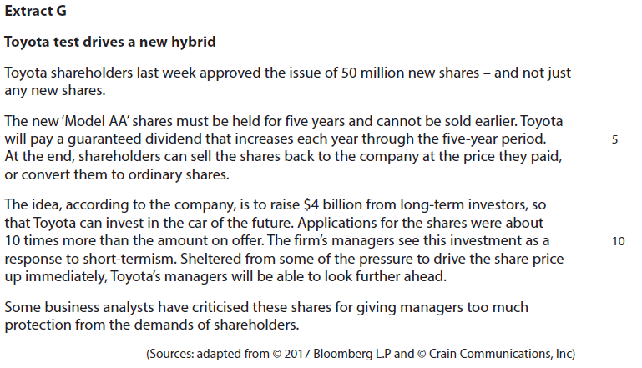**3.4.1 Corporate influences**

Corporate timescales can be short-term or long-term.

1 Assess Toyota’s decision to issue ‘Model AA’ shares as a means of raising finance.

(12)

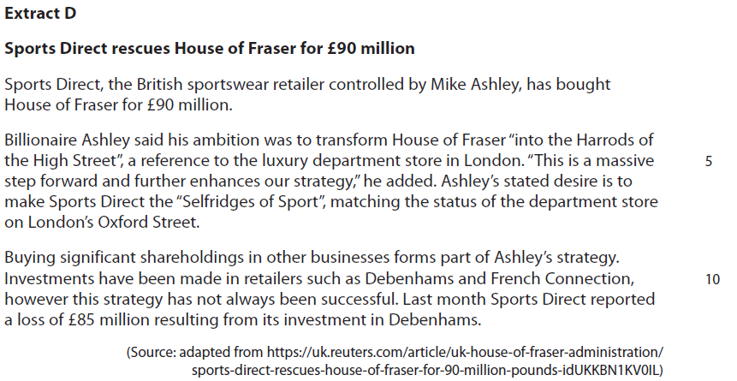**3.4.2 Corporate culture**

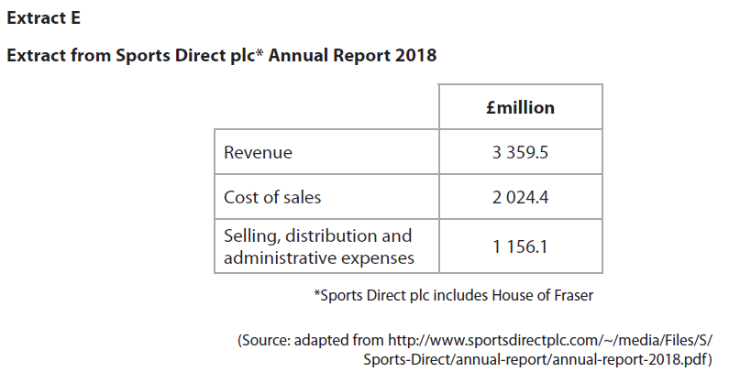

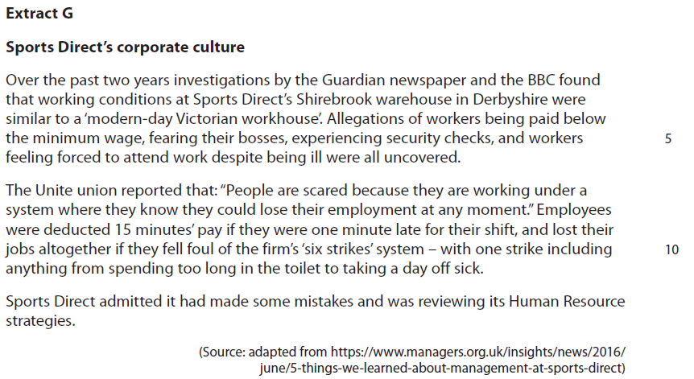

2 Assess the usefulness of a sales forecast for Sports Direct.

(10)

**3.4.3 Shareholders versus stakeholders**

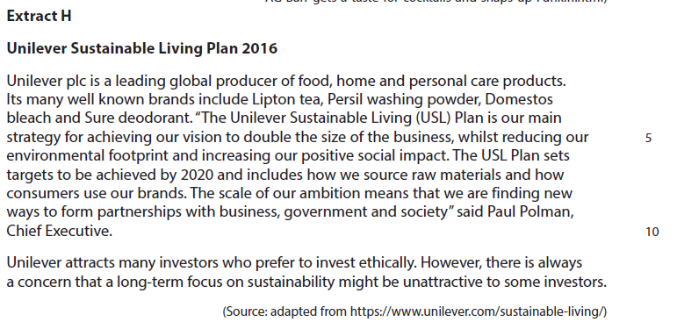

Unilever’s Chief Executive believes that Unilever should aim to consider all of its stakeholders in its main business decisions. Some business analysts consider that Unilever should instead consider an aim of focusing purely on its shareholders.

3 Evaluate these **two** aims and recommend which is most suitable for a business, such as Unilever.

(20)

**3.4.4 Business ethics**

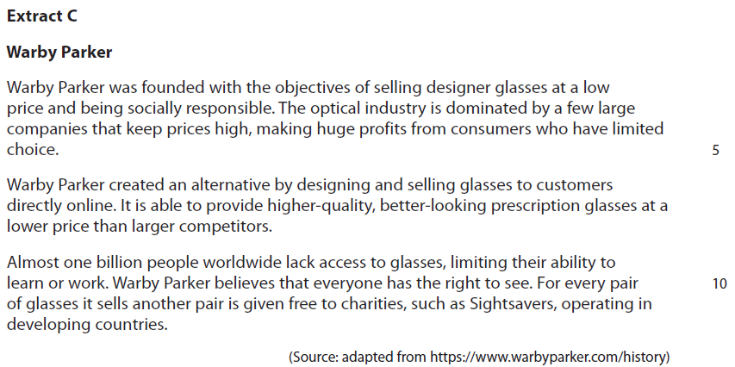

4 Assess whether the decision to be a socially responsible business is likely to increase Warby Parker’s profits.

(12)

|  |  |  |
| --- | --- | --- |
| Question Number | Indicative content | Mark |
| **1** | **Knowledge 2, Application 2, Analysis 4, Evaluation 4**  **Reasons for issuing AA shares (a long-term approach):**   * It provides Toyota’s managers with more time to develop new cars because ‘Model AA’ shares must be held for five years * Toyota aims to raise $4 billion for long-term investment in the car of the future, including areas such as R+D, technology and staff development * Toyota’s shareholders could benefit from sustained profitability, for example ‘Model AA‘ shareholders are paid a guaranteed dividend each year   *Possible counterbalance:*   * Some shareholders may demand more immediate rewards. This may force managers to work more efficiently because Toyota need to satisfy their demands * Some shareholders may encourage managers to respond more quickly to market changes e.g. rise in demand for hybrid and electric cars and criticisms of diesel cars in order to generate immediate returns * Shareholders own the business and may expect good dividends and a rising share price each year   *Potential judgement*   * Toyota is in a highly competitive/dynamic market and needs to respond quickly to market changes and consumer preferences. This supports meeting the needs of short-term investors * Toyota requires long-term investors because it needs to invest in assets such as robotics and plant, in order to maintain competitiveness in a market known for innovation and technological. * Ultimately a long-term investment will only work if shareholders are prepared to be patient and accept this strategy | **(12)** |

|  |  |  |
| --- | --- | --- |
| Level | Mark | Descriptor |
|  | 0 | A completely inaccurate response. |
| Level 1 | 1–2 | Isolated elements of knowledge and understanding –  recall based.  Weak or no relevant application to business examples. Generic assertions may be presented. |
| Level 2 | 3–4 | Elements of knowledge and understanding, which are applied to the business example.  Chains of reasoning are presented, but may be assertions or incomplete.  A generic or superficial assessment is presented. |
| Level 3 | 5–8 | Accurate and thorough knowledge and understanding, supported by relevant and effective use of the business behaviour/context.  Analytical perspectives are presented, with developed chains of reasoning, showing cause(s) and/or effect(s).  An attempt at an assessment is presented, using quantitative and/or qualitative information, though unlikely  to show the significance of competing arguments. |
| Level 4 | 9–12 | Accurate and thorough knowledge and understanding, supported throughout by relevant and effective use of the business behaviour/context.  A coherent and logical chain of reasoning, showing cause(s) and/or effect(s).  Assessment is balanced, wide ranging and well contextualised, using quantitative and/or qualitative information, and shows an awareness of competing arguments/factors leading to a supported judgement. |

|  |  |  |
| --- | --- | --- |
| Question Number | Indicative content | Mark |
| **2** | **Knowledge 2, Application 2, Analysis 3, Evaluation 3**  **Indicative content**   * A sales forecast is a prediction of the expected level of sales volume/revenue for a business for a future period.   **Potential usefulness:**   * Sports Direct can plan how many stores it will need in order to achieve its aim of becoming the ‘Selfridges of Sport’. * Online purchases account for almost 20% of retail sales, Sports Direct can plan to expand this side of its business by increasing the capacity of its Shirebrook warehouse and employ more staff. * Sports Direct can plan how much stock such as sportswear it needs to order from suppliers such as Nike and Adidas.   **Potential limitations:**   * External factors such as changes in the economy and social trends may affect the accuracy of sales forecasts. For example, consumers may boycott Sports Direct as a result of the bad publicity it has received thus reducing sales. * Its usefulness may be limited by the type of market Sports Direct operates in; the retail market is undergoing considerable structural change, which may result in inaccurate sales forecasting for its stores. * Past performance is no guarantee of the future – predicting future sales based on previous year’s sales could therefore be incorrect.   *Potential judgement*   * Sales forecasting is a useful planning tool, without it Sports Direct could encounter problems such as running out of stock and not having sufficient employees to work in the warehouse. * Sports Direct is moving into a new market through its acquisition of House of Fraser – this lack of knowledge of this type of customer’s preferences could lead to inaccurate sales forecasts. | **(10)** |

|  |  |  |
| --- | --- | --- |
| Level | Mark | Descriptor |
|  | 0 | A completely inaccurate response. |
| Level 1 | 1–2 | Isolated elements of knowledge and understanding – recall based.  Weak or no relevant application to business examples.  Generic assertions may be presented. |
| Level 2 | 3–4 | Elements of knowledge and understanding, which are applied to the business example.  Chains of reasoning are presented, but may be assertions or incomplete.  A generic or superficial assessment is presented. |
| Level 3 | 5–6 | Accurate knowledge and understanding, supported by relevant and effective use of the business behaviour/context.  Analytical perspectives are presented, with chains of reasoning, showing cause(s) and/or effect(s).  An attempt at an assessment is presented, using quantitative and/or qualitative information, though unlikely to show the significance of competing arguments. |
| Level 4 | 7–10 | Accurate and thorough knowledge and understanding, supported throughout by relevant and effective use of the business behaviour/context.  A coherent and logical chain of reasoning, showing cause(s) and/or effect(s).  Assessment is balanced and well contextualised, using quantitative and/or qualitative information, and shows an awareness of competing arguments/factors leading to a supported judgement. |

|  |  |  |
| --- | --- | --- |
| Question Number | Indicative content | Mark |
| **3** | **Knowledge 4, Application 4, Analysis 6, Evaluation 6**   * The stakeholder approach considers that a business should consider all of its stakeholders in its business decisions/objectives * The shareholder approach is that a business should focus purely on shareholder returns in its business decisions/objectives   **Stakeholder approach – arguments for:**   * Better image – positive publicity from reducing Unilever’s environmental impact and increasing its positive social impact. This could attract customers * Attract ethical investors who would actively choose to buy shares in Unilever * Improved relations with suppliers by paying fair prices and placing regular orders should ensure reliability of good quality raw materials   **Shareholder approach – arguments for:**   * Increased costs from the stakeholder approach could reduce profitability resulting in lower dividends and a falling share price * Lack of focus on shareholder returns could lead to confusion and inefficiency * Shareholders are the owners of the business and consequently their interests should be more important than other stakeholders   *Potential recommendation (Two examples)*   * The stakeholder approach should be adopted as the long term success of a business is dependant upon developing good relations with all of its stakeholders * The shareholder approach should be adopted as the main purpose of a business is to generate good profits for its shareholders, without whom the business would not exist | **(20)** |

|  |  |  |
| --- | --- | --- |
| Level | Mark | Descriptor |
|  | 0 | A completely inaccurate response. |
| Level 1 | 1–4 | Isolated elements of knowledge and understanding. Weak or no relevant application of business examples.  An argument may be attempted, but will be generic and fail  to connect cause(s) and/or consequence(s)/effect(s). |
| Level 2 | 5–8 | Elements of knowledge and understanding, which are applied to the business example.  Arguments and chains of reasoning are presented, but connections between cause(s) and/or consequence(s)/ effect(s) are incomplete. Attempts to address the question. A comparison or judgement may be attempted, but it will not successfully show an awareness of the key features of business behavior or business situation. |
| Level 3 | 9–14 | Accurate and thorough knowledge and understanding, supported throughout by relevant and effective use of the business behavior/context.  Uses developed chains of reasoning, so that cause(s) and/or consequence(s)/effect(s) are complete, showing an understanding of the question. Arguments are well developed.  Quantitative or qualitative information is introduced in an attempt to support judgements, a partial awareness of the validity and/or significance of competing arguments and may lead to a conclusion. |
| Level 4 | 15–20 | Accurate and thorough knowledge and understanding, supported throughout by use of relevant and effective use of the business behavior/context.  Uses well-developed and logical, coherent chains of reasoning, showing a range of cause(s) and/or effect(s). Arguments are fully developed.  Quantitative and/or qualitative information is/are used well to support judgements. A full awareness of the validity and significance of competing arguments/factors, leading to balanced comparisons, judgements and an effective conclusion that proposes a solution and/or recommendations. |

|  |  |  |
| --- | --- | --- |
| Question Number | Indicative content | Mark |
| **4** | **Knowledge 2, Application 2, Analysis 4, Evaluation 4**  **Indicative content**   * A socially responsible business considers business ethics as a key influence on its strategic decisions * **Positive effects:** * Warby Parker donates one pair of glasses to Sightsavers for every pair it sells – this may improve its reputation * Increased sales and brand loyalty may result from Warby Parker’s improved reputation * Warby Parker may also attract ethical investors and be viewed as a good company to work for by potential employees   *Possible counterbalance*   * Potential trade-off between being ethical and profitable, because of the costs of producing a pair of glasses that yield no revenue i.e. giving away a pair of glasses for each one sold * Lower profit may reduce shareholders/owners returns   *Potential judgement*   * Being socially responsible is a key USP for Warby Parker and differentiates it from its rivals. This could enable it to gain brand loyalty and further increase sales, resulting in greater profit * Customers may choose to purchase from Warby Parker because it offers lower prices, rather than because it is socially responsible. Lower prices may lead to smaller profit margins and reduced profits | **(12)** |

|  |  |  |
| --- | --- | --- |
| Level | Mark | Descriptor |
|  | 0 | A completely inaccurate response. |
| Level 1 | 1–2 | Isolated elements of knowledge and understanding – recall based.  Weak or no relevant application to business examples.  Generic assertions may be presented. |
| Level 2 | 3–4 | Elements of knowledge and understanding, which are applied to the business example.  Chains of reasoning are presented, but may be assertions or incomplete.  A generic or superficial assessment is presented. |
| Level 3 | 5–8 | Accurate and thorough knowledge and understanding, supported by relevant and effective use of the business behaviour/context.  Analytical perspectives are presented, with developed chains of reasoning, showing cause(s) and/or effect(s).  An attempt at an assessment is presented, using quantitative and/or qualitative information, though unlikely to show the significance of competing arguments. |
| Level 4 | 9–12 | Accurate and thorough knowledge and understanding, supported throughout by relevant and effective use of the business behaviour/context.  A coherent and logical chain of reasoning, showing cause(s) and/or effect(s).  Assessment is balanced, wide ranging and well contextualised, using quantitative and/or qualitative information, and shows an awareness of competing arguments/factors leading to a supported judgement. |