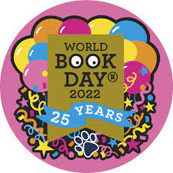
The Masked Reader

Can you work out which Beckfoot staff member is behind each mask and the title of the book they are reading?
Character | Staff Member | Book Title
Zebra
Skunk
Octopus
Bat
Deer
Leopard
Flamingo
Monkey
Sheep
Crocodile
Chipmunk
Unicorn
Owl
Submit your answers to beclrc@beckfoot.org, or print out the form and hand it in to the library, by 12:30pm Friday 11th March.
The student with the most correct answers will win a £10 Amazon voucher. Good luck!

