

Additional Assessment Materials

Pearson Edexcel AS Level in Business (8BS0)

Resource Set 1.5: Entrepreneurs and leaders

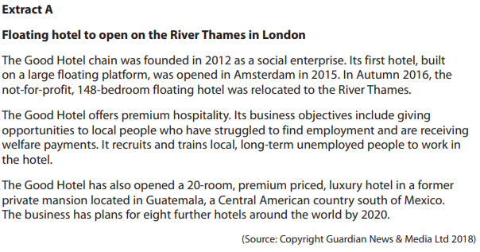

1. (a) What is meant by social enterprise? (2)

________________________________________________________________________________________________________________________________________________________________________________________________________________________________________________________________________________________________________________________________________________

(b) What is meant by business objective? (2)

________________________________________________________________________________________________________________________________________________________________________________________________________________________________________________________________________________________________________________________________________________

(c) Explain how The Good Hotel’s social objectives could lead to an increase in added value. (4)

________________________________________________________________________________________________________________________________________________________________________________________________________________________________________________________________________________________________________________________________________________

________________________________________________________________________________________________________________________________________________________________________________________________________________________________________________________________________________________________________________________________________________

1. (a) What is meant by public limited company?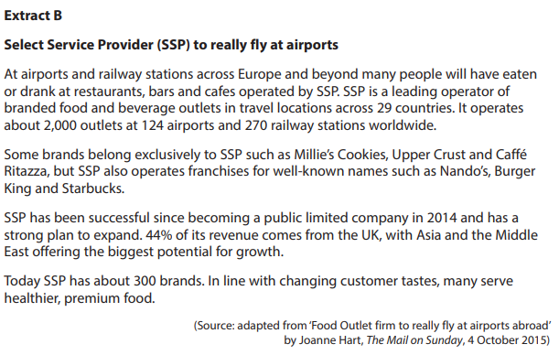 (2)

________________________________________________________________________________________________________________________________________________________________________________________________________________________________________________________________________________________________________________________________________________

(b) What is meant by a franchise? (2)

________________________________________________________________________________________________________________________________________________________________________________________________________________________________________________________________________________________________________________________________________________

(c) Assess **two** benefits to SSP of operating franchises. (8)

________________________________________________________________________________________________________________________________________________________________________________________________________________________________________________________________________________________________________________________________________________

________________________________________________________________________________________________________________________________________________________________________________________________________________________________________________________________________________________________________________________________________________

________________________________________________________________________________________________________________________________________________________________________________________________________________________________________________________________________________________________________________________________________________

________________________________________________________________________________________________________________________________________________________________________________________________________________________________________________________________________________________________________________________________________________

________________________________________________________________________________________________________________________________________________________________________________________________________________________________________________________________________________________________________________________________________________

________________________________________________________________________________________________________________________________________________________________________________________________________________________________________________________________________________________________________________________________________________

________________________________________________________________________________________________________________________________________________________________________________________________________________________________________________________________________________________________________________________________________________

________________________________________________________________________________________________________________________________________________________________________________________________________________________________________________________________________________________________________________________________________________

________________________________________________________________________________________________________________________________________________________________________________________________________________________________________________________________________________________________________________________________________________

________________________________________________________________________________________________________________________________________________________________________________________________________________________________________________________________________________________________________________________________________________

________________________________________________________________________________________________________________________________________________________________________________________________________________________________________________________________________________________________________________________________________________

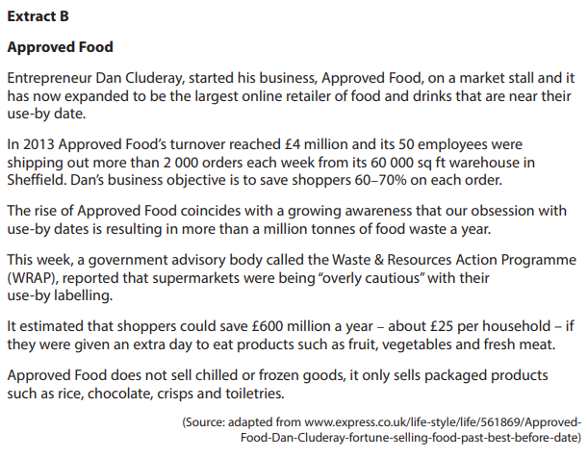

1. (a) What is meant by entrepreneur? (2)

________________________________________________________________________________________________________________________________________________________________________________________________________________________________________________________________________________________________________________________________________________

(b) What is meant by business objective? (2)

________________________________________________________________________________________________________________________________________________________________________________________________________________________________________________________________________________________________________________________________________________

(c) Assess the importance of profit maximisation to a business such as Approved Food. (10)

________________________________________________________________________________________________________________________________________________________________________________________________________________________________________________________________________________________________________________________________________________

________________________________________________________________________________________________________________________________________________________________________________________________________________________________________________________________________________________________________________________________________________

________________________________________________________________________________________________________________________________________________________________________________________________________________________________________________________________________________________________________________________________________________

________________________________________________________________________________________________________________________________________________________________________________________________________________________________________________________________________________________________________________________________________________

________________________________________________________________________________________________________________________________________________________________________________________________________________________________________________________________________________________________________________________________________________

________________________________________________________________________________________________________________________________________________________________________________________________________________________________________________________________________________________________________________________________________________

________________________________________________________________________________________________________________________________________________________________________________________________________________________________________________________________________________________________________________________________________________

________________________________________________________________________________________________________________________________________________________________________________________________________________________________________________________________________________________________________________________________________________

________________________________________________________________________________________________________________________________________________________________________________________________________________________________________________________________________________________________________________________________________________

________________________________________________________________________________________________________________________________________________________________________________________________________________________________________________________________________________________________________________________________________________

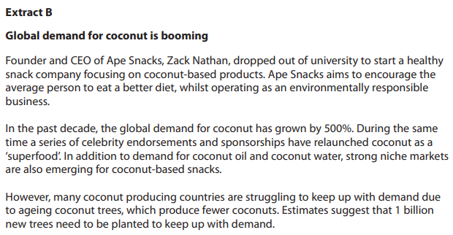

1. State **two** examples of entrepreneurial motives. (2)

________________________________________________________________________________________________________________________________________________________________________________________________________________________________________________________________________________________________________________________________________________

1. (a) What is meant by sole trader? (2)

________________________________________________________________________________________________________________________________________________________________________________________________________________________________________________________________________________________________________________________________________________

(b) Assess **two** difficulties Ryan may face as he develops from an entrepreneur to a leader. (8)

________________________________________________________________________________________________________________________________________________________________________________________________________________________________________________________________________________________________________________________________________________

________________________________________________________________________________________________________________________________________________________________________________________________________________________________________________________________________________________________________________________________________________

________________________________________________________________________________________________________________________________________________________________________________________________________________________________________________________________________________________________________________________________________________

________________________________________________________________________________________________________________________________________________________________________________________________________________________________________________________________________________________________________________________________________________

________________________________________________________________________________________________________________________________________________________________________________________________________________________________________________________________________________________________________________________________________________

________________________________________________________________________________________________________________________________________________________________________________________________________________________________________________________________________________________________________________________________________________

________________________________________________________________________________________________________________________________________________________________________________________________________________________________________________________________________________________________________________________________________________

________________________________________________________________________________________________________________________________________________________________________________________________________________________________________________________________________________________________________________________________________________

________________________________________________________________________________________________________________________________________________________________________________________________________________________________________________________________________________________________________________________________________________

________________________________________________________________________________________________________________________________________________________________________________________________________________________________________________________________________________________________________________________________________________

________________________________________________________________________________________________________________________________________________________________________________________________________________________________________________________________________________________________________________________________________________

(c) Assess the likely benefits to Hydra Creative of becoming a private limited company. (10)

________________________________________________________________________________________________________________________________________________________________________________________________________________________________________________________________________________________________________________________________________________

________________________________________________________________________________________________________________________________________________________________________________________________________________________________________________________________________________________________________________________________________________

________________________________________________________________________________________________________________________________________________________________________________________________________________________________________________________________________________________________________________________________________________

________________________________________________________________________________________________________________________________________________________________________________________________________________________________________________________________________________________________________________________________________________

________________________________________________________________________________________________________________________________________________________________________________________________________________________________________________________________________________________________________________________________________________

________________________________________________________________________________________________________________________________________________________________________________________________________________________________________________________________________________________________________________________________________________

________________________________________________________________________________________________________________________________________________________________________________________________________________________________________________________________________________________________________________________________________________

________________________________________________________________________________________________________________________________________________________________________________________________________________________________________________________________________________________________________________________________________________

________________________________________________________________________________________________________________________________________________________________________________________________________________________________________________________________________________________________________________________________________________

________________________________________________________________________________________________________________________________________________________________________________________________________________________________________________________________________________________________________________________________________________

________________________________________________________________________________________________________________________________________________________________________

1. Assess whether there is likely to be a trade-off for M&S when it targets a younger market segment for its women’s clothes. (10)

________________________________________________________________________________________________________________________________________________________________________________________________________________________________________________________________________________________________________________________________________________

________________________________________________________________________________________________________________________________________________________________________________________________________________________________________________________________________________________________________________________________________________

________________________________________________________________________________________________________________________________________________________________________________________________________________________________________________________________________________________________________________________________________________

________________________________________________________________________________________________________________________________________________________________________________________________________________________________________________________________________________________________________________________________________________

________________________________________________________________________________________________________________________________________________________________________________________________________________________________________________________________________________________________________________________________________________

________________________________________________________________________________________________________________________________________________________________________________________________________________________________________________________________________________________________________________________________________________

________________________________________________________________________________________________________________________________________________________________________________________________________________________________________________________________________________________________________________________________________________

________________________________________________________________________________________________________________________________________________________________________________________________________________________________________________________________________________________________________________________________________________

________________________________________________________________________________________________________________________________________________________________________________________________________________________________________________________________________________________________________________________________________________

________________________________________________________________________________________________________________________________________________________________________________________________________________________________________________________________________________________________________________________________________________

________________________________________________________________________________________________________________________________________________________________________________________________________________________________________________________________________________________________________________________________________________

________________________________________________________________________________________________________________________________________________________________________________________________________________________________________________________________________________________________________________________________________________

________________________________________________________________________________________________________________________________________________________________________________________________________________________________________________________________________________________________________________________________________________

________________________________________________________________________________________________________________________________________________________________________________________________________________________________________________________________________________________________________________________________________________

________________________________________________________________________________________________________________________________________________________________________________________________________________________________________________________________________________________________________________________________________________

________________________________________________________________________________________________________________________________________________________________________________________________________________________________________________________________________________________________________________________________________________

**1(a)**

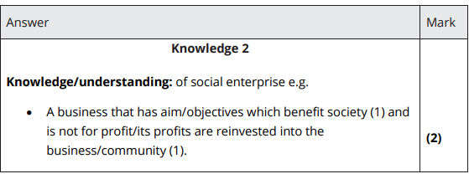

**1(b)**

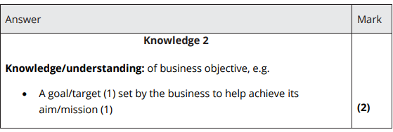

**1(c)**

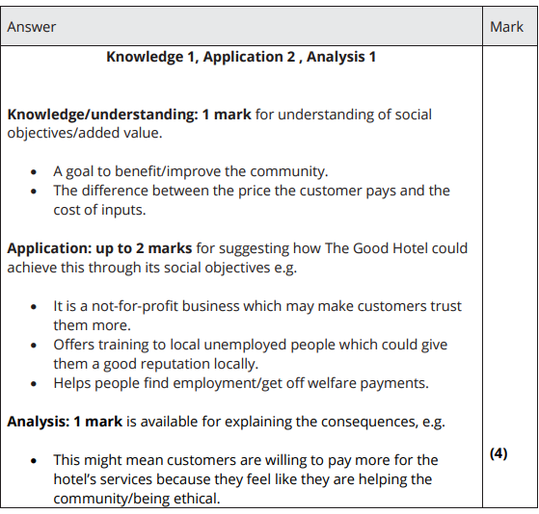

**2(a)**

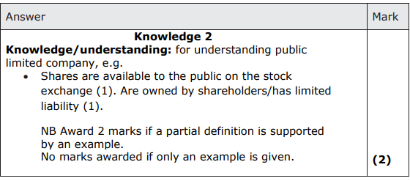

**2(b)**

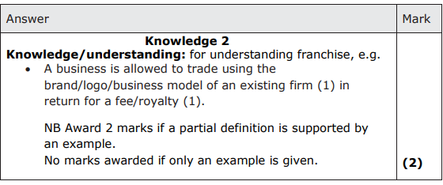

**2(c)**

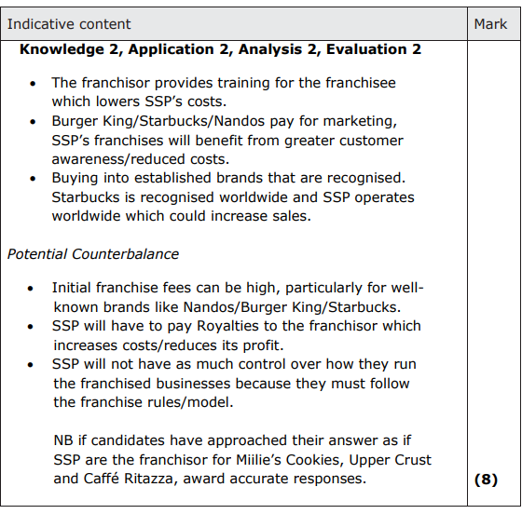

**3(a)**

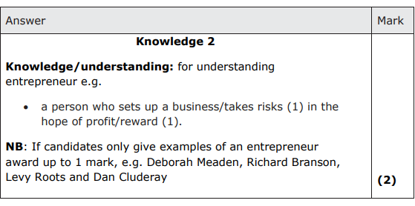

**3(b)**

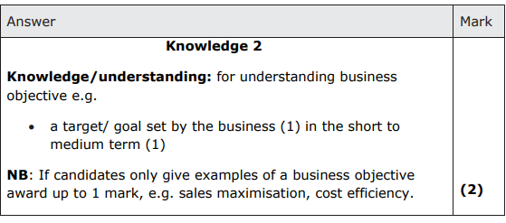

**3(c)**

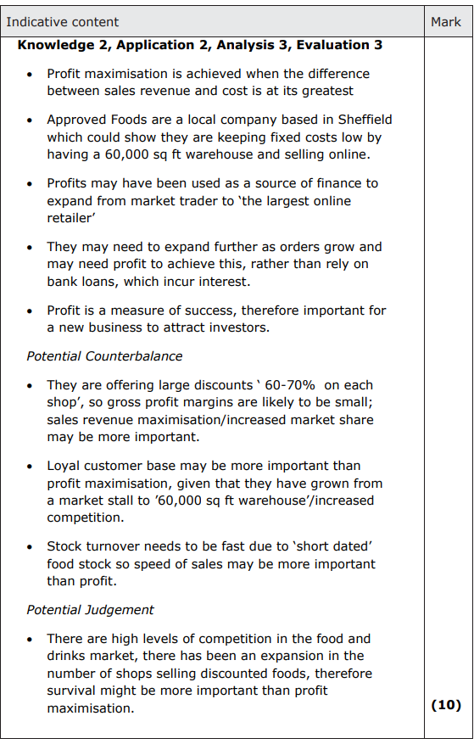

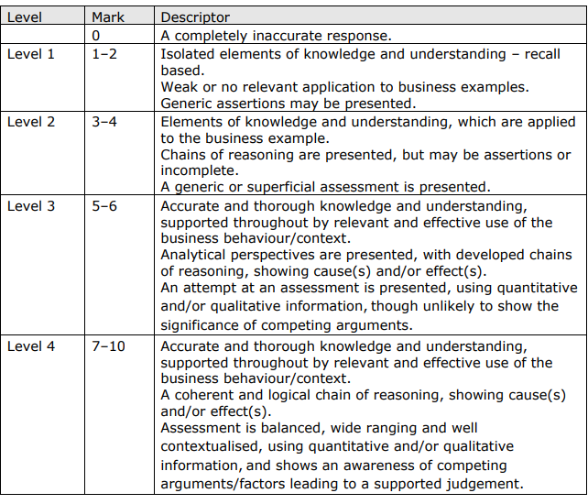

**4**

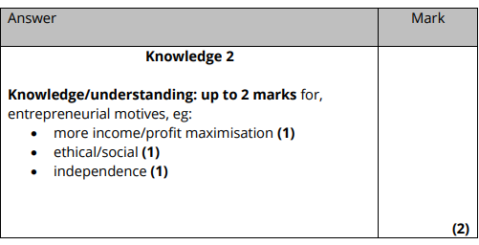

**5(a)**

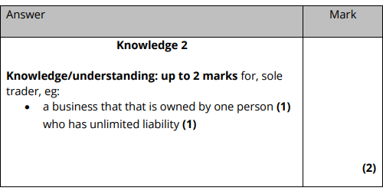

**5(b)**

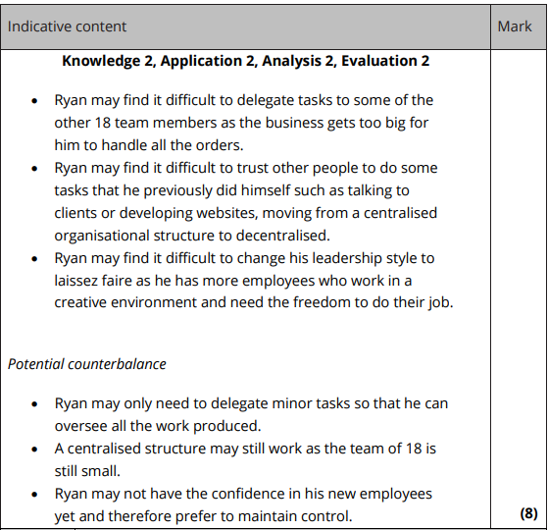

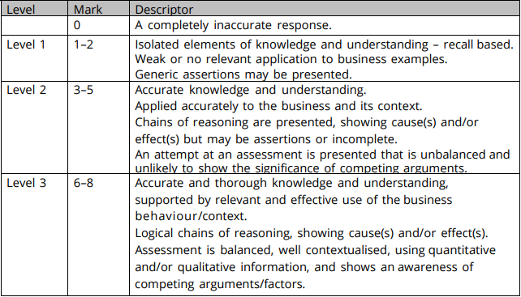

**5(c)**

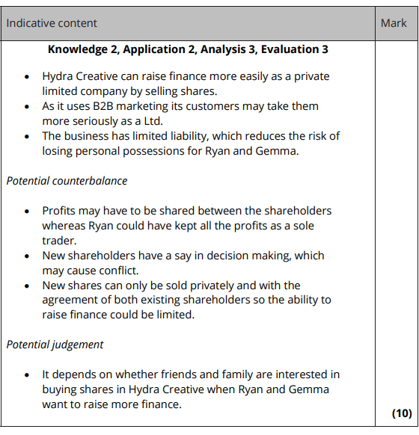

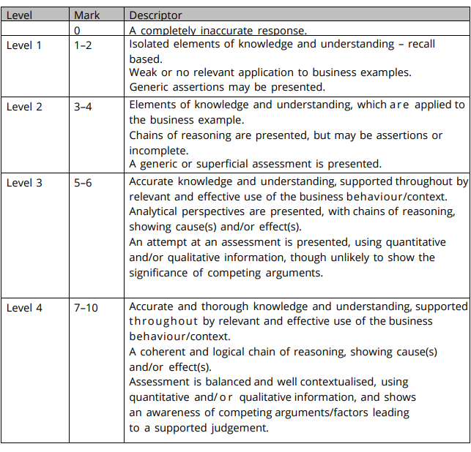

**6**

