A-Level Maths Handbook

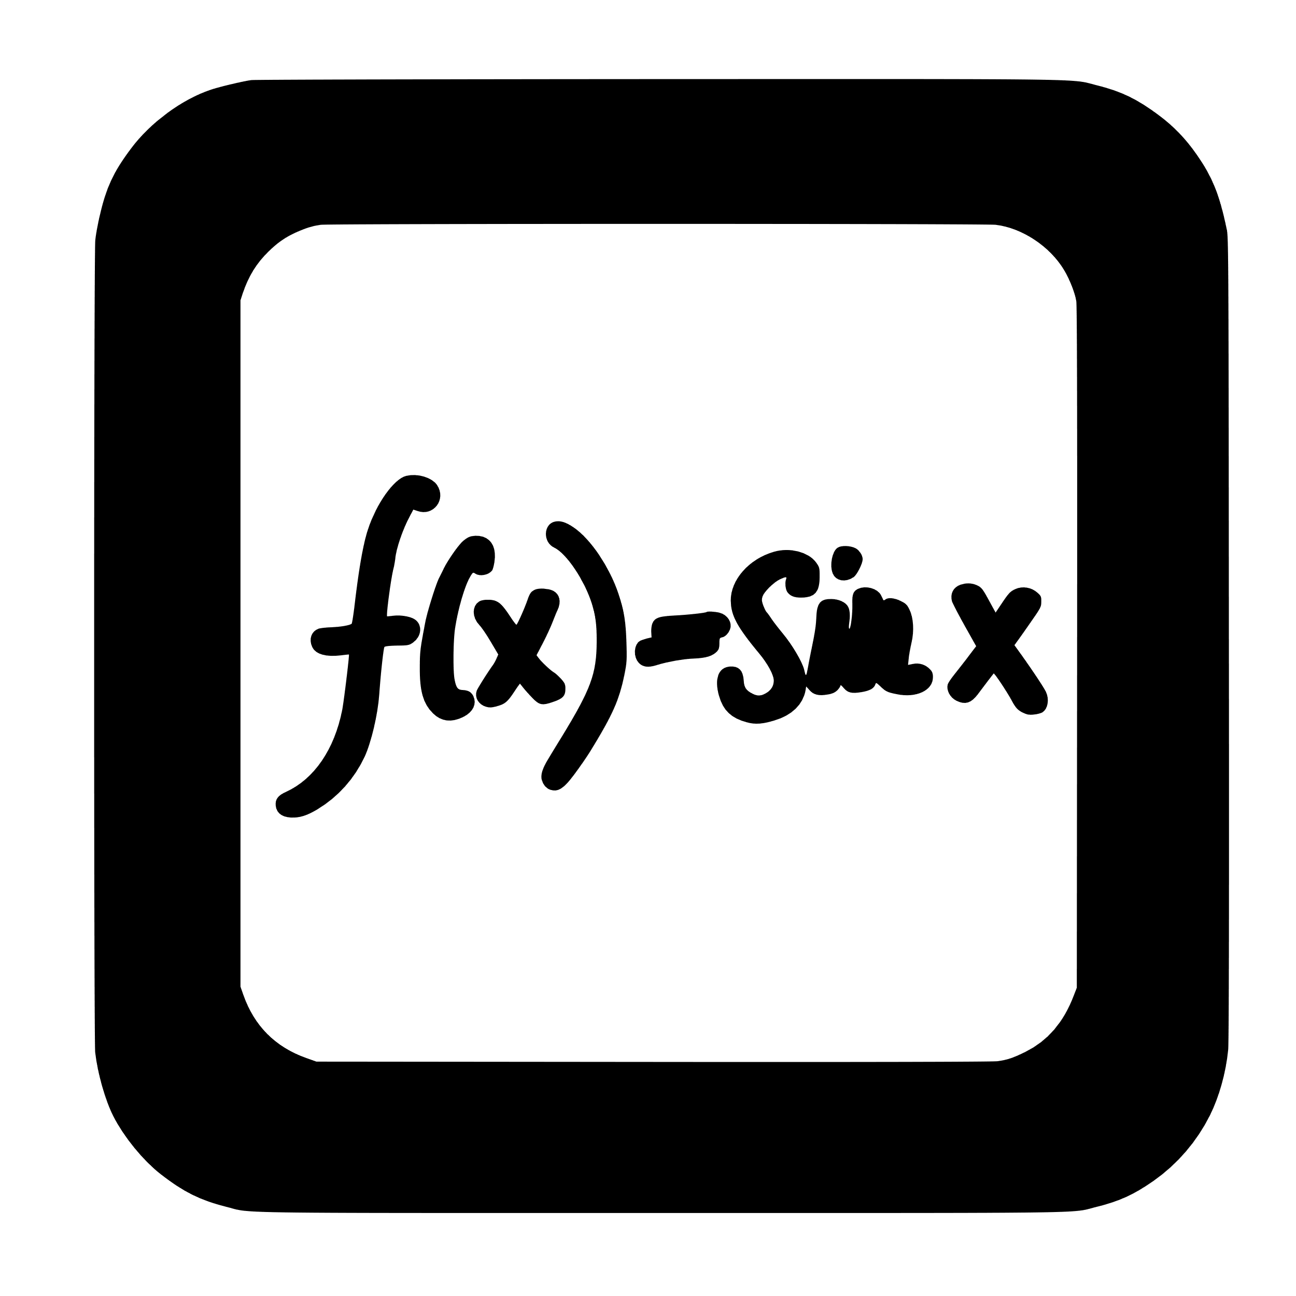

# Contents

Contents 2

Course details 3

Qualification 3

Specification 3

Entry Requirements 3

Calendar 3

Contact details 3

Organisation 4

Equipment 4

Assessment 5

External assessments 5

Grade boundaries 5

Internal assessments 6

5 hours in… Maths 7

Supercurricular 8

Read 8

Watch 8

Listen 8

Compete 8

Online 8

Write like a Mathematician 9

Command words 9

Specification 18

# Course details

## Qualification

AQA A-Level Maths

## Specification

[AQA | AS and A-level | Mathematics | Specification at a glance](https://www.aqa.org.uk/subjects/mathematics/as-and-a-level/mathematics-7357/specification-at-a-glance)

## Entry Requirements

* Grade 7 in GCSE Maths

## Calendar

|  |  |  |  |  |
| --- | --- | --- | --- | --- |
| **Half-term** | **Year 12** | | **Year 13** | |
| **Teacher 1** | **Teacher 2** | **Teacher 1** | **Teacher 2** |
| 1 | Algebra and Functions | Co-ordinate Geometry, Graphs and Circles | Algebraic Methods, Functions, Parametric Equations | Trigonometry |
| 2 | Proof, Binomial Expansion and Trigonometry | Differentiation | Differentiation | Trigonometry, Vectors, Numerical Methods. |
| 3 | Exponentials and Logarithms | Integration, Vectors | Sequences and Series, Binomial Expansion | Integration |
| 4 | Mechanics (Kinematics 1) | Statistics (Sampling, Data Representation and Data Interpretation) | Statistics (Correlation, Regression and Probability) | Mechanics (Dynamics) |
| 5 | Mechanics (Forces and Newton’s Laws) | Statistics (Probability, Statistical Distributions and Statistical Hypothesis Testing) | Statistics (Normal Distribution) | Mechanics (Kinematics 2 and Moments) |
| 6 |  |  |  |  |

## Contact details

Maths Faculty Leader: Holly Mclean [hmclean01@beckfoot.org](mailto:hmclean01@beckfoot.org)

Maths KS5 Co-ordinator: Mel Dworakowski [mdworakowski01@beckfoot.org](mailto:mdworakowski01@beckfoot.org)

A-Level Maths teacher: Adam Braid [abraid01@beckfoot.org](mailto:abraid01@beckfoot.org)

A-Level Maths teacher: Charlotte Holden [cholden01@beckfoot.org](mailto:cholden01@beckfoot.org)

A-Level Maths teacher: Neil Kendall [nkendall01@beckfoot.org](mailto:nkendall01@beckfoot.org)

A-Level Maths teacher: Neil Kettle [nkettle01@beckfoot.org](mailto:nkettle01@beckfoot.org)

A-Level Maths teacher: Nick Illingworth [nillingworth01@beckfoot.org](mailto:nillingworth01@beckfoot.org)

# Organisation

You are expected to maintain a well-organised exercise book:

* All examples should be fully written as they are modelled.
* All examples should be clear and highlighted to separate them from other workings.
* All worksheets/CMPs/Feedback should be glued in.
* All class work should be completed in your own time, if not in lesson time.
* Your assessments will be contained in a folder, kept by a teacher. Photocopies to take home may be requested.

**You will be given a Formulae booklet – this should be brought to every lesson.**

**Your exercise book should be a complete revision guide – any lessons missed due to absence must be copied up.**

**You will be given a ‘5 hours in’ booklets each half term – these contain exam questions from every topic covered within the half term to complete when applicable.**

# Equipment

**You must bring the following to all lessons**:

* Black pens, green pen, mini-whiteboard pen, pencil, and highlighter pen.
* Scientific calculator, with STATS functioning (casio 991-CW)
* 30 cm Ruler
* Maths Formulae Booklet
* Exercise Book
* 5 hours in Booklet
* Textbook (CGP Mathematics for A-Level) - issued by the LRC.

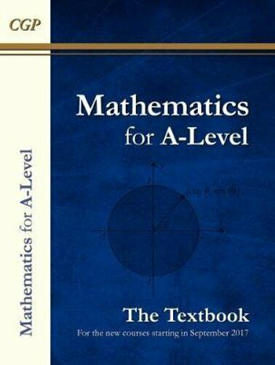

# Assessment

## External assessments

A-Level Mathematics is a linear course, and you will sit all external exams at the end of Year 13. These take the form of three papers, as shown below:

## Grade boundaries

Below is an indication of the recent 2023 grade boundaries that have been used in AS and A-Level Maths exams. These are indicative only – actual grade boundaries used for in-class assessments may vary.

|  |  |  |
| --- | --- | --- |
| **Grade** | **AS Maths (Year 12)** | **A-Level Maths (Year 13)** |
| A* |  | 83 % |
| A | 66 % | 67 % |
| B | 57 % | 54 % |
| C | 48 % | 42 % |
| D | 38 % | 29 % |
| E | 29 % | 16 % |

# Internal Assessments

Topic assessments (CMPs) will be sat in class at the end of every topic, on average every three to four weeks.

You will have one set of mock exams in Year 12, and two sets of mock exams in Year 13. These mocks will cover all topics that have been covered up to that point in time.

You will also have termly assessments which will take the form of past paper questions on topics covered up to that point.

# 5 hours in… Maths

Research shows that the most successful students (i.e. those that make the most progress and get the highest grades) are doing between 20 and 25 hours of independent study per week by the end of Year 13. That may seem a lot, but it’s something that you would build up to over the course of your A-Levels. In Year 12, we’re talking something more like 15 hours per week. This equates to roughly 5 hours of independent study per A-Level per subject.

The best way to improve your maths is to practise maths. Your “5 hours in” should focus on questions from the following three sources:

**Consolidation**

The evening following a maths lesson, you should spend 12-15 minutes (24-30 minutes for a double) rereading your notes, writing a summary section at the bottom of your notes and making relevant flashcards e.g. for equations, definitions, facts you need to recall etc.

* Consolidation exercises – from CGP A level book. (Continue / finish after each lesson)
* Complete review exercises from end of each topic area in CGP A level book
* Videos and exercises from Integral Maths (logins provided)
* Exam questions and past paper practice (you will be given a booklet linking to hundreds of past exam questions on the Exampro website).
* AQA past exam papers and practice papers

**Reactive**

This is your ’homework’. Each of your maths teachers should give you at least 1 hours’ worth of homework each week. If they don’t – ask them for some! If you find this takes more than 1 hour, that’s fine, you can take this from the proactive phase (not from the consolidation phase though). Equally, if you find you finish your reactive work quickly, spend more time on your proactive work.

* Home learning set by class teacher using Integral maths (logins provided)
* “5 hours in maths” booklet with exam questions (provided - solutions on mathsgenie website)
* Exam Question QR code Booklet (provided

**Proactive**

This is the section that will broaden and deepen your overall understanding of the subject you are studying. It will not necessarily involve work that has been set by your teacher, but instead it is about you doing the extra practice questions, reading articles, watching videos, TED talks etc. This might contain some of the following:

* Try a Maths UKMT Senior Challenge question - [Senior Mathematical Challenge - UKMT](https://ukmt.org.uk/senior-challenges/senior-mathematical-challenge)
* Attempt some interesting questions on the nRich website [Post-16 Students (maths.org)](https://nrich.maths.org/students/post-16)
* Use a search engine to find interesting videos to expand your maths knowledge, try searching for Numberphile; or Hannah Fry, be proactive.

Useful websites if you are stuck:

* Mathsgenie [Maths Genie - A Level Maths Revision](https://www.mathsgenie.co.uk/newalevel.html)
* TL Maths [TLMaths](https://www.tlmaths.com/home)
* Physics and Maths Tutor [Physics & Maths Tutor (physicsandmathstutor.com)](https://www.physicsandmathstutor.com/)
* Bicen Maths [Bicen Maths - YouTube](https://www.youtube.com/channel/UC58b34-W7M-bLEARri1912g)
* Integral [Home - Integral Maths](https://integralmaths.org/)
* Dr Frost [Dr Frost Learning](https://www.drfrost.org/)
* Desmos [Desmos | Graphing Calculator](https://www.desmos.com/calculator)

# Supercurricular

## Read (available from the LRC)

* Professor Stewart’s Hoard of Mathematical Treasures - Ian Stewart
* How Many Socks Make a Pair? - Rob Eastaway

# Fermat's Last Theorem - Simon Singh

# The Number Mysteries - Marcus Du Sautoy

# Things to Make and do in the Fourth Dimension – Matt Parker

# The Code Book – Simon Singh

# How Not to be Wrong – Jordan Ellenberg

# The Simpsons and their Mathematical Secrets by Simon Singh

# Humble Pi – Matt Parker

* A white paper glasses with blue lenses

  Description automatically generatedA colorful book cover with numbers

  Description automatically generatedA close-up of a book cover

  Description automatically generatedA book cover with socks on a line

  Description automatically generatedA book cover with text and a circle with a keyhole

  Description automatically generatedA white card with black text

  Description automatically generatedA yellow book cover with black text

  Description automatically generatedA red cover with white text and black numbers

  Description automatically generated
* [Five of the best books about maths | Books | The Guardian](https://www.theguardian.com/books/article/2024/jun/20/five-of-the-best-books-about-maths) Article from June 2024, scroll below the line to see all the other recommendations people suggest.
* Any books by Ian Stewart, Marcus Du Sautoy, Hannah Fry, Simon Singh.
* “Algorithms to live by” by Brian Christian and Tom Griffiths

## Watch

* Queen of Katwe (PG)
* A Beautiful Mind (PG-13)
* The Man Who Knew Infinity (PG-13)
* The Imitation Game (12A)
* Good Will Hunting
* Numberphile <https://www.numberphile.com/>
* TED Talks – Maths to Blow Your Mind <https://www.ted.com/playlists/189/math_talks_to_blow_your_mind>

[The mathematics of love | Hannah Fry (youtube.com)](https://www.youtube.com/watch?v=yFVXsjVdvmY)

* Oxford Mathematics <https://www.youtube.com/channel/UCLnGGRG__uGSPLBLzyhg8dQ/playlists>

## Compete

* UKMT <https://www.ukmt.org.uk/>

## Online

* Parallel by Simon Singh <https://parallel.org.uk/>
* NRICH <https://nrich.maths.org/>

## Visit

* Leeds University online problem solving classes – run by the Advanced Maths Support Programme (AMSP)
* Maths Inspiration (when on tour locally): <https://mathsinspiration.com/>
* Girls into STEM university day at Sheffield University (AMSP)
* STEP support classes (by request through AMSP)

## Write like a Mathematician

It is important that you can explain yourself clearly in your written work. Writing like a Mathematician will ensure you are able to structure your solutions logically and accurately to achieve the most marks possible.

# Specification