

Additional Assessment Materials

Summer 2021

Pearson Edexcel GCE in A level Business

9BS0

Resource Set 2

4.2 Global markets and business expansion

4.2.1 Conditions that prompt trade

4.2.3 Assessment of a country as a production location

4.2.4 Reasons for global mergers or joint ventures

4.2.5 Global competitiveness

**Pearson: helping people progress, everywhere**

Pearson aspires to be the world’s leading learning company. Our aim is to help everyone progress in their lives through education. We believe in every kind of learning, for all kinds of people, wherever they are in the world. We’ve been involved in education for over 150 years, and by working across 70 countries, in 100 languages, we have built an international reputation for our commitment to high standards and raising achievement through innovation in education. Find out more about how we can help you and your students at: [www.pearson.com/uk](http://www.pearson.com/uk)

Additional Assessment Materials, Summer 2021

All the material in this publication is copyright

© Pearson Education Ltd 2021

**General guidance to Additional Assessment Materials for use in 2021**

**Context**

* Additional Assessment Materials are being produced for GCSE, AS and A levels (with the exception of Art and Design).
* The Additional Assessment materials presented in this booklet are an **optional** part of the range of evidence you may use when deciding on a candidate’s grade.
* 2021 Additional Assessment Materials have been drawn from previous examination materials, namely past papers.
* Additional Assessment Materials have come from past papers both published (those materials available publicly) and unpublished (those currently under padlock to our centres) presented in a different format to allow you to adapt them to use with your candidates.

**Purpose**

* The purpose of this resource to provide qualification-specific sets/groups of questions covering the knowledge, skills and understanding relevant to this Pearson qualification.
* This document should be used in conjunction with the mapping guidance which will map content and/or skills covered within each set of questions. The mapping guidance will also highlight where the question originally came from to allow you to access further support materials (mark schemes, examiner reports).
* Use of these assessment materials will assist you in assessing candidates’ current performance in areas not assessed elsewhere. Their use will also provide an extra opportunity for candidates to demonstrate their performance at the end of their course of study.
* These materials are only intended to support the summer 2021 series.

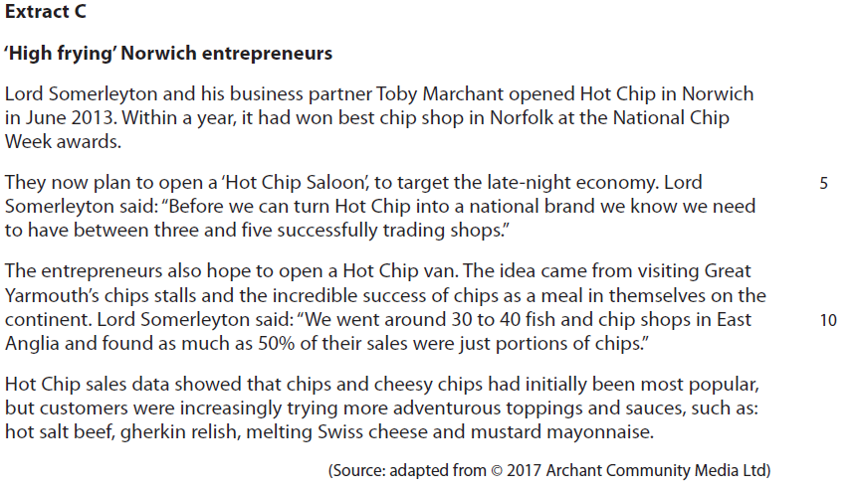**4.2.1 Conditions that prompt trade**

Hot Chip will employ a manager in each of its outlets. These managers could use a broadly autocratic or democratic leadership style.

1 Evaluate these **two** options and recommend which is the most suitable leadership style for a business such as Hot Chip.

(20)

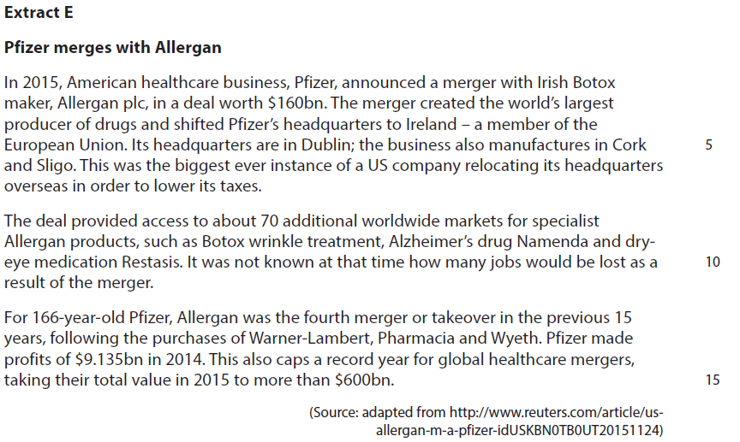**4.2.3 Assessment of a country as a production location**

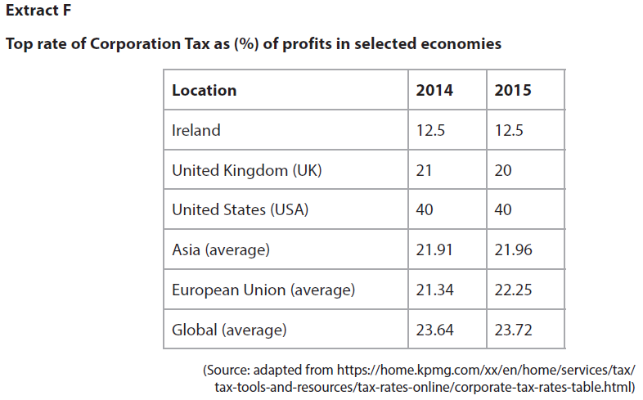

2 Using the data in Extracts E and F, calculate the amount Pfizer would have saved in 2014 if it had paid corporation tax in Ireland, rather than the USA.

You are advised to show your working.

(4)

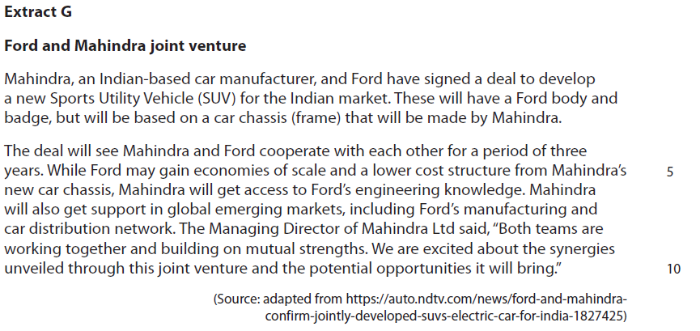**4.2.4 Reasons for global mergers or joint ventures**

3 Assess the likely consequences for Ford of its joint venture with Mahindra.

(12)

**4.2.5 Global competitiveness**

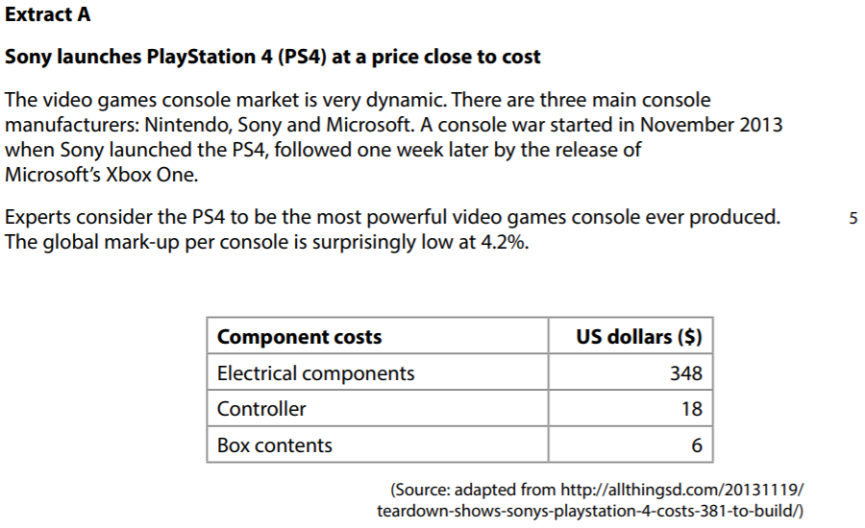

4 Using the data in Extract A, calculate the UK retail price of a PS4 to the nearest pound if the exchange rate is £1 = $1.68. You are advised to show your working.

(4)

|  |  |  |
| --- | --- | --- |
| Question Number | Indicative content | Mark |
| **1** | **Knowledge 4, Application 4, Analysis 6, Evaluation 6**  **Option 1**   * Autocratic leadership assumes that decision-making is best kept with managers, who will direct subordinates with little consultation * Autocratic leadership can suit fast-paced business environments such as the fast food business, where quick customer service is an expectation and staff may not have time to ask questions or consult on decisions such as the best way of organising the processing of customer orders * Autocratic leadership can also suit businesses with high staff-turnover, which is often a characteristic of fast food businesses – workers may receive limited training and need direction from an experienced manager. * As Hot Chip is a new business, with a unique product, it may be that the owners want managers to direct workers in an autocratic way so that the business culture can be established and high levels of customer service through accurate food orders and quick service, are provided   **Option 2**   * Democratic leadership means leading a business based on decisions agreed by the majority. It involves consultation between managers and subordinates. * Democratic leadership might suit a new business such as Hot Chip because subordinates who are serving customers will gain an understanding of what is popular and what customers see as important – this can be relayed to managers in meetings and inform decisions about menus, working rotas, and dishes/flavours * Evidence D suggests that managers in the fast food industry that train and listen to employees tend to help deliver higher levels of customer service. This comes from open communication and offering a realistic perspective on working in the fast food business. * As a new business Hot Chip may recruit staff from other fast food outlets that can offer suggestions of procedures and ways of organising that work well. If managers can take advantage of this knowledge and experience, this could improve the performance of Hot Chip as it establishes itself.   *Potential judgement:*   * Autocratic leadership may be most suitable in the first few months of a new Hot Chip saloon opening. This should provide stability and clarity to new staff as they join and could help Lord Somerleyton establish a clear business culture in keeping with the values he had in setting up the business. * Hot Chip is a different type of fast food outlet to places such as McDonalds – its menu is still evolving and consulting with employees from the beginning is likely to have a positive impact on customer service and the way staff are organised and work. * It is likely that managers may use a combination of leadership styles, but the one which is most dominant may depend on the priorities that Lord Somerleyton has for the business and linked to this, the nature of the managers recruited. | **(20)** |

|  |  |  |
| --- | --- | --- |
| Level | Mark | Descriptor |
|  | 0 | A completely inaccurate response. |
| Level 1 | 1–4 | Isolated elements of knowledge and understanding. Weak or no relevant application of business examples.  An argument may be attempted, but will be generic and fail to connect cause(s) and/or consequence(s)/effect(s). |
| Level 2 | 5–8 | Elements of knowledge and understanding, which are applied to the business example.  Arguments and chains of reasoning are presented, but connections between cause(s) and/or consequence(s)/ effect(s) are incomplete. Attempts to address the question.  A comparison or judgement may be attempted, but it will not successfully show an awareness of the key features of business behaviour or business situation. |
| Level 3 | 9–14 | Accurate and thorough knowledge and understanding, supported throughout by relevant and effective use of the business behaviour/context.  Uses developed chains of reasoning, so that cause(s) and/or consequence(s)/effect(s) are complete, showing an understanding of the question. Arguments are well developed.  Quantitative or qualitative information is introduced in an attempt to support judgements, a partial awareness of the validity and/or significance of competing arguments and may lead to a conclusion. |
| Level 4 | 15–20 | Accurate and thorough knowledge and understanding, supported throughout by use of relevant and effective use of the business behaviour/context.  Uses well-developed and logical, coherent chains of reasoning, showing a range of cause(s) and/or effect(s). Arguments are fully developed.  Quantitative and/or qualitative information is/are used well to support judgements. A full awareness of the validity and significance of competing arguments/factors, leading to balanced comparisons, judgements and an effective conclusion that proposes a solution and/or recommendation(s). |

|  |  |  |
| --- | --- | --- |
| Question Number | Answer | Mark |
| **2** | **Knowledge 1, Application 3**  Quantitative skills assessed:  **QS2:** calculate, use and understand percentages and percentage changes  **QS9**: interpret, apply and analyse information in written, graphical and numerical forms  **Knowledge: 1 mark** for understanding how corporation tax is calculated e.g.   * Profit x corporation tax rate (%)   **Application: up to 3 marks**   * Corporation tax in USA was 40% in 2014, so Pfizer’s tax would be $9.135bn x 40% = $3.654bn * Corporation tax in Ireland was 12.5% in 2014, so Pfizer’s tax bill would have been $9.135bn x 12.5% = $1.141875bn * Therefore, they would have saved $3.654 - $1.411875 = **$2.512125bn** had they been based in Ireland.   NB: if answer given is $2.512125bn award 4 marks  Accept any accurate version of $2.5bn to a range of decimal points.  An alternative way of getting the same answer as above:   * $9.135bn x 1.4 = $12.789bn (USA); so $12.789bn – $9.135bn = $3.654bn Tax * $9.135 x 1.125 = $10.276875bn (Ireland) = $10.276875bn – $9.135bn = 1.141875 * Therefore, they would have saved $3.654bn - $1.141875bn = **$2.512125bn** had they been based in Ireland   Situation 2 – The candidate assumes that $9.135bn is **after tax** and we need to add tax on USA **and** Ireland and compare the difference:   * If 9.135bn is after tax, we need to add the tax on again * The calculation for this is:   After tax figure  100% – tax rate % X 100   * So, for Pfizer in the USA: $9.135bn/60 x 100 = $15.225bn before tax. Therefore, tax paid in USA is $15.225bn – $9.135bn = **$6.09bn** * In Ireland it is: $9.135bn/87.5 x 100 = $10.44bn before tax. Therefore, tax paid in Ireland is $10.44bn - $9.135bn = **$1.305bn** * Therefore: $6.09bn - $1.305bn = **$4.785bn**   Accept any answer, rounded correctly up to 1.d.p. i.e:  $4.8bn  $4.79bn  Situation 3 – The candidate assumes that $9.135bn is **after tax** and that Pfizer paid tax in Ireland at the original pre-tax profit level   * If 9.135bn is after tax, we need to add the tax on again * The calculation for this is:   After tax figure  1 – tax rate (%) X 100  So, for Pfizer in the USA: $9.135bn/60 x 100 = **$15.225bn before tax**.   * Pfizer’s tax bill was therefore: $15.225bn - $9.135bn = **$6.09bn** * Pfizer would therefore pay $15.225bn x 12.5% = **$1.903125bn** in Ireland * The saving is therefore $6.09bn - $1.903125bn = **$4.186875bn**   Accept any answer, rounded correctly up to 1.d.p. i.e:  $4.186875 bn  $4.18688 bn  $4.1869 bn  $4.187 bn  $4.19 bn  $4.2bn | **(4)** |

|  |  |  |  |  |
| --- | --- | --- | --- | --- |
| Question Number | | Indicative content | | Mark |
| **3** | | **Knowledge 2, Application 2, Analysis 4, Evaluation 4**   * A joint venture may be a one-off or temporary arrangement, or a lasting collaboration in a specific market. * In this case, the Ford-Mahindra deal is for three years. There is no change of ownership and the relationship between the two businesses will be controlled by legal agreement. * Ford is likely to gain increased sales from its joint venture with Mahindra as they are likely to know the specific needs of the Indian market and have access to workers familiar with this market. * Ford may gain economies of scale and a lower cost structure from Mahindra's existing manufacturing plants, Mahindra will get access to Ford engineering knowledge and expertise in Sports Utility Vehicles. * As an American brand, Ford may be seen as desirable for aspirational consumers in an emerging market such as India. This is because Ford is associated with the USA and ‘Western lifestyles’, that are desirable by some consumers in India.   *Potential counterbalance*   * Ford and Mahindra may have different visions for how the joint venture will work, which can lead to disagreements over business strategy such as pricing and marketing. * Indian consumers may be confused by the two businesses working together, which could limit sales. Mahindra is an established brand in the Indian market, Ford less so and their brand strength may be diluted by this arrangement. * As the joint venture develops, the aims of Mahindra and Ford might diverge: Mahindra may want to focus on budget sales, while Ford may want to target higher socio-economic groups. * Mahindra might benefit from transfer of knowledge of new technology and techniques, so once joint venture ends, it can use this knowledge to compete with Ford.   *Potential judgement*   * The joint venture is likely to benefit Ford as it could reduce its manufacturing costs as Mahindra provides the chassis for the new SUV enabling Ford to be more price competitive in the Indian market where incomes are relatively low so making the cars more affordable so sales may increase. * The main consequence of the joint venture is likely to be positive for Mahindra, rather than Ford as it gain sales from the support of the Ford brand and their expertise in selling Sports Utility Vehicles in other markets. This success will depend on the degree to which Mahindra and Ford can agree on the overall strategy for the three years. | | **(12)** |
| Level | Mark | Descriptor | |
|  | 0 | A completely inaccurate response. | |
| Level 1 | 1–2 | Isolated elements of knowledge and understanding – recall based.  Weak or no relevant application to business examples.  Generic assertions may be presented. | |
| Level 2 | 3–4 | Elements of knowledge and understanding, which are applied to the business example.  Chains of reasoning are presented, but may be assertions or incomplete.  A generic or superficial assessment is presented. | |
| Level 3 | 5–8 | Accurate knowledge and understanding, supported by relevant and effective use of the business behaviour/context.  Analytical perspectives are presented, with developed chains of reasoning, showing cause(s) and/or effect(s). An attempt at an assessment is presented, using quantitative and/or qualitative information though unlikely to show the significance of competing arguments. | |
| Level 4 | 9–12 | Accurate and thorough knowledge and understanding, supported throughout by relevant and effective use of the business behaviour/context.  A coherent and logical chain of reasoning, showing cause(s) and/or effect(s).  Assessment is balanced, wide ranging and well contextualised, using quantitative and/or qualitative information and shows an awareness of competing arguments/factors leading to a supported judgement. | |

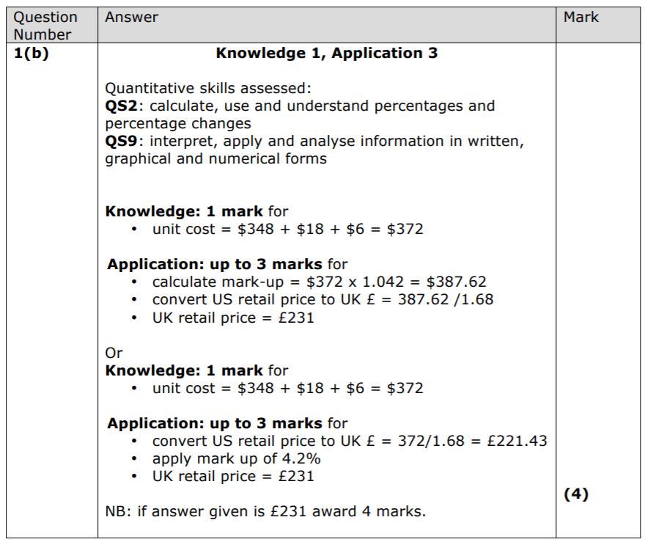

**4**