

Additional Assessment Materials

Summer 2021

Pearson Edexcel GCE in A level Business

9BS0

Resource Set 4

4.4 Global industries and companies

4.4.1 The impact of MNCs

4.4.2 Ethics

**Pearson: helping people progress, everywhere**

Pearson aspires to be the world’s leading learning company. Our aim is to help everyone progress in their lives through education. We believe in every kind of learning, for all kinds of people, wherever they are in the world. We’ve been involved in education for over 150 years, and by working across 70 countries, in 100 languages, we have built an international reputation for our commitment to high standards and raising achievement through innovation in education. Find out more about how we can help you and your students at: [www.pearson.com/uk](http://www.pearson.com/uk)

Additional Assessment Materials, Summer 2021

All the material in this publication is copyright

© Pearson Education Ltd 2021

**General guidance to Additional Assessment Materials for use in 2021**

**Context**

* Additional Assessment Materials are being produced for GCSE, AS and A levels (with the exception of Art and Design).
* The Additional Assessment materials presented in this booklet are an **optional** part of the range of evidence you may use when deciding on a candidate’s grade.
* 2021 Additional Assessment Materials have been drawn from previous examination materials, namely past papers.
* Additional Assessment Materials have come from past papers both published (those materials available publicly) and unpublished (those currently under padlock to our centres) presented in a different format to allow you to adapt them to use with your candidates.

**Purpose**

* The purpose of this resource to provide qualification-specific sets/groups of questions covering the knowledge, skills and understanding relevant to this Pearson qualification.
* This document should be used in conjunction with the mapping guidance which will map content and/or skills covered within each set of questions. The mapping guidance will also highlight where the question originally came from to allow you to access further support materials (mark schemes, examiner reports).
* Use of these assessment materials will assist you in assessing candidates’ current performance in areas not assessed elsewhere. Their use will also provide an extra opportunity for candidates to demonstrate their performance at the end of their course of study.
* These materials are only intended to support the summer 2021 series.

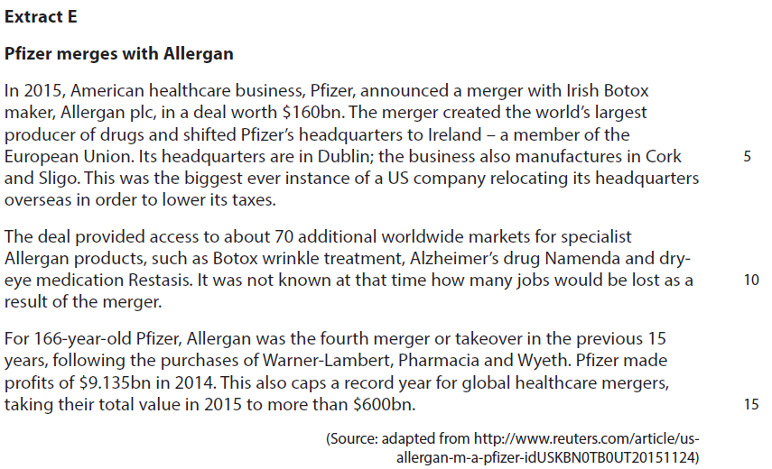**4.4.1 The impact of MNCs**

The government of Ireland supports the location of multinationals, such as Pfizer, in their country if this benefits the local and national economy overall.

1 Evaluate the likely impacts on the Irish economy of Pfizer locating there and recommend if the Irish government should have supported this decision or not.

(20)

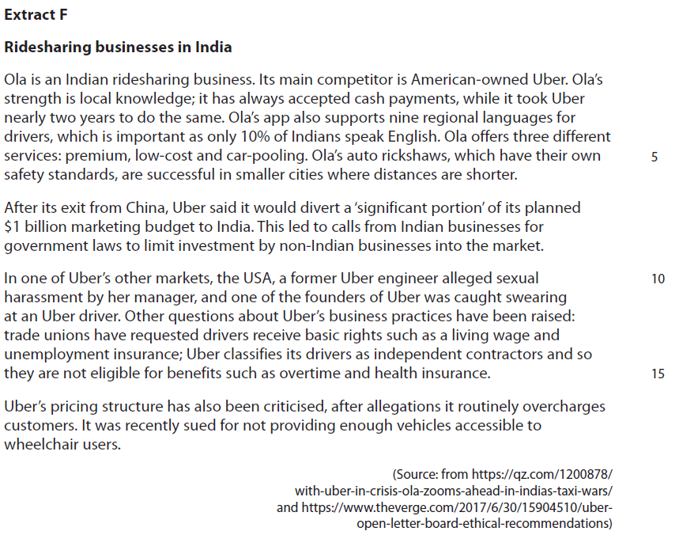**4.4.2 Ethics**

Uber aims to become the market leader in Indian ridesharing. To achieve this Uber could either focus on adapting its service to the needs of Indian consumers or improve its

business ethics.

2 Evaluate these two options and recommend which **one** Uber should choose to become market leader.

(20)

|  |  |  |
| --- | --- | --- |
| Question Number | Indicative content | Mark |
| **1** | **Knowledge 4, Application 4, Analysis 6, Evaluation 6**  **Decision for**   * Foreign owned multinationals such as Pfizer bring skills and new technology to an economy, which are not always present in a host economy such as Ireland * These gains can spill-over to local businesses in Ireland in the form of technological transfer, making them more innovative and productive * Dublin pharmacies could also benefit from increased competition amongst drug manufacturers which could increase choice and reduce prices for healthcare products in Ireland and in the EU, which would also benefit the Irish consumer * The Multinationals currently located in Ireland are from a range of sectors including IT and building. Allowing a pharmaceutical business to locate there will help broaden the employment base of the economy and reduce dependence a small number of sectors * Businesses in the Cork area supply chain will also benefit from the increased need for supplies for the Pfizer / Allergan business by increasing sales * As Pfizer / Allergan may recruit more skilled staff, which may increase the average wage in the Irish economy or at least the local economy. This could lead to increased local spending / an increase in Ireland’s GDP * The Irish government could gain from increased corporation tax revenue as the new company declares profits there, as well as VAT and other revenues from increased consumer spending.   **Decision against**   * Irish businesses may not be able to compete in paying higher wages, so they lose out on recruiting the most able scientists and staff in the healthcare sector * Following this, there may be a skills shortage in the Irish economy for employees in the healthcare sector elsewhere as Pfizer / Allergan increases its recruitment * Pfizer is still a majority US-owned company and it may send profits from the business back to shareholders registered abroad, so the economy of Ireland does not benefit from investment and spending in the long-run * The Irish economy is already dominated by multinational businesses, such as Microsoft, so another one will increase its vulnerability to MNCs choosing to relocate and leave Ireland at short-notice, without Irish businesses to replace them * The expertise and growth of the Irish economy is mainly in IT services, not healthcare / pharmaceuticals, so there may not be sufficient expertise for Irish workers to benefit from the relocation of Pfizer’s operations.   *Potential judgements*   * The Irish government should have supported this decision for Pfizer to locate in Ireland because of the gains in corporation tax revenue and potential for increased employment. The increased tax revenue could be spent elsewhere in the Irish economy to support local firms, develop new areas of specialisation and support education and training. The local supply chain will also benefit from new demand which supports employment and spending in the economy * The Irish government should have opposed the decision as it is already overly dependent on multinational businesses in its economy. This makes them vulnerable to sudden decisions about relocation which can damage Irish workers and consumers. It seems clear that Pfizer’s decision has been based on reducing its tax bill, with less consideration for Allergan and Ireland. This means it is very likely to leave Ireland (for countries such as Hungary which has a 10% tax rate) as quickly as it arrived, damaging consumers and Irish businesses hugely. | **(20)** |

|  |  |  |
| --- | --- | --- |
| Question Number | Indicative content | Mark |
| **2** | **Knowledge 4, Application 4, Analysis 6, Evaluation 6**  **Decision for adapting its products to India**   * India is the second biggest country in the world by population and therefore home to a diverse range of language groups, customs and tastes. By adapting its service to local needs, such as by recruiting staff that speak each local language fluently, they will reach a wide market and compete effectively with Ola and other Indian businesses. * Uber has been involved in disputes in some developed markets such as the US. Adapting their service to the specific features of Indian cities, such as using appropriate pricing strategies, which are likely to attract customers * The ridesharing market around the world does not differ between markets. Therefore, Uber can continue to use the strategies that they have used in the US and UK to grow, including adaptive pricing and up to date customer interaction through an app. * Ola has already gained success from adapting by accepting cash, employing drivers that speak different languages and offering auto rickshaw journeys. Uber may need to differentiate themselves in other ways, such as being the most reliable, to differentiate their service in India.   **Decision for focusing on improving its business ethics**   * Business ethics are the moral principles that may or may not be used as a basis for decision-making. * Uber has faced criticisms for its treatment of staff and customers in some markets. Getting this aspect right, could help to differentiate itself from India competitors such as Ola, who may have lower ethical standards. * Customers who use ridesharing will want to be confident of the safety of the service they are using. This means that drivers are well-rested and paid fairly, rather than simply completing as many jobs as possible. * Offering good pay to Uber’s drivers in India will allow them to choose from a better calibre of employee and should help to improve the quality of the service. Uber can benefit from more productive drivers, that make fewer mistakes and therefore offer a better service to Indian customers. * Being ethical may lead to lower costs than adapting its strategy to the Indian market. Indian labour standards and rights may be lower than other markets, so the costs of compliance may be lower too. * India may have lower labour standards than Uber’s other markets, so this may not be a big issue. Customers may be more concerned with the service being cheap and reliable, as the customers themselves may have limited disposable income or work in areas with questionable business ethics.   *Potential judgement:*   * The primary concern of customers in the Indian ridesharing market is likely to be a cheap and reliable ridesharing, so adapting the service is likely to be the most successful. This adaption could be in terms of making the app and service as reliable and accessible as possible, perhaps by designing an app that works on a less reliable phone network infrastructure. Matching Ola by offering drivers who speak local languages and accepting cash payments may be a good place to begin. * Ethics affects the perception of customers and in a competitive market, Uber might lose more customers to Ola if it does not improve its ethical position. It might also be that as a ‘Western’ brand, it can use an ethical stance as a way of differentiating itself from Ola, whose ethical standards may be lower. Ridesharing is more environmentally friendly than car ownership, for example, so a focus on this may help to attract customers with environmental concerns. | **(20)** |

|  |  |  |
| --- | --- | --- |
| Level | Mark | Descriptor |
|  | 0 | A completely inaccurate response. |
| Level 1 | 1–4 | Isolated elements of knowledge and understanding. Weak or no relevant application of business examples.  An argument may be attempted, but will be generic and fail to connect cause(s) and/or consequence(s)/effect(s). |
| Level 2 | 5–8 | Elements of knowledge and understanding, which are applied to the business example.  Arguments and chains of reasoning are presented, but connections between cause(s) and/or consequence(s)/ effect(s) are incomplete. Attempts to address the question.  A comparison or judgement may be attempted, but it will not successfully show an awareness of the key features of business behaviour or business situation. |
| Level 3 | 9–14 | Accurate and thorough knowledge and understanding, supported throughout by relevant and effective use of the business behaviour/context.  Uses developed chains of reasoning, so that cause(s) and/or consequence(s)/effect(s) are complete, showing an understanding of the question. Arguments are well developed.  Quantitative or qualitative information is introduced in an attempt to support judgements, a partial awareness of the validity and/or significance of competing arguments and may lead to a conclusion. |
| Level 4 | 15–20 | Accurate and thorough knowledge and understanding, supported throughout by use of relevant and effective use of the business behaviour/context.  Uses well-developed and logical, coherent chains of reasoning, showing a range of cause(s) and/or effect(s). Arguments are fully developed.  Quantitative and/or qualitative information is/are used well to support judgements. A full awareness of the validity and significance of competing arguments/factors, leading to balanced comparisons, judgements and an effective conclusion that proposes a solution and/or recommendation(s). |