

Additional Assessment Materials

Pearson Edexcel AS Level in Business (8BS0)

Resource Set 1.4: Managing people

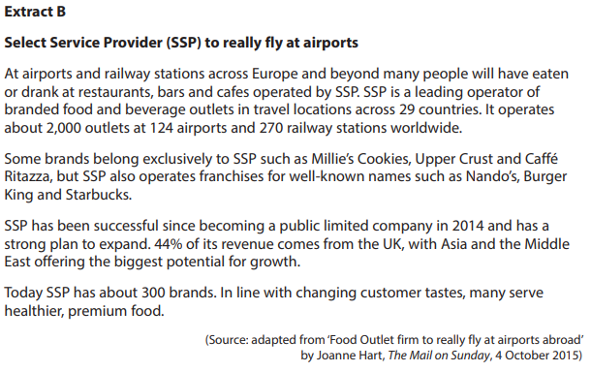1. Explain how a flexible workforce might benefit SSP. (4)

________________________________________________________________________________________________________________________________________________________________________________________________________________________________________________________________________________________________________________________________________________

________________________________________________________________________________________________________________________________________________________________________________________________________________________________________________________________________________________________________________________________________________

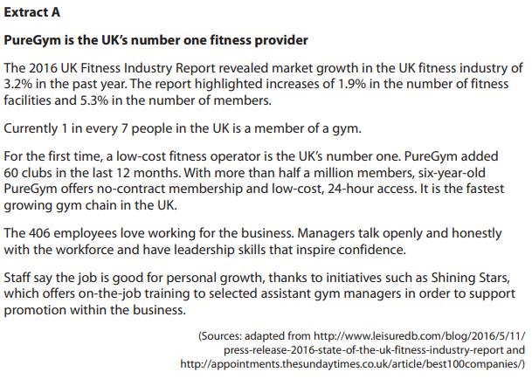

1. (a) What is meant by on-the-job training? (2)

________________________________________________________________________________________________________________________________________________________________________________________________________________________________________________________________________________________________________________________________________________

(b) Assess **two** likely benefits for PureGym of its managers using a paternalistic leadership style. (8)

________________________________________________________________________________________________________________________________________________________________________________________________________________________________________________________________________________________________________________________________________________

________________________________________________________________________________________________________________________________________________________________________________________________________________________________________________________________________________________________________________________________________________

________________________________________________________________________________________________________________________________________________________________________________________________________________________________________________________________________________________________________________________________________________

________________________________________________________________________________________________________________________________________________________________________________________________________________________________________________________________________________________________________________________________________________

________________________________________________________________________________________________________________________________________________________________________________________________________________________________________________________________________________________________________________________________________________

________________________________________________________________________________________________________________________________________________________________________________________________________________________________________________________________________________________________________________________________________________

________________________________________________________________________________________________________________________________________________________________________________________________________________________________________________________________________________________________________________________________________________

________________________________________________________________________________________________________________________________________________________________________________________________________________________________________________________________________________________________________________________________________________

____________________________________________________________________________________

________________________________________________________________________________________________________________________________________________________________________________________________________________________________________________________________________________________________________________________________________________

________________________________________________________________________________________________________________________________________________________________________________________________________________________________________________________________________________________________________________________________________________

(c) Assess the extent to which training assistant managers for promotion to managers could benefit a business, such as PureGym. (10)

________________________________________________________________________________________________________________________________________________________________________________________________________________________________________________________________________________________________________________________________________________

________________________________________________________________________________________________________________________________________________________________________________________________________________________________________________________________________________________________________________________________________________

________________________________________________________________________________________________________________________________________________________________________________________________________________________________________________________________________________________________________________________________________________

________________________________________________________________________________________________________________________________________________________________________________________________________________________________________________________________________________________________________________________________________________

________________________________________________________________________________________________________________________________________________________________________________________________________________________________________________________________________________________________________________________________________________

________________________________________________________________________________________________________________________________________________________________________________________________________________________________________________________________________________________________________________________________________________

________________________________________________________________________________________________________________________________________________________________________________________________________________________________________________________________________________________________________________________________________________

________________________________________________________________________________________________________________________________________________________________________________________________________________________________________________________________________________________________________________________________________________

________________________________________________________________________________________________________________________________________________________________________________________________________________________________________________________________________________________________________________________________________________

________________________________________________________________________________________________________________________________________________________________________________________________________________________________________________________________________________________________________________________________________________

____________________________________________________________________________________________________________________________________________________________________________________________________________________________________________________________



1. (a) What is meant by span of control? (2)

________________________________________________________________________________________________________________________________________________________________________________________________________________________________________________________________________________________________________________________________________________

(b) What is meant by consultation? (2)

________________________________________________________________________________________________________________________________________________________________________________________________________________________________________________________________________________________________________________________________________________

(c) Assess the potential benefits for Beaverbrooks of having a more decentralised organisational structure. (10)

____________________________________________________________________________________

________________________________________________________________________________________________________________________________________________________________________________________________________________________________________________________________________________________________________________________________________________

________________________________________________________________________________________________________________________________________________________________________________________________________________________________________________________________________________________________________________________________________________

____________________________________________________________________________________

________________________________________________________________________________________________________________________________________________________________________________________________________________________________________________________________________________________________________________________________________________

________________________________________________________________________________________________________________________________________________________________________________________________________________________________________________________________________________________________________________________________________________

____________________________________________________________________________________

________________________________________________________________________________________________________________________________________________________________________________________________________________________________________________________________________________________________________________________________________________

________________________________________________________________________________________________________________________________________________________________________________________________________________________________________________________________________________________________________________________________________________

____________________________________________________________________________________

________________________________________________________________________________________________________________________________________________________________________________________________________________________________________________________________________________________________________________________________________________

________________________________________________________________________________________________________________________________________________________________________________________________________________________________________________________________________________________________________________________________________________

1. Assess whether there is likely to be a trade-off for M&S when it targets a younger market segment for its women’s clothes. (10)

____________________________________________________________________________________

________________________________________________________________________________________________________________________________________________________________________________________________________________________________________________________________________________________________________________________________________________

________________________________________________________________________________________________________________________________________________________________________________________________________________________________________________________________________________________________________________________________________________

____________________________________________________________________________________

________________________________________________________________________________________________________________________________________________________________________________________________________________________________________________________________________________________________________________________________________________

________________________________________________________________________________________________________________________________________________________________________________________________________________________________________________________________________________________________________________________________________________

____________________________________________________________________________________

________________________________________________________________________________________________________________________________________________________________________________________________________________________________________________________________________________________________________________________________________________

________________________________________________________________________________________________________________________________________________________________________________________________________________________________________________________________________________________________________________________________________________

____________________________________________________________________________________

________________________________________________________________________________________________________________________________________________________________________________________________________________________________________________________________________________________________________________________________________________

________________________________________________________________________________________________________________________________________________________________________________________________________________________________________________________________________________________________________________________________________________

____________________________________________________________________________________

________________________________________________________________________________________________________________________________________________________________________________________________________________________________________________________________________________________________________________________________________________

________________________________________________________________________________________________________________________________________________________________________________________________________________________________________________________________________________________________________________________________________________

The Chief Executive has reorganised management by taking out a level of the hierarchy in Aston Martin’s organisational structure.

1. Assess the likely impact of this change on the motivation of the workforce.

 (10)

____________________________________________________________________________________

________________________________________________________________________________________________________________________________________________________________________________________________________________________________________________________________________________________________________________________________________________

________________________________________________________________________________________________________________________________________________________________________________________________________________________________________________________________________________________________________________________________________________

____________________________________________________________________________________

________________________________________________________________________________________________________________________________________________________________________________________________________________________________________________________________________________________________________________________________________________

________________________________________________________________________________________________________________________________________________________________________________________________________________________________________________________________________________________________________________________________________________

____________________________________________________________________________________

________________________________________________________________________________________________________________________________________________________________________________________________________________________________________________________________________________________________________________________________________________

________________________________________________________________________________________________________________________________________________________________________________________________________________________________________________________________________________________________________________________________________________

____________________________________________________________________________________

________________________________________________________________________________________________________________________________________________________________________________________________________________________________________________________________________________________________________________________________________________

________________________________________________________________________________________________________________________________________________________________________________________________________________________________________________________________________________________________________________________________________________

____________________________________________________________________________________

________________________________________________________________________________________________________________________________________________________________________________________________________________________________________________________________________________________________________________________________________________

________________________________________________________________________________________________________________________________________________________________________________________________________________________________________________________________________________________________________________________________________________

**1**

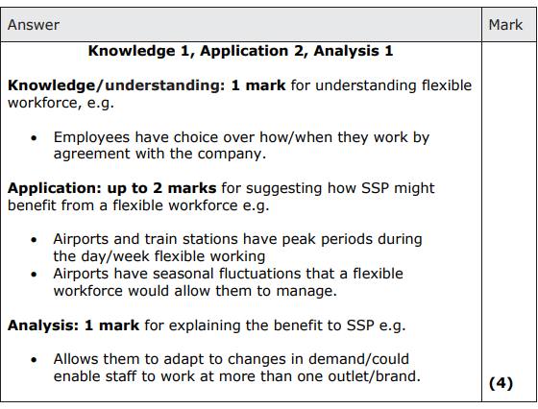

**2(a)**

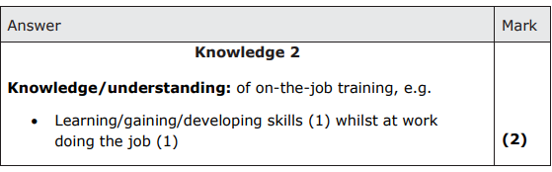

**2(b)**

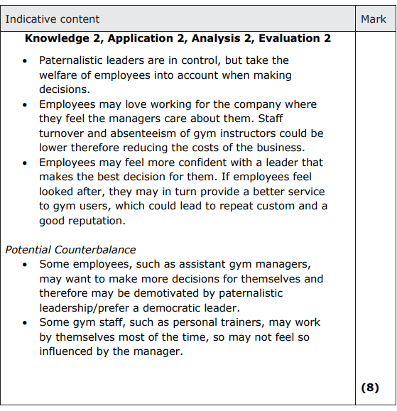

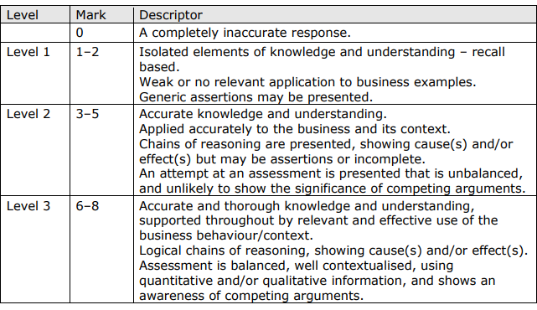

**2(c)**

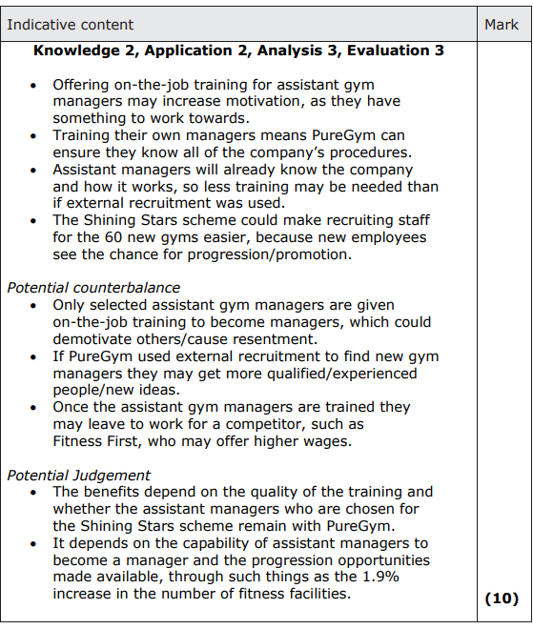

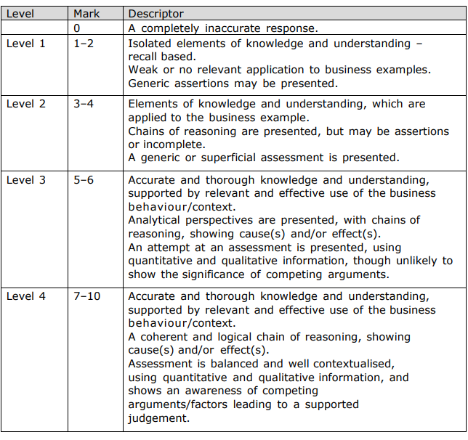

**3(a)**

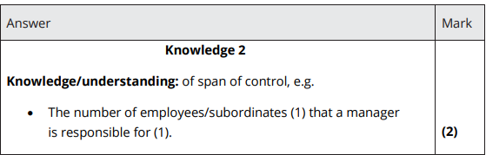

**3(b)**

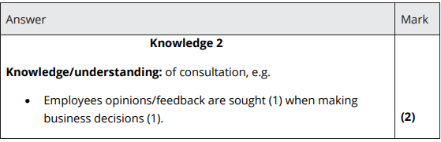

**3(c)**

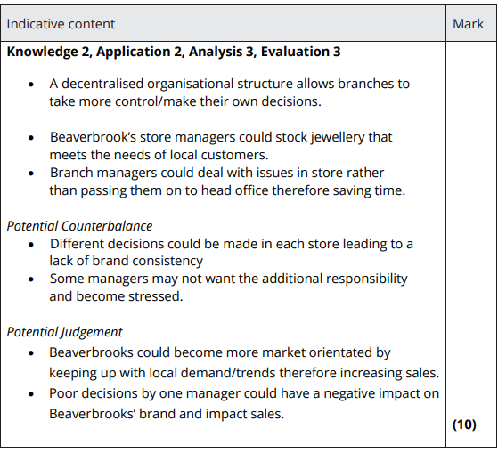

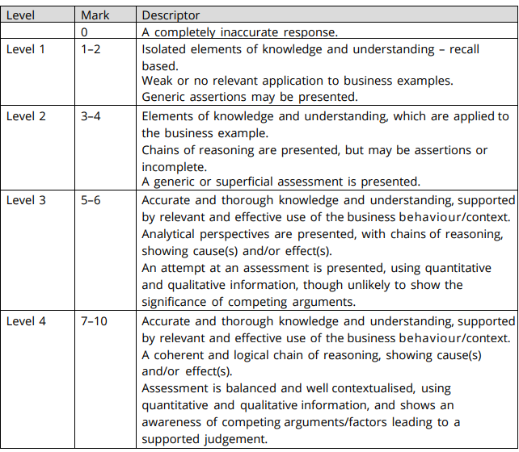

**4**

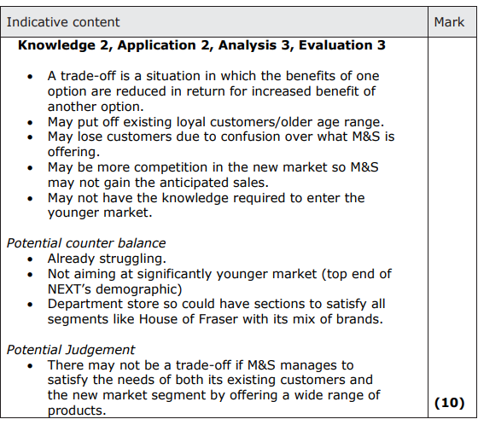

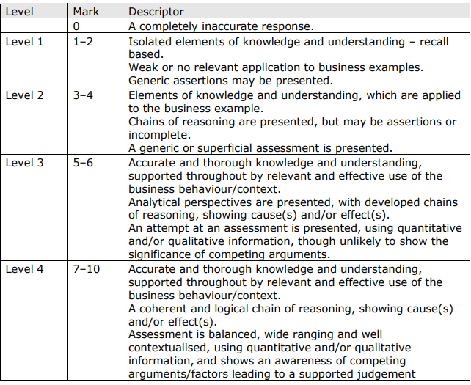

**5**

