Labour Market Information
April 2021

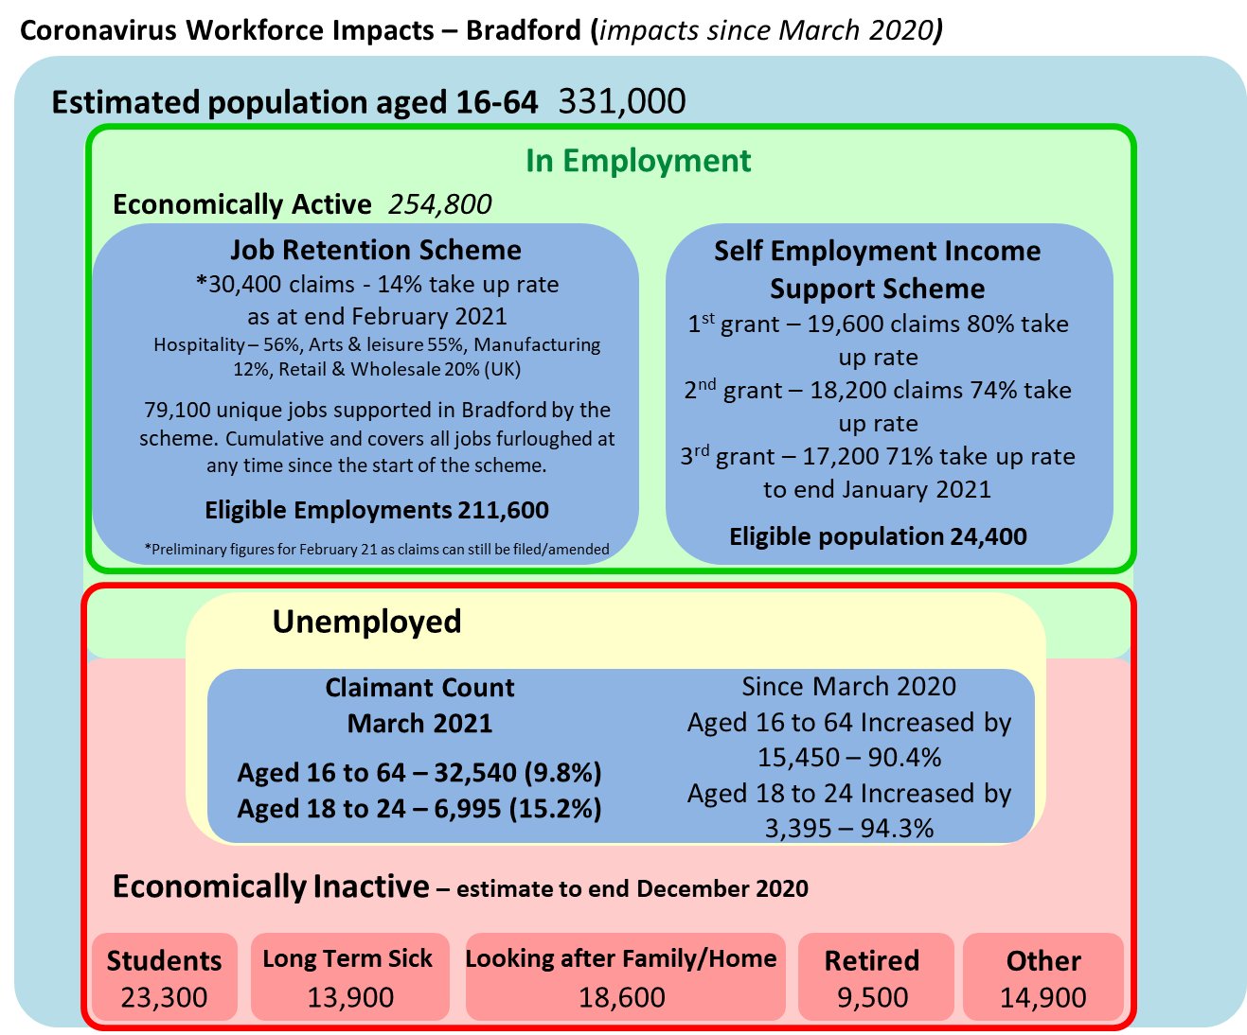

Sources: NOMIS - Annual Population Survey (October 2019 - September 2020), NOMIS - Claimant Count February 2021, HMRC coronavirus (COVID-19) Statistics CJRS – March 2021 & SEISS February 2021

Job Retention Scheme - The February release provides claims data as at the end of February 2021, but claims data from the start of February is provisional and likely to be revised.

Claimants

The claimant count is a measure released monthly of the number of people claiming unemployment related benefits. The Bradford District claimant rate (proportion of residents aged 16 – 64) increased from 5.2% in March 2020 to 9.8% in March 2021. The 18-24 year old claimant rate increased from 7.8% in March 2020 to 15.2% in March 2021.

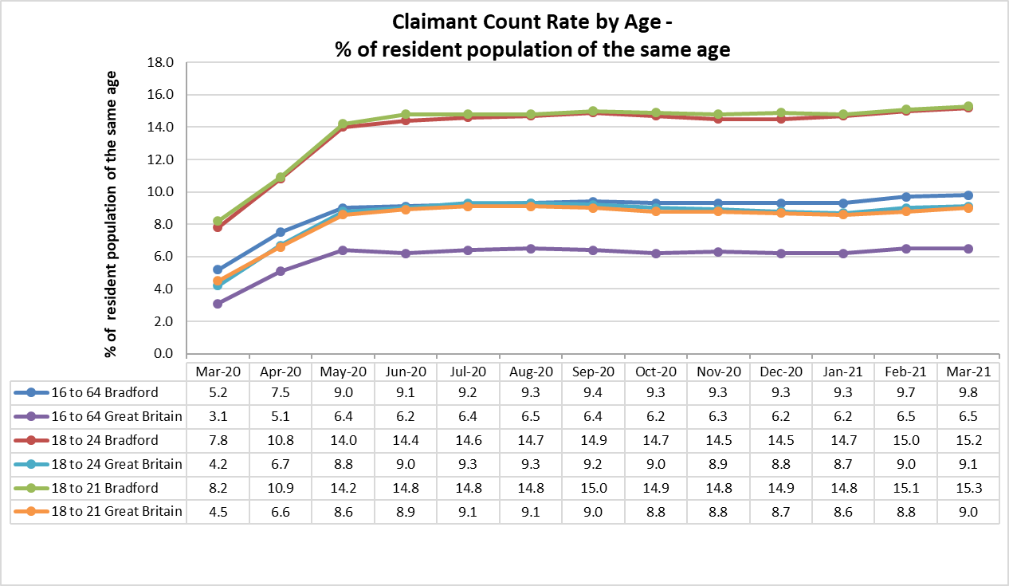

Source: NOMIS - Claimant Count March 2021 – Claimant count includes those claiming Job Seekers Allowance and those claiming the unemployment-related element of Universal Credit. In some cases claimants are not unemployed, but are eligible due to low wages and hours. The figures are subject to revision.

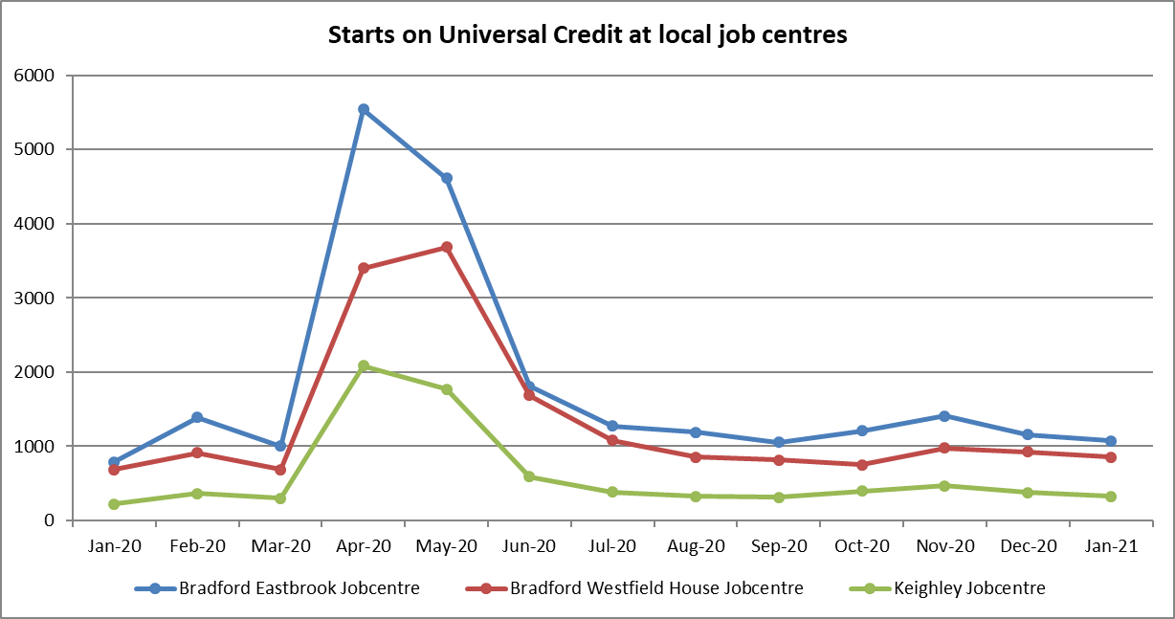
Source – Department for Work and Pensions - Stat-Xplore – 23rd February 2021. Next update due 18th May 2021.

Vacancies

Research by West Yorkshire Combined Authority indicates that there has been volatility in the number of vacancies posted online over the past few weeks in West Yorkshire. There was a sharp increase of 11% towards the end of March followed by sharp fall of 9% in week ending 10th April. Bradford followed this volatility with a 13% increase and then a fall of 7%. The West Yorkshire weekly count is on a par with pre-crisis levels.

Source: West Yorkshire Combined Authority, Covid 19 economic monitor / dashboard – latest 23rd April 2021

Employment by occupation

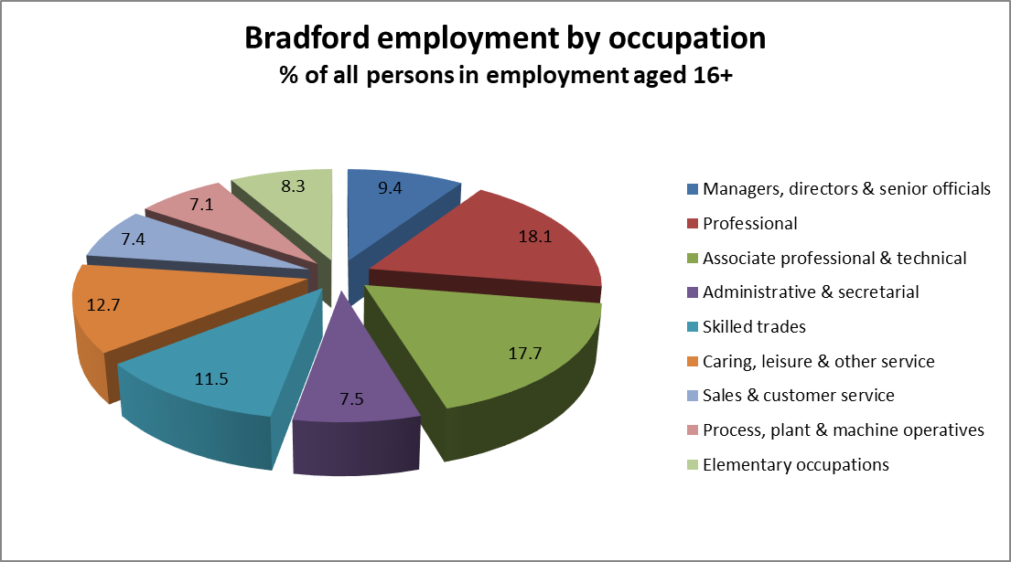

Source: NOMIS - ONS annual population survey – (January 2020 to December 2020)

Qualifications

Level of Qualifications in Population
(Jan 2020-Dec 2020)
 | Bradford | Bradford | Yorkshire And The Humber | Great Britain
 | (Level) | (%) | (%) | (%)
NVQ4 And Above | 114,700 | 34.7 | 37.3 | 43.1
NVQ3 And Above | 175,100 | 53.0 | 57.7 | 51.4
NVQ2 And Above | 230,300 | 69.6 | 75.9 | 78.2
NVQ1 And Above | 272,900 | 82.5 | 86.9 | 87.9
Other Qualifications | 26,200 | 7.9 | 6.2 | 5.7
No Qualifications | 31,600 | 9.5 | 7.0 | 6.4

Source: NOMIS - ONS annual population survey - Numbers and % are for those of 16 - 64 & % is a proportion of resident population aged 16 - 64

Apprenticeships – Bradford starts & achievements

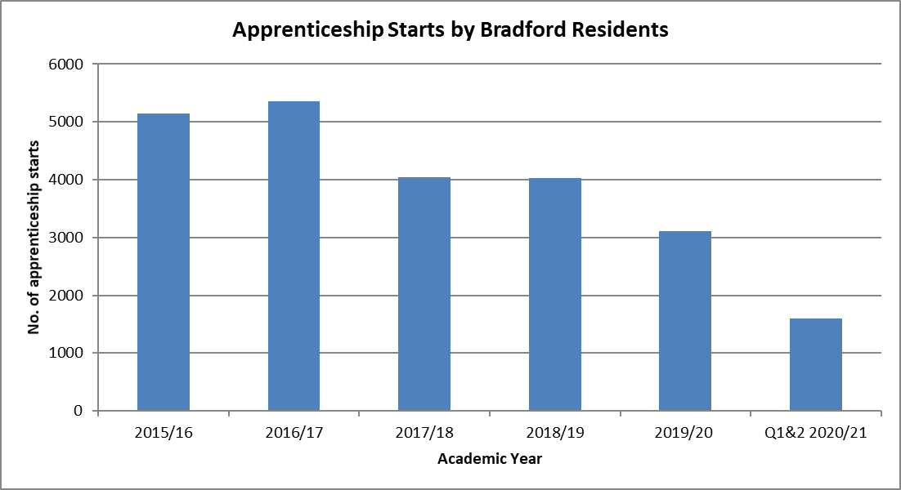

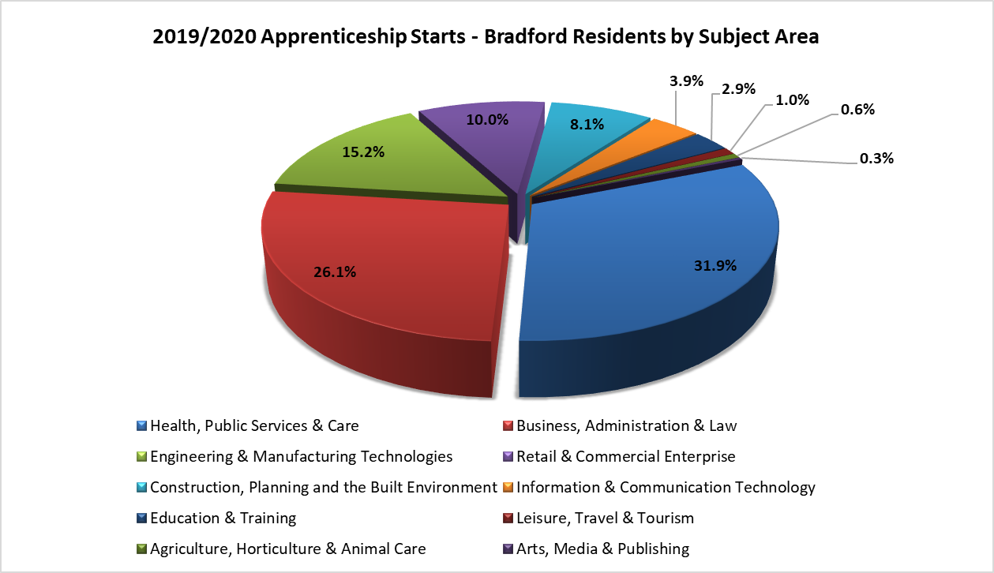
 | 2019/2020 Starts |  |  |  | 2019/2020 Achievements
 | Intermediate |  | Advanced | Higher | Intermediate | Advanced | Higher
Under 19 | 430 |  | 410 | 40 | 280 | 180 | 10
19 to 24 | 300 |  | 430 | 160 | 160 | 230 | 30
25+ | 320 |  | 630 | 370 | 180 | 250 | 100
Total | 1,060 |  | 1,470 | 580 | 620 | 650 | 140

Volumes are rounded to the nearest ten.

The data covers the period affected by Covid-19 and the national lockdown. This is likely to have impacted on apprenticeship training activity and the reporting of data.

2019/2020 achievements published in November 2020 are now treated as the final record. Overall 2019/2020 had less achievements than would normally have been expected due to disruption to exams and assessments and breaks in learning etc. 2020/21 will have more given the delays in training, passing assessments etc.

Source: https://explore-education-statistics.service.gov.uk/find-statistics/apprenticeships-and-traineeships/2019-20 . 2020/21 https://explore-education-statistics.service.gov.uk/find-statistics/apprenticeships-and-traineeships

Bradford Young People – 16/17 year olds Not in Education, Employment or Training (NEET) & Participation in Learning

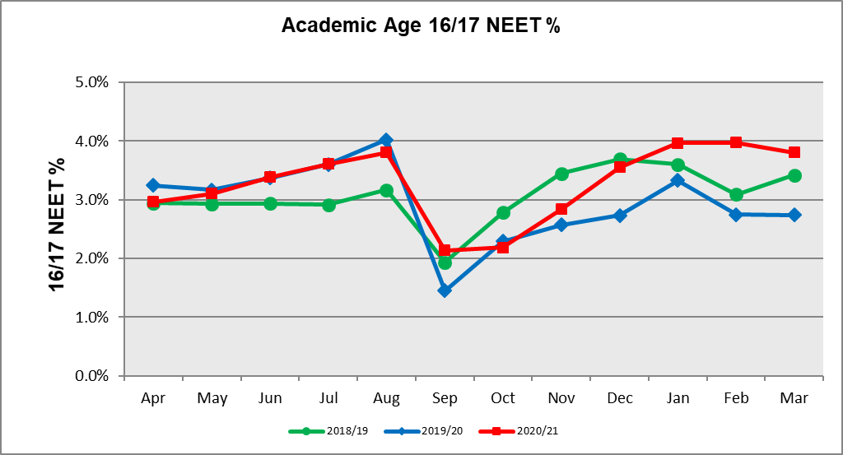

In March 2021, compared with March 2020, there were:
- Fewer young people in employment with training, apprenticeships and training (1,220 versus 1,568)
- More young people in NEET & Not Known (874 versus 565)

Source: Participation & Transition Monthly Summary March 2021.

