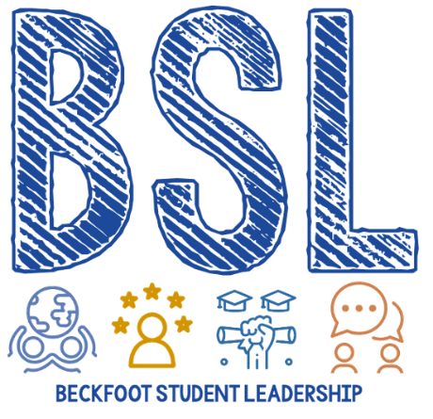
BSL Application Form
- Name and Tutor Group

- Which aspect of BSL are you interested in?

Mental Health Eco The Buzz
Equality, Diversity and Inclusion Tutor Time Curriculum
Disability Awareness Charity LRC
Extra-Curricular Activities Behaviour and PLS Other (please specify)

- Why do you want to be part of BSL team? What do you want to change? Why are you passionate about your chosen aspect?

- What qualities can you offer to the BSL team?

